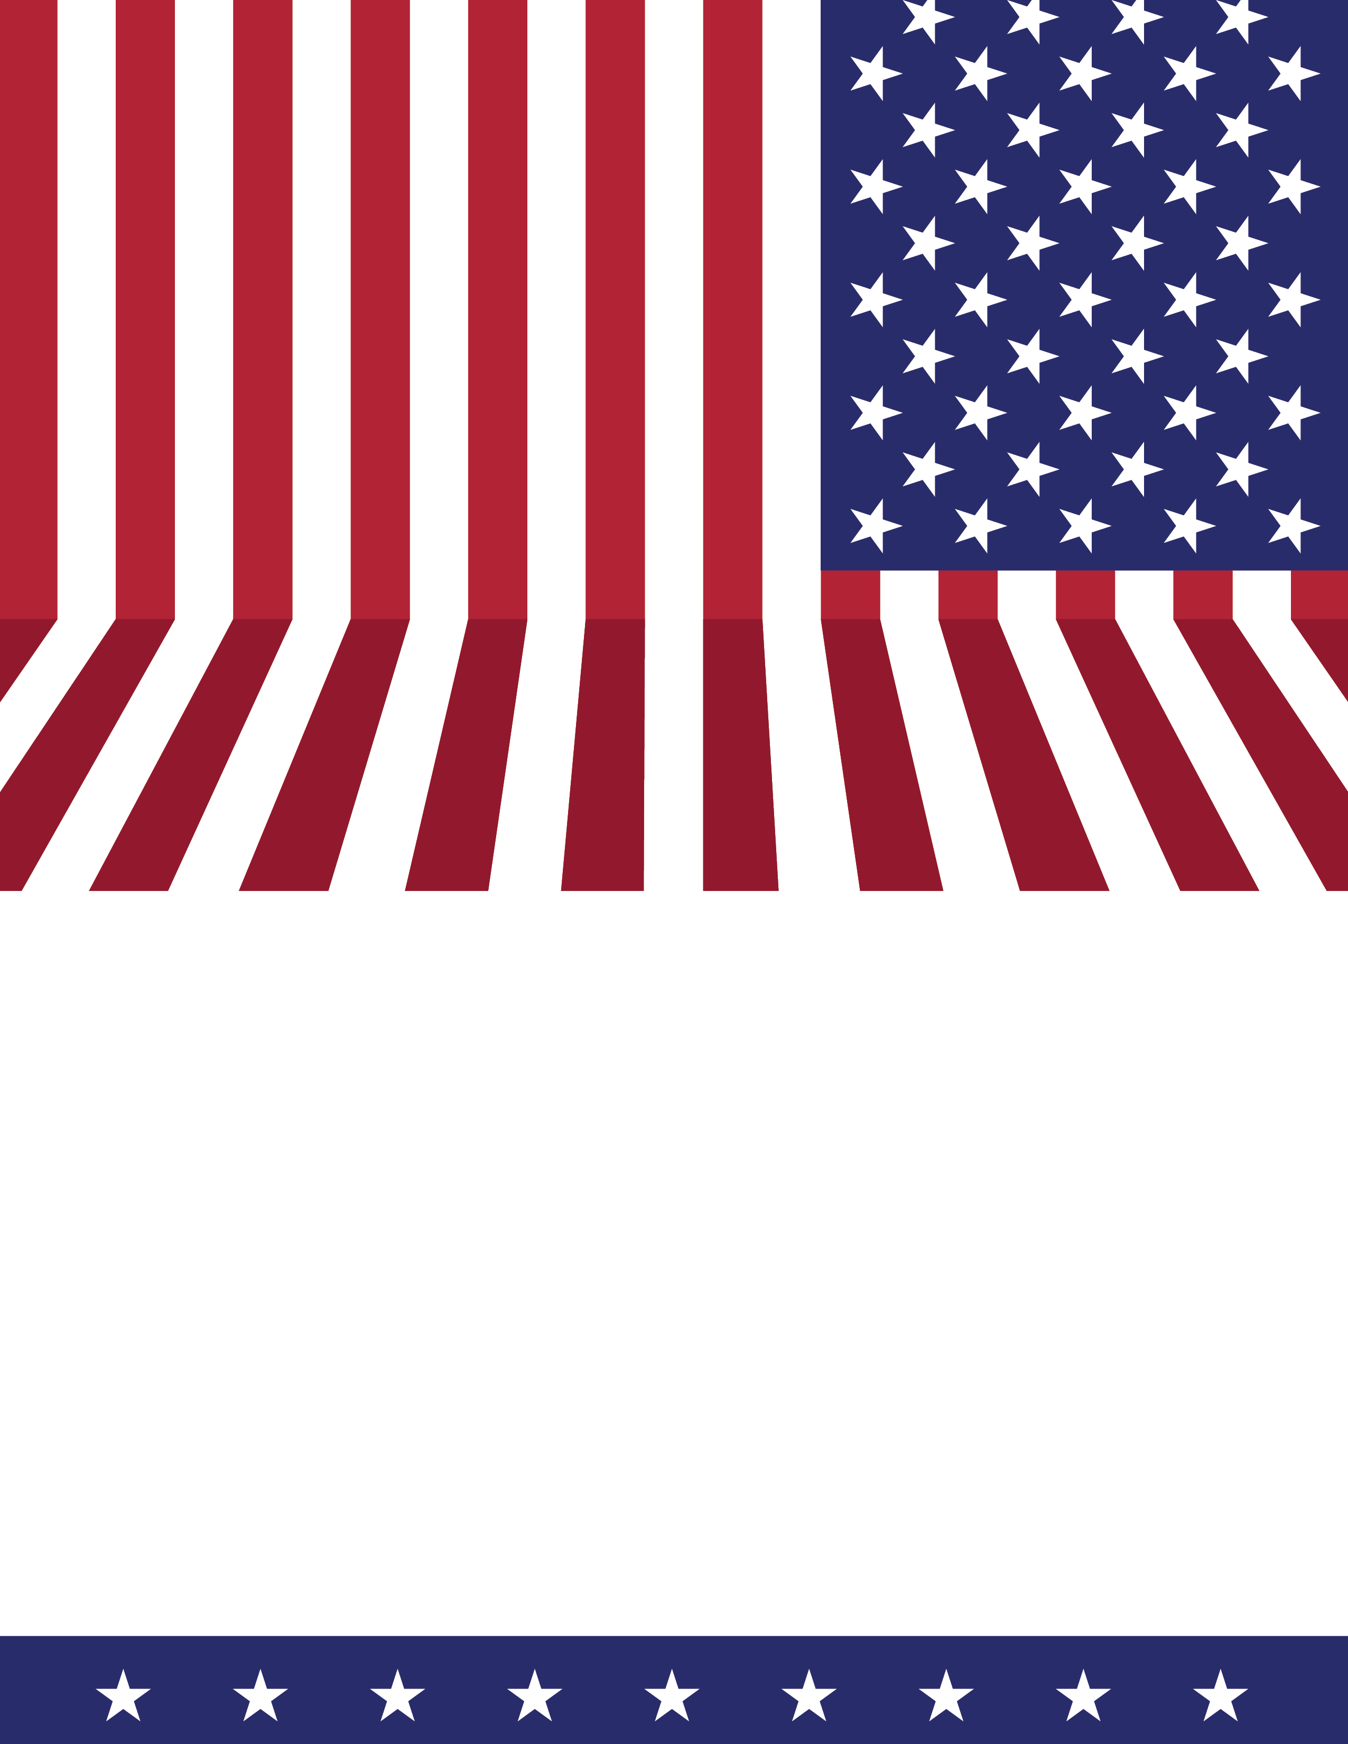

Memorial Day
This Nation will remain the land of the free only so long as it is the home of the brave.
presented by:
Harper Ferry/Bolivar Veterans Honor Guard

Monday, May 25, 2026
Parade: Washington Street, Bolivar: 9:00 am
Speaking Event: Harpers Ferry Middle School : following the parade

