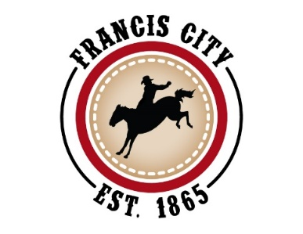

**Public Notice**

The Francis City Council will hold a public hearing on July 10th, 2025, at 6:00 p.m. at the Francis City Hall, located at 2317 So. Spring Hollow Rd. The purpose of the public hearing is a code text amendment in Francis City Code Title 18 (Zoning). This is a comprehensive amendment impacting the allowed and conditional uses in almost all zones in the City. The public is welcome to attend in person and make comments. Comments may also be submitted in writing to Suzanne Gillett, Francis City Recorder prior to 3:00 p.m. on the day of the public hearing or by email to comments@francisutah.gov.

**Published in The Wasatch Wave, Public Notice Website, and Francisutah.gov**

The meeting will be streamed live on the Francis City YouTube channel:

<https://www.youtube.com/channel/UC-9wahpEELShvGQZShXGIXg>

In compliance with the American with Disabilities Act, Individuals needing special accommodations for this meeting should notify Suzanne Gillett at 435-783-6236 at least 3 days prior to this meeting.