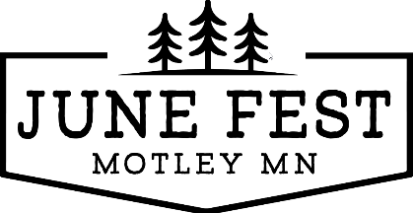

**Join the Motley June Fest Parade on June 14, 2025**

Greetings from the Motley Community Events Organization. June Fest is a big event for our city of Motley. The parade will start at 11 am and check in will be 10 am at the intersection of Hwy 10 and Mill Pond Street, near the Crown Gas building. Candy is allowed to be passed out, not thrown.

Prizes: 1st $150; 2nd $75; 3rd $25

Thank you for considering being part of our parade. If you have any questions, please contact Bruce @ 218-839-2140 or email [motleyjunefest@gmail.com](mailto:motleyjunefest@gmail.com)

Name of Unit or Group: _______________________________________________________________

Name of Contact: ____________________________________________________________________

Address: ___________________________________________________________________________

Email Address: _____________________________________________ Phone: ___________________

Type of Unit/Length: __________________________________________________________________

Does your unit have music? (Music is encouraged!) _____________

Street Performers/Walkers: _____________________

Please send completed form by June 1st, 2025

Email to: [motleyjunefest@gmail.com](mailto:motleyjunefest@gmail.com) OR

Mail to: Motley June Fest PO BOX 562 Motley MN 56466