**Creating a Unique Student Identifier (USI) Number**

To view a short video which explains how a student can create their USI, please visit the link below <https://www.usi.gov.au/students/how-do-i-create-usi>

Note on Identification:

Students will need to have a valid form of ID handy, the forms of ID include:

* Australian Passport
* Australian birth certificate
* Australian Driver’s Licence
* Medicare Card
* Certificate Of Registration By Descent
* Citizenship Certificate

Have at least one form of current and valid ID handy that will be accepted. Don't worry, they except many forms of ID and most people will own not one, but two or three forms of ID which they accept. If you do not have any of these forms of ID, please see Mr Impey (Career Advisor) for further assistance.

IMPORTANT: When you create your USI, enter your details exactly as they appear on your form of ID.

* To answer questions and complete your application for USI, please click on the “I want to create a USI now” button (Blue Button) located at the bottom of the page via this link: <https://www.usi.gov.au/students/how-do-i-create-usi>
* After completing the questions listed, please read the terms and conditions carefully and if you agree, click the agree button.

Under the terms and conditions, you will view a tick box adjacent to the question, which states,

**I confirm that I have the consent of the applicant to apply for a USI on their behalf.** (you are the applicant and you have consent as yourself to tick this box, it in the instance somebody else is applying on your behalf)

After agreeing to terms and conditions, you will be taken to this screen, please click the **“Create USI”** button and answer the questions (questions marked with a red star are mandatory

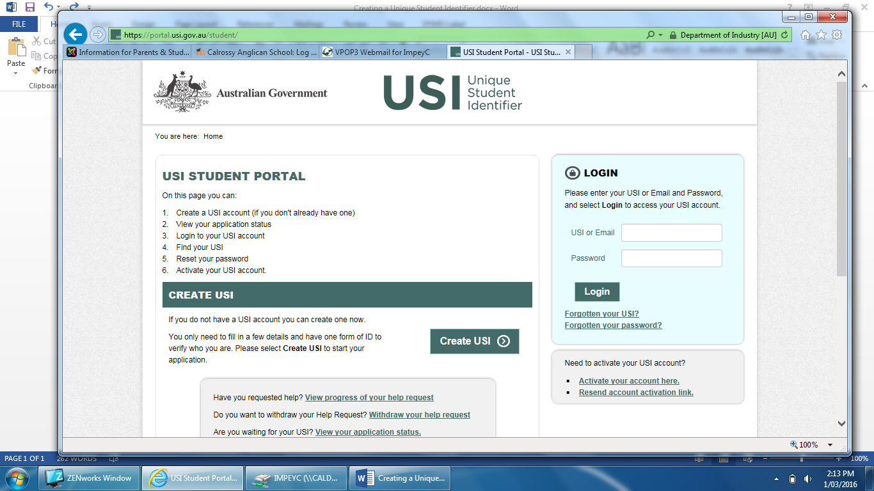

After questions have been successfully and correctly answered, you may confirm your details and click “Next” at the bottom of the screen

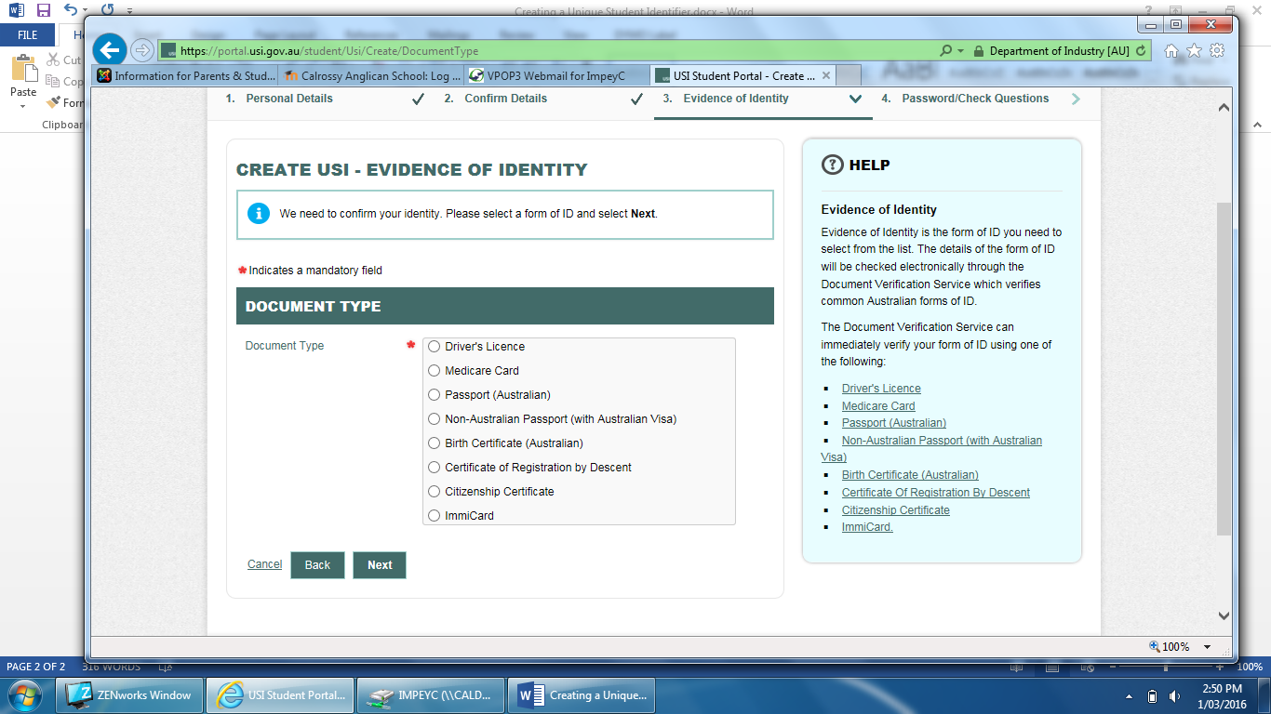The next screen is the ‘Evidence of Identity’ Screen as below, tick the box linked to your form of identification, or document type, e.g. Birth Certificate then click next located again at the bottom of the screen

The next screen will ask you further questions, complete the necessary details and you will be taken to the final stage of the USI process, the “Password /Check Questions Page” follow the prompts and you should have then complete the process of creating your unique student identifier (USI).

**Please let Mr Impey know your USI, we can collate all student USI’s and provide to TAFENE as part of a ‘student list’**

Thankyou,

Charles Impey

Career Advisor