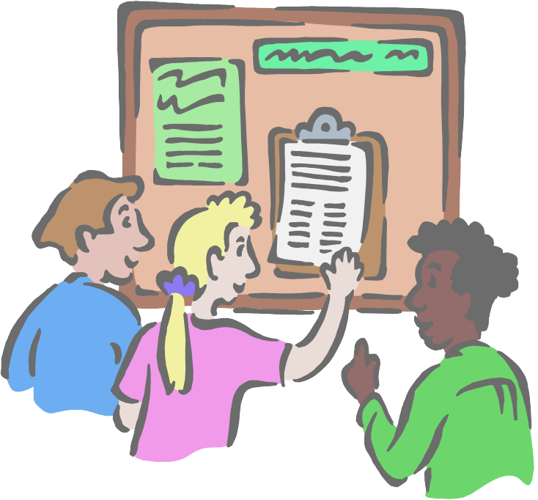

Interview Do's and Don'ts

- First and last impressions are very important so smile at the interviewer and look her/him in the eye when you meet and when you leave.

- Follow the interviewer's lead in shaking hands. Try to ensure that your hand is warm and dry and your handshake firm - but do not squash fingers especially those that are wearing rings!

- Maintain lots of eye contact in the interview - and remember to smile occasionally.

- Look and sound both enthusiastic and interested. Be positive always.

- Keep your hands still and avoid nervous mannerisms which may irritate the interviewer and detract from your presentation. If in any doubt, hold onto your interview folder.

- Do not be afraid to respond to the interviewer's sense of humour, but resist all temptation to be take it too far.

- Make sure that you turn off your mobile phone before the interview. However, if you forget and the phone rings during the interview, switch it off immediately rather than take the call.

- If discussing controversial issues, aim for a balanced view and avoid engaging in heated argument - but do have a point of view and be prepared to defend it tactfully.

- Use any opportunity offered to volunteer information about your strengths. If pressed about your weaknesses, try to finish your sentence on a positive note, e.g. "I haven't done a great deal of public speaking but I'm sure that with practice I would come to enjoy it."

- Try not to be distracted if an interviewer takes notes. Your actual responses are not being recorded but rather the impressions made by your responses.

- At the place of interview, be as positive and pleasant as possible to everyone you meet - bad news travels fast!

- Don't panic if there is a period of silence - you should avoid talking for the sake of talking. Don't be evasive in your answers or try to bluff. If you don't know the answer to a question say so - and say how you would find out the answer in a situation.

- Don't boast or "sell" yourself directly unless invited to.

- Don't allow yourself to be put off by a bored, tired or unenthusiastic interviewer.

- Don't speak too quickly.

- Don't volunteer information about your real or imagined deficiencies.

- Have a summary of your key strengths ready in case you can use it. You may be asked "anything else you would like to add?"

- Before you leave the interview, ask when you can expect to hear from them.

- Thank the interviewer for their time.

- Remember final impressions also count! Leave the interviewer with a positive impression. Don't leave the room like a loser; leave like you've got the job!

Source Sydney University Website - Career Options Interviews Do’s and Don’ts

