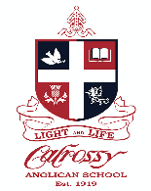

**CALROSSY ANGLICAN SCHOOL  
Uniform Shop**

**TERM 4 EXTENDED TRADING HOURS**

Monday 2nd November – Friday 4th December 2020

Monday 8am – 4.30pm  
Wednesday 8am – 4.30pm  
Friday 8am – 4.30pm

**DECEMBER HOLIDAY TRADING HOURS**

We will be open over the school holiday period   
  
**Monday 7th December 10am – 3pm Appointment Only**

**Monday 25th January 2021 8am – 4.30pm**

**Wednesday 27th - Friday 29th January 8am – 4.30pm**

**To book an Appointment follow the link below**

**https://www.noone.com.au/schoolwear/0n-campus/calrossy**   
 Calrossy Uniform Shop  
 132 Brisbane Street, Tamworth NSW 2340  
 Phone: (02) 5776 5194  
 **Email:** calrossy@noone.com.au