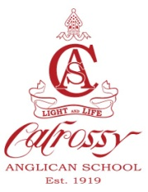
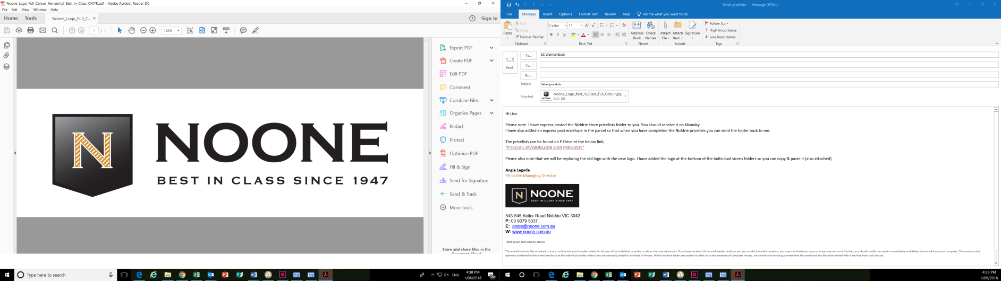
Calrossy Anglican School Uniform shop
Trading hours during Term
Monday: 8am-4.30pm
Wednesday: 11.00am-4.30pm
Friday: 8am-4.30pm
Phone: 5776 5194
Email: Calrossy@noone.com.au

CALROSSY ANGLICAN SCHOOL
SECONDARY UNIFORM
GIRLS & BOYS PRICE LIST VALID TO 30th JUNE 2020
Girls Summer Uniform |  | Boys Summer Uniform
Blazer |  | Blazer
Size 80-85-90-95 | $199.50 | Size 80-85-90-95 | $199.00
Size 100 + | $204.50 | Size 100 + | $204.00
Summer Dress – Year 7-10 |  | Short Sleeve Shirt
Size 2-16 | $100.00 | All sizes | $ 31.00
Senior Dress Blue tie – Senior Yr 11 | $ 94.00
Senior Summer Red tie – Senior Yr 12 | $ 12.50 | Senior Shorts
Socks – white anklets 2 Pack | $ 11.50 | All sizes Youth | $ 47.00
Socks – white anklets 3 Pack | $ 14.50 | Mens | $ 49.00
Girls Winter Uniform |  | Boys Winter Uniform
Pullover |  | Pullover
Size 80-85-90 | $ 75.00 | Size 80-85-90 | $ 75.00
Size 95+ | $ 81.00 | Size 95+ | $ 81.00
Vest |  | Vest
Size 80-85-90-95 | $ 63.00 | Size 80-85-90-95 | $ 63.00
Size 100 + | $ 71.00 | Size 100 + | $ 71.00
Pinafore |  | Long Sleeve Shirt
Size 6-20 | $107.00 | All sizes | $ 35.00
Senior Winter Skirt | $ 79.50 | Trousers
Long Sleeve Shirt - White |  | Youth  Mens | $53.00  $ 53.95
All Sizes | $ 29.50 | Tie – junior navy – Year 7-10 | $ 23.00
Tights – Navy | $ 8.50 | Tie – senior red – Year 11-12 | $ 23.00
Tights – Cotton Child sizes  Tights - Cotton Adult sizes | $ 17.50  $ 19.95
Winter Tie | $ 17.00 | Socks – Putty from | $ 8.00
Co-Curricular |  | New Unisex Sport Uniform
Agriculture H & H Dress Shirt | $ 99.00 | Sport Polo | $ 46.50
Agriculture Work Shirt | $ 65.00 | Shorts | $ 35.50
Agriculture Polo Shirt | $ 44.50 | Soft Shell Jacket | $112.00
Agriculture Scarf | $ 17.50 | Rugby Top (Optional) | $ 87.50
Equestrian Polo Shirt | $ 54.50 | Sport Cap | $ 17.50
Performing Arts Polo Shirt | $ 36.50 | Girls Sport Skort (optional) Hockey Skort | $ 46.50
Chefs Set | $ 85.00 | Senior Microfibre Trackpants | $ 61.95
Saddlecloth Pony  Full  Agriculture Stripe Dress Shirt | $120.00  $130.00  $ 55.00 | Sport Vest  Sport Socks - single | $ 89.95  $ 10.00
Accessories |  | Specialist Sport
Girls Dress Hat - Navy | $ 61.00 | Basketball Shorts | $ 45.00
Boys Dress Hat - Akubra | $118.00 | Netball Dress | $ 89.00
Sports Cap | $ 17.50 | Swimmers Zedar - Girls From | $ 70.00
Bucket Hat – Navy/Red with logo – Girls optional | $ 16.00 | Swimmers Waterpolo - Girls | $ 88.00
Backpack – Airo Large | $ 82.00 | Swimming Caps | $ 5.00
Sports Kit Bag | $ 37.00 | HRIS- Swimming Cap | $ 11.50
Sport /Travel Bag | $ 55.00 | Cricket Cap | $ 70.00
Gearsak | $ 34.00 | Cricket Shirt | $ 45.00
School / House Badge | $ 5.00 | Sports briefs (boy leg) | $ 10.00
Belt | $ 15.95 | Rugby Shorts | $ 37.50
Apron – White / Navy | $ 14.00 | Rugby / Hockey Socks | $ 10.00
Gloves | $ 6.50 | Bathers
Scarf | $ 13.00 | Boys Sizes | $ 45.00
Lanyard | $ 6.00 | Mens Sizes | $ 49.00
Ribbon – white / navy per meter from | $ 2.40 | Girls Bike Shorts | $ 36.00
Scrunchies – white/navy | $ 7.00 | Athletics Shorts | $ 37.00
Pony Bow – white / navy | $ 8.00
Tortoiseshell Headband | $ 8.00
Invisi Stud Earrings | $ 6.00
Pearl Earrings (Year 11-12) | $ 10.00 | Name Labels
Laundry Bag (for Boarders) | $ 20.00 | Name Labels Pre-ordered Garment Labels (Sew or | $ 23.50
 |  | Iron on ) per 50 units

