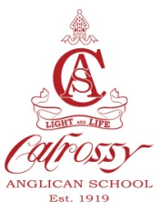
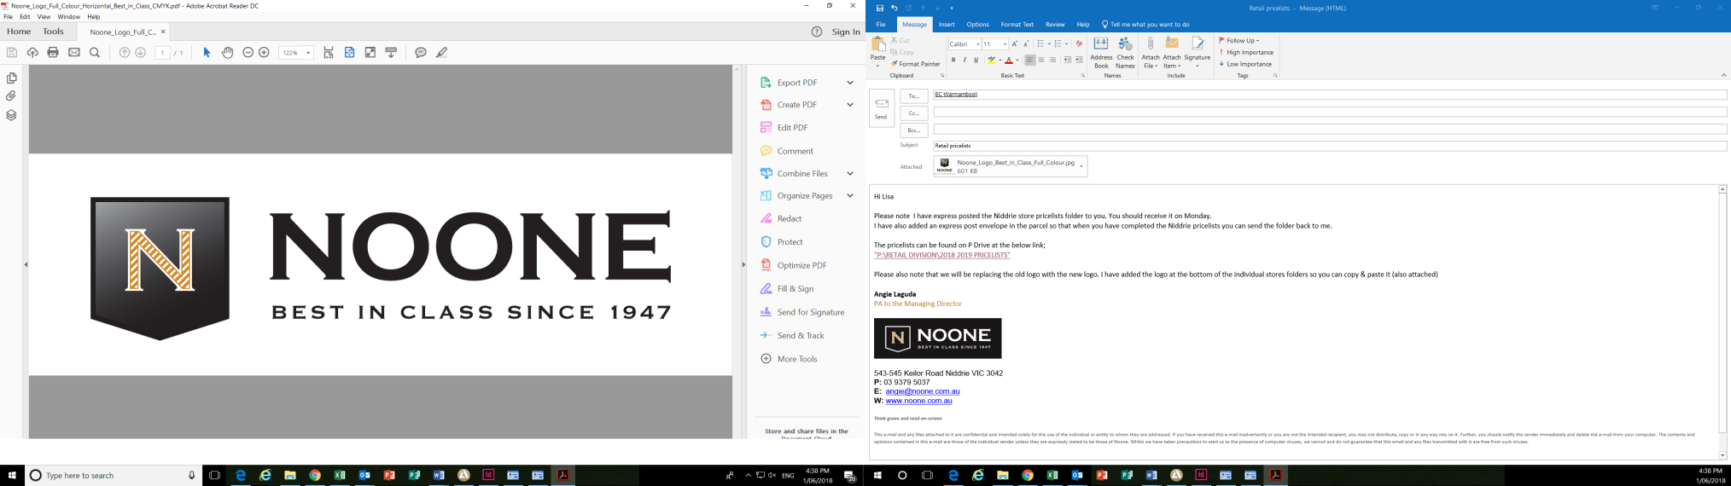
Calrossy Anglican School Uniform shop
Trading hours during Term
Monday: 8am-4.30pm
Wednesday: 11.00am-4.30pm
Friday: 8am-4.30pm
Phone: 5776 5194
Email: Calrossy@noone.com.au

CALROSSY ANGLICAN SCHOOL
PRIMARY UNIFORM
GIRLS & BOYS PRICE LIST VALID TO 30TH JUNE 2020
Girls Summer Uniform |  | Boys Summer Uniform
Blazer- Year 3-6 only |  | Blazer- Year 3-6 only
Size 65-70-75 | $195.00 | Size 65-70-75 | $195.00
Size 80-85-90-95 | $199.00 | Size 80-85-90-95 | $199.00
Size 100 + | $204.00 | Size 100 + | $204.00
Summer Dress |  | Short Sleeve Shirt
Size 4-10 | $ 77.50 | All sizes | $ 30.00
Size 12-18 | $ 82.50 | Shorts – Bottle Green
 |  | All sizes | $ 23.00
Socks – Navy 3 Pack | $ 14.50 | Socks – Navy 3 Pack | $ 14.50
Girls Winter Uniform |  | Boys Winter Uniform
Pullover |  | Pullover
Size 60-65-70-75 | $ 69.00 | Size 60-65-70-75 | $ 69.00
Size 80-85-90 | $ 75.00 | Size 80-85-90 | $ 75.00
Size 95-100 | $ 81.00 | Size 95-100 | $ 81.00
Vest |  | Vest
Size 60-65-70-75 | $ 59.95 | Size 60-65-70-75 | $ 59.95
Size 80-85-90 | $ 63.00 | Size 80-85-90 | $ 63.00
Pinafore |  | Long Sleeve Shirt
Size 4-10 | $ 89.95 | All sizes | $ 29.50
Size 12-18 | $ 94.95 | Trousers – Grey Melange
Long Sleeve Shirt - White |  | All sizes | $ 44.50
All Sizes | $ 29.95
Tights – Navy  Tights – Cotton Child sizes  Tights – Cotton Adult sizes | $ 8.50  $ 17.50  $ 19.95 | Socks – Grey (single)  Socks – Grey 3 Pack | $ 6.00  $ 14.50
Tie – Red | $ 12.50
Knee- Hi Navy Socks | $ 7.00 | Tie | $ 23.00
Unisex Uniform |  | New Unisex Sport Uniform
Showerproof Jacket |  | Sport Polo | $ 46.50
All sizes | $ 44.95
Co-Curricular |  | Shorts | $ 35.50
Equestrian Polo Shirt | $ 54.50
Saddlecloth Pony | $120.00 | Soft Shell Jacket | $112.00
Full | $130.00
Basketball Shorts | $ 45.00
Accessories |  | Rugby Top (Optional) | $ 77.50
Primary Mesh Hat | $ 13.50
Prep Hat | $ 10.50 | Sports Vest | $ 89.95
Girls Dress Hat | $ 61.00
Boys Dress Hat | $ 92.00 | Girls Sport Skort (optional) | $ 46.50
Backpack – Medium Physio M | $ 53.95
Backpack – Large Physio L | $ 59.95 | Long Sleeve Polo | $ 21.00
Sports Kit Bag | $ 37.00
Gearsak | $ 34.00 | Sport Socks - single | $ 10.00
School Badge | $ 5.00
Art Smock | $ 20.50 | Socks – Hockey / Rugby | $ 10.00
Gloves | $ 6.50
Scarf | $ 13.00 | Junior Microfleece Trackpants | $ 55.00
Ribbon – girls navy per meter from | $ 2.40
Scrunchies | $ 7.00 | Alternative Microfibre Trackpants | $ 61.95
Pony Bow navy | $ 8.00
Pony bow fabric | $ 11.00 | PRE SCHOOL UNIFORM
Headband fabric | $ 10.00 | Pre School Polo | $ 16.00
 |  | Pre School Sun Hat | $ 10.50
 |  | Name Labels
 |  | Name Labels – Pre ordered garment labels (Sew or Iron on)
 |  | Per 50 units | $ 23.50

