FRONT END ANALYSIS
PROCESS GUIDE


PREPARED BY

Kristen Suarez

APPROVED BY

REVIEWED BY

Table of Contents

Change History………………………………………………………………4
Purpose…………………………………………………………………….….5
Procedure Overview………………………………………………………..5
Needs Analysis……………………………………………………………5
Impacted Users……………………………………………………...5
Roles…………………………………………………………………...6
Task Complexity and Frequency………………………………...6
Training Plan and Scope………………………………………………..8
Training Purpose………………………………………………………10
Target Audience……………………………………………………..10
Team Members Involved…………………………………………..10
Training Development……………………………………………...11
Delivery………………………………………………………………….12
Key Considerations for Delivery…………………………..12
Establish KPIs…………………………………………………………………..13
Tracking Metrics…………………………………………………..13
Measuring Success…………...………..…...……………………14

Kick-Off Brief with Stakeholders………..……………...……………...14
Key Activities…………………………………………………….......15
Review and Continuous Improvement………………………………15
Frequency……………………………………………………………15
Review Process………………………………………………………..15
Improvement Implementation…………………………………...16
Responsible Parties…………………………………………………..16

CHANGE HISTORY

Version | Date | Description | Responsible POC
Initial draft | 12/20/2024 | Minimum value draft  established | Kristen Suarez

PURPOSE

The purpose of this document is to outline a systematic approach for completing a front-end analysis to identify and define the root cause of a performance problem or opportunity before developing a solution. It provides clear instructions on how to complete the necessary tasks, ensuring consistency, accuracy, and completeness. Having this process ensures that efforts are targeted, and the right issues and solutions are designed effectively.

PROCEDURE OVERVIEW

This document outlines each step to complete a front-end analysis, breaks down each step, outlines the initial requirements and deliverables or goals to achieve, and identifies the responsible parties for each stage.

1. NEEDS ANALYSIS

A Needs Analysis is a systematic process used to identify gaps between current and desired performance or outcomes. It evaluates the factors influencing these gaps, such as user roles, task complexity, and organizational requirements, to determine the most effective solutions or interventions.

IMPACTED USERS

Impacted users include individuals or teams directly responsible for performing tasks within the scope of the process, those dependent on the outcomes of these tasks, and any stakeholders requiring awareness for decision-making or support. Identifying specific users is essential to tailoring solutions effectively and ensuring organizational alignment.

ROLES

The success of a needs analysis depends on the coordinated efforts of a diverse team, each bringing specialized skills and perspectives. This section centers on identifying performance gaps, understanding learner needs, and recommending training solutions. It includes roles such as project

sponsors, instructional designers/analysts, subject matter experts (SMEs), and data analysts.

Understanding these roles ensures clear communication, efficient resource allocation, and alignment with organizational goals. The following details the essential team members and their contributions to the needs analysis process.

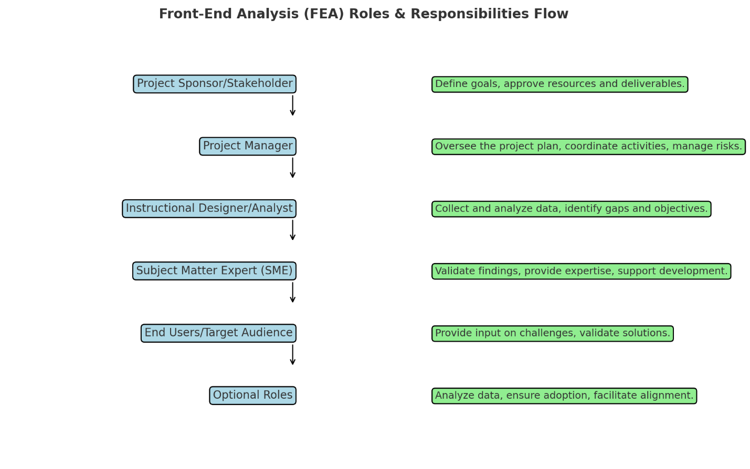
TASK COMPLEXITY AND FREQUENCY

Effective front-end analysis requires a clear understanding of the tasks being performed. Evaluating both complexity and frequency provides insights into which tasks require focused training, resources, or support. This section outlines how these factors influence the design of learning solutions and resource allocation, ensuring the right level of support for each task.

Task Complexity
Task complexity refers to the level of difficulty, effort, and skill required to perform a task. It is influenced by factors such as:

- Cognitive Demand: How much thinking, problem-solving, or decision-making is required.
- Steps Involved: The number and intricacy of actions needed to complete the task.
- Tools or Resources: The complexity of the tools, systems, or processes used.
- Variability:

- Whether the task involves consistent, predictable steps or adapts based on changing conditions.

Purpose:
Understanding task complexity helps identify training needs, ensuring resources match the difficulty of the task.

Task Frequency
Task frequency describes how often a task is performed within a specific timeframe (e.g., daily, weekly, monthly).

Purpose

Understanding frequency ensures appropriate focus during training and resource allocation. High-frequency tasks often require mastery, while low-frequency tasks may need quick-reference materials or just-in-time support.
- High Frequency: Tasks performed regularly, such as daily customer service calls.
- Low Frequency: Tasks performed occasionally, such as annual performance reviews or system updates.
Incorporating Both in Analysis
- Mapping Tasks: Identify each task's complexity and frequency to prioritize training and resources effectively.
- Decision Matrix: Use a matrix (e.g., high complexity/high frequency) to determine whether a task requires in-depth training, job aids, or automation.

Example Matrix:
Frequency | Low Complexity | High Complexity
High Frequency | Basic training and practice | Comprehensive training
Low Frequency | Quick-reference guides | Advanced training + support

2. TRAINING PLAN AND SCOPE

A training plan for a front-end analysis outlines the approach to equipping
the target audience with the knowledge and skills needed to close
performance gaps and meet organizational objectives. It defines the
training's scope, purpose, and methods, ensuring alignment with the specific
needs identified during the analysis. By establishing clear goals and delivery
strategies, the training plan serves as a roadmap to achieve measurable
results.

The scope and scale of the front-end analysis impact is identified based on
dependencies such as the number of users, their roles, and the complexity
and frequency of the associated tasks. This ensures that solutions are tailored
to the specific needs and operational setting.

Training Plan and Scope Visual Diagram
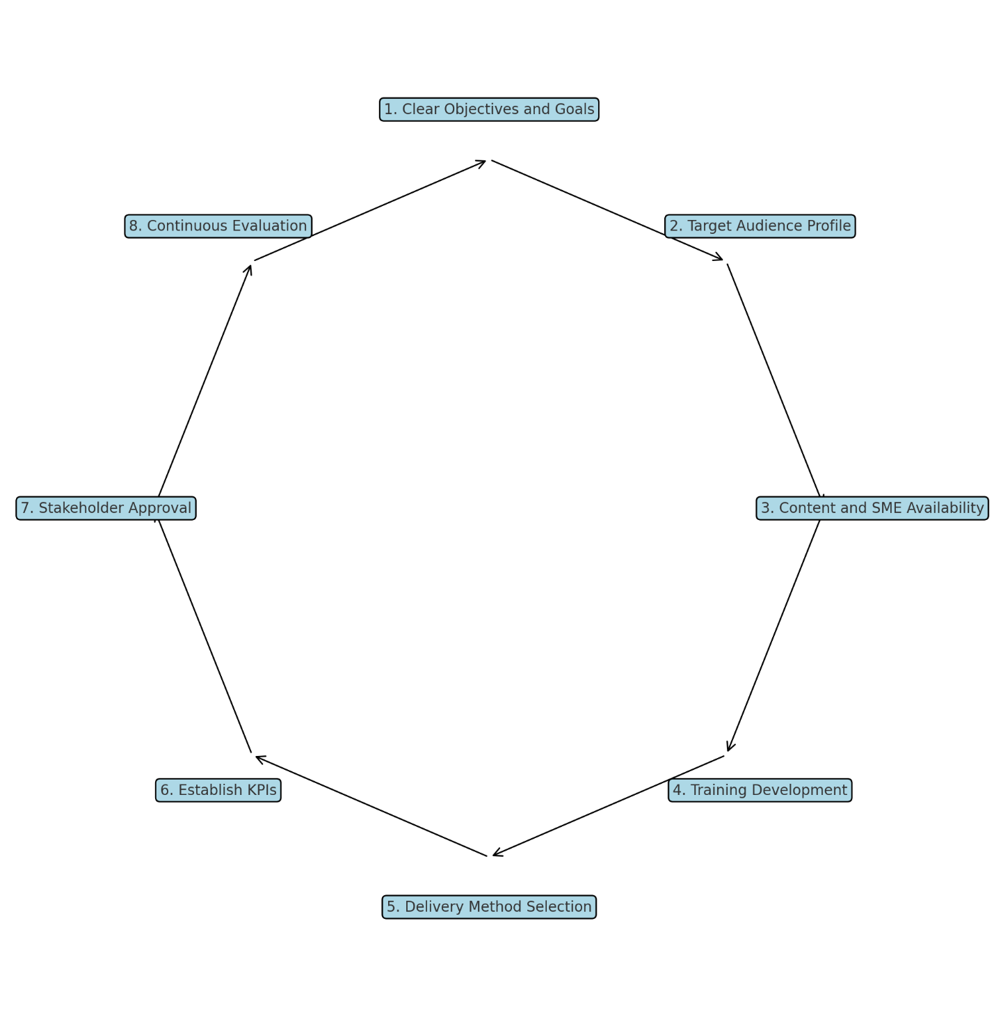

The training plan should include the following information:

    - TRAINING PURPOSE

Training serves as a critical component in a front-end analysis by bridging the gap between current and desired performance levels. It addresses specific skill deficits, aligns team capabilities with organizational goals, and ensures participants are equipped to contribute effectively to the project's success. It also targets the purpose of the training by attempting to close skill gaps, ensuring compliance, or enhancing performance. By focusing on targeted outcomes, training solidifies the foundation for sustainable improvements and measurable impact.

    - TARGET AUDIENCE

Identifying the target audience is essential to designing an effective training plan. This involves determining the roles and responsibilities of participants, assessing their baseline knowledge and skills, and understanding their learning preferences. A well-defined target audience ensures that the training content is relevant, impactful, and aligned with both individual and organizational goals.

    - TEAM MEMBERS INVOLVED

A successful training plan and scope depend on the collaboration of a well-defined team. Each member plays a crucial role in ensuring the needs analysis, design, and implementation are aligned with organizational goals.

Developing a training plan and scope involves a broader team responsible for executing the entire training project. This includes roles engaged in planning, development, implementation, and evaluation, as well as stakeholders involved in delivering and
managing the training. Responsibilities extend beyond needs analysis to encompass instructional design, training delivery, technology support, and post-training evaluation. Key team members may include project sponsors, instructional designers, trainers, IT support, and change management specialists.

    - TRAINING DEVELOPMENT

The Training Development phase translates the insights from the needs analysis into actionable learning solutions. This section focuses

on designing and creating training materials tailored to address identified performance gaps, meet organizational objectives, and align with the needs of the target audience. By clearly defining objectives, developing tailored content, and selecting effective delivery methods, this phase bridges the gap between analysis and implementation.

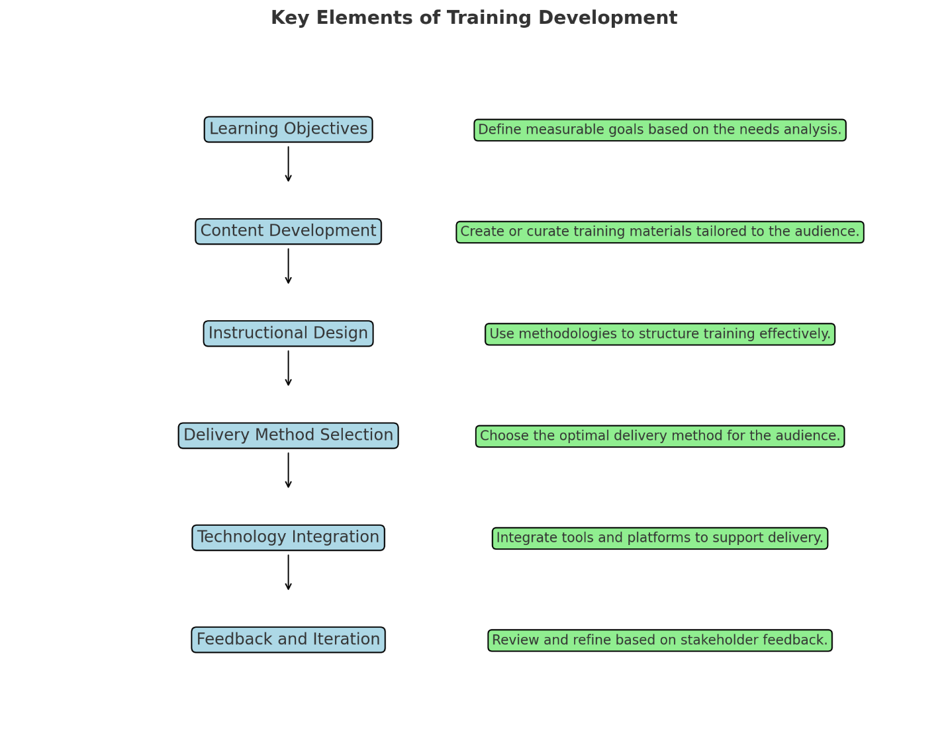

DELIVERY

Choosing the right delivery method is essential to ensure the training program is accessible, engaging, and effective for the target audience. The delivery method impacts how learners interact with the content, retain information, and apply their new skills.

Key Considerations for Delivery Method Selection:
- Audience Needs and Preferences:
  - Assess the learning preferences of the target audience (e.g., visual, auditory, hands-on learners).
  - Consider factors like age, job role, technical skills, and work environment.
  - Address accessibility requirements, such as language options or assistive technologies.
- Training Content:
  - Match the delivery method to the complexity and type of content.
  - For example:
    - Interactive, scenario-based training for problem-solving skills.
    - Self-paced eLearning for procedural or compliance training.
    - Instructor-led workshops for team collaboration skills.
- Available Resources:
  - Evaluate the budget, tools, and technology available for delivery.
  - Consider the time constraints and availability of trainers or facilitators.
  - Leverage existing infrastructure, such as Learning Management Systems (LMS) or video conferencing tools.
- Delivery Formats:
  - In-Person Training: Best for hands-on activities, group discussions, and immediate feedback.
  - Virtual Instructor-Led Training (VILT): Combines the benefits of live training with remote access.
  - Self-Paced eLearning: Offers flexibility for learners to complete training at their own pace.
  - Blended Learning: Combines multiple formats (e.g., online modules with live sessions) for a comprehensive approach.
  - On-the-Job Training (OJT): Provides real-world practice with coaching or mentoring support.
- Scalability and Consistency:
  - Ensure the chosen method can be scaled to reach a larger audience if necessary.
  - Aim for consistency in delivery across teams, locations, or departments.
- Engagement and Interaction:
  - Incorporate elements that promote learner engagement, such as:
    - Gamification (e.g., quizzes, leaderboards).
    - Interactive features (e.g., simulations, role-playing).
    - Collaborative tools (e.g., discussion boards, breakout rooms).

- Evaluation and Feedback:
  - Choose a method that allows for easy evaluation of learner progress and feedback collection.
  - Incorporate post-training surveys or quizzes to measure immediate outcomes.

4. ESTABLISH KEY PERFORMANCE INDICATORS (KPIs)

Key Performance Indicators (KPIs) are measurable values that demonstrate
how effectively a process, training program, or project achieves its
objectives. They serve as benchmarks for success and provide actionable
insights into performance. KPIs are critical in a front-end analysis because
they provide a clear way to measure progress toward desired outcomes, help identify performance gaps and prioritize areas for improvement and offer stakeholders tangible evidence of success or inadequacy.

TRACKING METRICS

Tracking metrics involves continuously monitoring and evaluating the progress of Key Performance Indicators (KPIs) to ensure that they effectively reflect the success of the process or initiative. This step ensures that adjustments can be made proactively to address any gaps or inefficiencies, providing a clear roadmap for achieving desired outcomes.

- Set Measurable Criteria: Define clear benchmarks for success that align with goals.
- Use Tools: Leverage dashboards or analytics to automate data tracking.
- Schedule Reviews: Regularly review metrics (e.g., weekly, monthly) to assess progress.
- Analyze Data: Compare data to objectives to identify strengths and gaps.
- Share Insights: Use visuals and summaries to communicate findings effectively.
- Refine as Needed: Adjust KPIs or processes based on feedback and results.

MEASURING SUCCESS

Success is measured by evaluating how well key objectives are met and whether outcomes align with the goals set during the front-end analysis.

Structuring a plan to communicate to stakeholders for measuring success may involve:
- Performance Against KPIs: Comparing actual results to predefined KPIs to track progress and success.
- Feedback from Stakeholders: Gathering qualitative input to understand the effectiveness and impact of the initiative.
- Completion Rates: Monitoring the percentage of tasks or training completed within set timelines.
- Skill Acquisition: Measuring improvements in skills or knowledge through assessments.
- Operational Impact: Assessing changes in efficiency, productivity, or compliance resulting from the intervention.
5. KICK-OFF BRIEF WITH STAKEHOLDERS

The kick-off brief with stakeholders sets the foundation for the project by aligning all parties with goals, roles, and expectations. It serves as an opportunity to present key information, establish communication protocols,
and gain consensus on the project scope and deliverables. This initial meeting ensures transparency and collaboration, fostering a shared understanding and commitment to success.

Key Activities

- Research the program to access as much content as possible to prepare for discussions with stakeholders

- Establish effective communication channels for collaboration (e.g., project management platforms, direct meetings)

- Set up recurring touchpoints to ensure consistent updates and maintain alignment with stakeholders

6. REVIEW AND CONTINUOUS IMPROVEMENT

Continuous evaluation and improvement are vital to ensuring the success
and longevity of any process or initiative. This section outlines the structured
approach to regular reviews, identifying opportunities for enhancement, and

implementing actionable changes. By incorporating stakeholder input and
performance data, the process remains adaptive, efficient, and aligned with organizational goals.

FREQUENCY

Reviews should be conducted on a regular basis, such as quarterly or annually, and triggered by specific events like project milestones or performance issues. Establish a consistent schedule to ensure ongoing evaluation and alignment with goals.

REVIEW PROCESS

The review process involves collecting and analyzing data from metrics, stakeholder feedback, and project outcomes. Key steps include:
- Identifying areas of improvement.
- Comparing results against established benchmarks.
- Conducting collaborative review sessions with stakeholders to gain insights.
IMPROVEMENT IMPLEMENTATION

Use the review findings to develop actionable plans for addressing gaps or inefficiencies. Prioritize changes based on impact and feasibility and establish timelines for implementation. Test improvements to ensure their effectiveness before full-scale integration.

RESPONSIBLE PARTIES

Assign accountability to specific roles, such as a Process Owner or Project Manager, for leading the review and overseeing improvement efforts. Ensure stakeholder involvement to maintain transparency and collective ownership of the outcomes.

