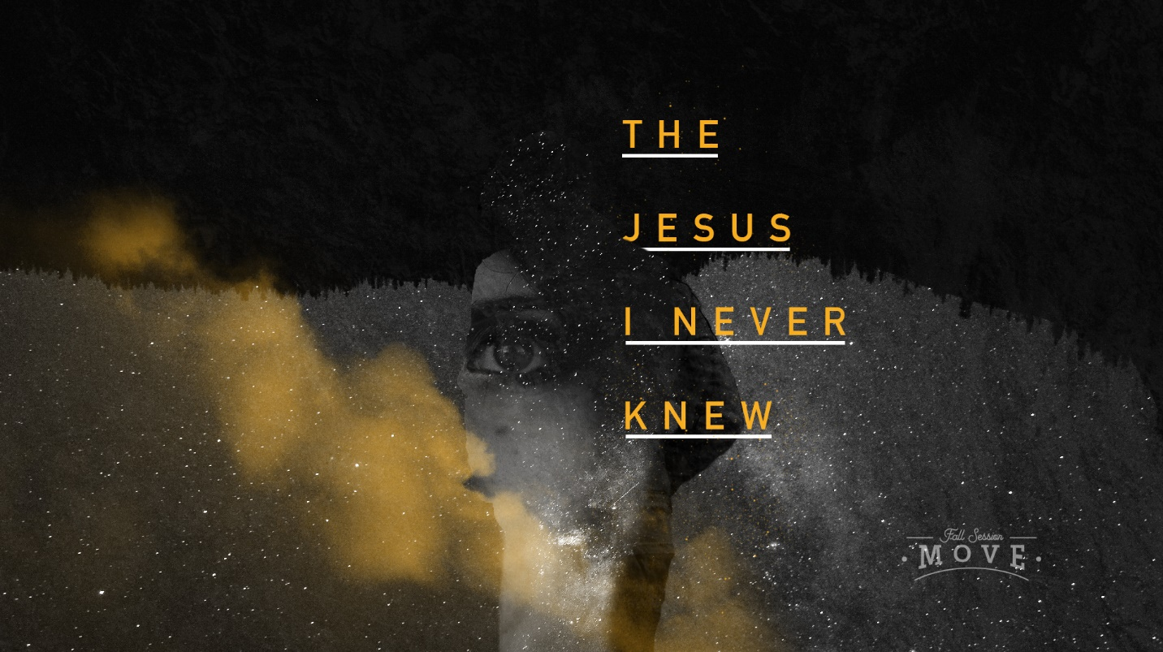

The Jesus I Never Knew // Week 6 Discussion Questions
As a group, do a ‘trust-fall’ experiment. Give everyone a turn to cross their hands across their chest and close their eyes. With their back turned to the group, fall backward to the rest of the group trusting them to catch you. Try it until you can really trust the rest of the group.

- How is the trust fall activity like faith? How is it different?
- Why do you think some disciples walked away from following Jesus?
- What would it take for you to walk away from Jesus in your life?
- If you were to walk away from your faith today, would it change the way that your life looked six months from now? Would you be a different person?
- Does your life look different than people who don’t follow Jesus?
- Are there areas in your life that need to look different? Do you need to trust Jesus more with your life? How?

