LIBERTYCE S
Liberty Chemical Equipment & Supply
ENGINEERING SPECIFICATION DOCUMENT

POLY PROCESSING XLPE CHEMICAL STORAGE TANKS
Sodium Hypochlorite Storage: Engineering Specification & System Design Reference
XLPE | OR-1000™ Antioxidant System | IMFO® Outlet | SAFE-Tank® Double-Wall | NSF/ANSI/CAN 61

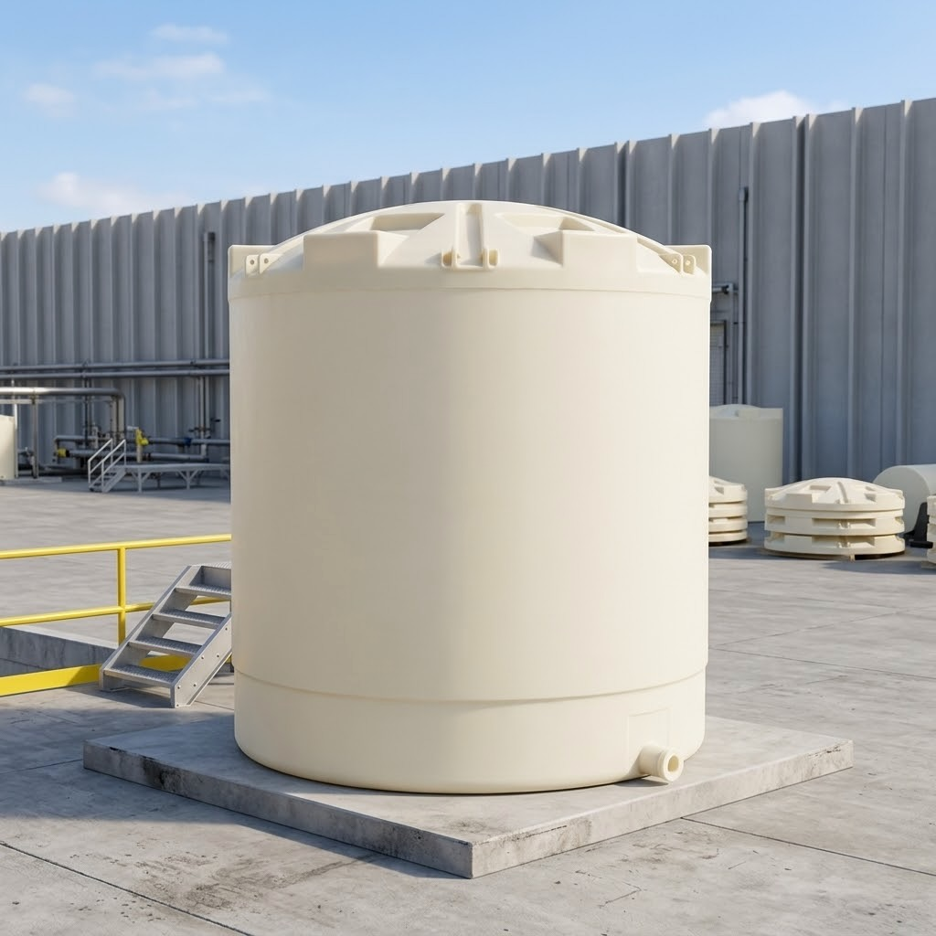
Poly Processing XLPE vertical chemical storage tank — outdoor industrial installation

Document Type | Engineering Specification & Procurement Reference
Vendor | Poly Processing Company
Primary Application | Sodium Hypochlorite (NaOCl) Storage — Municipal & Industrial Water Treatment
Specification Issued By | LibertyCES — Liberty Chemical Equipment & Supply
Classification | INTERNAL USE ONLY — CONFIDENTIAL

1. DOCUMENT PURPOSE & SCOPE
This specification document defines the engineering basis for selecting, procuring, and integrating Poly Processing crosslinked polyethylene (XLPE) chemical storage tanks in sodium hypochlorite service. It is written for process engineers, system designers, and procurement personnel responsible for chemical storage system specification at water treatment facilities, wastewater plants, and industrial chemical handling installations.

This document covers:
- Material science basis for XLPE selection in oxidizing chemical service
- OR-1000™ antioxidant barrier system — composition, mechanism, and when it is required
- IMFO® (Integrated Molded Fitting Outlet) system — design, specification rationale, and installation requirements
- SAFE-Tank® double-wall system — containment compliance, sizing, and integration
- Vertical tank capacity range, dimensional data, and fitting options
- NSF/ANSI/CAN 61 certification scope
- Critical specification parameters for sodium hypochlorite service
- Common specification failures and failure mode analysis

LibertyCES Position
Poly Processing XLPE tanks with the OR-1000™ system are the specification-of-record for sodium hypochlorite storage across all LibertyCES water treatment and chemical feed projects. HDPE is not an acceptable substitute in NaOCl service above trace concentrations. This document explains exactly why and provides the engineering basis to defend that specification to clients, engineers, and procurement teams.

2. MATERIAL SCIENCE: XLPE VS. HDPE IN OXIDIZING CHEMICAL SERVICE
2.1 What Crosslinking Achieves
Standard linear high-density polyethylene (HDPE) consists of long polymer chains that are not bonded to adjacent chains. These chains can slide relative to each other under stress, which creates the mechanism for environmental stress cracking — a progressive failure mode that accelerates in the presence of oxidizing chemicals.

Crosslinked polyethylene (XLPE) introduces covalent bonds between adjacent polymer chains during the rotational molding process. These inter-chain bonds are chemically equivalent in strength to the bonds along the polymer backbone itself. The result is a three-dimensional molecular network rather than a collection of parallel chains.

Property | Standard HDPE | Poly Processing XLPE
Molecular Structure | Linear polymer chains; no inter-chain bonding | Crosslinked 3D network; inter-chain covalent bonds
Environmental Stress Crack Resistance | Baseline | 10–20× greater than HDPE
Molecular Weight | Standard | Approximately 10× higher than HDPE
Impact Resistance | Baseline | 3–5× greater than HDPE
Tensile Strength | Baseline | 3–5× greater than HDPE
Failure Mode | Linear unzipping — can fail catastrophically | Localized pinhole or tear; catastrophic failure rare
Service Life (typical) | 5–10 years in chemical service | 15–20 years in equivalent chemical service
Susceptibility to Oxidizers | Progressive embrittlement and stress cracking | Requires OR-1000™ barrier for strong oxidizers
Seamless Construction | Yes (rotational molded) | Yes (rotational molded)
NSF-61 Certification | Varies by manufacturer | Certified for 38 chemicals

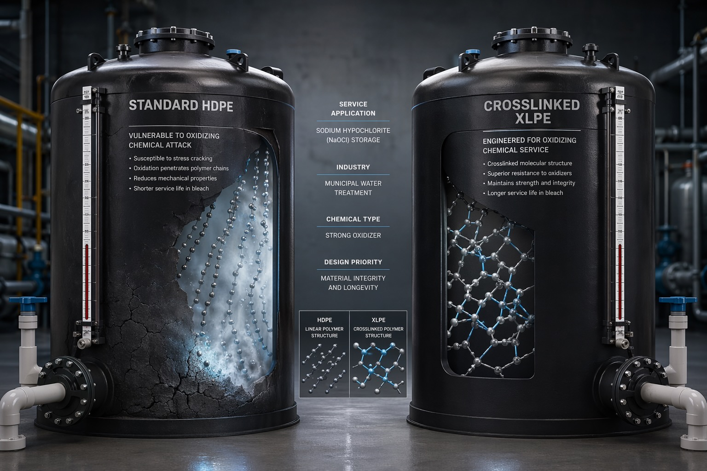
Structural comparison: Standard HDPE (left) vs. Crosslinked XLPE (right) in sodium hypochlorite service. HDPE susceptibility to oxidative attack shown alongside XLPE crosslinked molecular structure.

2.2 Why Linear Polyethylene Fails in NaOCl Service
Sodium hypochlorite is a strong oxidizer. At concentrations above 1–2%, NaOCl attacks polyethylene by penetrating the polymer matrix and oxidizing the carbon-hydrogen bonds along the polymer chain backbone. In linear HDPE, this degradation pathway is unrestricted — oxidation progresses inward from the wetted surface, reducing molecular weight, eliminating the plasticizing effect of long chains, and producing a progressively brittle material.

The failure typically initiates at the highest-stress locations on the tank: around penetrations, fittings, and the sidewall-to-dome transition. Once cracking initiates, linear polyethylene's parallel chain structure allows crack propagation to run the length of adjacent chains — the unzipping mechanism that produces rapid, large-area failure rather than a contained pinhole.

Critical Failure Mode: HDPE in NaOCl Service
HDPE tanks storing sodium hypochlorite above approximately 1% concentration are subject to progressive oxidative embrittlement. This is not a slow wear mechanism — failure can initiate within 2–5 years and progress to full-tank loss of containment. The failure typically appears first as hairline cracking around fittings and at the sidewall-to-dome transition. Do not specify HDPE for NaOCl service at any concentration above water treatment trace levels.

3. OR-1000™ ANTIOXIDANT BARRIER SYSTEM
3.1 System Description
OR-1000™ is a proprietary antioxidant package integrated into the interior wetted surface of an XLPE tank during the rotational molding process. It is not a coating, liner, or separate layer — it is a chemically-incorporated antioxidant formulation that becomes part of the tank wall itself.

The OR-1000™ system functions as a sacrificial antioxidant barrier. When oxidizing chemicals contact the wetted interior surface, the antioxidant package preferentially reacts with the oxidizing species, consuming them before they can penetrate the polymer matrix and attack the XLPE molecular structure beneath. This preserves the crosslinked network and maintains the structural integrity of the tank wall over the service life.

OR-1000™ System Parameter | Specification / Description
System Type | Integrated antioxidant package — not a coating or liner
Application Method | Incorporated during rotational molding process; bonded to interior surface
Mechanism | Sacrificial antioxidant barrier; protects XLPE matrix from oxidative attack
Oxidation Resistance | 4× the anti-oxidation of standard XLPE per Poly Processing data
Primary Application | Strong oxidizing chemicals: sodium hypochlorite, sulfuric acid, hydrogen peroxide
Compatibility Basis | Engineered specifically for NaOCl and H2SO4 service; verify other oxidizers with Poly Processing
Visual Identification | Dark interior surface visible on tanks equipped with OR-1000™ system
Availability | Available on XLPE vertical tanks, SAFE-Tank® double-wall systems, and IMFO® configurations
Surface Condition | All-polyethylene wetted surface — no metallic components in chemical contact
NSF-61 Status | Certified on applicable tank configurations; verify for specific chemicals

3.2 When OR-1000™ Is Required
OR-1000™ is the standard specification for any NaOCl storage application at LibertyCES. The following conditions define when OR-1000™ is mandatory versus optional:

Application Condition | OR-1000™ Requirement
NaOCl ≥1% concentration | Required. No exception.
NaOCl 10–12.5% (bulk delivery grade) | Required. Standard specification.
Sodium hypochlorite + elevated temperature (>80°F) | Required. Oxidation rate increases with temperature.
Sulfuric acid storage | Required for H2SO4 concentrations above 10%.
Hydrogen peroxide storage (>8%) | Required. Verify with Poly Processing for concentration-specific guidance.
NaOCl <0.5% (disinfection residual, not bulk storage) | Evaluate with Poly Processing; XLPE without OR-1000 may be acceptable for trace concentrations only.
Non-oxidizing chemicals (acids, caustics, ferric sulfate, alum) | OR-1000™ not required; standard XLPE is the specification.

Specification Error: XLPE Without OR-1000™ for NaOCl
Specifying standard XLPE (without OR-1000™) for bulk sodium hypochlorite storage is a common and consequential error. XLPE without the antioxidant barrier will outperform HDPE but will still degrade progressively in NaOCl service. The OR-1000™ system is not optional for this application — it is the engineering specification. Confirm OR-1000™ inclusion on every tank order for NaOCl service.

4. IMFO® — INTEGRATED MOLDED FITTING OUTLET
4.1 System Description and Engineering Basis
The IMFO® (Integrated Molded Fitting Outlet) is a tank discharge configuration in which the primary outlet fitting is molded directly into the sloped tank floor rather than penetrating the sidewall above the tank base. The tank floor incorporates a sloped geometry — typically a conical or compound radius — that directs liquid to the lowest point in the tank, where the IMFO® fitting is located.

Standard sidewall-outlet tank designs retain a residual heel of chemical at the base of the sidewall fitting. The residual volume is determined by the distance from the bottom of the fitting bore to the lowest point of the tank floor. In a flat-bottom 12-foot-diameter tank, this can represent several hundred gallons of unusable chemical inventory that degrades in place.

The IMFO® outlet eliminates the residual heel entirely. Because the fitting is located at the absolute lowest point of the tank geometry, the tank drains completely. For sodium hypochlorite — which degrades continuously from the moment of manufacture — this is a material specification requirement, not a convenience feature.

IMFO® System Parameter | Specification / Description
Outlet Location | Molded into sloped tank floor at lowest point — not a sidewall penetration
Residual Volume | Zero measurable residual; complete tank drainage achieved
Structural Advantage | Eliminates high-stress sidewall penetration below maximum fill level; fitting located at lowest-stress zone of tank
Fitting Material | Poly-SAFE™ fitting; all-polyethylene wetted components — no metallic contact surfaces
Bellows Transition Fitting | Required at the IMFO® outlet to accommodate tank thermal expansion and minimize stress transmission to piping
Available Configurations | Standard IMFO® (vertical tanks); Sloped-Bottom Vertical Tanks with IMFO® (enhanced drainage geometry)
Compatible Systems | Available with OR-1000™ and SAFE-Tank® double-wall configurations
Primary Application | NaOCl storage, sulfuric acid, any chemical where complete drain-down and low-stress outlet are required

Why IMFO® Matters for NaOCl
Sodium hypochlorite degrades continuously in storage: heat, light, metals, and time all accelerate decomposition. Chemical inventory that cannot be removed from the tank continues to decompose, generating chlorine gas and reducing effective concentration. IMFO® ensures complete tank turnover with each delivery cycle, which extends effective NaOCl shelf life and reduces the decomposition gas load on the tank vent system.

4.2 Bellows Transition Fitting
The bellows transition fitting is a flexible connector installed between the IMFO® outlet and the rigid discharge piping system. It serves a critical mechanical function: it decouples the thermal expansion and contraction of the tank body from the rigid piping system.

Polyethylene tanks expand and contract with temperature. A large XLPE tank in outdoor service or an indoor installation without temperature control will experience vertical and radial dimensional change that, transmitted directly to rigid piping through a hard-coupled fitting, creates bending stress at the fitting interface. Over time, this stress initiates cracking at the fitting penetration — one of the highest-consequence failure locations on any chemical storage system.

The bellows fitting absorbs dimensional change in all axes, eliminates bending stress at the IMFO® interface, and extends the service life of both the tank fitting and the downstream piping. Poly Processing considers the bellows transition fitting a required component for proper IMFO® system performance.

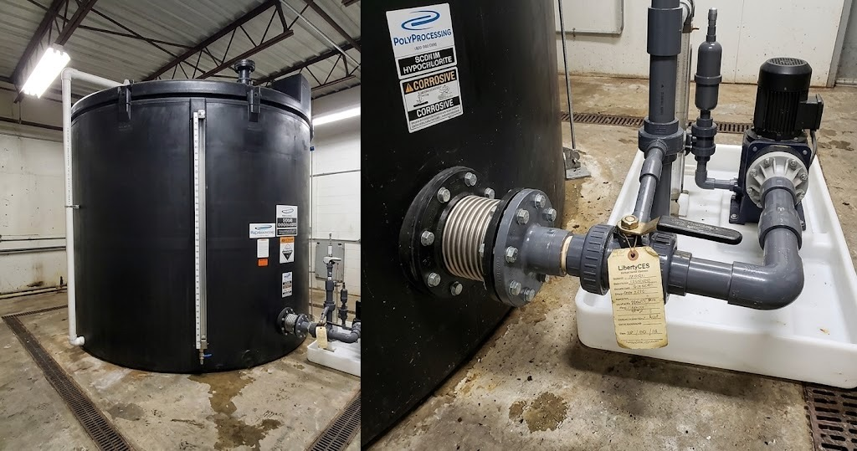
LibertyCES-supplied Poly Processing SAFE-Tank with IMFO® outlet and bellows transition fitting — municipal sodium hypochlorite storage installation. Metering pump and containment tray visible at right.

5. SAFE-TANK® DOUBLE-WALL TANK SYSTEM
5.1 System Architecture
The SAFE-Tank® is a double-wall chemical storage system consisting of a primary XLPE tank nested inside a larger XLPE outer containment vessel. Both walls are manufactured from crosslinked polyethylene. The interstitial space between the inner and outer tanks constitutes the secondary containment volume.

The system eliminates the need for a separate external containment structure — concrete dike, HDPE liner, or secondary berm — by integrating 110 percent secondary containment capacity within the tank's own footprint. The SAFE-Tank® occupies approximately the same floor area as a standard vertical tank of equivalent primary capacity.

SAFE-Tank® System Parameter | Specification / Description
Construction | Inner primary tank + outer containment vessel; both XLPE
Containment Capacity | 110% of primary tank nominal capacity
Footprint vs. Standard Tank | Comparable to single-wall vertical tank of same capacity
Secondary Containment Standard | Meets EPA SPCC secondary containment requirements for single-tank installations
Interstitial Space Function | Containment reservoir; also provides visual inspection access if equipped with leak indicator
Compatible Inner Tank | XLPE primary tank with OR-1000™ for NaOCl service
Compatible Outlet | IMFO® fitting on inner tank; bellows transition fitting through outer wall
Available Capacity Range | 3,150 gallons through 10,500+ gallons (see Section 7 for dimensional data)
Exothermic Chemical Suitability | Preferred configuration for sulfuric acid — outer containment isolates reactive chemical from water contact in spill scenario
Available Factory Locations | Louisiana (Monroe), California (French Camp)

5.2 Regulatory Compliance Basis
Secondary containment requirements for chemical storage systems are defined under EPA SPCC regulations (40 CFR Part 112), applicable state environmental regulations, and facility-specific permit conditions. The SAFE-Tank® system provides 110 percent containment, which exceeds the EPA minimum requirement of 100 percent of the largest tank volume within a containment area.

For sodium hypochlorite systems at water treatment facilities, secondary containment requirements also interact with local fire code requirements and, in some jurisdictions, Department of Health or state drinking water program requirements. The SAFE-Tank® system generally satisfies the containment volume requirements of these regulations. Verify local regulatory applicability with the facility's environmental compliance manager.

SAFE-Tank® vs. Concrete Containment
A poured concrete secondary containment structure for a single 6,000-gallon NaOCl tank typically requires 6–8 weeks of construction lead time, requires ongoing inspection for concrete degradation from chlorine exposure, occupies 3–5× the floor area of the tank itself, and represents $15,000–$40,000 in construction cost depending on local conditions. The SAFE-Tank® delivers equivalent regulatory compliance in the tank's own footprint at a fraction of that cost, with no concrete maintenance requirement.

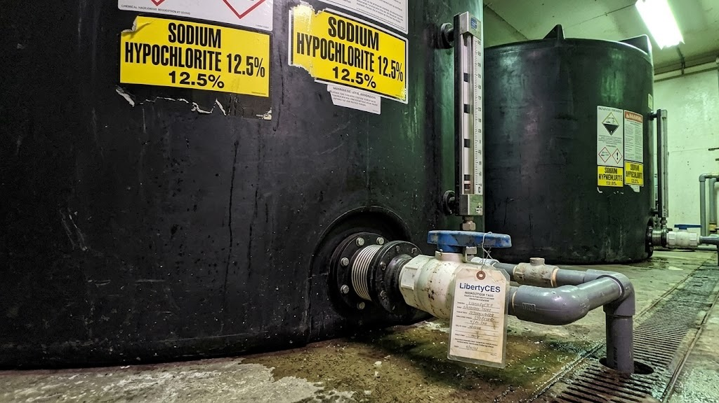  LibertyCES SAFE-Tank® installation — NaOCl 12.5% service with IMFO® outlet and bellows fitting visible at base | 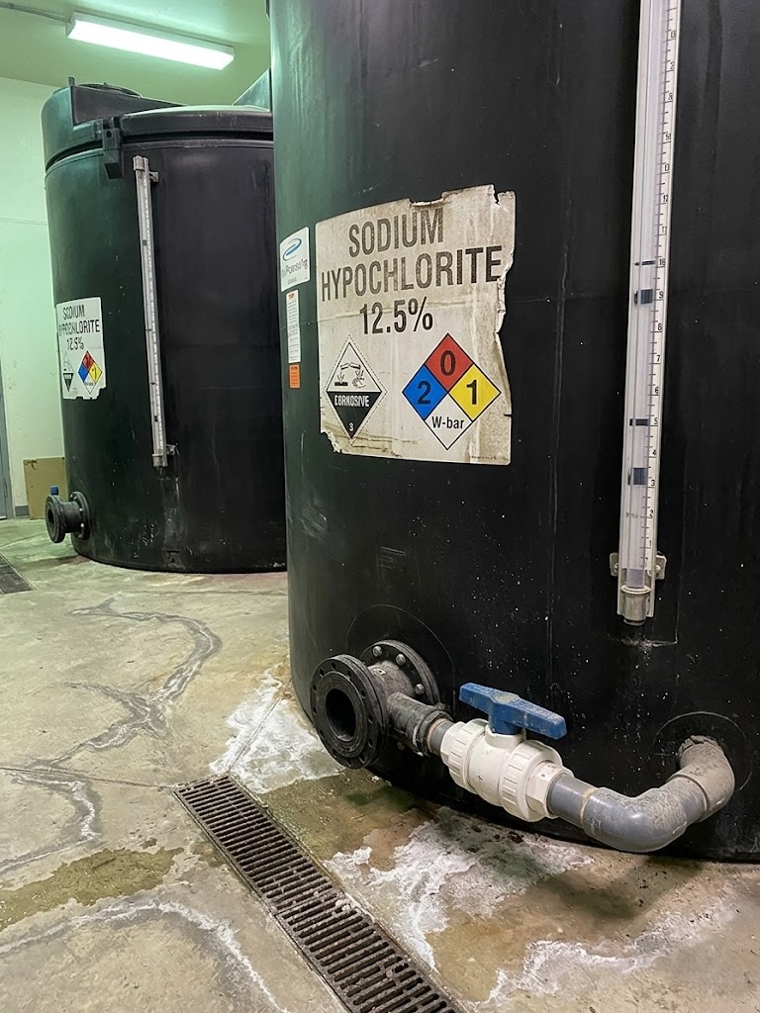  Poly Processing SAFE-Tank® — outer containment vessel with IMFO® outlet at grade

6. SODIUM HYPOCHLORITE STORAGE: ENGINEERING SPECIFICATION PARAMETERS
6.1 Chemical Properties Relevant to Tank Selection
NaOCl Storage Parameter | Engineering Data / Specification Basis
Standard Delivery Concentration | 10–12.5% (trade grade); 15% (high-strength)
Specific Gravity (12.5%) | 1.17–1.20 (use 1.20 for structural design; drives wall thickness requirement)
Chemical Classification | Strong oxidizer (NFPA Oxidizer Class 2); corrosive
Degradation Rate | Continuous from point of manufacture; accelerated by elevated temperature, UV exposure, heavy metal contamination, and agitation
Decomposition Products | Oxygen gas + sodium chlorate; gas generation creates pressure and requires venting
Temperature Effect on Degradation | Rate approximately doubles for each 10°C (18°F) increase in storage temperature
UV Sensitivity | Significant; indoor storage or UV-inhibited tank specified for outdoor applications
Metal Contamination Sensitivity | Copper, iron, and manganese ions catalyze decomposition at trace concentrations; specify no metallic fitting contact surfaces
Freeboard Requirement | Minimum 15–20% of tank capacity for gas headspace; verify with Poly Processing and local regulatory guidance
Maximum Recommended Fill Level | 80–85% of nominal tank capacity (chemical-specific; confirm with Poly Processing)

6.2 Tank Configuration Specification for NaOCl Service
The following configuration is the LibertyCES standard specification for sodium hypochlorite storage tanks at water treatment facilities. Deviations from any of these parameters require documented engineering justification.

Component / Parameter | Specification Requirement
Tank Material | Poly Processing crosslinked polyethylene (XLPE) — not HDPE
Interior Surface Treatment | OR-1000™ antioxidant system — required for all NaOCl concentrations ≥1%
Tank Configuration | Vertical cylindrical; sloped-bottom with IMFO® outlet preferred
Outlet System | IMFO® Integrated Molded Fitting Outlet with bellows transition fitting to discharge piping
Secondary Containment | SAFE-Tank® double-wall system preferred; external concrete containment acceptable if SAFE-Tank® is not available for required capacity
Fitting Material — Wetted | Poly-SAFE™ polyethylene fittings; no metallic components in chemical contact
Venting | Activated carbon vent or equivalent; sized for maximum decomposition gas generation rate plus fill/drain displaced volume
Level Indication | External polysight or rotary gauge; ultrasonic preferred; non-contact; no metallic float mechanisms in chemical contact
Exterior UV Protection | Dark-pigmented tank for outdoor service (UV-inhibited resin) or indoor installation with light exclusion
Certification | NSF/ANSI/CAN 61 for potable water chemical contact service (required for municipal water treatment systems)

Do Not Use Metallic Fittings in NaOCl Service
Iron, copper, brass, bronze, stainless steel, and galvanized components in contact with sodium hypochlorite accelerate decomposition, generate chlorine gas, reduce effective concentration, and initiate corrosion failures that can result in full-system leaks. Specify all-polyethylene (Poly-SAFE™ or equivalent PVDF/polypropylene) fittings, valves, and piping in the chemical wetted path. This applies to fill lines, discharge connections, vent connections, and any instrumentation ports.

7. TANK CAPACITY AND DIMENSIONAL REFERENCE
7.1 Vertical XLPE Tanks — Selected Capacity Range
The following table presents selected tank capacities from the Poly Processing vertical tank lineup. Manufacturing facilities are located in French Camp, California (CA); Monroe, Louisiana (LA); and Winchester, Virginia (VA). Select the factory nearest to the project site to minimize freight cost and lead time.

Capacity (gal) | Approx. O.D. | Approx. Height | Manway | Ship. Wt. (lb) | Factory
15,500 | 13'-9" | 16'-5" | 24" | 5,000 | LA
13,650 | 13'-9" | 14'-7" | 24" | 4,661 | LA, CA
10,305 | 11'-11" | 14'-4 3/4" | 24" | 3,500 | LA
8,500 | 10'-0" | 16'-8 1/2" | 24" | 3,400 | LA
7,300 | 10'-2" | 14'-1 3/4" | 24" | 2,100 | LA, CA
6,150 | 10'-2" | 12'-3 3/4" | 24" | 1,500 | LA, VA
5,300 | 9'-2" | 12'-9 3/4" | 24" | 1,400 | LA, VA
4,250 | 11'-11" | 7'-1 3/4" | 24" | 1,050 | LA
3,900 | 7'-10" | 12'-8 3/4" | 24" | 1,000 | LA, VA
3,000 | 7'-1" | 11'-11 3/4" | 24" | 900 | LA, VA
2,650 | 8'-0" | 8'-9 1/4" | 24" | 535 | LA, VA
2,250 | 8'-0" | 7'-9 1/4" | 24" | 450 | LA, VA
1,400 | 5'-4" | 10'-2 1/2" | 17" | 320 | LA, VA
1,150 | 5'-4" | 8'-6" | 17" | 260 | LA
905 | 5'-4" | 7'-0" | 17" | 195 | LA, VA

Note: Contact LibertyCES for full tank selection tables including 2D and 3D CAD files, capacity-per-inch charts, and current availability by factory. Weights are approximate and for freight estimation only.

7.2 SAFE-Tank® Double-Wall — Selected Capacity Range
Primary Cap. (gal) | Approx. O.D. | Approx. Height | Manway | Ship. Wt. (lb) | Factory
10,500 | 11'-11" | 17'-8 1/2" | 24" | 9,950 | LA
8,700 | 11'-11" | 14'-10 1/2" | 24" | 5,400 | LA
6,650 | 10'-2" | 14'-9 1/2" | 24" | 4,400 | LA, CA
5,400 | 11'-11" | 10'-1/2" | 24" | 2,750 | LA
4,400 | 10'-3" | 10'-4 1/4" | 24" | 2,250 | VA
4,350 | 10'-3" | 10'-4 1/4" | 24" | 2,125 | CA
3,150 | 10'-2" | 8'-1 1/2" | 24" | 1,960 | LA

8. NSF/ANSI/CAN 61 CERTIFICATION
NSF/ANSI/CAN Standard 61 governs drinking water system components — health effects. Compliance with NSF-61 means the tank material and construction have been tested to confirm that chemical extractables from the tank wall do not exceed maximum contaminant levels when the tank is used to store chemicals that will contact potable water supplies.

Poly Processing holds NSF-61 certification for crosslinked polyethylene tanks on 38 chemicals. Sodium hypochlorite is included in the certified chemical list for applicable tank configurations.

For municipal water treatment applications — where sodium hypochlorite contacts the potable water supply or is stored within a facility regulated under a drinking water permit — NSF-61 certification is a procurement requirement, not a preference. Verify NSF-61 certification on every tank order for municipal water system service.

NSF-61 Parameter | Specification
Certified Chemicals | 38 chemicals on XLPE tank construction; confirm NaOCl included on current certificate
Applicable Tank Types | Standard vertical XLPE; SAFE-Tank®; verify configuration-specific certification
Regulatory Driver | Required for chemical storage in direct or indirect potable water contact service
Certificate Verification | Request current NSF-61 certificate from Poly Processing or LibertyCES with each order
OR-1000™ Compatibility | OR-1000™ surface treatment is compatible with NSF-61 certification on applicable configurations

9. SYSTEM INTEGRATION — NAOCL CHEMICAL FEED SYSTEM
9.1 Complete System Component Specification
The Poly Processing XLPE tank is the storage component in a complete sodium hypochlorite chemical feed system. The following table defines the full system component specification for a standard municipal NaOCl dosing installation.

System Component | Specification | LibertyCES Vendor
Primary Storage Tank | Poly Processing XLPE vertical, IMFO® outlet, OR-1000™, SAFE-Tank® double-wall, NSF-61 | Poly Processing
Outlet Fitting | IMFO® Poly-SAFE™ fitting — all-polyethylene; no metallic wetted components | Poly Processing
Bellows Transition | Poly Processing bellows transition fitting; installed between IMFO® and rigid discharge piping | Poly Processing
Discharge Valving | PVC or CPVC ball valve at tank outlet; PVDF for high-concentration service | Multiple vendors
Discharge Piping | Schedule 80 PVC or CPVC; PVDF where temperature exceeds 140°F | GF Piping Systems
Metering Pump | ProMinent or Blue-White peristaltic; PVDF or polypropylene pump head; verify tube material for NaOCl | ProMinent / Blue-White
Flow Measurement | Paddlewheel or mag-meter; polypropylene or PVDF body; no metallic wetted parts | Flowline / Badger
Level Indication | Poly Processing polysight gauge or ultrasonic; no metallic float in chemical contact | Poly Processing / Flowline
Tank Vent | Activated carbon vent; sized for fill rate + decomposition gas generation | Poly Processing
Containment Tray (pump) | HDPE or polypropylene secondary containment tray under pump and suction manifold | Multiple vendors
Chlorine Detection | Electrochemical sensor; NEMA 4X housing; 4–20mA output to SCADA | Analytical vendor

9.2 Critical Installation Requirements
The following requirements apply to all NaOCl system installations using Poly Processing XLPE tanks:

- Install bellows transition fitting between IMFO® outlet and all rigid piping connections. Never hard-couple rigid piping directly to the tank fitting.
- Do not install metallic supports, brackets, or clamps in direct contact with the tank sidewall. Use polypropylene or HDPE tank support saddles where lateral support is required.
- Provide minimum 6-inch clearance between tank exterior and surrounding walls, structures, or other tanks for inspection access.
- Slope tank pad to drain toward containment sump. No ponding on pad surface.
- Install fill line to bottom of tank interior (submerged fill) to minimize aeration, foaming, and gas generation during delivery. Fit fill line with check valve to prevent backflow.
- Size vent for maximum fill rate displaced volume plus steady-state decomposition gas generation. Vent to outdoors or through carbon scrubber. Do not dead-end vent.
- Locate metering pump suction connection at or near the IMFO® discharge manifold. Minimize suction lift — NaOCl outgassing on suction can vapor-lock positive displacement pump heads.
- Install suction-side strainer (polypropylene, 40–80 mesh) if particulate contamination from delivery is a concern.

10. FAILURE MODE ANALYSIS — NAOCL STORAGE SYSTEMS
The following failure modes represent the most common causes of NaOCl storage system failures observed in water treatment facilities. Each failure mode identifies the root cause and the specification that prevents it.

Failure Mode | Root Cause | Preventive Specification
Tank wall cracking around fittings | Oxidative embrittlement at stress concentration around sidewall penetrations; accelerated in HDPE or XLPE without OR-1000™ | XLPE + OR-1000™; IMFO® outlet (removes outlet fitting from high-stress sidewall zone)
Catastrophic linear tank failure | HDPE unzipping failure: crack propagates along linear polymer chains; entire tank wall fails | XLPE construction (crosslinked network prevents chain-by-chain crack propagation); SAFE-Tank® for containment of failure scenario
Chemical decomposition in residual heel | NaOCl retained below sidewall outlet level degrades in place; generates gas and reduces effective concentration of incoming delivery | IMFO® outlet with sloped-bottom tank geometry; ensures complete drain-down at each delivery cycle
Fitting leak from thermal cycling | Rigid piping hard-coupled to tank fitting; tank thermal expansion/contraction creates bending stress at fitting interface; crack initiates at fitting bore | Bellows transition fitting between IMFO® and rigid piping system; decouples thermal movement from piping stress
Accelerated concentration decay | Metallic fittings (iron, copper) in chemical contact catalyze NaOCl decomposition; UV-transparent tank material in outdoor service | Poly-SAFE™ all-polyethylene fittings; dark-pigmented UV-resistant tank for outdoor service; activated carbon vent to manage gas
Secondary containment non-compliance | No secondary containment installed; or concrete containment degraded from chlorine exposure and no longer watertight | SAFE-Tank® double-wall system; 110% containment; all-polyethylene construction resistant to chlorine degradation

11. PROCUREMENT SPECIFICATION CHECKLIST
The following checklist must be completed for every Poly Processing tank order in sodium hypochlorite service. Verify each item before submitting the purchase order.

# | Specification Requirement | Status / Notes
1 | Tank material confirmed as Poly Processing XLPE (crosslinked polyethylene) — not HDPE | □ Confirmed □ Pending □ N/A
2 | OR-1000™ antioxidant system specified and confirmed on order documents | □ Confirmed □ Pending □ N/A
3 | IMFO® outlet specified; sloped-bottom tank configuration confirmed if available | □ Confirmed □ Pending □ N/A
4 | Bellows transition fitting included in order for IMFO® outlet connection | □ Confirmed □ Pending □ N/A
5 | SAFE-Tank® double-wall system specified (or alternative containment engineering documented) | □ Confirmed □ Pending □ N/A
6 | NSF/ANSI/CAN 61 certification confirmed for NaOCl on this tank configuration | □ Confirmed □ Pending □ N/A
7 | Tank capacity sized for maximum delivery volume + 15–20% freeboard + reserve margin | □ Confirmed □ Pending □ N/A
8 | Specific gravity of 1.20 confirmed as design basis for structural wall thickness | □ Confirmed □ Pending □ N/A
9 | All wetted fittings confirmed as Poly-SAFE™ polyethylene — no metallic components in chemical contact | □ Confirmed □ Pending □ N/A
10 | Vent specified (type and sizing) for fill rate + decomposition gas generation | □ Confirmed □ Pending □ N/A
11 | Level gauge type confirmed (no metallic float in chemical contact) | □ Confirmed □ Pending □ N/A
12 | Factory location selected based on project site; freight terms confirmed | □ Confirmed □ Pending □ N/A
13 | Current NSF-61 certificate requested with order confirmation | □ Confirmed □ Pending □ N/A
14 | 2D and 3D CAD files requested for piping design and structural coordination | □ Confirmed □ Pending □ N/A

12. INFORMATION GAPS — PENDING RESOLUTION
The following information was not available from vendor source materials at the time this document was prepared. These gaps should be resolved with Poly Processing directly before specification on projects where they are relevant.

Gap 1: Temperature Limits for OR-1000™ in NaOCl Service
Poly Processing source materials do not specify a maximum storage temperature for the OR-1000™ system in concentrated NaOCl service. Higher storage temperatures accelerate NaOCl decomposition and may affect OR-1000™ antioxidant depletion rate. Contact Poly Processing for temperature-specific guidance on projects where tank operating temperature may exceed 90°F.

Gap 2: OR-1000™ Service Life / Antioxidant Depletion Rate
OR-1000™ functions as a sacrificial antioxidant — the antioxidant package is consumed over time as it reacts with oxidizing species. Source materials do not specify the expected service life of the OR-1000™ barrier before antioxidant depletion. This information should be obtained from Poly Processing for long-lifecycle project planning.

Gap 3: Chemical Compatibility Matrix for Other Oxidizers
Source materials confirm OR-1000™ suitability for sodium hypochlorite and sulfuric acid. Suitability for hydrogen peroxide (above approximately 8%), peracetic acid, and other oxidizing chemicals at elevated concentrations should be verified directly with Poly Processing before specification.

Gap 4: Full XLPE vs. OR-1000™ Decision Matrix
The source materials describe OR-1000™ as required for 'highly oxidizing' chemicals but do not provide a quantitative threshold (e.g., NaOCl concentration vs. temperature) that defines the boundary condition. LibertyCES policy is to specify OR-1000™ for all NaOCl concentrations ≥1%. For borderline cases, contact Poly Processing for written recommendation.

LibertyCES — Liberty Chemical Equipment & Supply
Specification questions: Contact James Riggins, LibertyCES
Poly Processing Company: 866-765-9957 | www.polyprocessing.com
INTERNAL USE ONLY — CONFIDENTIAL — LibertyCES Vendor Reference Library v1.0

