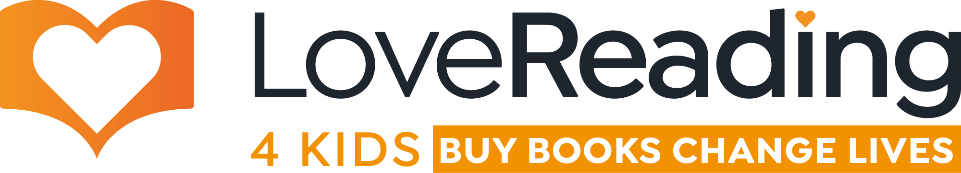

Do you want to support our school?
Do you buy books?
If so, we need your help!

LoveReading4Kids.co.uk is an online bookstore with social purpose. When you buy a book, you can donate 25% of the spend to a school of your choice, to purchase books.

The LoveReading family — LoveReading and LoveReading4Kids exists because reading matters, and books change lives.

Reading is key to unlocking success across the curriculum. We know that improving reading standards has a huge impact on students’ wellbeing, academic achievement, and future success. But it’s a real challenge affording the latest and greatest children’s books with declining school budgets. However all is not lost, there is a new way to help redress that shortfall through the launch of two online bookshops with social purpose.

Buy books, change lives - how it works
- When book lovers buy from the LoveReading and LoveReading4Kids bookstores, 25% of the cover price can be donated to a school, such as ours!
- At checkout, you will be asked to donate to a school, and this automatically and immediately gives us the 25% to spend on books.
- If you are looking at buying books for your children you take take a look at our school’s page here where we have created some recommended reading lists
- In addition, we have created a wishlist of books we’d love to have in school, but are unable to currently afford. If you can help us, we would be very grateful for your support. Take a look at the list here, and thanks in advance for all you do for our school.

Like we said at the start, reading matters, books change lives, and joining this community will ensure that we will continue to be able to invest in reading for pleasure at our school and get fabulous books into the hands of our children.

