BREAKFAST PLAN FOR SCHOOL TEAM SAMPLE

UNIVERSAL BREAKFAST NEW DUTY SCHEDULE BEGINNING 4/14

MORNING (every day @ 7:40 a.m.)

- Primary Door: Loretta (new hours: 7:40-2:10)
- Circle Drive: Chris Bala (new hours: 7:40-2:40)
- Busses: Doris (and Laurie, MaryKay, Jean)

AFTERNOON

Playground/ Sweep Monday - Friday: Doris (get kids to busses, then monitor playground/ gazebo. Bring in kids who are still waiting for parents at 2:50)

Circle Drive:

- Monday: Kim H.
- Tuesday: Jenean
- Wednesday: Kim B.
- Thursday: Debbie Fuelling
- Friday: Lisa Boston

SCHEDULE AND LINING UP PLAN FOR UNIVERSAL BREAKFAST

Preschool: Business as usual. If you have students eating breakfast they will eat in the cafeteria.
Grades K-2: Students will line up outside the end of ramp door. Photo below:

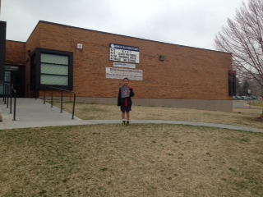
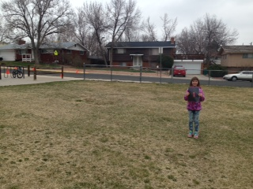
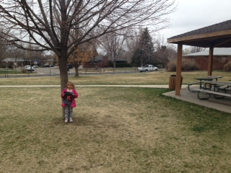

Kinder: Gathers by the gazebo tree, first in the middle of the grass, second up by the ramp… then, when the bell rings, they’ll line up here:
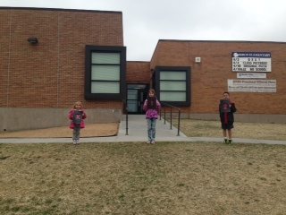

Grades 3-5: Students will line up near the flagpole and enter through the front door. Photo below:
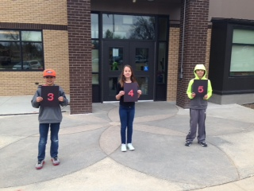

THIS YEAR: The bell will ring at 7:45. Kids will line up at 7:40 in their designated areas, supervised by Loretta (K-2) and Chris B. (3-5). Kids enter the building at 7:45. Students will just enter the building, hang up their stuff, and enter the classroom. Teachers do not need to pick up their students outside before school. Loretta and Chris will remain in their duty areas until 8am.

NEXT YEAR: School will be STARTING at 7:50. At the beginning of the year, we’ll have teachers picking up their kids for the first week or so (and kindergarten, probably for longer than that) so that kids can get used to the routine.

TO DO IN YOUR CLASSROOM

You need to determine where in your classroom you’d like breakfast to be placed. Put your pink bulldog sign in your classroom where you want it… and let Kort know if you need an extra desk or table brought to your room.

Please review the system of breakfast with kids, maybe even creating a new classroom job. The informational review includes where they’ll get their breakfast in the classroom, the expectations of napkins, and the responsibility around trash. Breakfast will come to the classroom like this:

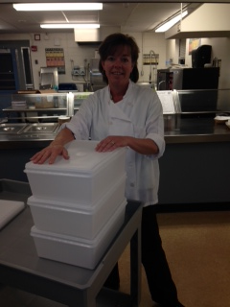
There will be 3-4 bins each day with both food and drink. Kids will get a piece of waxed paper, a napkin, and bring their breakfast to their desk. They (or you… or a student helper) will mark on the roster that they’ve had breakfast.
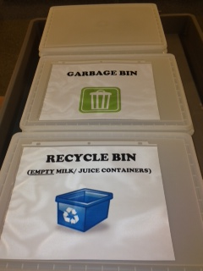
The extras will be combined into one bin
and then the other bins will be used for trash and recycle. The cereal, milk, and juice containers must be EMPTY to go into the recycle bin. (Encourage kids to finish their milk, juice, or cereal. That’s the ideal way for things to be empty. IF they ABSOLUTELY cannot finish their cereal/ milk/ juice, then they can dump the liquid in the garbage bin container and put the recycled material in the recycle bin.)

The garbage bin and recycle bin signs STAY WITH YOU. The things that come to you each day and leave each day are the big plastic tubs and the class roster.
We will have two YouTube videos ready for viewing by next Thursday and Friday. One will be about lining up… the other will be about breakfast itself.

OKAY… BUT WHAT ABOUT…

- Soft Start: These kids are already rostered into special groups with VanDyke, Fields, and Sudia.
- High Five and Go: For kids doing High Five and Go, they will get breakfast in the office and eat it while they’re helping others. Kids doing CICO with office staff members will also eat in the office.
- Motor Lab: Kids in motor lab will come in, hang up their backpacks, get breakfast, and then go to motor lab… or they’ll go to motor lab and THEN come to class for breakfast. Most of these kids are soft start kids with VanDyke, Fields, and Sudia anyway.

