Curbside Delivery
Standard Operating Procedure
Materials needed for successful curbside delivery:
- Sanitizer bucket with QUAT sanitizer with disposable towels
- Spray bottle with QUAT sanitizer
- Gloves
- Hand Sanitizer
- Multiple Carts or cafeteria table or 6 ft table
- Cones
- SIGNS: “Please Wait in Your Car” and “Social Distancing”
- Prepared breakfast and lunch meals
- Trash can
- POS (check WiFi)

Curb-Side Delivery in Vehicle
- Wash hands prior to starting service.
- Display sign to the public during meal distribution, “Please Wait in Your Car”

How to determine how many meals to provide:
- As the car approaches, signal for them to roll down their window. Stay back 6-10 feet to limit exposure.
  - Best practice: use cones or milk crates to create a lane for cars to drive through, allowing Food Service Staff to maintain a safe distance away from cars
- Ask the driver, “How many children are enrolled at XXX?” The driver may crack their window to communicate, or using their fingers show the NS employee how many children they have.
- Using the POS verify student ID number and eligibility.
- The number of children is called out loud to Food Service staff, who are 10-15 yards beyond the driver and staging meals.
- Food Service staff will place the correct number of breakfast and lunches on the end of a table/cart/crate. The table should be set up perpendicular to the approaching car, but far enough away that requires the driver to exit the vehicle, once prompted to grab their meals.
Procedure for Meal Pick Up; use of TABLE or CART
- The driver is instructed to pull forward to retrieve food items once the Food Service staff member has backed away 6-10 feet, to the designated space. Then the driver will EXIT their vehicle to pick up their food items.
- If using a table, the NS staff member should be on the opposite end of the table prior to the driver exiting their vehicle.
- If using a cart, the NS staff member should have a clear marker (use a line on ground, cone, milk crate, etc.) that is at least 6-10 ft. away from the cart that they must be standing behind, prior to the driver exiting the vehicle.

**For safety purposes, handing food through the car window is not allowed**
** We are no longer placing food items in trunks, back seats or handing through the car window of the vehicle**

- Once the family has picked up the meals the Food Service staff member will then sanitize the table/cart/crate after each meal pick up with gloves on. Repeat this process after each car.
- If you come into contact with any passengers, remove your gloves, sanitize or wash your hands, put on new gloves. Change your gloves frequently throughout service.

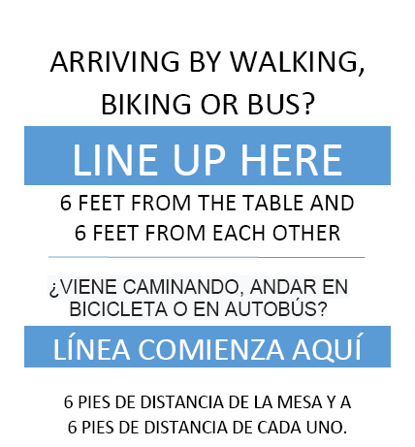
Walk-up Customers (families on bike, on foot, etc.)
- Post the following “Arriving by Walking, Biking or Bus” Sign→
- Use large “We are Practicing Social Distancing” Sign
- For walk ups, have a cart /table/crates outside to place food on requested by families.
  - Mark lines on the ground with blue tape 6 feet apart to keep proper distance between families lining up.
  - From a distance of 6-10 feet count the number of meals needed by the family.
  - Using the POS verify student ID number and eligibility.
  - Place meals on cart or table for family then back away 6-10 feet
  - Instruct the family to pick up the meals. Sanitize the table/cart after pick up.
- Repeat this process for each walk-up family.
- Gloves must be worn during this process. If you come in contact with anyone, sanitize hands and change your gloves.
- Gloves must be changed frequently throughout the curbside delivery process.

