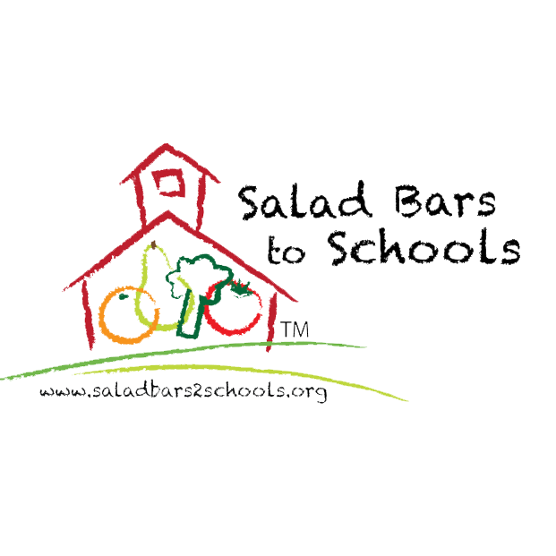
New Salad Bar! Letter to Families

SALAD BARS NOW AVAILABLE AT [school/district name]!
[Insert school district logo]

[DATE]
Dear families,

We are excited to announce that school meals will be available free to all students all year long, and thanks to a grant from the Salad Bars to Schools Program, [School] will be offering a salad bar(s) as part of our meal program(s) this school year. [City’s] local health department has approved salad bars for use in schools for SY21-22, and their most recent guidance can be found [insert link to health department website] here.

According to the CDC: Given very low risk of transmission from surfaces and shared objects, there is no need to limit food service approaches to single use items and packaged meals.
We feel that salad bars are a safe and healthy option for our school(s) and are taking the following precautions:
- Students and staff will wear masks at all times indoors including while in the food service line and at the salad bar
- Students will maintain a distance of at least 3 feet apart (as suggested by CDC)
- Hand sanitizer/ hand washing stations will be available in the cafeteria to be used prior to entering the service line.
- All serving utensils and contact areas will be cleaned and sanitized routinely between groups.
- Staff & students will be trained on how to properly use the salad bar(s).
- [include any other modifications that are relevant to your program: e.g. cohorts or multiple serving lines]

Our salad bars will offer daily access to a variety of fresh fruits and vegetables. [include any details about local/organic procurement for salad bar options, or any upcoming salad bar related events this year] We know that healthy options in the lunchroom fuel success in the classroom, foster lifelong healthy eating habits, and maximize future potential. (include anything else related to your program’s mission or vision as it relates to healthy school meals)

We look forward to a safe and successful school year. Thank you for your support of our school meal programs! If you have any questions, please contact the Food Services Department at [phone #} or {email}

Sincerely,

