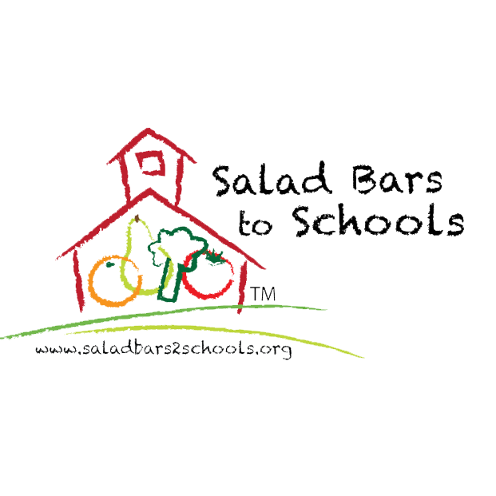

SALAD BARS DURING COVID SOP

For SY 21-22, follow the most recent recommended guidance from the Centers for Disease Control (CDC). , your state’s department of education, and your district’s local public health officials.

Staff Safety
- Follow State or local health department requirements.
- Follow Employee Health Policy, Personal Hygiene, and Washing Hands SOPs.
- Wash hands before preparing food and after removing used gloves and changing tasks.
- Maintain physical distance of at least 6 feet from other workers/students/school employees. (current recommendation for students is 3 feet minimum)
- Always wear a mask indoors during food preparation, except when eating or drinking.
- If possible, wear disposable aprons.

Washing Fruits & Vegetables (including vegetables that will be peeled)

The salad greens that are being used in every school have been triple washed and sealed. They are as clean and safe as they can be, and it is the manufacturer’s intention that they are to be washed before using. Additional washing will only degrade the product. Additionally, many sites do not have the proper sink setup needed to effectively and safely wash greens. Therefore, the mandatory standard procedure for all greens that are used is that they NOT be washed, unless they are being procured directly from a local farm, in which case they would be washed according to the following protocols.
All other fruits and vegetables used on the salad bars DO need to be washed as they may have loose dirt and microbes on them that must be removed. Here are procedures for those products:

- Wear single-use gloves when washing fruits and vegetables per HACCP SOP.
- Remove all stickers. Soak produce to loosen foreign particles and reduce the risk of food-borne illness. This can be done in a clean, sanitized container such as a large bowl, bus tub or deep hotel pan. Do not fill up a sink for washing unless you have a dedicated vegetable sink that has been sanitized.
- For produce with thick skin (such as carrots, potatoes, and bell peppers), use a vegetable brush to help wash away loose dirt and microbes.
- Some produce should not be soaked in water or scrubbed with a brush. Put fragile produce (such as cherry tomatoes and peaches) in a sanitized colander and spray with water.
- Drain fruits and vegetables well in a colander or other drain pan before cutting or storing.

Peeling and Cutting Salad Bar Items

- Wash, rinse, and sanitize all workspace surfaces including countertops, cutting boards, and utensils before and after food preparation, and when changing tasks.
- Bacteria from the outside of raw produce can be transferred to the inside when cut or peeled. As stated above, even products that will be peeled must be washed properly.

Salad Bar Setup

- Wash and sanitize all salad bar surfaces, pans, condiment dispensers and utensils prior to service.
- Follow manufacturer’s instructions for pre-heating and pre-chilling food bar equipment before use
- Refrigerate all canned or bottled items (such as beans and salad dressing) and their backups before putting out on the salad bar. For example, if you generally use one can of beans for service, have another one refrigerated in case you run out.
- Keep all salad bar containers refrigerated and ice packs frozen once they have been cleaned and sanitized. This will ensure that you start with a cold environment and will help maintain a safe product temperature while it is on the salad bar.
- When ready to set up the salad bar (as close to the start of service as possible), remove ice packs from freezer and place in the base of the salad bar.
- Put dividers in place according to the department’s planned salad bar grid (menu).
- Set out filled refrigerated pans as close to the start of service as possible.
- Follow the grid guide for your menu. If you must substitute an ingredient, make sure you are subbing with a like ingredient (example, don’t substitute eggs for tomatoes, put out carrot sticks in addition to carrot coins, or more of another popular vegetable). Substitute vegetables for vegetables, beans for beans, fruit for fruit, and protein for protein.
- Record how much product is prepared on the Production Record. After lunch, record what is left.

Salad Bar Food Safety

- Wash and sanitize salad bar utensils, pans, condiment dispensers, and contact surfaces before and after each meal period.
- Place all exposed food under sneeze guards.
- Products must be maintained at a temperature below 41°F or must only stay out on the salad bar for a 2-hour period. Time/Temperature logs must be maintained for all salad bar items
- Products may be reused for service the following day if they are clean, free of other items, appear fresh, and have been held below 41°F or have been out on the salad bar for under 2 hours and have been recorded on a food time/temperature log. Never combine an old product with a new one, even if it has been properly handled.
- When changing out an old product with a new one, use a new, clean and sanitized container. Do not add new product to a used container.
- Do not fill protein containers more than halfway. This will ensure that the product remains at a safe temperature.
- Provide an appropriate clean and sanitized utensil for each container on the food bar.
- Assist customers who are unable to properly use utensils.
- Ensure that customers use a clean dish when returning to the food bar.
- Store eating utensils with the handles up or in a manner to prevent customers from touching the food contact surfaces.
- Avoid using spray chemicals to clean food bars when in use.

Monitoring

- When staffing allows designate a staff member as “salad bar attendant” to monitor student/staff salad bar safety and clean/sanitize as necessary.
- Monitor and record temperatures of food in accordance with the Hot and Cold Holding for Time Temperature Control for Safe Foods SOP
- Continually monitor food containers to ensure that utensils are stores on a clean and sanitized surface or in the containers with the handles out of the food.
- Continually monitor customers’ use of the food bar to ensure that customers are not:
  - Touching food with bare hands
  - Coughing, spitting, or sneezing on food
  - Placing foreign objects in the food.

