Boulder Valley School District
School Food Project

Sustainable Lunchrooms Case Study

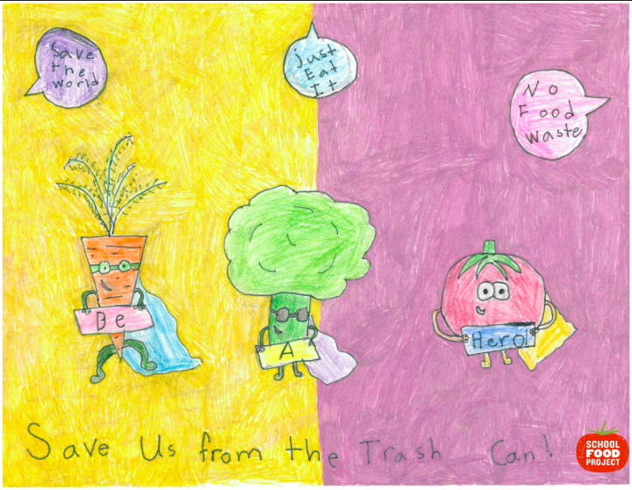

Written by:

Laura Smith
laura.a.smith@bvsd.org

February 2020

Table of Contents

Background 2
Introduction 3
Bulk Milk 4
Reusables vs. Disposables 5
Procurement 6
Back of House Food Waste 9
Front of House Food Waste 11
Recycling & Composting 12
Food Appreciation and Education 13
Student Engagement 13
Sustainable Cleaners 15
Equipment Efficiency 16
Transport of Food 17
Sustainable Program Certifications 17
Conclusion 19
Appendix 19

Background
The Boulder Valley School District (BVSD) is a public PK-12 school district and currently has 57 pre-kindergarten through twelfth grade schools, including five charter schools, an online school, and numerous magnet schools with focal programs ranging from Montessori to Core Knowledge to Pre-Engineering. Total enrollment as of August 1, 2019, was just over 31,000. The District’s students are demographically diverse: 30% minority, 20% low-income, 10% English Language Learners, and 11% with disabilities.

BVSD Food Services, also known as the School Food Project, serves fresh and nutritious food every day, amounting to nearly 14,000 scratch-cooked meals each day. Using healthier, locally-sourced, and organic ingredients whenever possible, BVSD avoids highly processed foods, high fructose corn syrup, chemicals, dyes and food additives. All beef and chicken on the bone and nacho meat is hormone- and antibiotic-free, and the bulk milk is organic. Salad bars are offered daily at every school and are stocked with fresh, delicious, and - when possible - local farm fresh produce.

BVSD Food Services operates under a regional production model, with one centralized warehouse. The three regional production kitchens each produce meals for 14-17 schools every day, which are then transported to 54 school-based satellite kitchens for final preparation and service the following day. Additional food deliveries are made directly from the district’s central warehouse, by a local produce distributor and by a local fluid milk vendor. While these nuances create a complex school food model, these intricacies allow BVSD to implement important, sustainability-based practices and procedures throughout the operation.

Introduction
BVSD has an ambitious sustainability plan, outlining a “green” mission and long-term objectives, including zero waste goals and sustainable purchasing practices. In 2009, BVSD adopted a resolution supporting environmental sustainability, jointly created with City of Boulder, University of Colorado at Boulder, and Boulder County. In 2010, the Board of Education passed a policy in support of sustainability efforts across the district. Together, the four organizations committed to prioritizing collaborative efforts in the following areas:

- Creation of a workforce available for green jobs through career and technical education training, and teaching and internship opportunities;
- Greenhouse gas emissions reductions and climate change adaptation planning, including unified carbon tracking and reporting;
- Identification of large-scale renewable energy opportunities;
- Pursuance of initiatives in furtherance of zero waste goals; and
- Exploration of joint funding opportunities to further implementation of all of the above.
BOY WITH BULK MILK IMAGE - use on new site
In order to align with this vision, the School Food Project made significant improvements to its daily operations. In 2009, BVSD moved to reusable trays, cups and silverware in all school cafeterias and began purchasing organic milk in bulk containers. The School Food Project has since introduced reusable plastic containers (RPCs) for the delivery of local produce, chicken and beef products; collecting used cooking oil to be turned into biofuel; expanded comprehensive recycling and composting programs in all school cafeterias, and more. This case study outlines best practices for several of BVSD Food Services’ sustainable kitchen and lunchroom initiatives. The intent is to provide guidance for other school food service
departments looking to transform their operations into environmentally-friendly hubs.

Bulk Milk
One of the first changes implemented in 2009 as part of the School Food Project’s meal program overhaul was to introduce bulk milk dispensers. Traditionally served in 8-ounce cartons to ensure compliance with federal meal reimbursement guidelines, milk is often one of the most wasted school meal components. While all National School Breakfast and National School Lunch Program operations are required to serve two types of milk, BVSD chooses not to rely on students taking a full eight ounces to create a reimbursable meal. While students are welcome to take a full eight ounces of milk with their meal, BVSD promotes the selection of three of the four other meal components - fruit, vegetable, meat/meat alternate and grain - before students arrive at the milk dispensers. As such, students are only taking as much milk as they will drink.
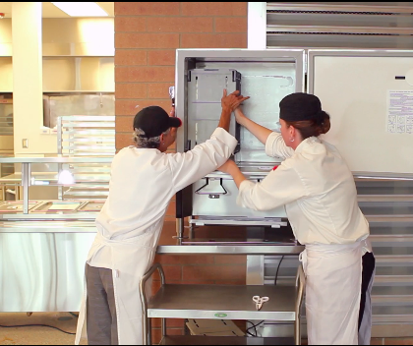
In addition to cutting down on milk waste from unfinished eight-ounce servings, bulk dispensers reduce the waste generated by milk cartons. In a medium-sized school district like BVSD, that keeps nearly 1.5 million single-serve milk cartons out of the waste stream each school year. The reduced milk waste also allows BVSD to serve organic 1% milk in all cafeterias; organic bulk milk can be less expensive per serving than conventional milk served in individual cartons or plastic containers. As an ardent supporter of a sustainable food system, BVSD values bulk milk as an additional opportunity to support the organic industry.

BVSD has establish operating procedures to overcome challenges associated with bulk milk:
- Reusable cups provided to students are nine ounces in order to comply with USDA requirements allowing for an eight-ounce fill.
- In order to reduce spills as well as waste, students are encouraged to take only as much milk as they would like, and to return for more as often as they would like during a meal period.
- While students purchasing school lunch are invited to return for more milk, that flexibility makes it more difficult for staff to track the students who are purchasing milk a la carte. BVSD established a policy requiring students to enter their meal account PINs prior to pouring a glass of milk. The policy also reduces spills near the register as students move straight from the dispenser to their seats.

Another impact of bulk milk on an operation is the ability to move and maneuver BIBs (bag-in-box) of milk, as opposed to crates of cartons. In order to avoid on-the-job injuries, BVSD introduced a standard operating procedure requiring any lift over 40 pounds to be performed by at least two staff. Arriving in five gallon bibs, staff use two people to lift the 43 pounds of milk into the dispenser, which many times is on top of a table and nearly at shoulder height.

Reusables vs. Disposables
In 2009, BVSD also decided that one of the most impactful ways to reduce the operation’s carbon footprint was to reduce the amount of waste generated by non-food supplies during meal service. Instead of single-use trays, silverware, and cups, the district fundraised to purchase durable trays, real silverware and hard plastic cups. With nearly 14,000 meals served daily at 54 sites, that equates to approximately three-quarters of a million single-use items saved from the waste stream each year.
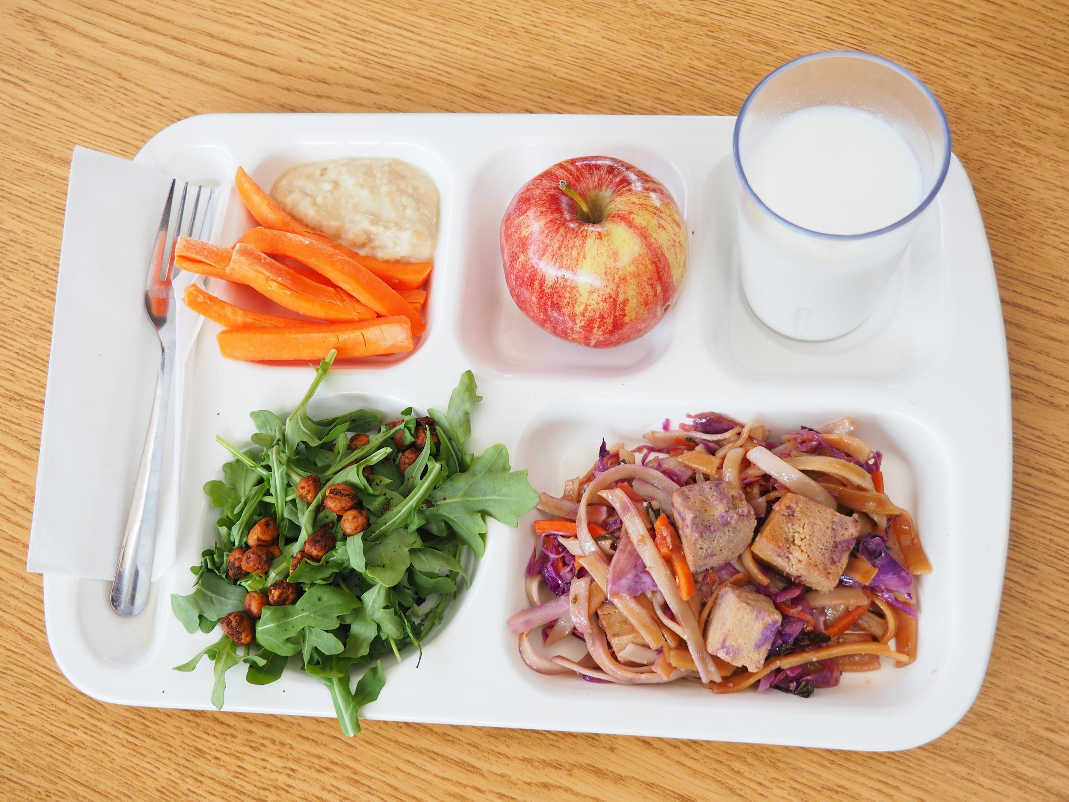
However, implementing the use of durables requires significant planning and incurs additional upfront costs for equipment and ongoing costs for labor. With compostable boats costing less than a dime per each, and styrofoam costing even less, the commitment to durable trays must be more than an environmental one. A food service operation must account for the cost of:
- durables,
- dishwashing equipment,
- consumable chemicals, such as dish detergents
- and labor to wash and sanitize the durables.
The upfront cost of commercial dishwashers and durable serveware can feel monumental, and the savings associated with reducing purchases of single-use items can feel small. However, the commitment to a more sustainable food services operation through durables can lend itself to the implementation of further environmentally friendly practices.

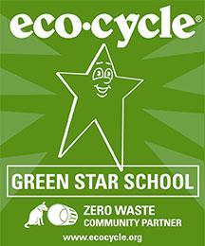
In the Boulder Valley School District, Food Services is supported by the local nonprofit zero waste provider, Eco-Cycle and their Green Star School Program (GSS). Through this partnership, school communities gain a better understanding of the impact of a healthier waste stream through education on compost, food waste, recycling and reuse (discussed below). Before introducing durable wares, all students participate in assemblies and education programs to engage in reducing environmental impacts throughout the building. To participate in the GSS program, schools are required to identify student and staff champions to promote zero waste practices and support their peers throughout the school year. Students are empowered to become champions of their school’s waste reduction and collaborate with Eco-Cycle and the School Food Project to encourage the proper use and reuse of durable trays, cups and silverware in the cafeteria. Although loss of any durable item is inevitable in a school environment, looping the school community into the bigger picture through ongoing education, hands-on learning, and leadership opportunities, the school takes ownership of the overall goal to achieve a more environmentally friendly kitchen and cafeteria.

Procurement and Reducing Food Waste
Agriculture places a significant burden on environmental resources by impacting the availability of freshwater and disrupting ecosystems to expand farming and ranching operations (World Wildlife Fund). As such, it is important for food service departments and school communities to understand the connection between soil health, water use and the overall environmental impacts of growing, procuring, transporting, and wasting food.
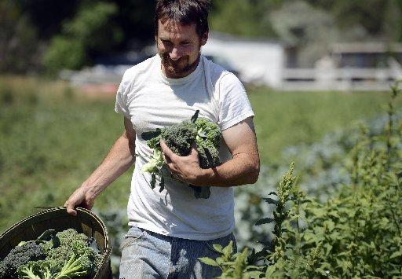
BVSD gives preference in its food purchasing to local growers, producers and processors in Boulder and Broomfield counties, Colorado; then to the surrounding counties (Gilpin, Grand, Larimer, Clear Creek, Arapahoe, Douglas, Weld); to other areas of Colorado; and finally to other states in the Rocky Mountain region (Idaho, Montana, Utah, Wyoming, New Mexico).

BVSD’s local purchasing is generally accomplished through direct relationships with farms, dairies, and producers. Local farmers working with the district are asked to complete a request for qualifications (RFQ), prioritizing the following qualifications:
- Farm Certified Organic, Certified Naturally Grown, member of Bionutrient Food Association, or other (farm without pesticides, herbicides, GMOs).
- Farms located within 50 miles of BVSD Ed Center at 6500 E. Arapahoe Road.
- Farms willing to commit in advance to estimates of needs, willing to receive orders via email PDF on Thursday for delivery the following Thursday/Friday to warehouse.
- Produce delivered within 48 hours of harvest.
- Produce delivered washed, in standard case weight sizes, in reusable containers/crates.
- Farmers willing to visit schools and host student farm visits.
- Payment net 30.
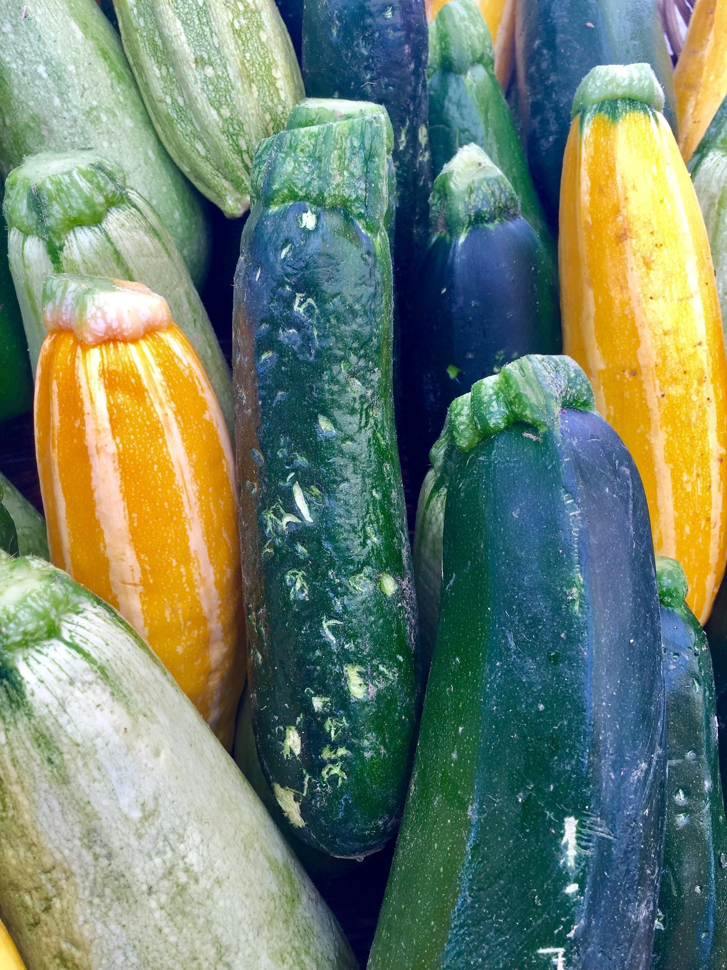

Each December, BVSD begins menu planning for the following school year. After reviewing successes and challenges of purchasing produce from local farmers during the spring and current fall semesters, the Food Services Director, Procurement Manager, and Production Manager/Chef meet with farmer partners to discuss the year ahead. This allows farmers and Food Services to agree upon the produce to be purchased, and avoids any confusion or uneducated guesses at what type & quantity of produce the district will want to purchase. (Click here for an example of BVSD’s Harvest of the Month Produce Planning sheet.) The growing and purchasing plan for the upcoming year gives farmers a sense of security about who will buy their product and ensures BVSD will know sources for local fruits and vegetables. By coordinating with farmers before planting season, this type of relationship can avoid unwanted produce, clarify fresh produce schedules, and promote local agriculture.

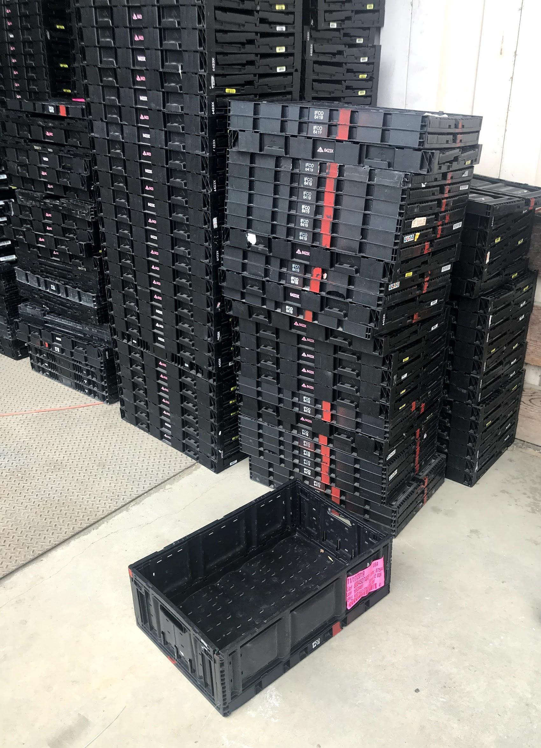
BVSD’s local produce procurement system also maintains built-in flexibility to account for unexpected and unavoidable circumstances, such as acts of mother nature. In August 2018, many partner farmers were devastated by a series of hail storms. Severe weather destroyed 80% of the tomato and pepper crops at one such farm and made much of their crop less marketable at farm stands, CSAs, and farmers markets. BVSD’s focus on local procurement and produce flexibility allowed the department to adjust purchasing plans and receive damaged produce, thus reducing food waste on area farms. Damaged tomatoes made great tomato sauce while hail-pocked peppers, squash, and cucumbers were chopped up for use on the salad bar. Such opportunities allow additional venues for educating students about “seconds” or “imperfect” produce, sources of food waste and food loss, and the importance of the district’s role in alleviating such stresses on the community.

BVSD’s commitment to low-waste procurement is also reflected in the implementation of reusable plastic containers (RPCs). Instead of receiving produce in one-time use cardboard, the district purchased a set of RPCs to be rotated throughout the operation. Marked with a red stripe to differentiate them from others’ RPCs, BVSD’s supply is stored outside of the warehouse, on the loading dock, for local farmer partners to pick up as needed. Farmers fill the RPCs to a specified weight depending on the type of produce and deliver them to the warehouse. BVSD sends the produce to the regional production kitchens and returns the RPCs to the stock for farmers to pick up. In addition to reducing cardboard waste, this process also reduces the cost for farmers, translating to higher yields for them and lower food costs for the district. BVSD has implemented a similar RPC system for fresh animal proteins, including bone-in chicken, ground beef and hamburger patties, and other locally produced products, such as tortillas.

Menu Cycles
The School Food Project also collects feedback from parents and students after the first semester of each school year. Accompanied by a letter from the Food Services Director, an online survey is sent to all BVSD households, asking for everyone’s top three items to keep and top three items to remove from the menu for the following year. The survey asks families to share their ideas for new entrees and sides to add to the menu. Through a series of target questions, Food Services also uses the opportunity to get a sense of the community’s understanding of the quality of the food, the lunchroom nutrition education programs, and the district’s commitment to a sustainable food system.

By tailoring the menu to the latest food trends, parents’/students’ wants, and seasonally available local foods, BVSD is able to create a highly desired, cost effective and sustainable year-long menu calendar.
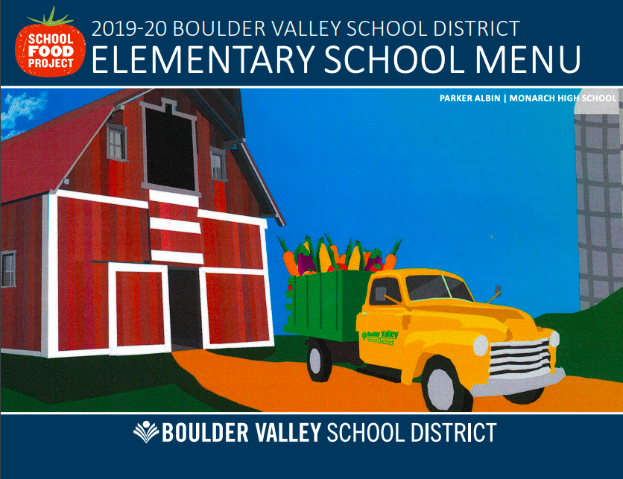
While maintaining flexibility on salad bars, BVSD’s lunch menu follows a regular structure to ensure predictability, projections, and tracking of procurement and meals served. Using a six-week cycle makes it easier to predict the quantities needed each time a menu item is served. Kitchen managers track the number of servings ordered versus the number of meals served and use that data to adjust their orders for the next time that same menu mix comes up. BVSD’s procurement manager and chefs also depend on the cycle menu to identify areas of overlap and multiple uses for ingredients. With this information, procurement managers can aggregate purchases, receive items in bulk and reduce over-purchasing of items or ingredients that will not get used before they go out of date.

Cycle menus can allow school districts to project purchasing needs for the entire year, reducing “guesstimates,” overpurchasing, and resulting waste. BVSD has developed a somewhat complex, but well-functioning system to order products from vendors far enough ahead so as to avoid any last-minute delays, but not so early as to make large guesses about the number of meals to be prepared and served at any given sites:
- Three weeks prior to the serve day, school-based satellite kitchen lead staff place their orders to the production kitchens, specifying how many of each entree, side, and salad bar servings they’ll need.
- Two weeks ahead of the serve day, production kitchens (led by the sous chefs) aggregate the orders from the 14-17 satellite schools they serve, consult existing inventory, and place their orders to the central warehouse.
- BVSD’s Procurement Manager then takes the consolidated orders and submits the purchase order to vendors for the quantities needed for the entire school district. Aggregated orders leverage buying power and provides multiple checkpoints throughout the order process to ensure that sites are not over-ordering in a way that will result in unusable, wasted food.

Back of House Food Waste
Piggybacking on the district’s partnership with Eco-Cycle’s Green Star Schools program, BVSD’s School Food Project targeted food waste as a department priority in 2017. In order to reduce food waste within the department, the kitchens first needed to understand what amount and type of waste was being created in daily operations. After receiving a grant from Boulder County’s Resource Conservation Division’s Zero Waste funding program, the district installed Leanpath machines in each of BVSD’s three regional production kitchens.
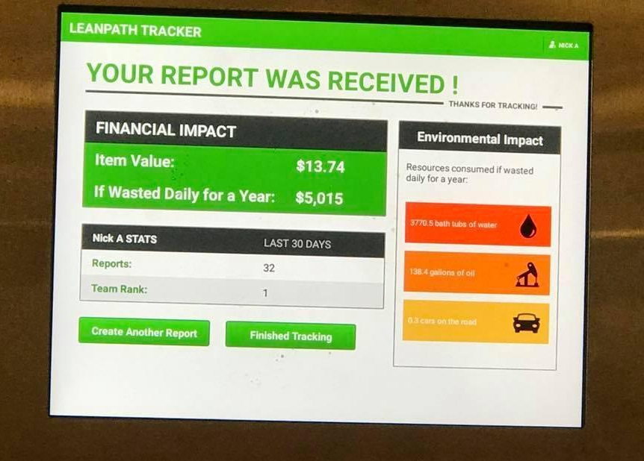
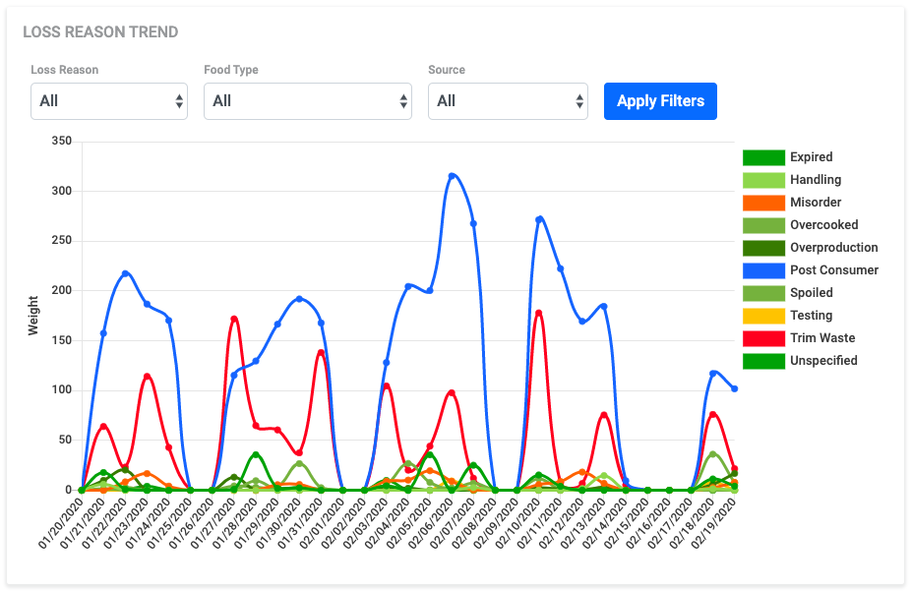
Using the Leanpath food waste tracking system, each time an employee goes to throw away food, he or she places the food waste in a compost bin permanently located on a floor scale. The employee selects the food type and specific item to be tossed and the reason for its disposal (ie, overproduction, spoilage, trimming, etc.). The system also tracks the employee name and estimates the cost associated with each item’s disposal. In addition to providing real-time feedback to the employee, the Leanpath system generates a series of reports including:
- pounds of food thrown away by day, week, month or year;
- estimated food cost lost;
- estimated fossil fuel used,
- water wasted and overall environmental impact;
- trends indicating type of foods most often wasted
- employees responsible for the majority of food waste;
- increases and decreases in waste over time and more.

These analytics have helped BVSD chefs and managers to introduce food waste reduction strategies, adjust future food purchases, and create awareness among employees of food wasted. Tracking allows for further comparisons by production kitchen, food vendor, and dish being prepared, and estimates wasted food costs and pounds of food wasted.

Having a better understanding of the waste being generated in BVSD production kitchens informs new, creative strategies to divert waste from being composted. For example, while broccoli stems may not be ideal for the salad bar, they can be repurposed for use in dishes such as the ever-popular Broccoli- and Cheese-Stuffed Potato where pretty florets may be less necessary.
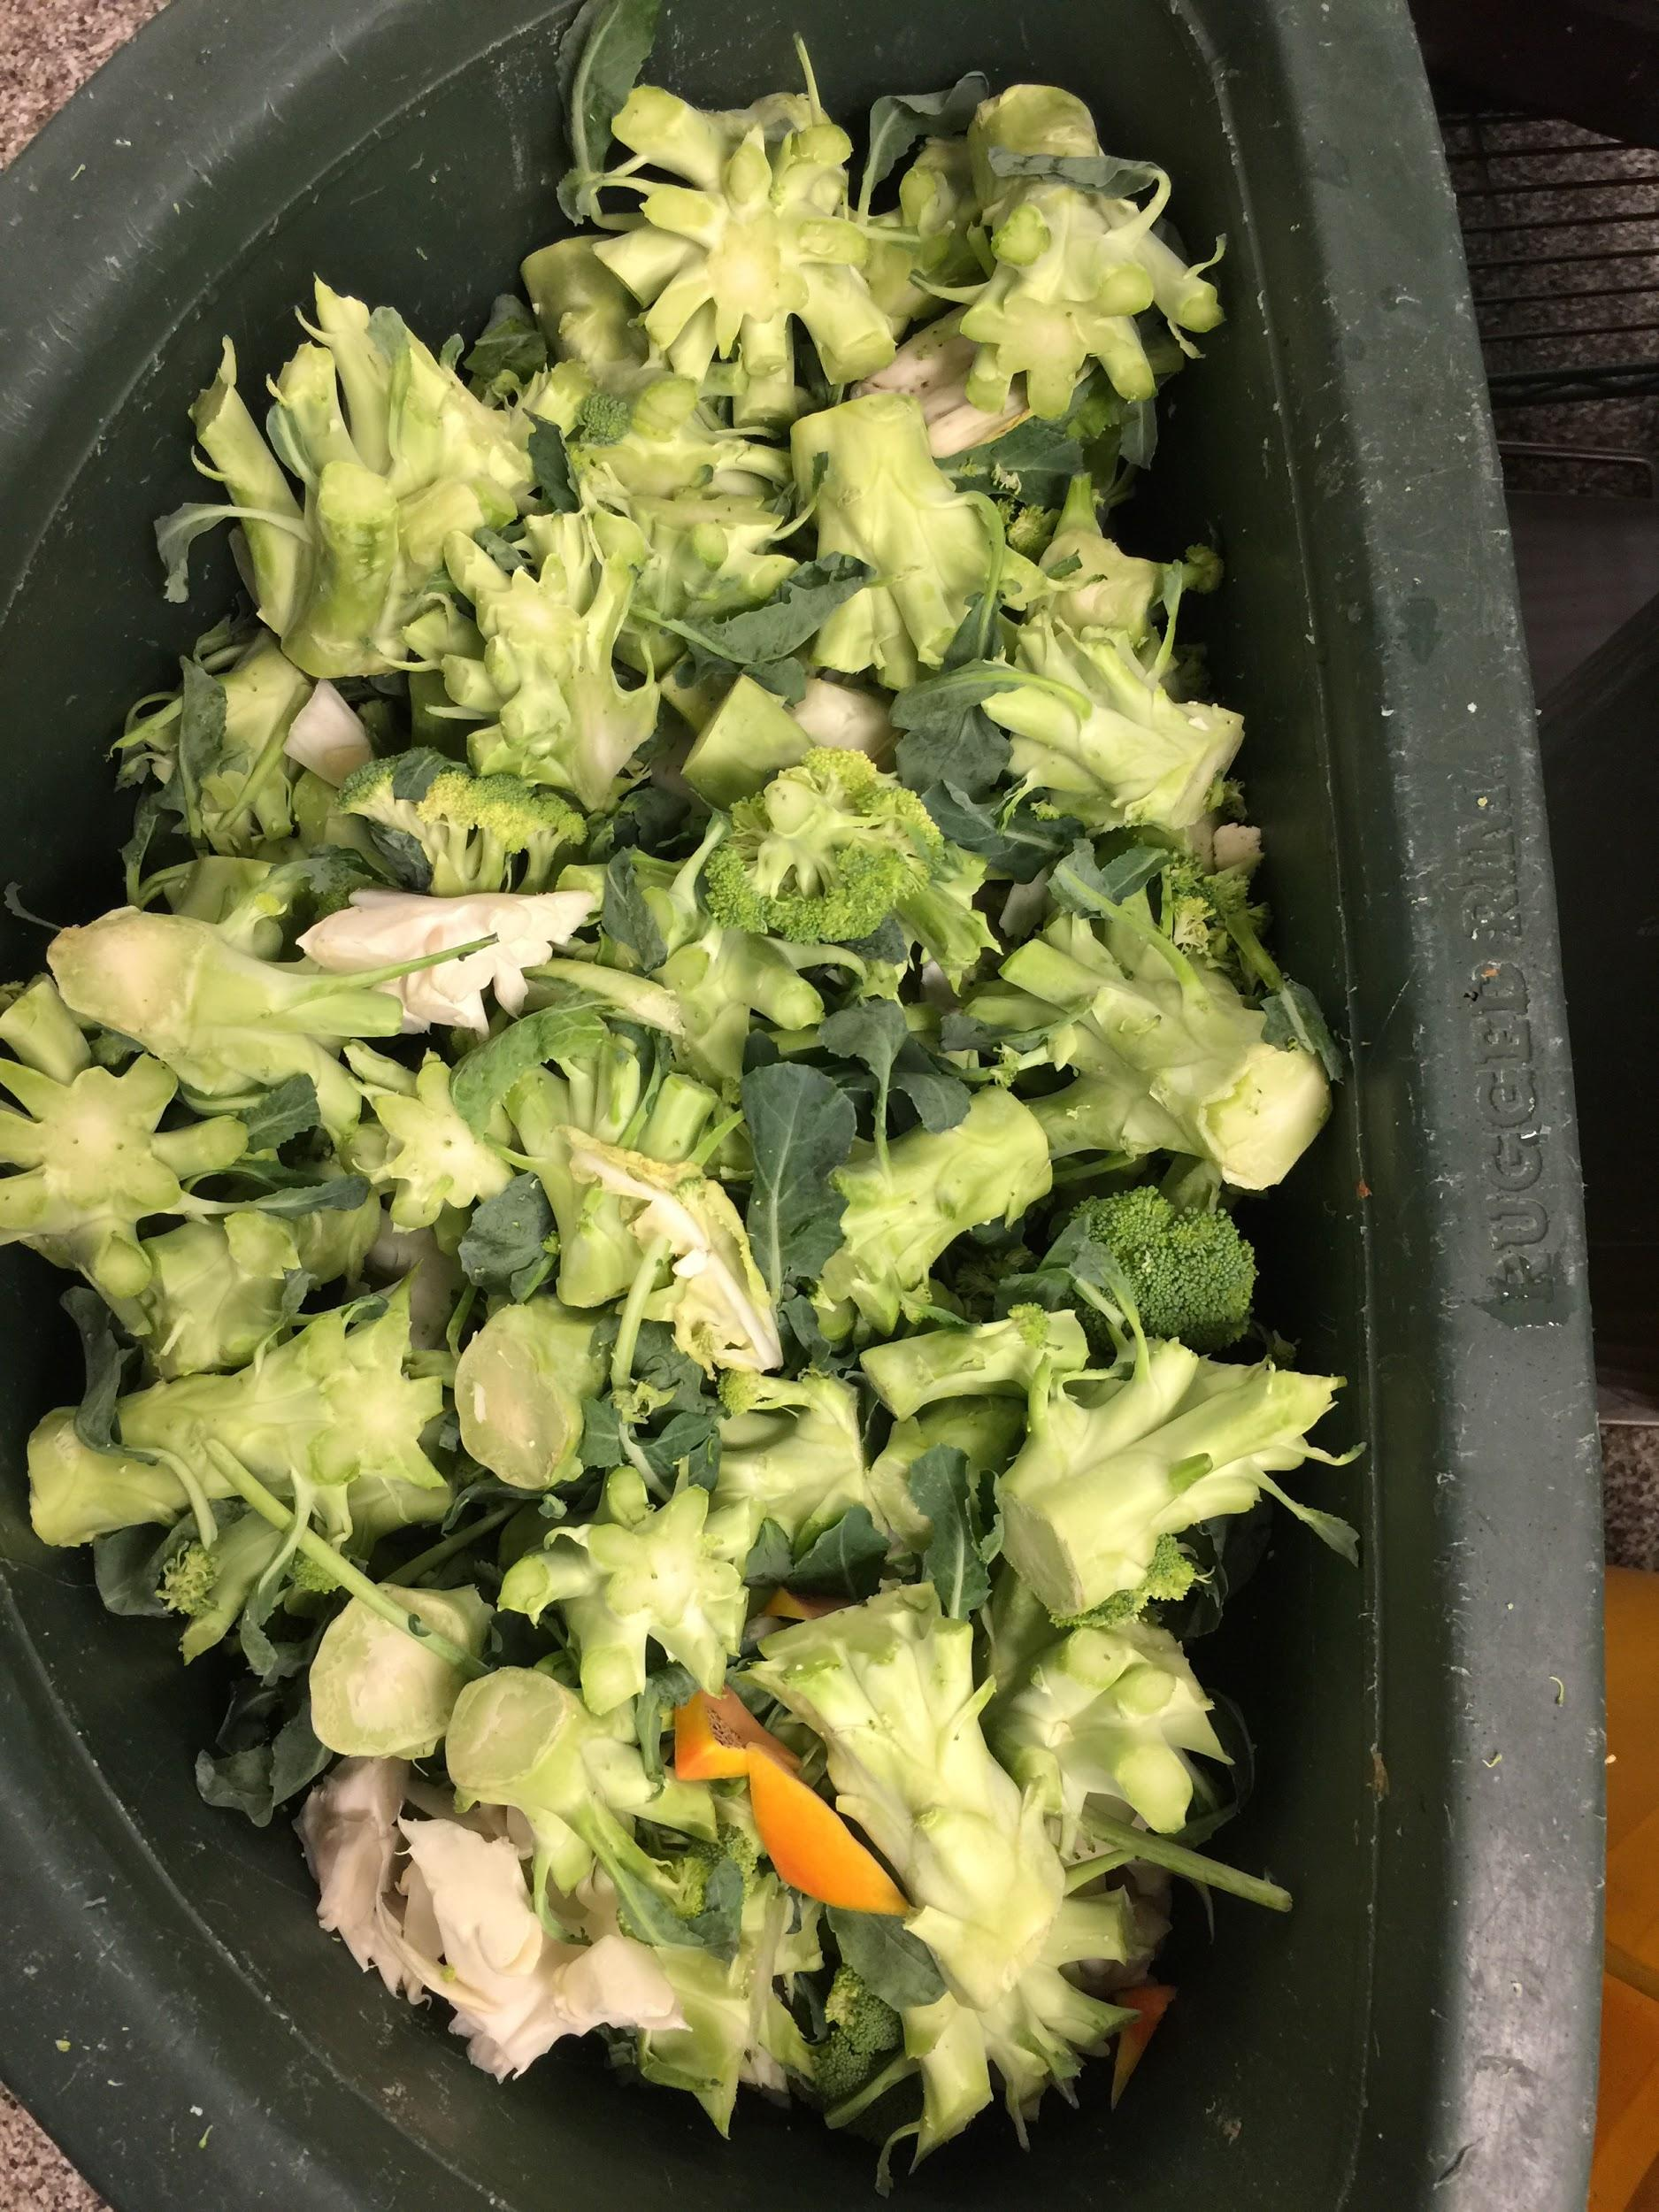
The Leanpath system also introduced opportunities to recognize staff for their efforts to track food waste. Leanpath is set up to incentivize staff for recording their waste, even if they are not immediately reducing the waste created. By tracking their waste, staff are creating opportunities to learn new techniques for food waste reduction and to understand the financial as well as environmental impacts of food waste and food waste reduction.

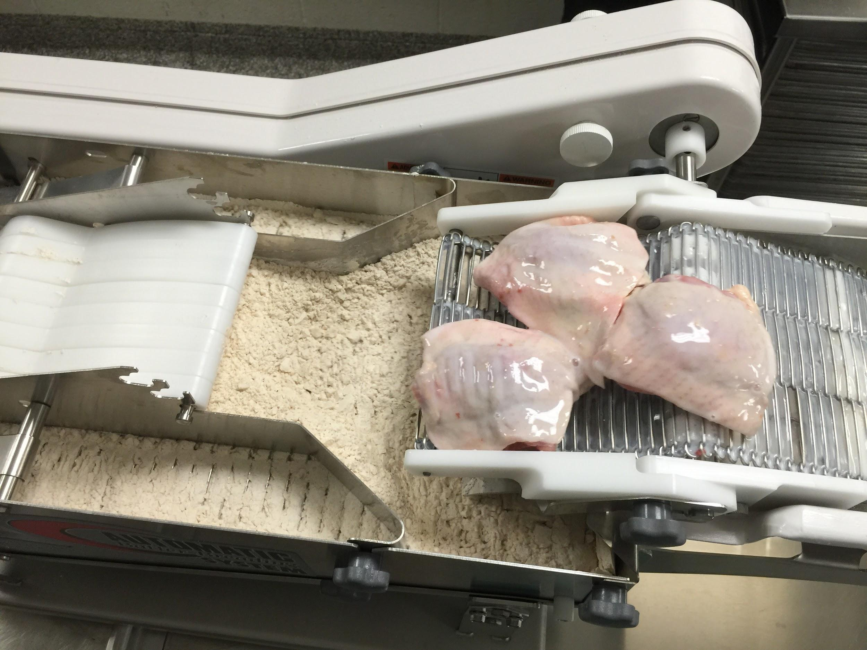
The Leanpath 360 FS system also allows kitchens to set goals to reduce waste over a certain time period, during a certain type of production, or for a certain product. BVSD uses this feature regularly and has implemented new procedures for breading chicken and salad bar preparation. For example, after setting a goal of reducing breading waste, it became clear that adding the breading mix to the machine at multiple times during a prep session could reduce waste by more than 25%, instead of adding the entire mix at the beginning. This simple change did not incur significantly more labor time and yielded an obvious cost savings and waste reduction.

Front of House Food Waste
BVSD is now home to a total of 11 Leanpath machines - three in production kitchens, two in school satellite kitchens, and six in school cafeterias. BVSD’s regional production model and scratch cooking operation means that food waste can be created at multiple points throughout the process. Involving students in the waste stream within their school communities further supports efforts to educate students on waste reduction and how they can make a difference. Capturing this data also allows for a better understanding of the food wasted by over-ordering and helps managers work with kitchen staff to reduce or adjust orders as necessary.
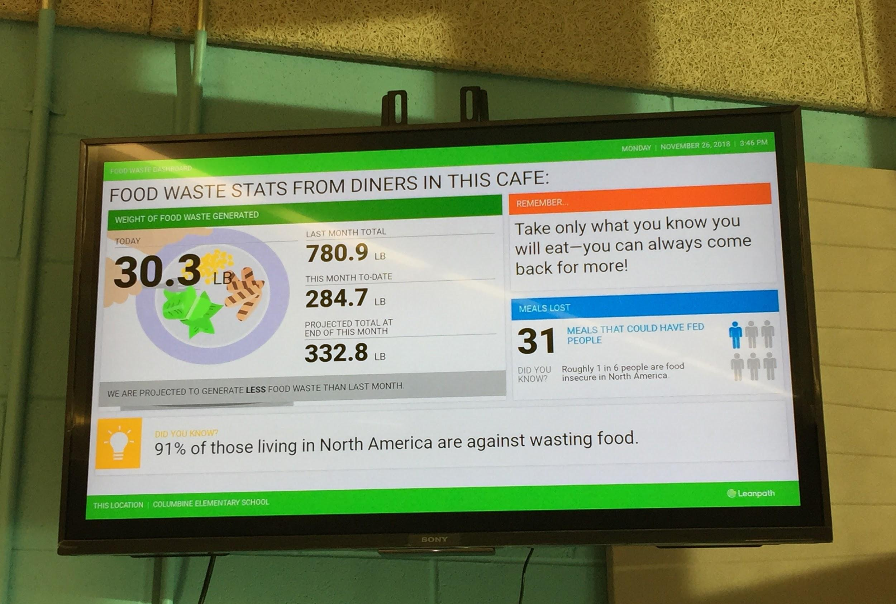
Using the Leanpath Spark system in cafeterias is one of BVSD’s newest food waste reduction strategies. At the end of a meal period, students scrape their plates into a large compost bin, like they would in any BVSD Green Star School. However, schools with Spark systems have a large floor scale underneath the compost bin to weigh every piece of organic waste generated in the cafeteria. Each transaction is recorded, generating a report much like those in production kitchens. Real-time data is also displayed in school cafeterias and translated into kid-friendly statistics and equivalents, such as amount of meals lost, swimming pools of water wasted, and number of cars on the road.

Having only piloted the program as a passive communication display, and having noticed a 30% reduction in post-consumer food waste, the School Food Project is working toward the introduction of a food waste toolkit with additional classroom and practice-based learning opportunities for teachers and students to implement using data generated in their own schools.

Leanpath has been invaluable to reducing food waste across BVSD Food Services but does come with a high price tag that may be too costly for some districts. As an alternative, schools can occasionally run their own food audits to collect data on what is being wasted during meal times. While they require planning, these “manual” audits offer a hands-on opportunity for students to learn about waste reduction. This comprehensive Guide to Conducting Student Food Waste Audits offers step by step directions and sample tracking sheets.

Recycling & Composting
Students do not stop learning when they leave the classroom. School settings help shape the habits that kids take into the rest of their lives. By teaching students how to recycle and compost, why it matters, and how easy it is to incorporate into daily life, schools can foster a new generation of sustainability-minded adults.
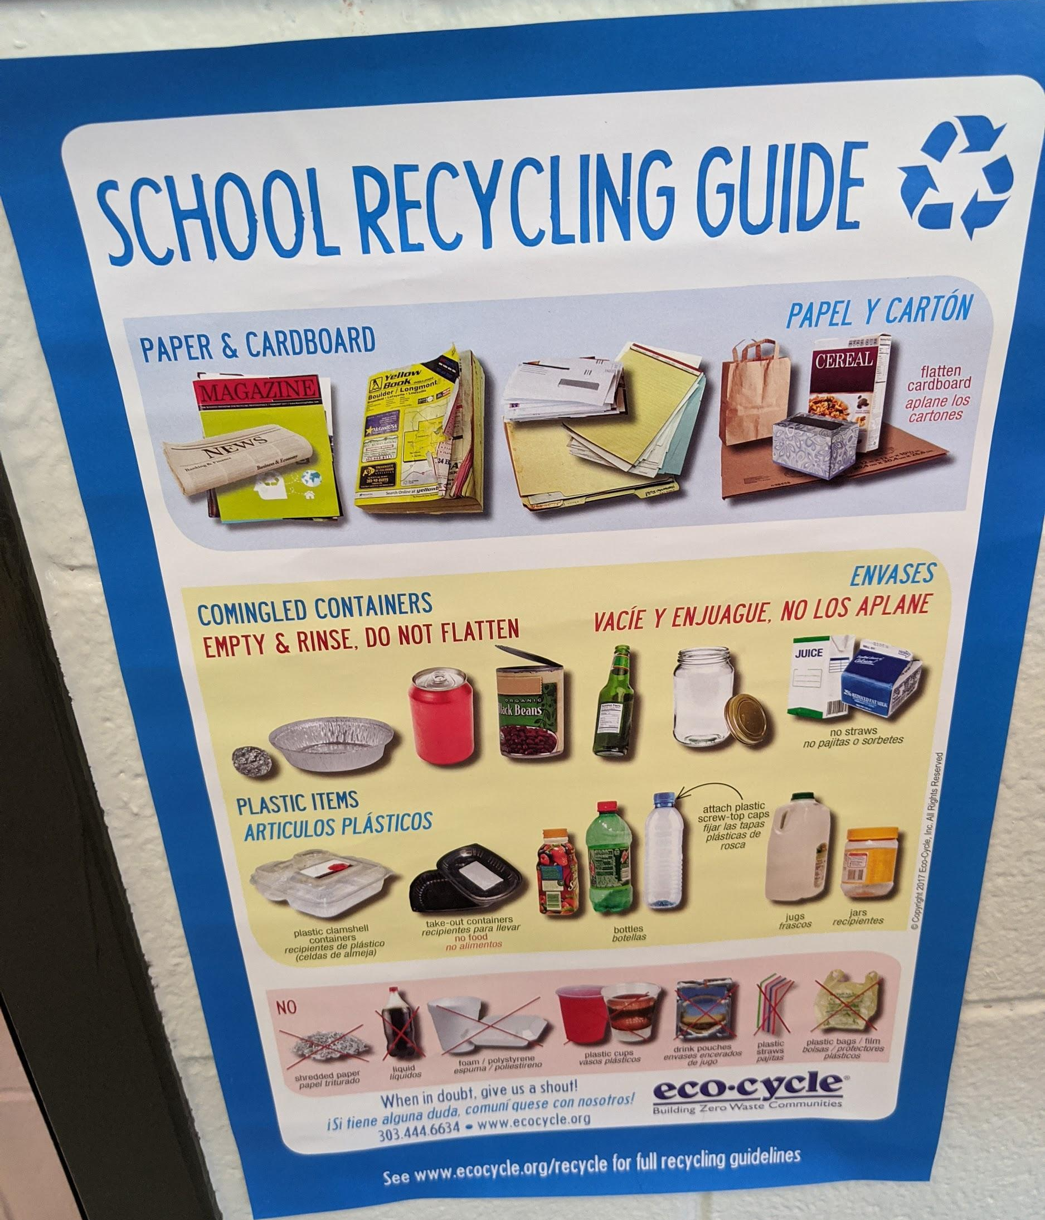
BVSD benefits from being located in an area that values sustainability, and having access to a zero waste hauler like Eco-Cycle. Vendor choice is a critical element of recycling and composting, as not all haulers prioritize composting and recycling.

Beyond basic recycling hauler services, Eco-Cycle has been building its Green Star Schools (GSS) program in BVSD schools since 2005. The program was the first in the country to incorporate:
- single stream recycling, including commingled drink containers,
- composting all food waste and non-recyclable paper,
- and special waste reduction projects and education, such as Waste-Free Lunch competitions.

GSS relies on service fees from school contracts and third-party grant funding to support the educational program that accompanies the introduction of expanded services at new schools. GSS continues to roll out its programming using a pyramid model, initiating the program at elementary schools within each community (Boulder, Lafayette, Louisville and Superior), then moving into “feeder” middle schools, and finally high schools.

With the introduction of additional services, Eco-Cycle provides education about the history of agriculture in BVSD, the shift to modern day farming, and the role that waste diversion and composting plays in the local food system. The GSS program also collaborates with students and teachers to host hands-on learning sessions to create posters for recycling and composting based on what they are actually seeing in their waste stream. Eco-Cycle estimates that “by implementing the Green Star Schools program, another one-third of waste is diverted due to increased recycling and the collection of organic materials. The overall average rate of diversion for the Green Star Schools is two-thirds.”

However, while some BVSD schools have access to robust recycling and composting services, the geographic range creates some complications for providing the same services across all communities. Eco-Cycle currently does not serve Broomfield, Erie, and Nederland, where BVSD has eight schools. BVSD is able to contract with trash hauler Western Disposal to also provide recycling services at those schools, however they do not benefit from composting. With Food Services’ prioritization to reduce the amount of food ending up in the landfill, this is an area for improvement within the district.

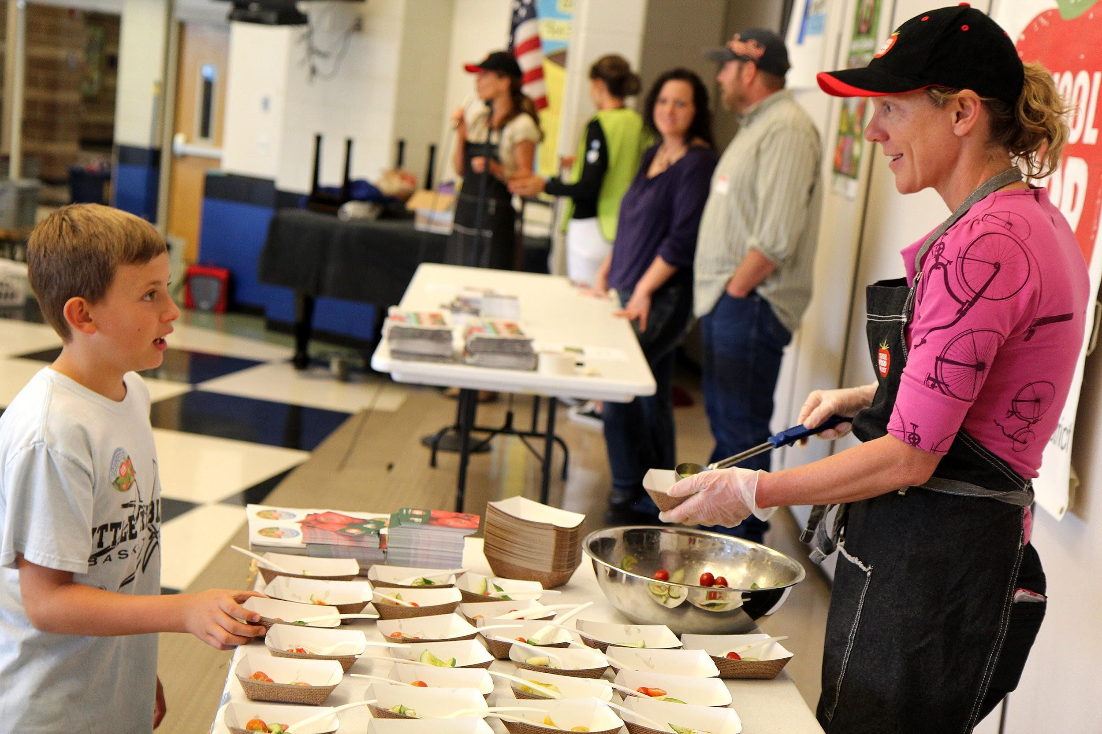
Food Appreciation and Education
Beyond providing healthy and delicious food, it is increasingly important to recognize the role schools can play in supporting a sustainable food system. Before expanding messaging about preventing waste, BVSD recognized the need to expand cafeteria-as-a-classroom education efforts focusing on the local food system and its impact on the environment. Too often, students associate food with grocery stores and pre-packaged, processed meals, instead of farming and agriculture. Embedded in the national culture is a lack of understanding of food and how it ends up on the school lunch tray. To engage students in a sustainable food system, BVSD hosts nearly 200 farm to school events each school year, including chef demonstrations, farmer visits, tastings, “Make a Rainbow at the Salad Bar” Days, farm field trips, and school gardens.

- Tastings provide an opportunity for students to try samples of menu items and Harvest of the Month featured produce.
- Rainbow Days invite everyone in the school to make a salad at the salad bar for free, taking and eating at least 3 colors of fruits and vegetables.
- Farmer Visits enable students to meet farmer partners who grow the beautiful produce for salad bars and lunch menus.
- Chef Demonstrations engage secondary students with a sensory approach to lunch and encourage them to try new foods.
- Farm Field Trips provide hands on experience for students to learn about farm operations, where food comes from and how it is grown.
- School gardens provide an “outdoor classroom” where student experiments and learning activities can be hosted. Participation in the planting, growing, and harvesting of crops in a school garden has been shown to increase a student’s willingness to try new vegetables, and generates learning about healthy diets and activities.

Student Engagement
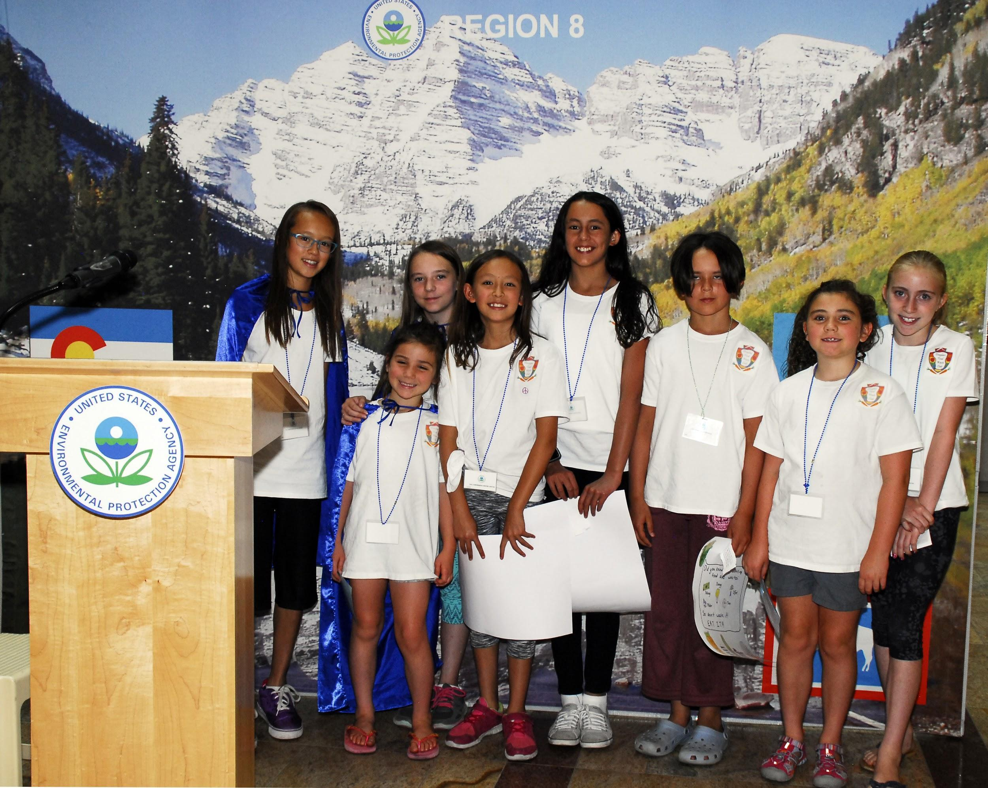
In 2016, the U.S. Environmental Protection Agency recognized Douglass Elementary, a BVSD elementary school, with the President’s Environmental Youth Award (PEYA) for outstanding environmental stewardship projects by K-12 youth. The students had formed a Food Waste Club to educate their school about food waste and ways to help reduce waste during the school day. Food waste was recognized as an environmental issue by students because it contributes to landfills, and it wastes resources used to produce the food, including water, electricity, plastics and paper.

The Food Waste Club started their project by collecting data. To begin, they sent out a survey to other students at Douglass Elementary to gauge which foods students did or did not like, as well as their thoughts on portion size, hot versus cold lunches, how hungry they were at lunchtime, and noise level in the cafeteria. The team then conducted a waste audit, weighing discarded food from the cafeteria to see how much food their school was wasting and discovered that many students were throwing away untouched fruits and vegetables.

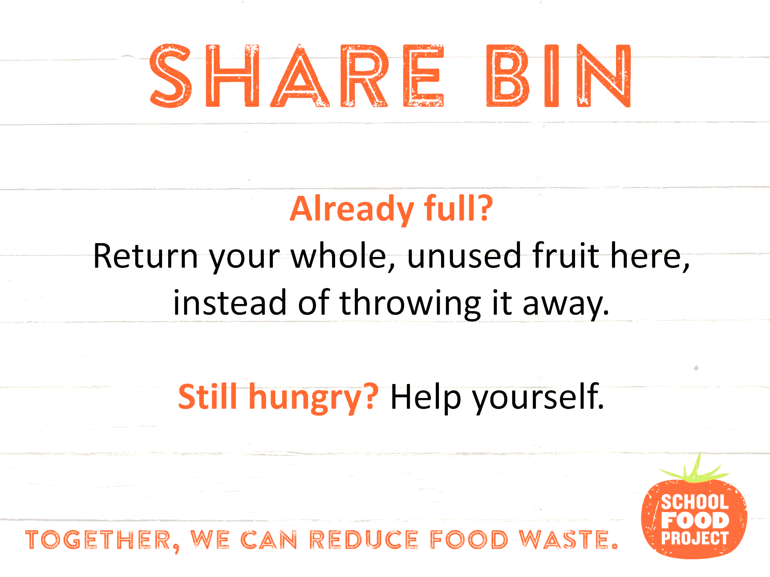
In response, the Food Waste Club created an “untouched food bin,” where students place uneaten fruits and vegetables to be washed and used in future lunches. The data was also used to educate students and families to increase their awareness of food waste and to promote the idea of “take what you want and eat what you take” in the school cafeteria. To further promote food waste awareness, members of the Food Waste Club prepared a video about food waste and being proactive in the lunchroom, which was shared with other classes and put on the Douglass Elementary website.

Thanks to a grant from the World Wildlife Fund (WWF), in spring 2019, BVSD schools were invited to participate in the first-ever district-wide food waste audit program to collect data and implement ways to help reduce food waste at schools and throughout the district. BVSD and eight other communities across the country collected data about the amount of food thrown out in school cafeterias.
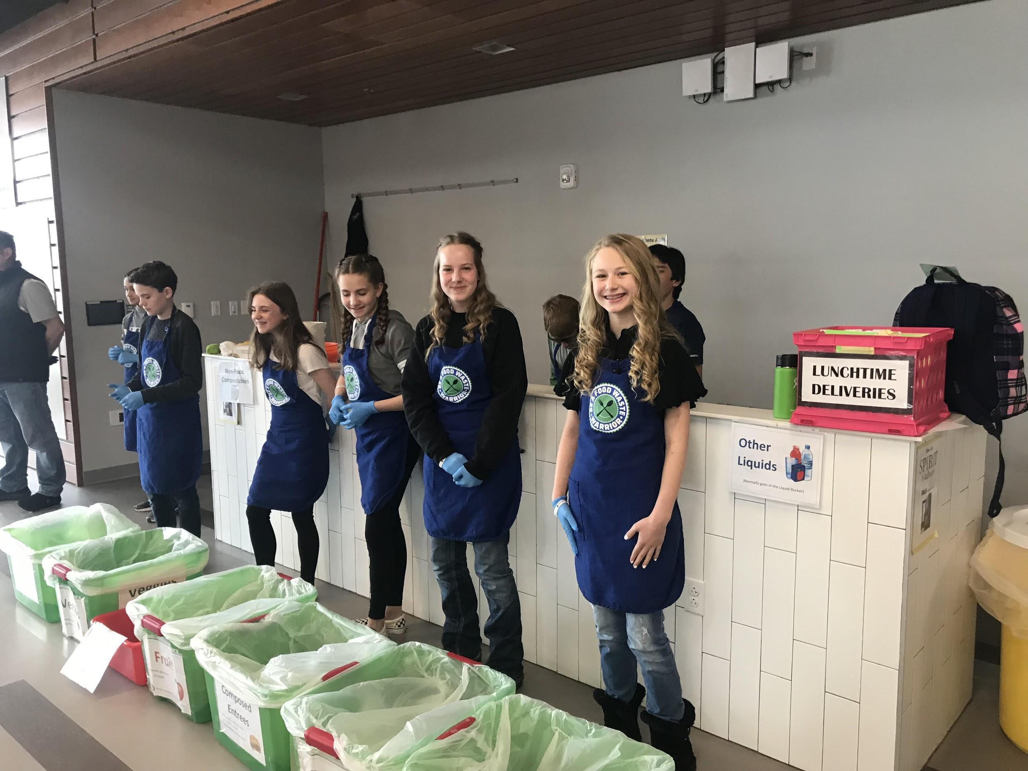
“Be a Food Waste Warrior” is a three-part science and math lesson from the World Wildlife Fund that can be adjusted in complexity depending on grade level. The toolkit includes food waste audit log sheets, discussion questions, a companion PowerPoint, and additional teacher resources and materials. Teams of students at five BVSD schools conducted a series of food waste audits in their cafeterias. With these Food Waste Warriors as peer leaders, students separated post-lunch waste into nine categories: fruits, vegetables, reusable fruit, composed entrees, fluid milk, other liquids, non-edible compostables, recycling, and landfill. Led by science and practice-based learning teachers, students weighed the waste after each lunch period over the course of six school days. Teachers and students were then able to use data and environmental impact calculations to better understand the ramifications of wasted food in their school’s cafeteria.

Students learned about the ways in which food waste impacts the environment by recording data from the student food waste audit during their lunch period. The audit engaged basic science and math skills to (1) convert food waste weights to water used and greenhouse gases (GHG) emitted, and (2) calculate the difference in GHG emissions depending on whether food waste is landfilled or composted. Participating students will ultimately understand how to reduce food waste and why reducing food waste is important to conserving natural resources and wildlife habitat. Backed by data and observations, the Food Waste Warrior teams designed communication campaigns and implemented new school-based strategies to further reduce waste in their schools. View the final WWF Food Waste Warriors report here.

Building off the Food Waste Warriors program, BVSD developed an expanded toolkit with presentations and resources for talking to teachers, students, food service professionals, and parents and other community members about food waste reduction. In collaboration with Leanpath, and with support from a University of Colorado Technical Communications & Design class, BVSD Food Services now maintains a toolkit of supplies to conduct food waste audits, as well as dataset from the district’s Leanpath tracking systems, and ideas for interdisciplinary study and engagement by all grade levels.

Sustainable Cleaners
Sustainable cleaners in a school environment can pose a challenge. With a high-risk population and the responsibility to ensure the safety of students in schools, it is not possible to use homemade, sustainable options like water and vinegar. However, sustainable cleaners do exist. Here’s a list of eco-friendly commercial cleaning products according to Janitorial Manager:

- SafeChoice Super Clean (all purpose)
- Greenmaker Glass and Window Concentrate
- Osmo Wash and Care (floor)
- Elements Bathroom Cleaner
- Moldex (mold inhibitor)
- Simple Green Disinfectant/Sanitizer
- Earth Friendly Products Furniture Polish
- EnviroCare Carpet and Upholstery Cleaner
- Odoban Earth Choice Toilet Bowl Cleaner
- Green Works Non-Chlorine Bleach

Be sure to look at the label before making any assumptions. Commercial grade “sustainable” cleaners also promote some benefits that might actually result in less sustainable outcomes. For example, just because a cleaner is advertised as sustainable, does not mean that it is any less caustic than a typical commercial cleaner - the “sustainable” label might just refer to packaging.

Similarly, higher concentrates can appear more cost effective, however some concentrations might contain fewer parts per million (ppm), making them less effective at cleaning and therefore requiring more cleaner to be used. Schools should request product details from their distributor and compare the specifications to recommendations from the EPA and other reputable sources.

Equipment Efficiency
While running commercial grade, high volume kitchen equipment can be an expensive proposition, there is payoff in the amount of energy that can be saved. With the increased emphasis on green school buildings, food service operations are highly encouraged to focus on energy efficiency and the financial impact of storing, preparing, cooking, and serving hundreds to thousands of meals each day.

BVSD prioritizes the purchase of Energy Star certified equipment to increase energy efficiency by 20% over traditional products. However, beyond the quality of the equipment, there are many best practices that any food services operation can implement to decrease energy costs and support a more sustainable operation:

- Gas fired - While the cost of gas versus electricity varies widely by geographic region, BVSD chooses equipment that uses natural gas because the overall impact is lower than electric-powered options.
- Keep doors closed - It may seem obvious, but training staff to keep refrigeration closed except when entering or exiting the walk-in can have significant impacts on energy use. Leaving the door open for two minutes to grab the ingredients needed for the next recipe can cause the refrigeration cycle to run for additional time. Consider how much extra energy is being used when the door is left open during a 30-minute inventory session.
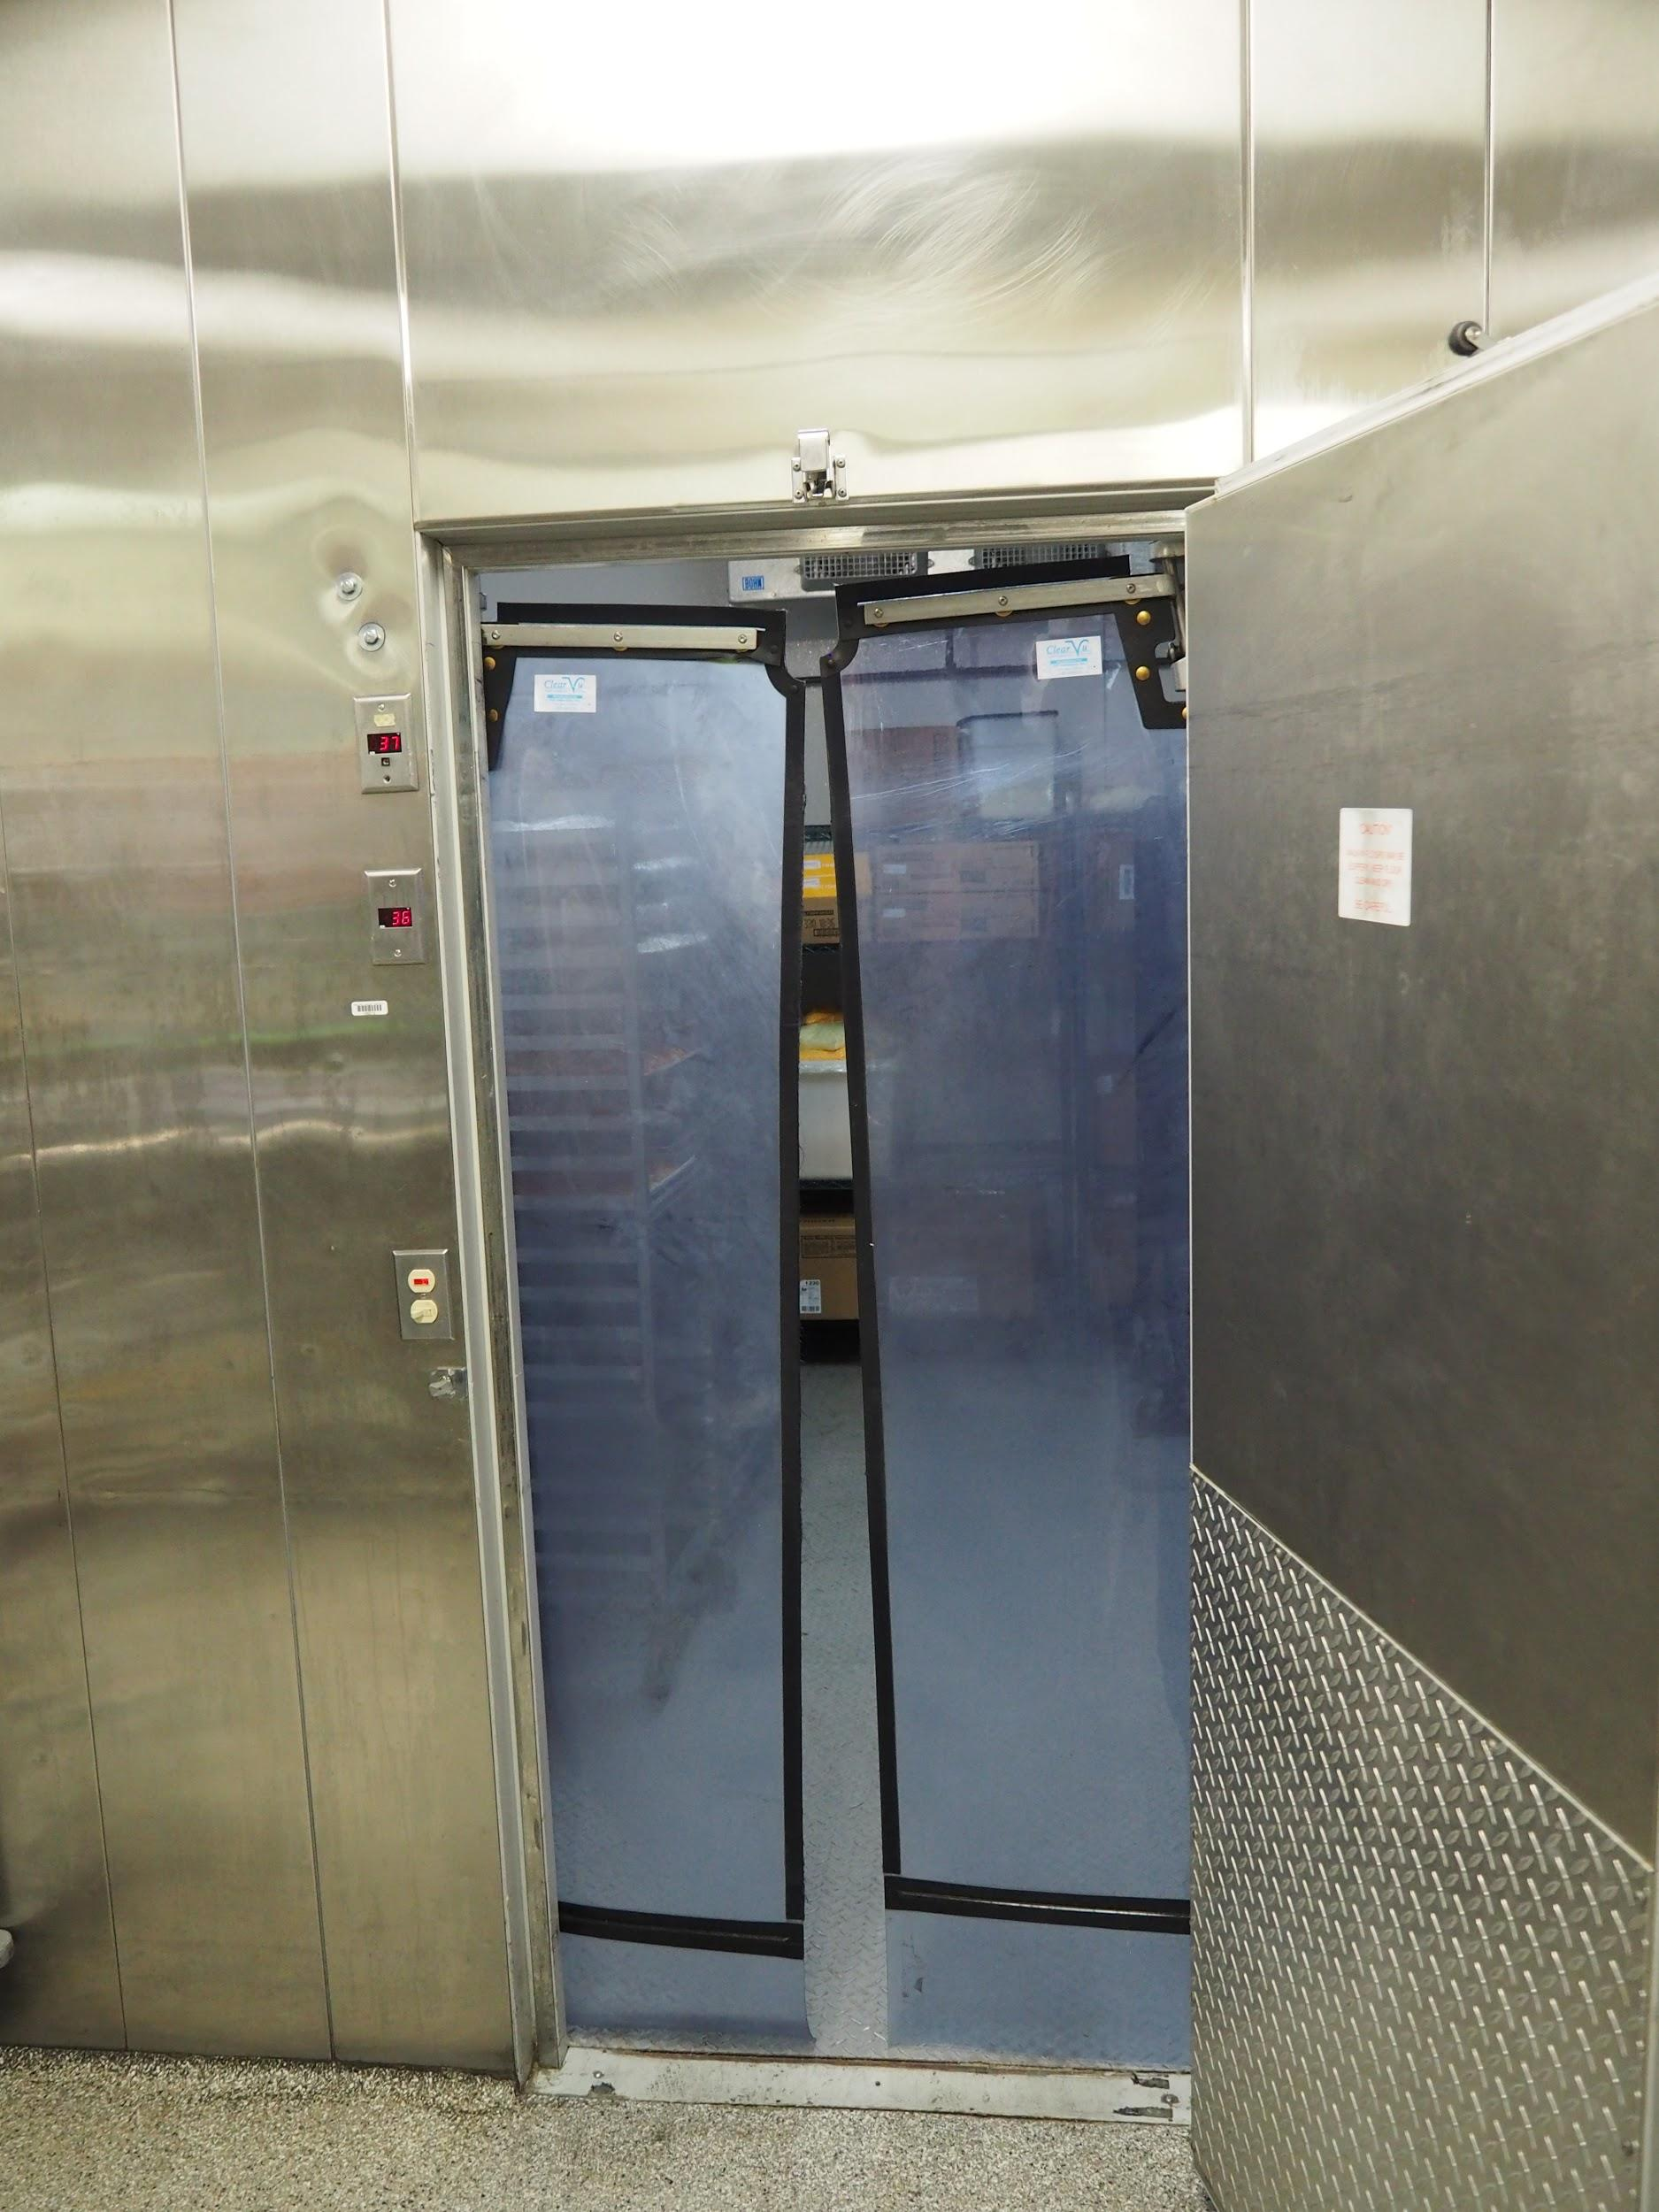
- Hang walk-in curtains - Like keeping the doors closed, hanging refrigeration curtain keeps the cold air in (and contamination out). While strips are common and cost-effective, BVSD has opted for bar door-style “curtains” because they are easier to navigate, have less chance to contaminate food being brought in or out, and while more expensive up front, generally last longer than low-cost strips.
- Defrost at night - In order to maintain the proper food safe temperatures, and not allow refrigerators and freezers to drop to a colder temperature that damages the food, commercial equipment generally runs a defrost cycle at least once per day. Letting the equipment run too cold can damage its efficiency and decrease the lifespan of high cost equipment. Because the defrosting process requires the production of heat, running the defrost cycle at night, when doors are not being opened and closed, can reduce excess heat created through the process.
- Don’t overfill - While it can be tempting to use up every inch of a large refrigeration unit, it is important to remember that good airflow is required to maintain proper temperatures and keep equipment running efficiently. BVSD ensures that satellite kitchens are not keeping a large inventory of foods in their site-based coolers and freezers by ordering each week and completing an inventory at the end of each month.
- Preventative maintenance - Keeping equipment in good condition is essential to the longevity and efficient function of refrigeration and cooking equipment alike. One unaddressed repair can beget another breakdown in the system. BVSD Food Services works closely with BVSD Maintenance to address equipment issues within 24 hours. While not every school district has an in-house maintenance team, school districts can retain local vendors to provide preventative maintenance and quick repairs throughout the school year and summer.

Transport of Food
With nearly 14,000 meals to move from 3 regional production kitchens to 54 school-based satellite kitchens, transportation coordination and delivery logistics are essential functions of BVSD’s operation. Spanning 500 square-miles, BVSD Food Services currently operates out of production kitchens regionally located throughout the district and one central warehouse. Each day, a team of six drivers starts at the central warehouse. In refrigerated trucks with cold storage curtains, drivers follow a set route, delivering scratch-cooked food to schools and picking up clean, used sheet pans and hotel pans to return to the production kitchens. BVSD has established a driving schedule and route to cut down on inefficient side trips and ensure predictable pick-up and delivery from the regional kitchens and warehouse to the school sites. Each truck is equipped with a GPS tracking system to support location and speed verification.
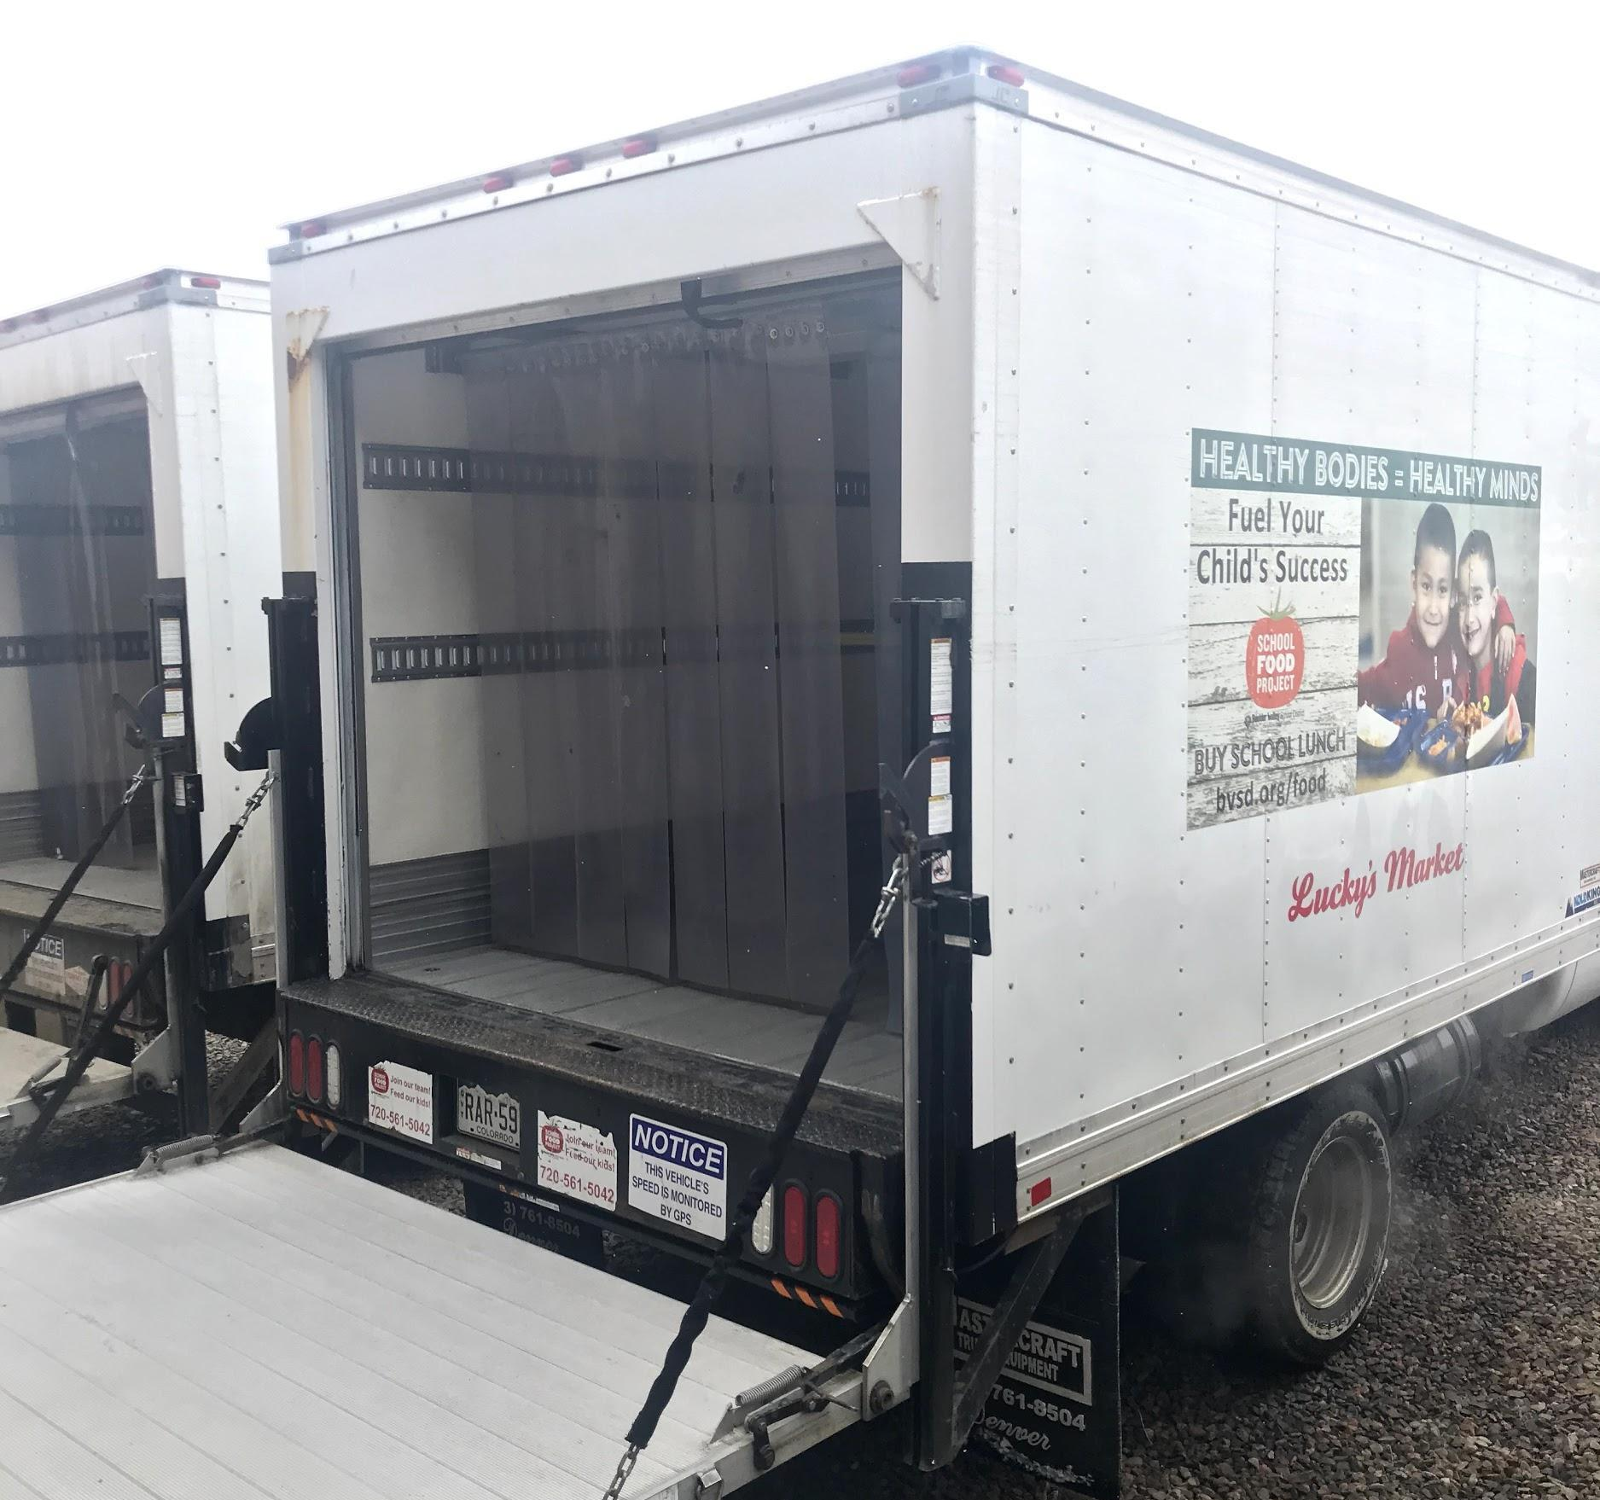
In addition to driving geographically efficient routes, delivery trucks are properly maintained to ensure they’re running efficiently. Preventative maintenance also helps avoid costly surprises. If a breakdown occurs with food on board, the loss can result in out of temperature food. This not only disrupts labor and the flow of operations, but leaves the district with a large amount of food waste and students without meals.

Sustainable Program Certifications
One of the newest ways for school districts to demonstrate their commitment to sustainability is through a number of operation assessments. A third party reviewer can look into the operation with an objective eye to identify the strengths of the program and areas to improve.

For example, BVSD is the first Eat REAL Certified school district in the country, the only school district to be named to the Good Food 100 Restaurants List (earning the top mark of six links twice), and the first entity of any kind to receive the highest, 5-star rating from the Center for Good Food Purchasing, twice. This collection of certifications and awards demonstrates a comprehensive focus on sustainability, food quality, and procurement.

Good Food Purchasing Program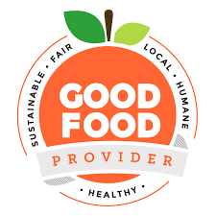
The Center for Good Food Purchasing’s Good Food Provider seal is a coveted marker of positive impact within the sustainable food system. Participation in this program included an analysis of BVSD’s food supply chain and its alignment with five core values:
- Local Economies
- Environmental Sustainability
- Valued Workforce
- Animal Welfare
- Nutrition.

After a deep dive into velocity reports from all of BVSD’s food vendors, the Center returned a full report of the sustainability achievements of each vendor. For example, a farmer within 25 miles of BVSD earns higher marks in the Local Economies category than purchasing from a farm in California. BVSD also earned marks in Environmental Sustainability for purchasing organic; in Valued Workforce for working with vendors who provide fair compensation to their workers; in Animal Welfare for sourcing hormone- and antibiotic-free animal proteins; and in Nutrition for serving and promoting high quality fruits and vegetables.

In December 2017, BVSD was named the first entity of any kind in the country to receive the Good Food Provider seal with the Center’s highest, five-star rating. The following year, on National Food Day, the School Food Project and Director Ann Cooper were recognized as The Center's 2018 Institutional Good Food Hero. BVSD re-certified under the program’s updated assessment guidelines in 2019, and again, earned a five-star rating.

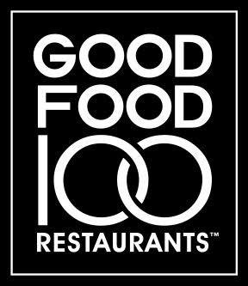

Good Food 100 Restaurants List
BVSD also participated in Good Food Media Network’s Good Food 100 Restaurants annual survey. The survey “aims to measure and spotlight how restaurants [and food service operations] are helping to build a better food system by being transparent with their business practices and positively impacting every link of the food chain: the environment; plants and animals; farmers, ranchers and fisherman; purveyors; restaurants; and eaters.” The list is based on self-reported annual food purchasing data, independently verified by NSF Responsible Sourcing. Restaurants are rated with two to six links—symbolizing links in the food chain—based on the percent of total food costs spent to support state, regional and national “good food” producers and purveyors. BVSD has been recognized for its role in promoting good food and sustainable food systems with six links, the highest possible level of achievement each year since its inauguration in 2017.

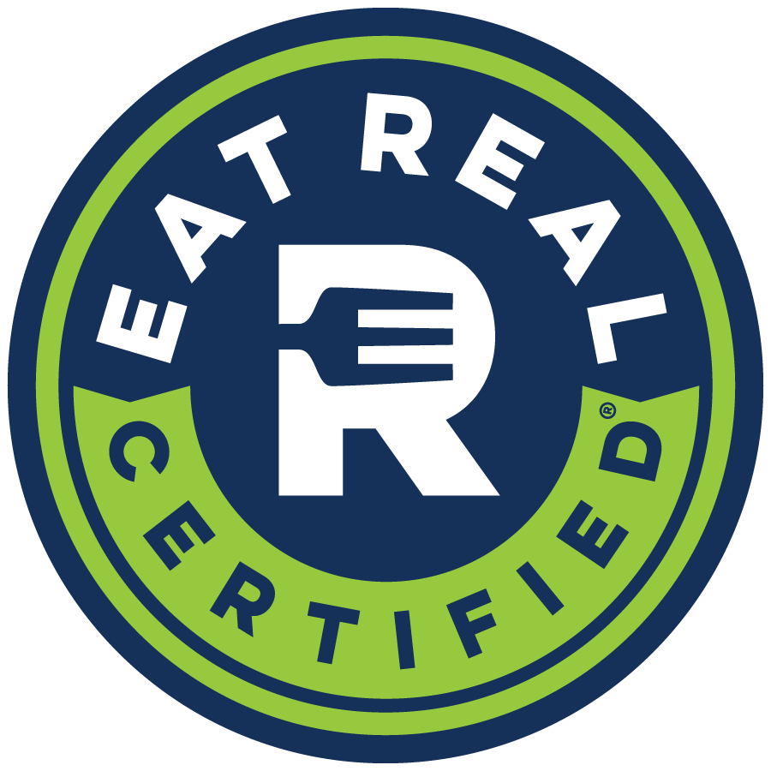
Eat REAL
In November 2016, BVSD became the first Eat REAL certified school district in the country. “Eat REAL’s certification program is built on comprehensive evidence-based standards that support continuous improvement [among school food service operations]. Third-party registered dietitians (RDs) lead an in depth, comprehensive assessment [using a] point-based system” that examines a school district’s commitment to Responsible Epicurean and Agricultural Leadership (REAL). School districts undergoing this assessment will identify the parts of the program already contributing to a sustainable food system and develop an action plan to improve upon their current operational standards.

Conclusion
Approaches to sustainable lunchroom can, and should, vary greatly between operations. The right answer or the first step should be whatever works for your school.

Starting small with a share bin or table can be the catalyst for bigger and better changes in the future. Food waste audits provide a new opportunity to engage the school community and recruit additional support for sustainability efforts. Linking lunch to academic subjects about the food system, agriculture, and the impact of food waste on the environment can help bring daily routine under a new microscope, opening students’ eyes to the need for change and the power they have to make an impact.

However, with any change implemented in a school cafeteria or kitchen, assessment, measurement, and evaluation are crucial components of the program. You can’t manage what you don’t measure. By examining your school’s current processes, you can create opportunities for sustainable processes and join the world effort of better practices for the planet and people.

Appendix

17 Resources for Teaching About Food Waste
Action for Healthy Kids: Food Waste
Cafeteria Culture
Cal Academy | Food Waste Audit
Clean Your Plate!
Connecticut DEEP: Grade School Recycling Resources
Finding Solutions to Food Waste: Persuasion in a Digital World
FoodCorps
Food Recovery Challenge (FRC) | Sustainable Management of Food
Food System Curriculum - Johns Hopkins University
Food Waste Minimization Toolkit for Iowa Schools
Food Waste Warrior Toolkit | Educators Toolkits
Food Waste Worksheets & Teaching Resources
Food Waste Videos
Food: Too Good to Waste Implementation Guide and Toolkit | US EPA
FOODWISE
Further with Food: Center for Food Loss and Waste Solutions
Healthy Planet US: Food Waste and the Environment
Leanpath White Papers
Lessons in Food Waste
Let's Resolve to Feed Kids: Start a School Food Share
Let's Talk Trash
Love Food Hate Waste
Lunchroom Waste Audit
National Farm to School Network
No Taste for Food Waste
NWF: Consumption & Waste
Purdue Food Waste Lesson Plans
Teaching kids to waste less food
The Edible Schoolyard Project
U.S. Food Loss and Waste Challenge
USDA Farm to School
Waste Not Food Waste Lessons and Websites

Folder of Additional Resources

BVSD serves nearly 14,000 meals each day. If we assume that 8,500 students are taking milk each day, over the course of a 174-day school year, that equates nearly 1.5 million milk cartons.
For a school with an average daily participation of 350 meals during lunch, BVSD budgets nearly $1,700 to cover the cost of plates, bowls, 9-ounce cups, silverware, a bus tub for collection, and a cart for transport. That startup cost does not include labor, dishwashing equipment or chemicals.

