**PLATE: 1 MICROPROPOGATION OF MEDICINAL PLANTS**

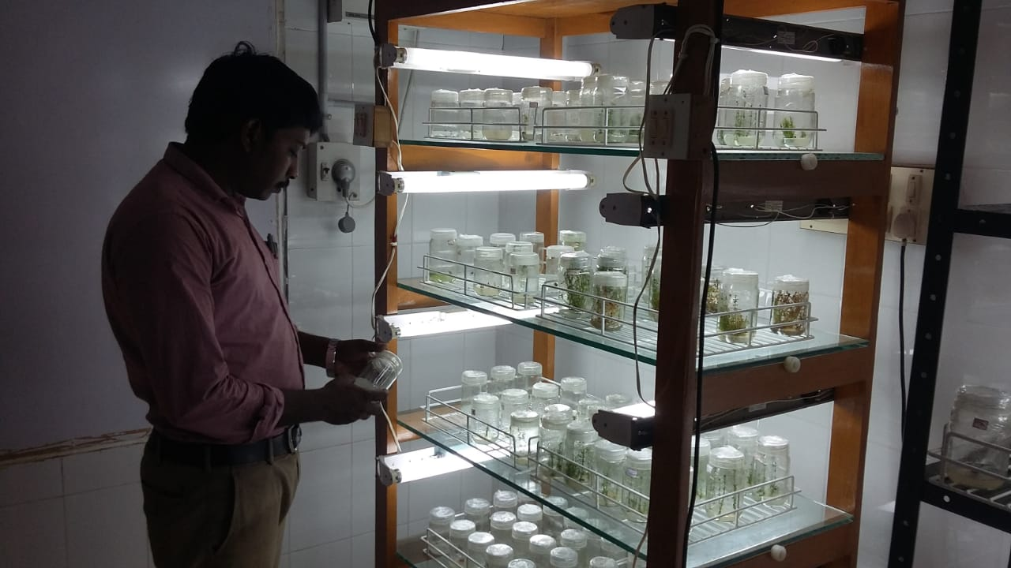

**PLATE: 2 MICROPROPOGATION OF ORCHIDS**

