**Pictures seen through Foldscope prepared students and faculty**

Pollen grains seen under Foldscope during Workshop

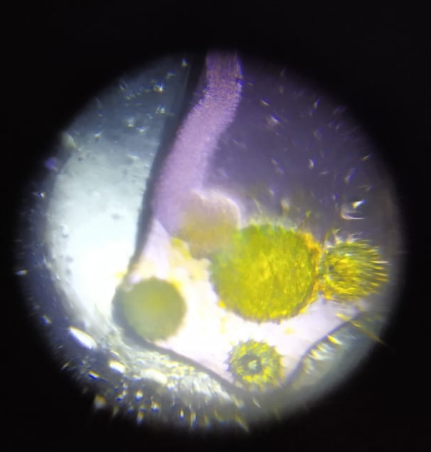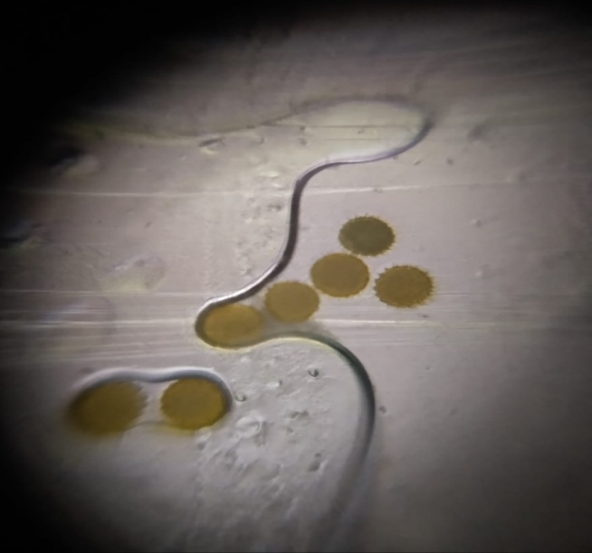

Different Motile micro-organisms seen under Foldscope in Community pond water

