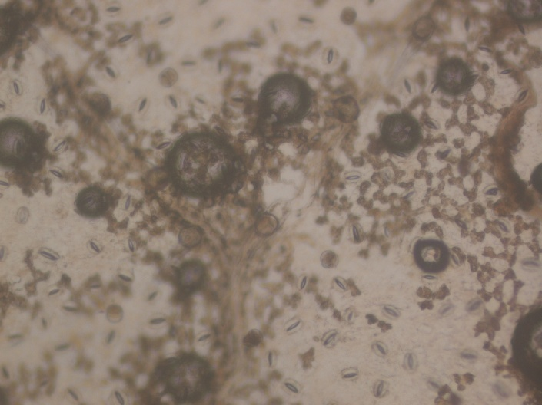
Pre-liminary studies using foldcsope on Stomata from leaf epidermal peel of Invasive alien plant, Lantana camara (Cat B)
Stomata of Invasive alien plant, Lantana camara
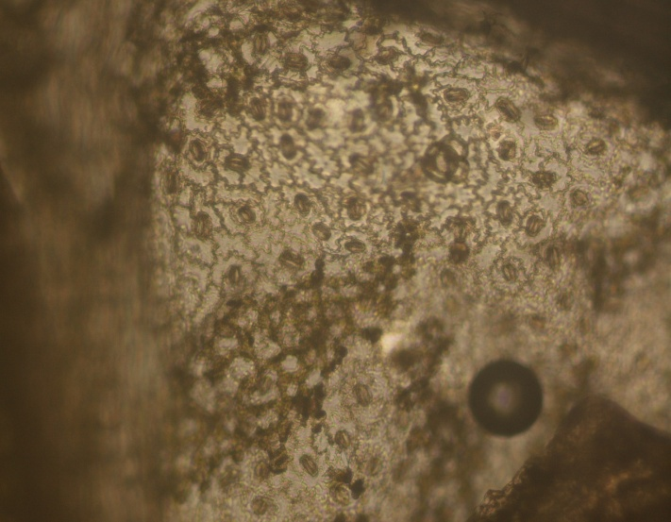
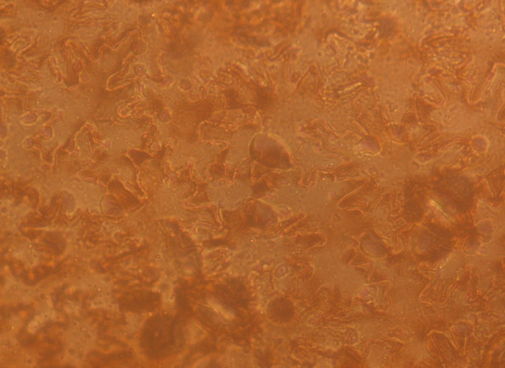
Stomata of Invasive alien plant, Lantana camara being stained with NBT for ROS detection, red arrow indicate stomata

Stomata of Invasive alien plant, Lantana camara being stained with DAB for ROS detection, red arrow indicate stomata

Stomata of Invasive alien plant, Lantana camara, red arrow indicate stomata

