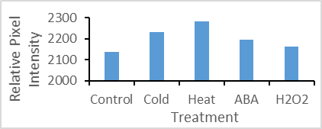
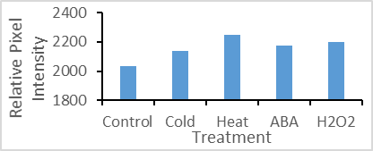
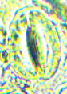
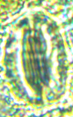
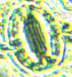
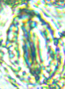
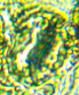
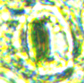
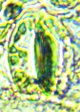
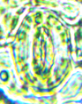
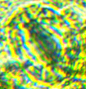
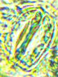
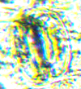
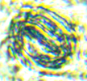
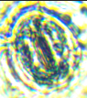
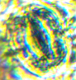
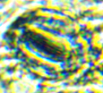
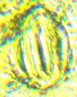
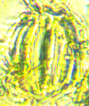
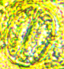
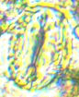
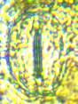
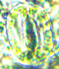
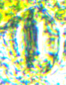
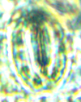
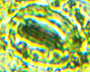
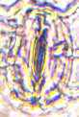
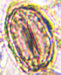
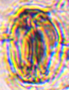
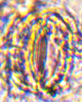
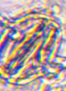
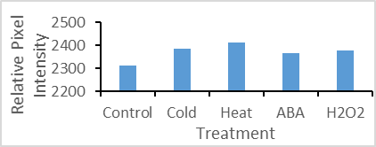
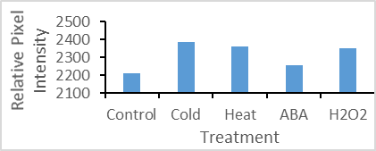
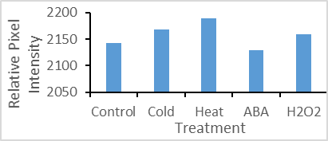
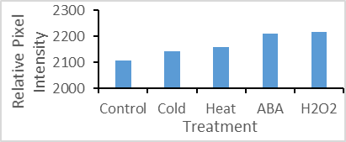
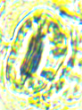
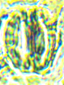
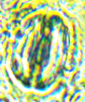
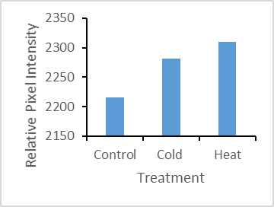
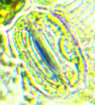
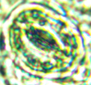
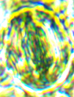
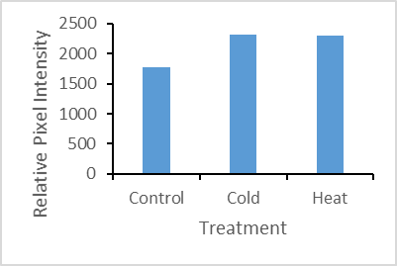
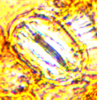
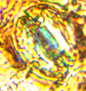
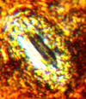
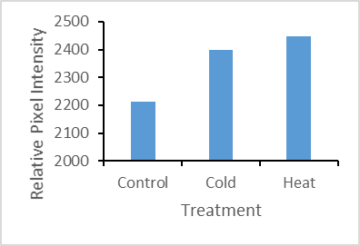
A
B
C
D
E
F
CONTROL COLD HEAT ABA
H2O2
C
D
E
F
CONTROL COLD HEAT ABA H₂O₂
Figure: Effect of different abiotic treatment dependent changes in the accumulation of various components in stomatal guard cells of leaves of Lantana camara. A: hydrogen peroxide; E: superoxide. In-stomatal analysis of various enzymes and antioxidants: Thioredoxin reductase(B), Glutathione(C), NADPH Oxidase(D), Glutathione-S-Transferase(F). The accumulation pattern (relative pixel intensity) of various components are shown in graphs. Marked areas as shown by rectangles in panel A of control guard cells are chosen for pixel intensity measurements. The sum total of pixel intensities of five marked regions are shown in graphs.
A
B
A

A
B
B
C
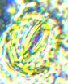
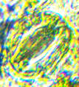
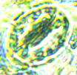
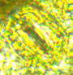
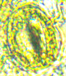
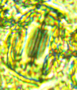
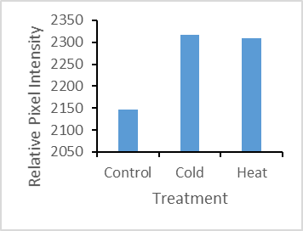
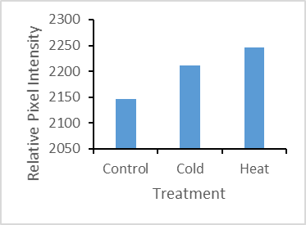
D
E
E
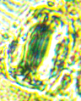
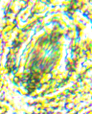
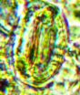
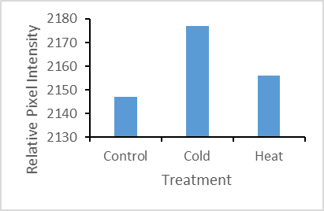
F

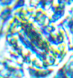
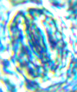

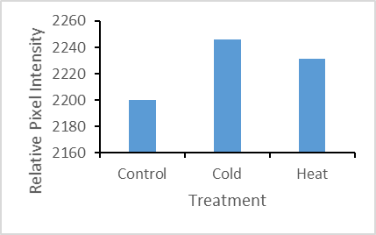
G

CONTROL COLD HEAT
CONTROL COLD HEAT
Figure: Cold- and Heat-stress induced changes in accumulation of different components in stomatal guard cells in the Leaves of Lantana camara– Ascorbate(A), Catalase(B), Peroxidase(C), Superoxide Dismutase(D), Xanthine Oxidase(E), Nitric Oxide(F), Monodehydroascorbate reductase(G).

C

D

E
F

G

