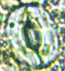
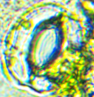

A
Control Heat
Heat + S. P

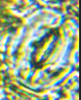
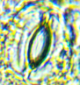
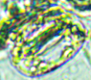
B

Control Cold
Cold + S. P
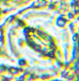
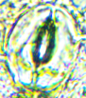
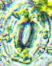
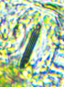
C
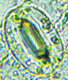
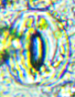
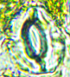
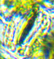
Control ABA
ABA + S. P
Washout
Control H₂O₂
H₂O₂ + S. P
Washout
D
Figure: Effect of different abiotic treatment on stomatal opening and closing in leaves of Lantana camara in different treatments-Heat(A), Cold(B), ABA(C), H₂O₂(D). Symbols used: S. P=Sodium Pyruvate. Stomatal bioassay were performed by taking epidermal strips of abaxial surface of the leaves. Immediately prior to each expt, the epidermis was peeled carefully from the abaxial surface of youngest, fully expanded leaves of Lantana camara. Isolated Strips were initially incubated in stomatal opening buffer (MES+ KCl, 50 mM) for 2 hr and then transferred to fresh MES buffer containing either no ABA/ H2O2 (control), ABA (50 uM), H2O2 (1mM), with or without Sodium Pyruvate (50 uM) for 3 hr. In washout expts, strips were subsequently transferred to fresh MES buffer after ABA and H2O2 treatments. For cold and heat treatments epidermal strips in MES buffer were shifted to 4°C (cold treatment) and 42ºC (heat treatment). Strips were subsequently examined under foldscope to determine aperture of the stomatal pores (opening/closing). Arrow indicate stomatal aperture open or closed. Control: indicates epidermal peels were placed MES Buffer and incubated for 3 Hr at room temperature (25C). [n=30]

