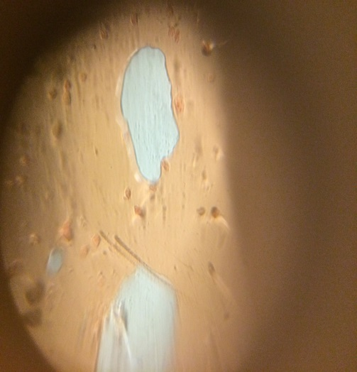

Madeline Beck and Natalie Lucas

Mrs. Steele

Slide Descriptions

For our experiment, we looked at skin cells. We took a simple toothpick and swipe it across our hands forcefully. Then, we took some food coloring and put two large drops on a slide. We rubbed the toothpick through the color and then pushed the slide cover on. We then continued to look through lens and snapped the picture above.

This experiment would be very beneficial for younger students and older students as they learn what the human body is made up of. And can even be moved into a deeper understanding of biology.