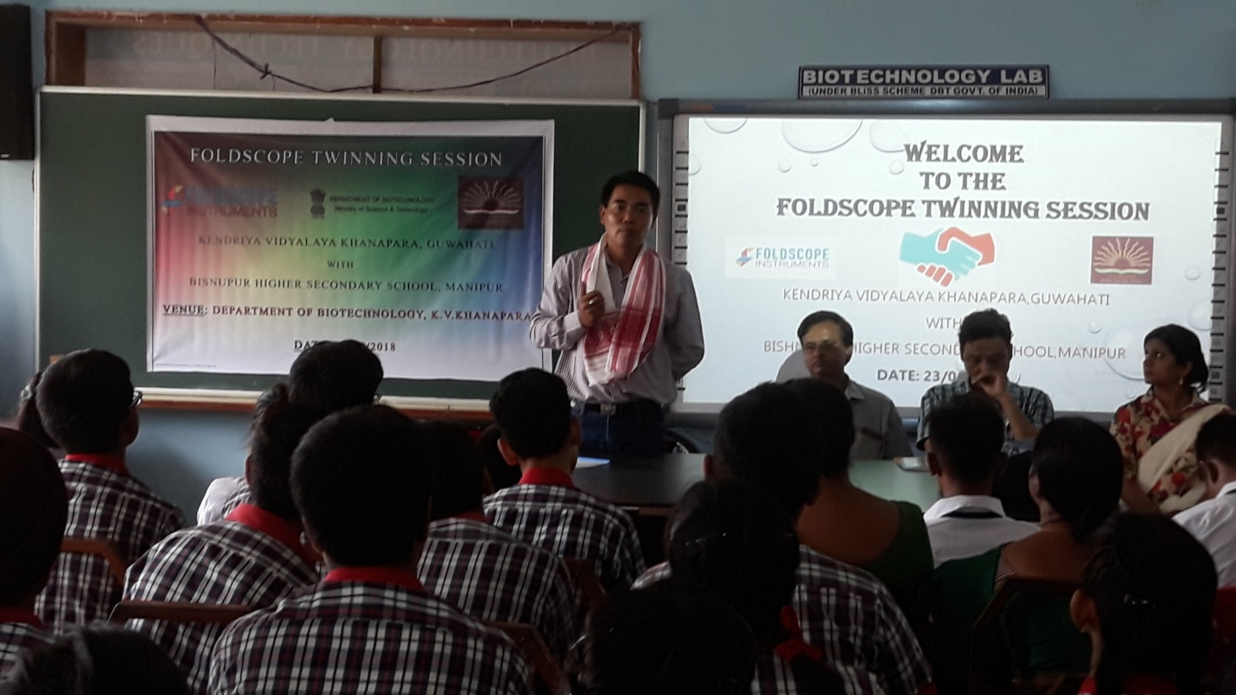

Receiption ceremony of the twinning programme at KV Khanapara on 23th August, 2018

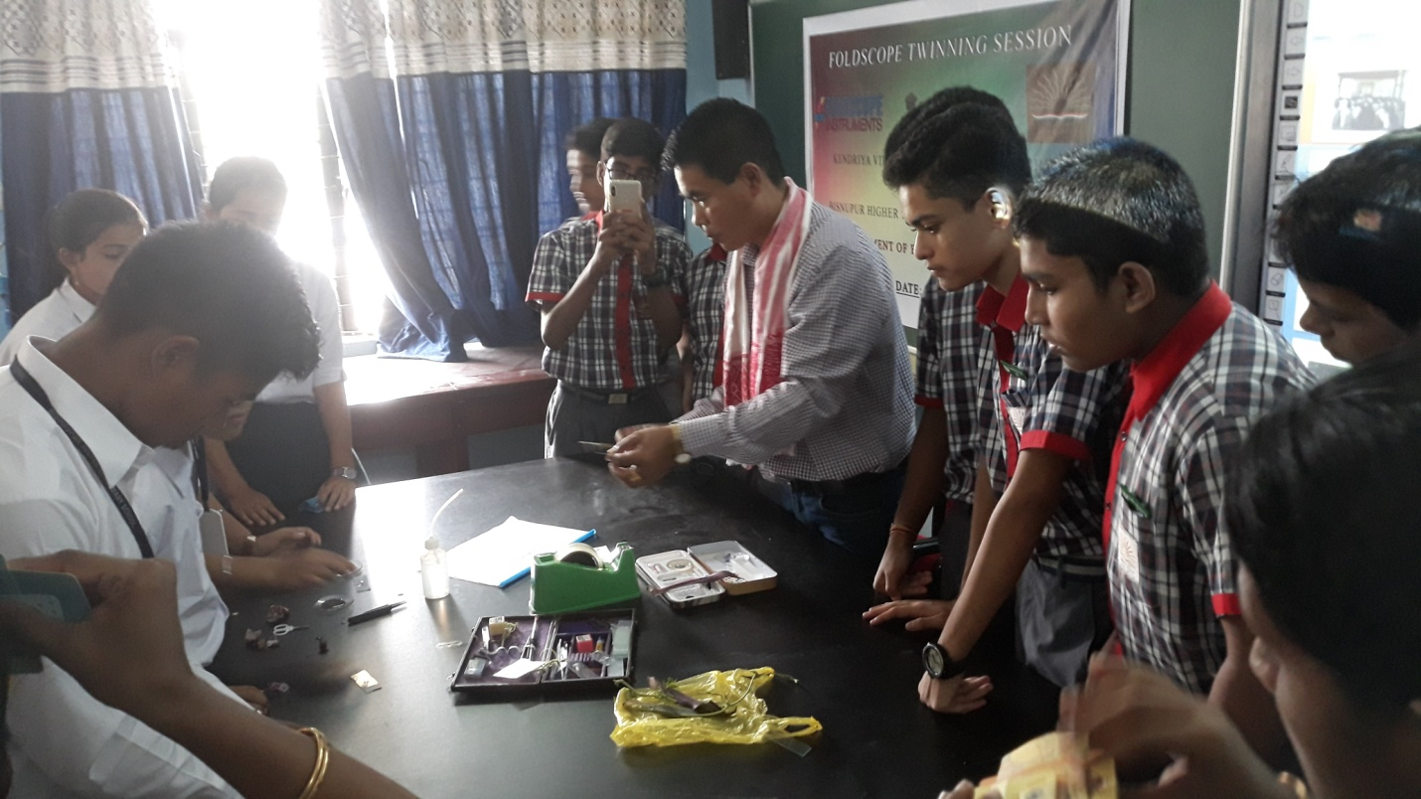

Techinical Session at KV Khanapara

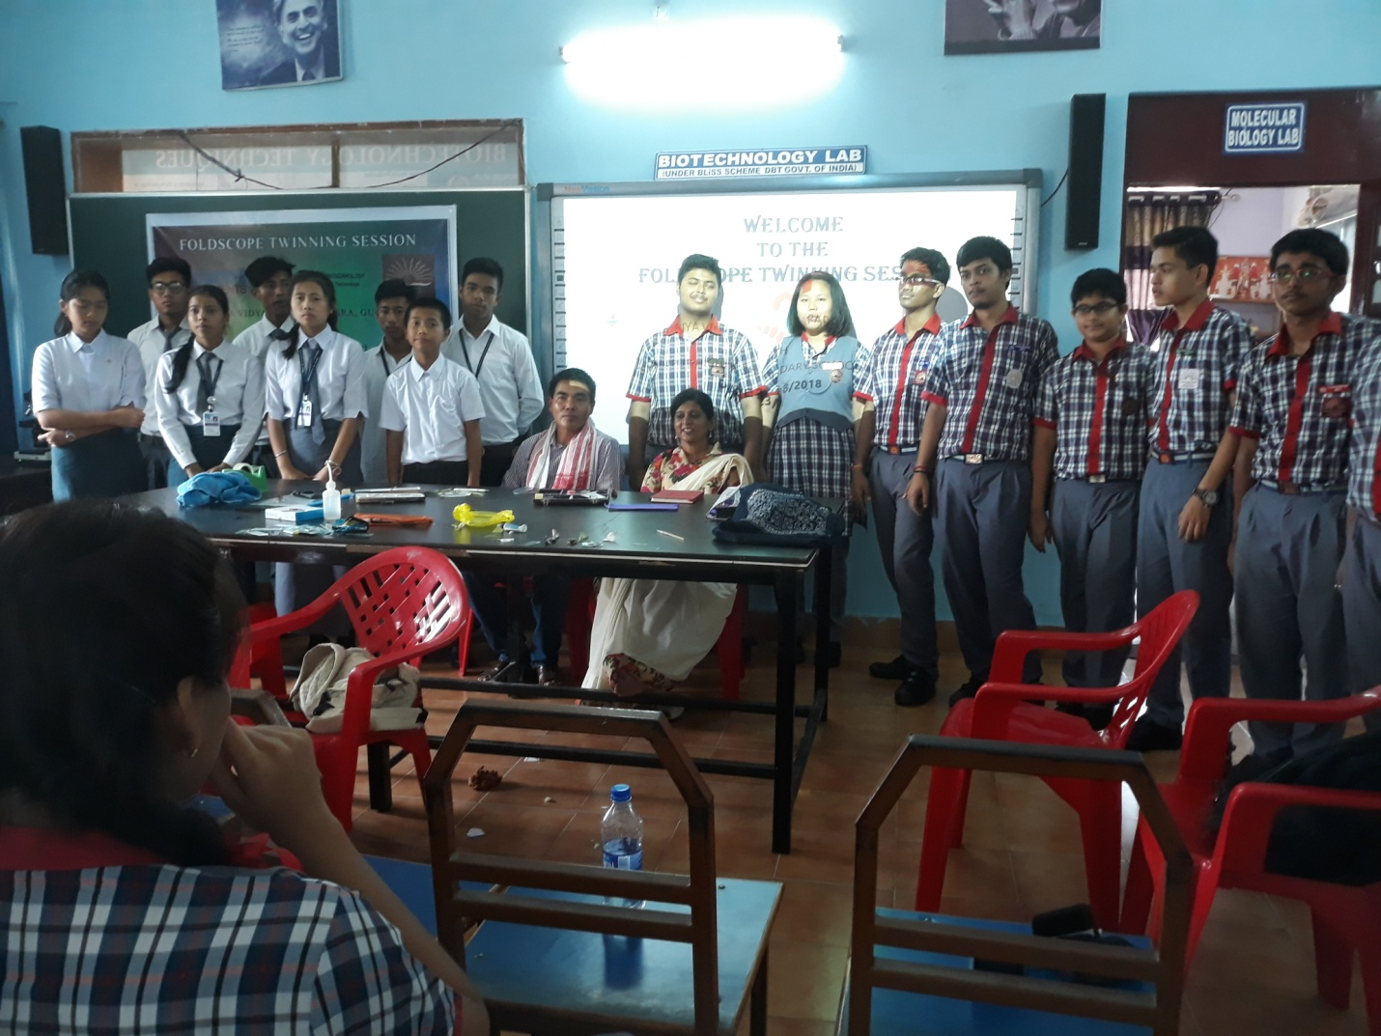

Photo session at KV Khanapara

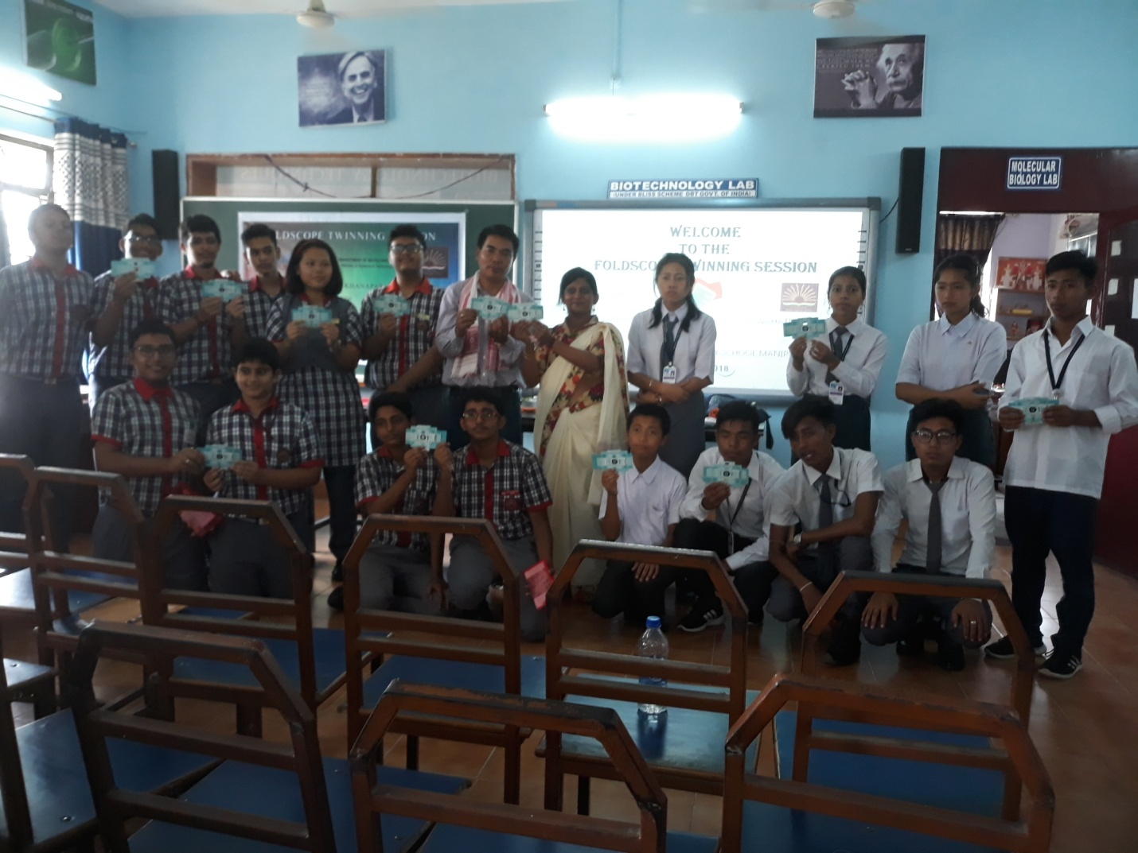Photo session with exchange of students