Companion Guide
for
#YesUCan
Presentation
Prepared by Dave Bowman
Farmor’s School, England, UK
May 2015

Introduction
This document provides supporting information and resources to accompany the presentation used to introduce the maths and mindsets revolution to teachers in the GLOWMaths region. This is a local initiative within the mathshubs programme. The first session was run in November 2014. The document is structured to give an overview of the objective of the presentation followed by notes for slides, references and copies of resources. The session time is approximately two hours. References used in the text are indicated by [ ], with details in reference section.
The presentation would not be possible without the support and resources from Professor Jo Boaler and the youcubed team and the PERTS team including Carissa Romero, Jacquie Beaubain and Rachel Herter at Stanford. My thanks go to all these people.
Overview of Presentation
The audience for the presentation is in response to an invitation sent to all schools in the region. The content of the invitation is shown in Annex A. The attendees comprise teachers of students of all ages from 5 to 19 and teaching support staff. Prior knowledge of attendees is not known with all having a variety of exposure to the work of Professor’s Carol Dweck, Jo Boaler and PERTS.
To establish their prior knowledge the attendees on entering the room are given two Post-It notes. They are asked to put their aim of the session on one of the notes and place it under one of the five headings given in Annex B. The second POST-It is placed under one of the other three headings and provides a visual indicator of their attitude to Mindsets.
Arrival time is spread over fifteen minutes, so some maths activities are provided on each table for people to think about. They are chosen to create discussion and thinking amongst the attendees. Examples of questions are given in Annex C.
The main body of the presentation is in five parts
- Messages on learning
- Introduction to the four Academic Mindsets
- Growth Mindset, Mistakes and the Power of YET
- Introduction to Positive Classroom Norms of Professor Jo Boaler
- Ideas to create positive Mindset messages

The following sections provide added detail for the slides
Messages on learning – Slides 6-9
These outline my philosophy towards learning, the key role that we as teachers have and that it is people that make things happen not policies, procedures or posters. It also includes the concept from Carol Dweck to make challenge the new comfort zone [1]
Academic Mindsets (major on Growth ) Slides 10-22
The concept of Growth Mindset is becoming more widely known but the other three Mindsets are not and are of equal importance. As an introduction to the topic, and to gain audience interaction, a selection of the phrases in slides 11 and 12 are on cards and distributed to attendees for them to discuss with each other. After about five minutes a selection of their responses shared with everyone.
Three video clips giving an overview of elements of a growth mindset [5], [6] and how mindset affects grades [7]. Then introduce how mistakes are important in brain development [8] and introduce concept of the power of YET [9]. I also talk about a ”Favourite No” book that I keep which records, celebrates and shares student misconceptions. Also reference the mindsetkit mistakes topic
This leads into the discussion of the four academic mindsets and Chapter 5 of reference [2] is handed out and attention brought to certain elements within it. Also included is use of the PERTS mindset meter [3] which I have used on my students and which participants are invited to use in their own school. Slides 17, 18, 19 indicate the importance of the messages teachers give students and reference the research [4]
Positive Classroom Norms Slide 23
This one slide creates much discussion as each of the seven norms is discussed. Participants are encouraged to say how this compares with their classroom. A handout is given detailing the classroom norms [10]
Ideas and Resources Slides 24 – 30
These slides talk through the possible posters, useful web sites and books. Importantly it includes a discussion about what next steps will be. We need to take messages back into the classroom and “make it happen”. To see feedback from sessions see
http://tinyurl.com/qbnq8rl
Conclusion and final message Slides 31 and 32
Reiterate how it is people who make this work. Ideally a picture which the audience recognise of respected individuals who are leading progress in this area.
Finally a light hearted song giving the very meaningful message of the Power of YET

References
[1] Carol Dweck : Make Challenge the new comfort zone
https://www.mindsetkit.org/growth-mindset/celebrate-mistakes/make-challenge-new-comfort-zone
[2] Teaching Adolescents to become learners; Farrington et al 2012
https://ccsr.uchicago.edu/sites/default/files/publications/Noncognitive%20Report.pdf
[3] PERTS growth Mindset meter
http://survey.perts.net/share/toi
[4] Rattan, Good, Dweck; Journal of Experimental Social Psychology; December, 2011
http://faculty.london.edu/arattan/main/CV_files/Rattan%20Good%20%26%20Dweck%20(2012).pdf
[5] Schematic overview of differences between Fixed and Growth Mindset
https://www.youtube.com/watch?v=brpkjT9m2Oo
[6] Further comparison between Fixed and growth Mindset- Carissa Romero
https://www.mindsetkit.org/growth-mindset/about-growth-mindset/what-is-growth-mindset
[7] Affect of Mindset on grades – Carissa Romero
https://www.youtube.com/watch?v=FeZ3re4KszY
[8] How our brain grows. Brain science from Jo Boaler
http://www.youcubed.org/brain-science/
[9] The Power of YET Carol Dweck talk at TED
https://www.youtube.com/watch?v=J-swZaKN2Ic
[10] Positive Classroom Norms – Jo Boaler
http://youcubed.org/wp-content/uploads/Positive-Norms-UK-Version1.pdf
[11] Power of YET song
https://www.youtube.com/watch?v=XLeUvZvuvAs

Mindsets, Mathematics and Mastery
RECOMMENDED WEB SITES

http://nrich.maths.org/frontpage
http://www.youcubed.org/
http://www.kangaroomaths.com/index.php
http://www.nnparenttoolkit.org.uk/
http://www.nationalnumeracy.org.uk/
https://www.mindsetkit.org/
http://hwb.wales.gov.uk/Resources

Annex A
Flyer used to attract audience for presentation
Yes you can!
Improving resilience and reducing anxiety in the Mathematics Classroom
An exciting opportunity for teachers to get involved in a FREE classroom based project aiming to transform the way all teachers and students think about what can be achieved. Based on the growth mindset research of Carol Dweck and Jo Boaler, teachers will explore the power of ‘Yet’ and other strategies to create positive norms in the mathematics classroom.
The project, funded by the GLOW Maths Hub, will involve a series of face to face sessions and action research in your own classroom. Initial sessions are planned at different locations
- Thomas Keble School, Stroud on Wednesday 4 February, from 3:30pm to 5:30 pm.
- The Chase School, Malvern on Wednesday 4 March, from 3:30pm to 5:30pm.
During this session, you will:
- Gain access to a Stanford University online survey indicating whether a group has a Fixed or Growth Mindset
- Hear how mathematics attainment suffers from Fixed Mindsets
- Be updated on the research of Carol Dweck, the Power of Yet and latest Academic Mindsets
- Understand the seven classroom norms that Jo Boaler recommends for learning mathematics
- Have practical ideas including posters, encouraging mistakes, words to use in order to change mindsets and engage students
- Have resources, books, videos, websites, free on line courses identified to support you back in school

Register your interest http://goo.gl/forms/5jmCUOYoZ8
Miss it, Miss out!

Annex B
Heading used for attendees to identify prior knowledge
Current Understanding
No idea, but I want to know
I know something about it
Secure on the facts and see how I can use it or have used it
Have experience of using it, looking to develop further
Can see how I can ,link to other areas

Belief in Mindsets
Need convincing it can be useful

Think it can be useful
Know it is useful

Annex C
Examples of Maths activities to think about

Do some Maths
Try to make every number between 0 and 20 using only four 4’s and any mathematical operation with all four 4’s being used each time.
I went into a shop and purchased 3 identical slices of ham that weighed in total 1/3 lb. I got home and my wife told me she was only allowed to eat 1/4lb of ham. How many slices do I give her?
Without a calculator, work out 6.2 x 37.5 + 38 x 3.75

Thanks to Professor Jo Boaler for these ideas

Annex D Words Count
These are phrases given to participants to see how they react to them

When describing the groups of children you teach
When child says “I don’t get it”
When child says “I forgot my homework”
When child says “It’s hard”
When child says “I don’t know”
When an incorrect answer is given
When an “A grade” child gets 40%
When a child gets 100% consistently in homework
When a parent writes “Kesta spent 1 hour doing this but I don’t know what to do”
When a parent says “I was no good at maths”
When a teacher says “ I was no good with maths”
When a colleague says Bethan’s really clever
When parent says “my son is a natural at tennis”

Annex E Possible Posters

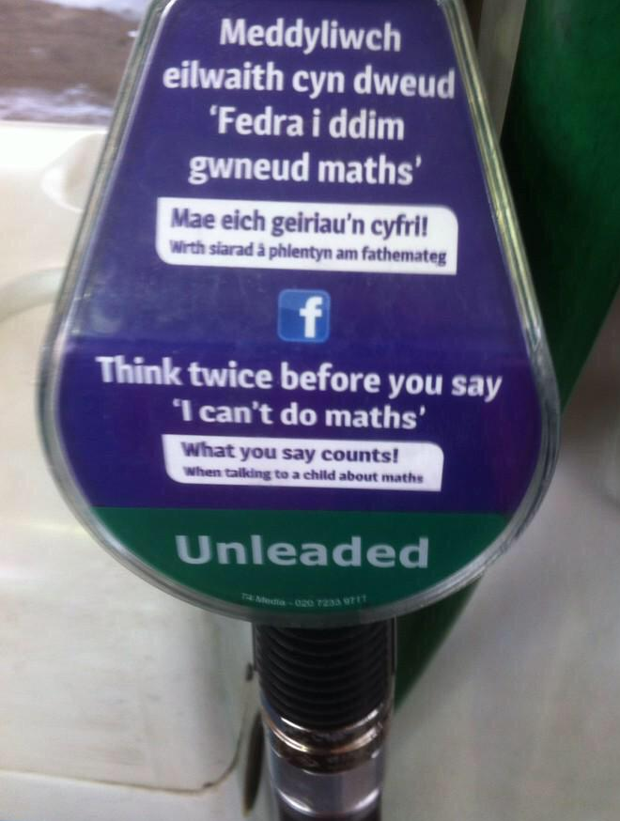

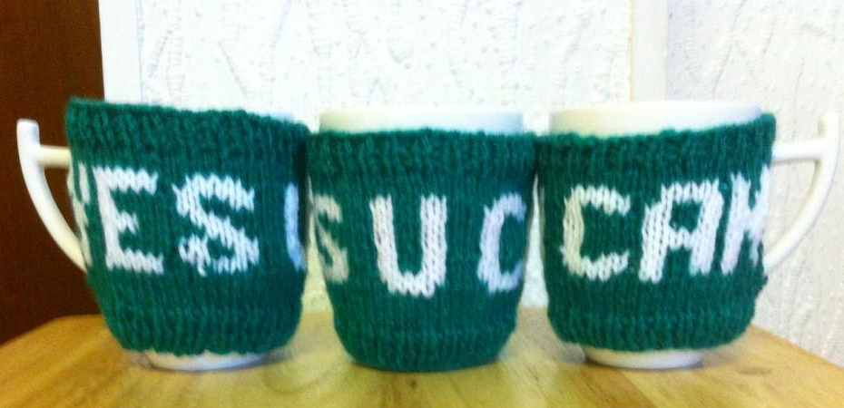

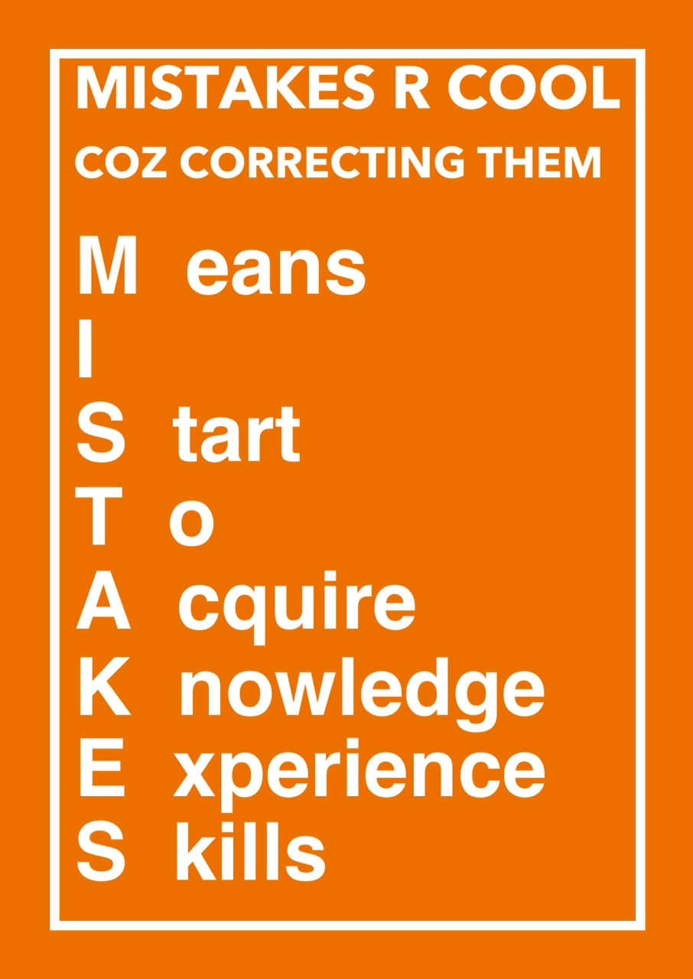
ROAD TO SUCCES POSTER

