Producer:  Pre-work | - Provide a link for Participant’s Guide in the chat at the start of the training.  - Participant’s Guide – slide #1 (will be linked)
- There are two (2) activities and one (1) assessment requiring prepared links: slides #10, #19, and #23.
- Assessment Link – slide #23 (will be linked)
 | - The activity on slide #19 requires break-out rooms. There should be a limit of five (5) learners in a room, so make the number of rooms accordingly. Learners may be randomly placed.
Facilitator:  Pre-Work | - Write in your name on slide #2.
 | - Test the virtual meeting platform, ensure smooth audio and video connectivity, and familiarize yourself with the available features for interaction and collaboration.
 | - There are two (2) activities on slides #10 and #19 where it will require coordination with the producer. Slide #10 is using Mentimeter and the producer will take over the screen to display a Word Cloud. Slide #19 requires break-out rooms and the producer will determine the number of rooms necessary. You will assign each group the number of the process step they are to discuss.

Session #1
Slides | Approximate Timing | Topic
1 - 5 | 20 min. | Instructions/Welcome/Virtual Courtesies/Ice Breaker Activity/Objectives
6 - 8 | 10 min. | Introduction to the Invention Disclosure Process
9 - 13 | 20 min. | Understanding Inventions/Activity
14 - 15 | 15 min. | Invention Disclosure Form: A Closer Look
16 - 19 | 30 min. | Invention Disclosure Process: Step-by-Step/Activity
20 - 23 | 15 min. | Questions/Summary/Assessment
Total: | 110 min
 | This is an estimation for each topic, however the scheduled amount for the training should be set to two (2) hours.

Slide#)  Duration | Slide | Facilitator Notes | Producer Notes
1) 2 min. | 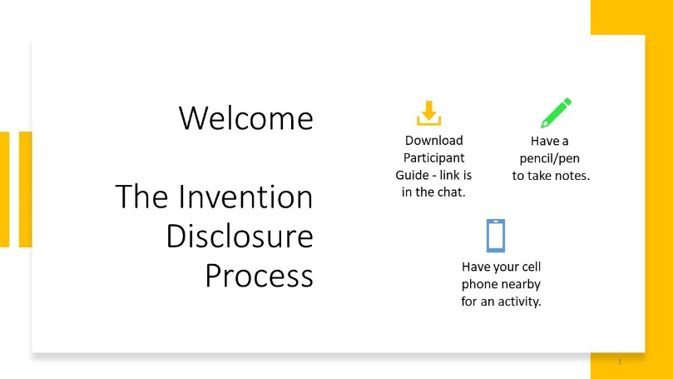 |  | DO: Put the link in the chat containing the Participant’s Guide. This is available in case they did not receive a copy prior to the start of today’s course.  SAY: Welcome. We will start in a few minutes. Please be certain you have the materials ready for today’s session.
2) 2 min. | 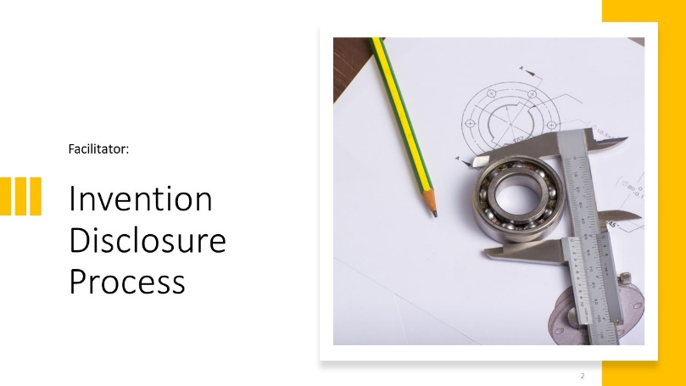 | DO: Introduce yourself and the producer. Briefly describe your expertise in the subject matter.
3) 2 min. | 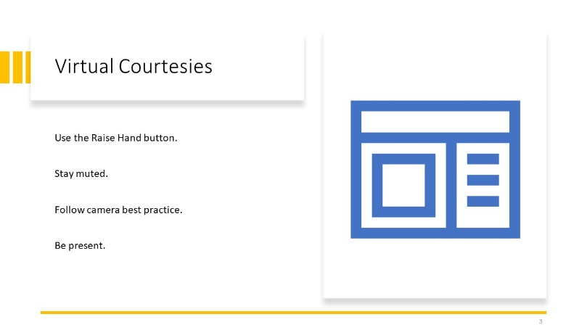 | EXPLAIN: Briefly talk about each ground rule:  1. Make sure learners know the location of the Raise Hand button.  2. Staying muted is standard practice, this is a visual reminder.  3. Camera best practice is to turn it on when you are speaking. All other times, it is up to the individual to keep it on or off.  4. Be present means to put away all distractions during this time. Encourage questions throughout the course.
4) 12 min. | 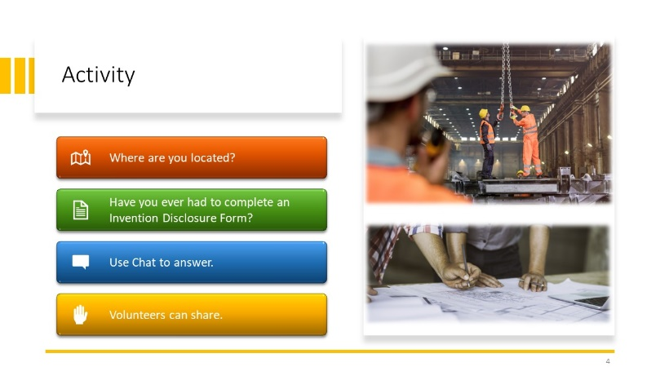 | SAY: We are going to do a quick activity to see where everyone is from and your familiarity with this topic. Answer the two questions you see on the screen in red and green. Type your answers in the chat. I will give you a minute to answer. Then, we will take a few volunteers who would like to share.  DO: Scan the answers to get an idea of the learners’ levels of experience with filling out an IDF. This will help with your pacing throughout the course.  Explain: (Debrief) Although we may have varying levels of experience, we all need to follow the same process and have a common understanding of what to do when disclosing an invention to the company.
5) 2 min. | 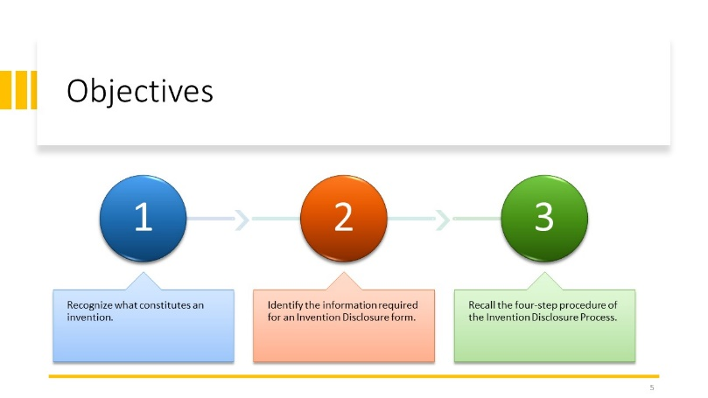 | DO: Read the objectives aloud.  SAY: Any questions before we continue?
6) 1 min. | 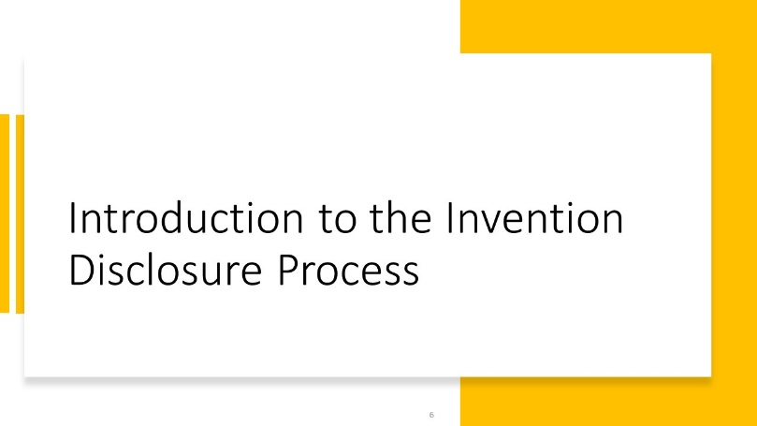 | SAY: Let’s begin by first asking, “What is Invention Disclosure,” and, “Why do we need to do it?”
7) 4 min. | 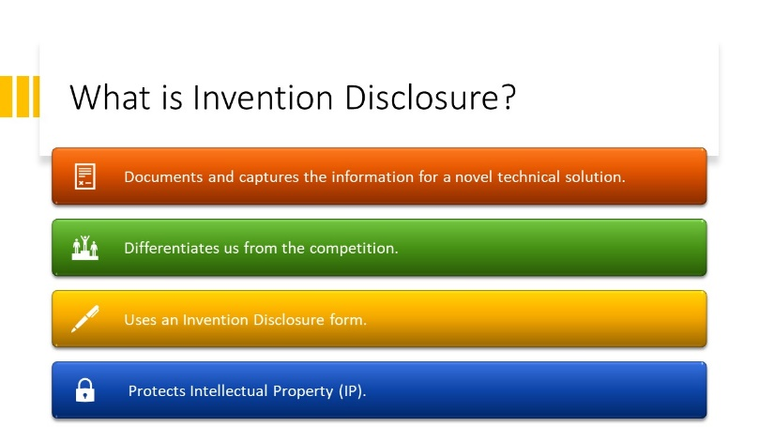 | Explain: Invention Disclosure is the formal capture and documentation of novel technical solutions, where such solutions serve to differentiate our organization from competitors.  - Invention Disclosure is made on an Invention Disclosure form Documentation should include a description of the novel technical solution and the technical problem to which it relates. It should also describe other efforts at solving the same or similar problems.  -IP Managers help with this form and the process all to protect Intellectual Property.
8) 5 min. | 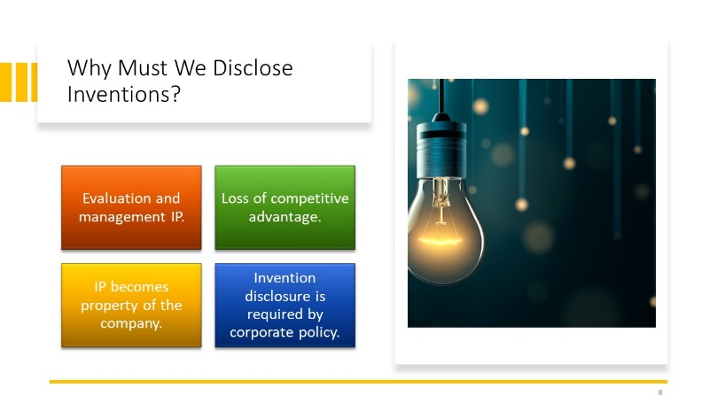 | Explain: Technical staff should already be documenting their work. The Invention Disclosure process merely extends this so that any associated intellectual property can be evaluated and managed accordingly. Failure to properly document inventive ideas can lead to forfeiture of any potential intellectual property rights and the competitive advantages that could be gained from those rights.  With a few exceptions, the company owns the intellectual property generated by its employees, and employees have an obligation to disclose any and all such intellectual property to the company.  Invention disclosure is required by corporate policies.  SAY: What questions do you have before we move on? | DO: Get Mentimeter Survey ready for slide #10. Sign into your account and create the survey if you have not already. You will type the question on the survey and create the link that will go into the chat.
9) 1 min. | 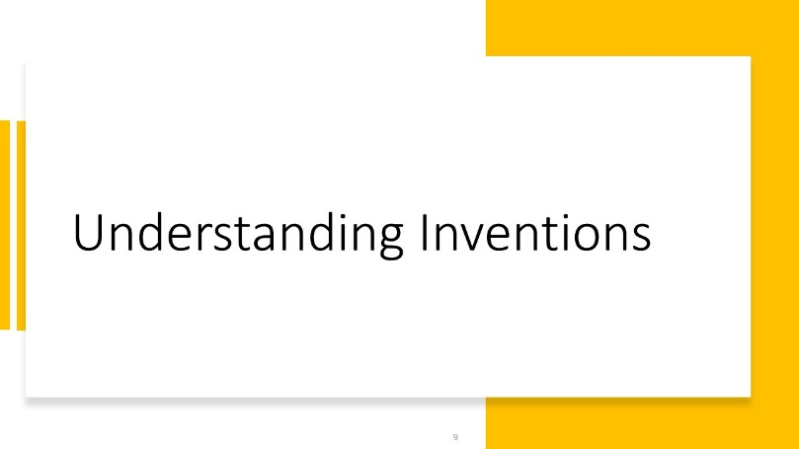 | SAY: We are now going to discuss inventions and come to a collective agreement on what constitutes an invention.
10) 2 min. | 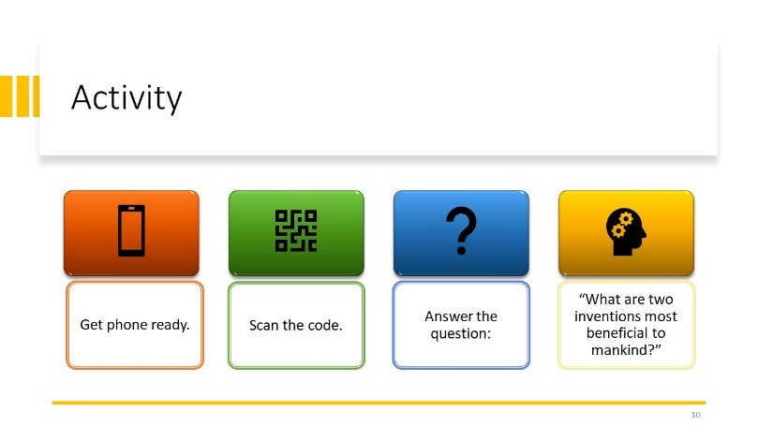 | Explain: Directions on the screen. The Producer will share the screen from Mentimeter when ready. Encourage learners to put more than two if they think of more inventions. | DO: Share your screen to Mentimeter after instructions are given. When ready, share your screen to display the webpage on Mentimeter. It will have the code for learners to use to get to website, along with the question. Word Cloud will start to build as words are added. Data is saved automatically.
11) 7 min. | 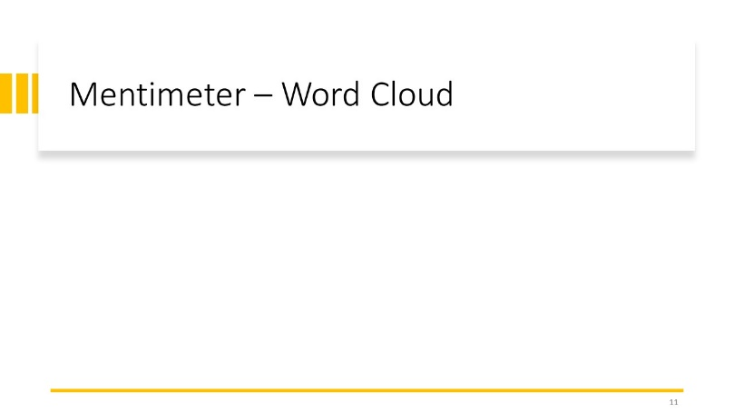 | Explain: (Debrief) Keep these inventions in mind as we discuss this next section. We could debate all day which two are the most beneficial or impactful. The idea here is to think about what constitutes an invention and what might you add to this list? | DO: Remove this slide if necessary; it is here to indicate a screen share of Mentimeter.  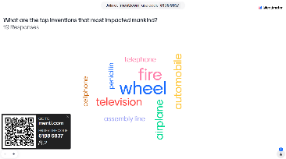  The screen should look like this.
12) 5 min. | 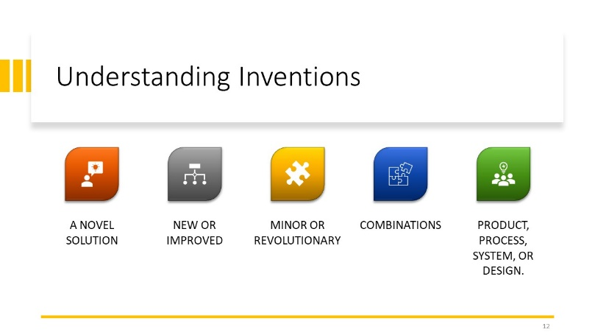 | Explain: Invention occurs when one or more people generate a novel solution to a technical problem. The terms “invention,” “inventive idea,” and “novel technical solution” are used interchangeably. Novel technical solutions can take the form of a new or improved product, process, system, or design. The novel technical solution can be a minor tweak to an existing solution, or it can be a revolutionary advance.  Many seemingly individual technologies are often combinations of numerous inventions or inventive ideas. Technical experts often dismiss their own inventive ideas as being obvious or unimportant because they seem obvious to them. This is not the proper test.
13) 5 min. | 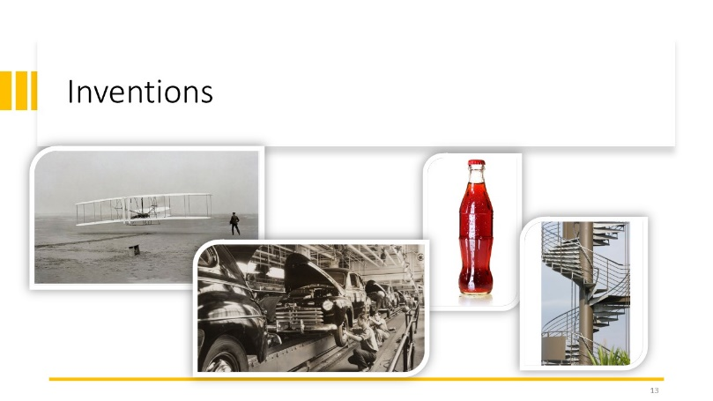 | SAY: Here are examples of inventions that were patented long ago that we recognize. By what criteria did these become patented inventions? Are they new? Revolutionary? Improvement on design?  DO: Ask learners to put their thoughts in chat or on their notes page.  EXPLAIN: The main idea of this is to remember that the smallest of an idea can spark change for a company and it needs to be protected as intellectual property. Such as Ford did with his assembly line process and Coca-Cola did with their bottle design for brand recognition.
14) 1 min. | 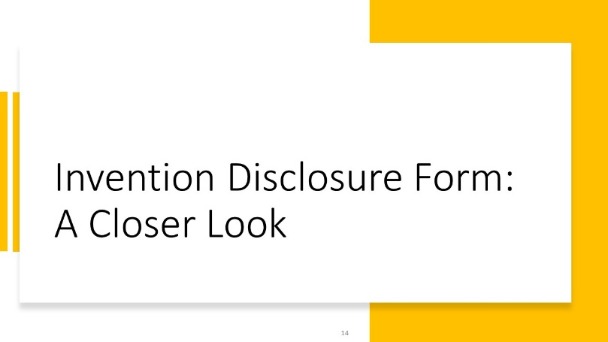 | SAY: In your Learner Packet, you have a copy of the Invention Disclosure Form. We are going to take a close look at this now.
15)14 min. | 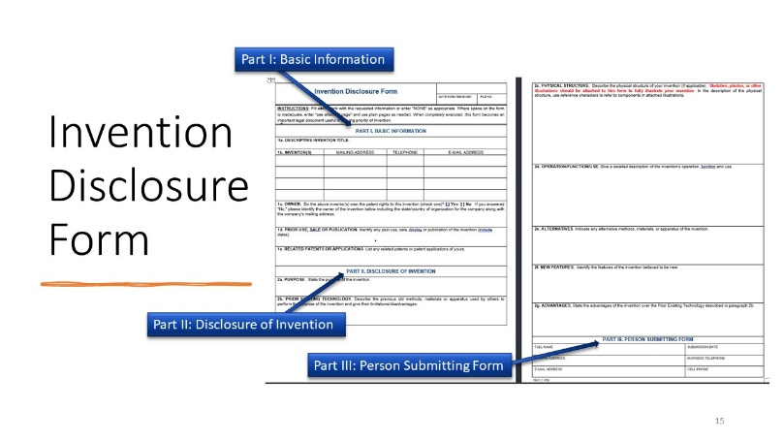 | SAY: The IDF has three main parts. Part one is Basic Information, part two is Disclosure of Invention, and part three is Person Submitting Form.  Explain: Go back to each part and explain what information is needed. Stress that each section must be filled in completely, especially in part two regarding the invention. If proper notations are completed throughout work on projects, it will make it easier to complete this form.  SAY: What questions do you have about the form?
16) 1 min. | 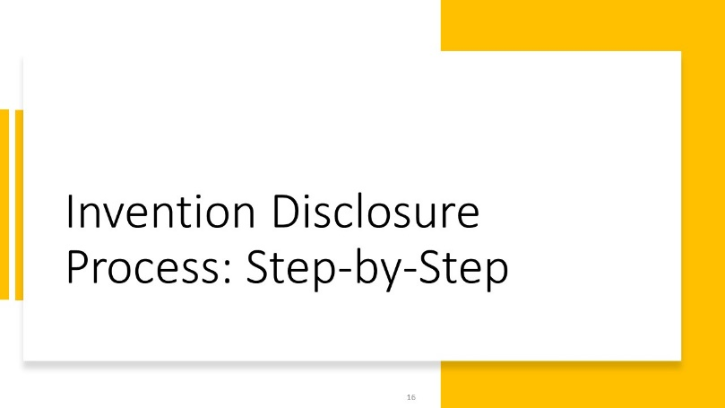 | SAY: Now we will discuss how this form fits into the entire process of Invention Disclosure. | DO: Prepare break-out rooms with 3-5 learners in each. The activity is on Slide #19.
17)10 min. | 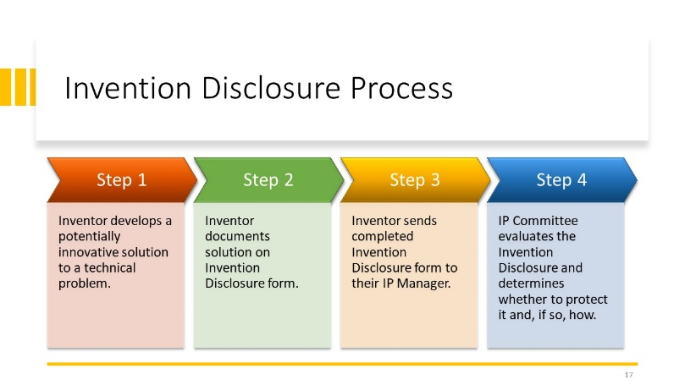 | Explain: Discuss each step, focusing on what/who are involved in each one.
18) 5 min. | 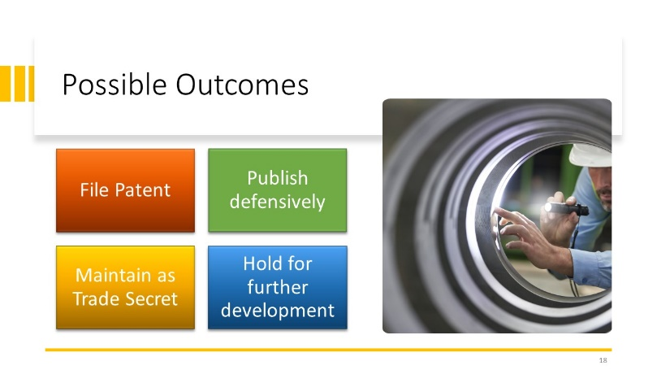 | SAY: Here are the four outcomes the IP committee may determine for an invention.  EXPLAIN: Describe each briefly.
19)15 min. | 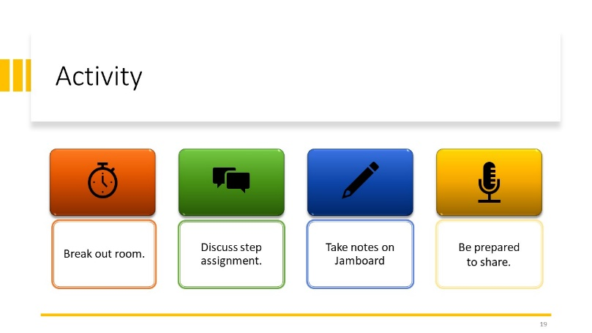 | SAY: Each of you are going to go into break out rooms now and have a small group discussion about one step in the Invention Disclosure Process. The invitation to join the room and the step number you are assigned (#1-#4) will appear on your screen. Proceed to the room and discuss these questions: What are the ramifications to the company if this step was completed inadequately? What best practices will you put into place following this training to be ready to take part in this process? There will be a link for a Jamboard in the chat in each chatroom. Please take notes there. Be prepared to share your answers with the group afterwards. You will have 10 minutes. Any questions?  DO: After time is up, have one person in each group show their screen and share their group’s answer.  DO: Debrief after all groups have had a turn to share. Fill in any points each group may have missed for each step. The discussion should focus on ramifications: possible loss of intellectual rights for the company if any of the steps are not done correctly; loss of revenue for patent rights, or other outcomes, for the company. Best practices: keeping detailed records of projects, seeking the advisement of the IP Manager if needed, completing your part of the process in timely manner. | DO: After directions are given and questions are answered, send learners to the break-out rooms with the assigned step numbers.  Visit each room and put the link for the Jamboard in the chat.  DO: Take screen shots of all group notes for post analysis.
20) 5 min. |  | Explain: Open the floor for learners to ask questions, share their experiences, or seek clarifications on any aspect of the Invention Disclosure Process. Facilitate discussions among participants to encourage peer learning and the exchange of insights.
21) 1 min. |  | SAY: We will now summarize what we have learned in today’s session.
22) 5 min. | 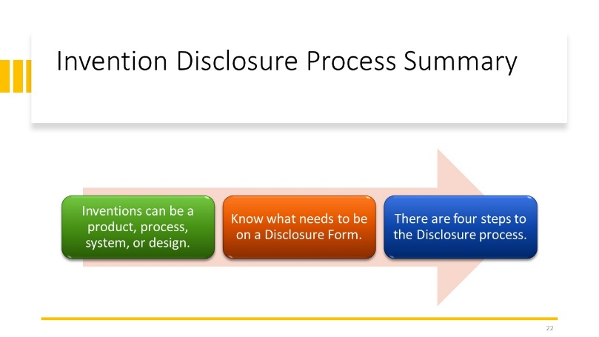 | EXPLAIN: Each of these points are the three objectives of this training. For each one, depending on time, you could ask learners to answer questions:  “True or False: I created a proto-type of a Swiss-Army knife that has the same gadgets as before, but I added wi-fi functionality. This could get a patent.”  “What are the three main sections on an Invention Disclosure Form?”  “What are the four steps to the Disclosure Process?”
23) 5 min. | 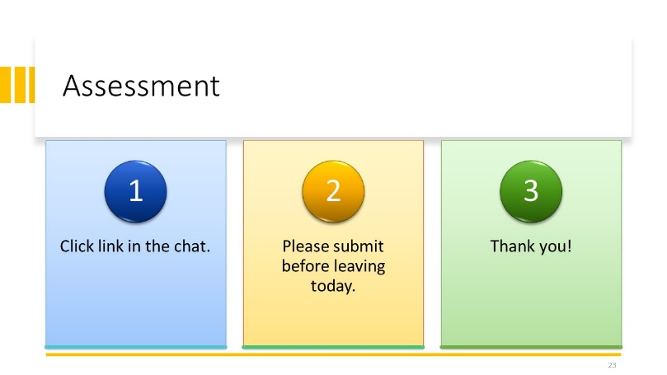 | EXPLAIN: Learners will take an assessment on Google Forms via a link provided. They are asked to complete and submit before leaving the session today. Thank learners for their participation. | DO: Put the link for the Google Forms Assessment in the chat. Ensure all participants complete the assessment before exiting the session.  Assessment Link

