
Go to “File” in the upper left hand corner of this page.
Click “Make a Copy”.
Then change the Title of YOUR Copy in the upper left corner to:
“{Your Name} Portal 5: Live Your Bliss Play Sheet”.
Go through the playsheet, completing each practice.
Click the checkbox once you have completed each practice.
Go to the SHARE button in the upper right corner,
Click “Anyone with the link”,
COPY the link,
Go to our FB Group and share your link,
With a comment on how these practices worked for you,
what came up for you, any challenges you faced, any breakthroughs that you had.

- 1- The Dharma Evaluation
- 2- Discover Your Dharma Formula
- 3 - Calibrate Your Calling Ceremony
- 4 - Roadmap for Success Tracker
- 5- The Radical Truth Teller

The Dharma Evaluation

Take a self evaluation quiz to discover how much your current work aligns with your Dharma.

Do you...

- like going to work?

- feel lit up by your work?

- like who you work with?

- get excited about your work?

- feel it aligns with your values

- feel happy to do your work?

- feel fulfilled by your work?

- feel satisfied at the end of the day?

HOW TO INTERPRET RESULTS
6-9 checks: You are aligned and love what you do.
4-6 checks: You can discover more ways to be in alignment with your ‘zone of genius’.
1-3 checks: SOS! You are not doing the work that you love and may consider something new!

Discover Your Dharma Formula

Gain clarity on your passions, mission, vocation, and profession.
Recognize how these elements align to reveal your life's purpose.

Step 1: Self-Reflection
What are your deepest passions and interests that bring you joy?
What activities make you lose track of time when you're engaged in them?
What aspects of life ignite a sense of purpose within you?

(room to write)

Step 2: Identify Your Strengths
List your skills, talents, and strengths.
Reflect on areas where others have praised you or where you feel a natural proficiency.

(room to write)

Step 3: Mission and Impact
What positive impact do you want to make in the world?
How do you envision contributing to the well-being of others?
What change or transformation do you aspire to facilitate?

(room to write)

Step 4: Ikigai Overlap
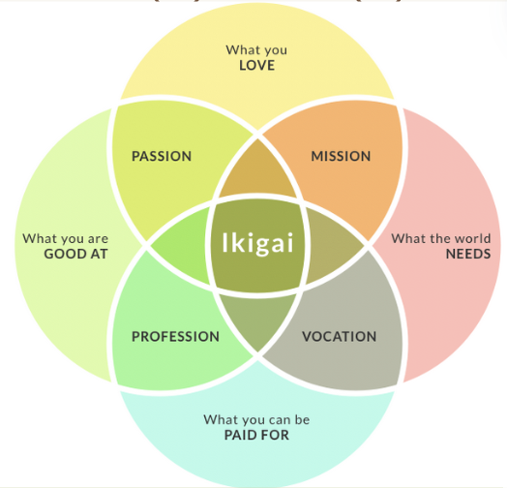
Create a Venn diagram with four circles representing your
passions, vocation, mission, and profession.


(room to write)

Step 5: Refinement
Refine your Ikigai by examining each element.
Passions: Ensure they align with your core values and bring you genuine joy.
Vocation: Consider how your skills and talents can be applied in a meaningful way.
Mission: Clarify the impact you want to have on the world.
Profession: Evaluate the practical aspects, such as financial sustainability.

Step 6: Write Your Ikigai Statement
Craft a concise Ikigai statement that encapsulates the essence of your discovery.
This statement should reflect the harmonious balance of your passions, vocation, mission, and profession.

My sweet spot is ______________________________________________________________

or

I am most in service when I am ___________________________________________________

Step 7: Reflection and Adjustment
Take time to reflect on your Ikigai statement.
Consider how it aligns with your aspirations and values. Make adjustments as needed to ensure authenticity and alignment with your evolving self.

Step 8: Integration
Embrace your Ikigai as a guiding principle for your life's purpose.
Integrate it into your daily decisions, actions, and long-term goals.
Once you have your Ikigai statement, you can post it somewhere that you see it daily.

Calibrate Your Calling Ceremony
This personal ceremony is for YOU!
Check off the box when you have completed the step.
- Step 1: Gather Materials: poster board, markers, magazines, glue, scissors

- Step 2: Create Your Ikigai Mandala: draw your core, draw around your core with your passions, towards the bottom draw your vocation, towards the top, draw your mission, and towards the sides, draw your profession.

- Step 3: Mindful Placement

- Step 4: Reflective Writing: Add short phrases or affirmations

- Step 5: Expressive Imagery

- Step 6: Personal Ritual: Light a candle, play calming music, or meditate

- Step 7: Contemplative Observation

- Step 8: Integration: Place your Ikigai Mandala in a space where you can regularly see and reflect upon it.

(room to draw your Ikigai Mandala)

Roadmap for Success Tracker

Here is where you can begin to set 10 SMART goals for tracking.

Milestones/Goals | Target Completion Date | Current Status & Date of Status | Resources Needed

How can you celebrate your achievements and small victories?

Which friend, mentor, or accountability partner would you
want to consider sharing your roadmap with?
Share it on our FB Group.

The Radical Truth Teller

Write about your experience with the content from Portal 5.
What came up for you?
Did you have any resistance to any of the practices? Why?
How did you move through it? Is there anything else you’d like to add here?

(room to write)

Portal 5 Resources

5 things to know about dharma

How To Find Your Ikigai And Transform Your Outlook On Life And Business

The Philosophy of Ikigai: 3 Examples About Finding Purpose

Bernard Bachard’s High Performance Indicator,
Discussed in his book “High Performance Habits”
Is now called the HP6 Assessment.

You can take it here!
https://www.growthday.com/hp6-assessment

You can also find out more about his work
And get a High Performance Planner (book) here:
https://www.highperformanceplanner.com/resources

Success Tracker helps you to track goals and habits. Whenever you set a new goal, you’re unlikely to achieve it unless your habits already support it. If your goal runs afoul of your current habits, you’ll need to change your habits in order to achieve your goal.
Reward yourself every time you finish a goal.
Business Planning Tracker Template/ Example

Portal 5 Resources

Course Dashboard

5 Things to Know About Darma

How To Find Your Ikigai And Transform Your Outlook On Life And Business
The Philosophy of Ikigai: 3 Examples About Finding Purpose
Bernard Bachard’s High Performance Indicator. Discussed in his book “High Performance Habits” is now called the HP6 Assessment. You can take it here!
https://www.growthday.com/hp6-assessment
You can also find out more about his work and get a High Performance Planner (book) here:
https://www.highperformanceplanner.com/resources
Success Tracker helps you to track goals and habits. Whenever you set a new goal, you’re unlikely to achieve it unless your habits already support it. If your goal runs afoul of your current habits, you’ll need to change your habits in order to achieve your goal.
Reward yourself every time you finish a goal.
Business Planning Tracker Template/ Example

