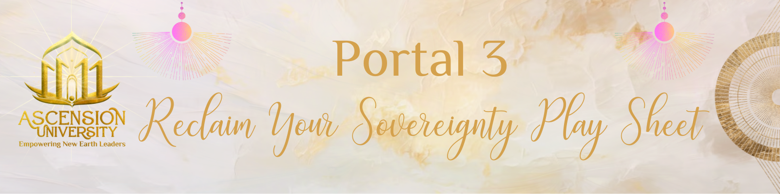

Go to “File” in the upper left hand corner of this page.
Click “Make a Copy”.
Then change the Title of YOUR Copy in the upper left corner to:
“{Your Name} Portal 3: Reclaim Your Sovereignty Play Sheet”.
Go through the playsheet, completing each practice.
Click the checkbox once you have completed each practice.
Go to the SHARE button in the upper right corner,
Click “Anyone with the link”,
COPY the link,
Go to our FB Group and share your link,
With a comment on how these practices worked for you,
what came up for you, any challenges you faced, any breakthroughs that you had.

- 1- The Self Worth Evaluation
- 2- The Divine Source Process
- 3- Share Your Experience in the FB Group
- 4- The “I SEE YOU” Practice
- 5- Your Mess is Your Message
- 6- Share Your Insights From the Exercise in the FB Group

The Self Worth Evaluation

Take a self evaluation quiz to discover how much self worth you have.
Do you say these things to yourself often?
I am not worthy of...
I can’t buy that thing because...
They won’t like me because..
I can’t do that thing I want to do
I won’t even attempt to do that
I suck at this, I can’t do it
I’ll never learn this
I won’t ever reach my goals

HOW TO INTERPRET RESULTS
1-3 checks: you’re doing great. Keep it up!
4-6 checks: You could use some help.
7-9 checks: SOS! Low Self Worth Alarm!

The Divine Source Process

This is an ongoing process…old patterns and programs can come up when certain ‘triggers’ occur in life. It’s about acknowledging them when they come up and then you can walk yourself through a personal, mini version of the Divine Source Process.
As you do your individual work, we are healing the collective as well.

What came up for you during the process during the training video?
What ‘wounds’ do you feel that you have been carrying and are ready to release?
How do you know when they come up?
What ‘triggers’ can you identify?

(room to write)

The “I SEE YOU” Practice
This Future Self communication process is one that has helped me so much on my path.
As your future self has reached your goals. She knows how to get there. She understands the challenges and struggles along the way. She can assure you that you DO achieve what you dream of today. She encourages, motivates and inspires you.

What did your Future Self say to you?
How did she console you?
How did she inspire you?
Write about your experience with the “I SEE YOU” Practice here.
(room to write)

Your Mess is Your Message

After you have gone through the Cathartic Dance process, come to this space to write.

What energies did you release?
How did it feel to do this exercise? (Liberating, fulfilling, etc.)?
Did you experience any resistance? Why do you think so?
How did you move through it?
What went through your mind during the experience?
Did you feel silly, stupid, etc.? Or were you all in from the beginning?

Take note of all that you went through…
Because WHAT’S IN THE WAY, IS THE WAY!
Your MESS is the beginning of your MESSAGE.

How you address your mess, move through it and get to the other side
is what YOU can teach to others.
Your experience gives you credibility, wisdom and knowledge to share.
(That’s why previous alcoholics are the ones that lead AA meetings,
Cancer survivors raise money for cancer foundations, etc.).

What is your MESSAGE for the world now?

(room to write)

(room to write)

Portal 3 Resources

Course Dashboard

Pussy: A Reclamation- a book by Mama Gena

