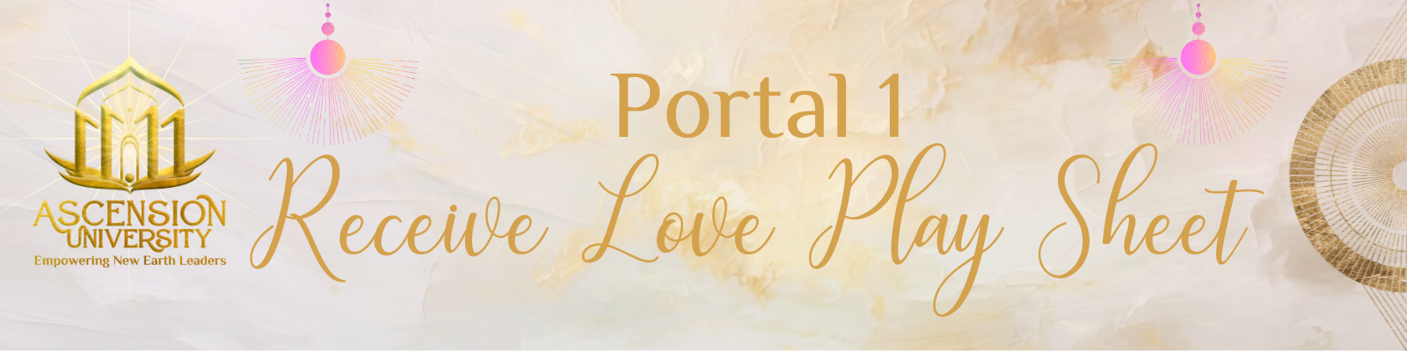

Go to “File” in the upper left hand corner of this page.
Click “Make a Copy”.
Then change the Title of YOUR Copy in the upper left corner to:
“{Your Name} Portal 1: Receive Love Playsheet”.
Go through the playsheet, completing each practice.
Click the checkbox once you have completed each practice.
Go to the SHARE button in the upper right corner,
Click “Anyone with the link”,
COPY the link,
Go to our FB Group and share your link,
With a comment on how these practices worked for you,
what came up for you, any challenges you faced, any breakthroughs that you had.

- The Self Love Evaluation
- The Embodied Love Method
- The True Nature Practice
- The Connection Formula
- Connecting with Your Higher Self
- The Intuition Activator
- Watch the film: What the Bleep Do We Know!?

The Self Love Evaluation
Let’s start with a self love quiz to discover how much self love you have.
Do you...? (check those that apply)
- criticize yourself daily
- hate what you see in the mirror
- feel shame often
- feel unworthy of love
- give your power away to others
- use daily coping mechanisms
- blame others for your actions
- feel undesirable or disconnected
HOW TO INTERPRET RESULTS 1-3 checks: You’re doing great! 4-6 checks: It’s time to UP your self love practices! 6-9 checks: SOS! Low Self Love Alarm!
Now that you’ve completed the evaluation.
How do you feel?
What came up for you?
What do you feel that you can improve upon?

(Room to write)

The Embodied Love Method

Keep a daily log of your experience with this mirror gazing technique.
Allow these prompts to initiate your writing.
Go deep here.
Free write and allow it all to spill out onto the page.

What came up for you?
How did you move through it?
Were you moved to tears?
What emotions came up for you?
What was some of the self criticism that came up for you?
What were some of the thoughts that went through your mind?
How did you shift them?
What was a breakdown and breakthrough you had?
What were some of your new positive mantras you created?

(room to write)

(room to write)

The True Nature Practice

Spending time in nature brings out our true nature.

After you have spent time in nature and moving your body…
What came through?
What did you channel?

(room to write)

The Connection Formula

1: Connect with the Quantum Field.
2: Connect to Creator/ Source Energy.
3: Connect with your Higher Self.
4: Feel connection and LOVE from within first.
5: Create Community of the same/ similar vibration. Effect the field.

Was there a difference when you connected to the Quantum Field,
Verses Creator/Source Energy and your Higher Self?

Why do you believe this happened?
If there wasn’t a difference, what was your experience?

What process helped you the most to feel connected to LOVE?

(room to write)

(room to write)

The Intuition Activator

STEP 1: STAND with your hands on your heart.
STEP 2: ASK: “What is my YES?”
STEP 3: FEEL: How does your body sway? Forward? Clockwise?
STEP 4: ASK: “What is my NO?”
STEP 5: FEEL: How does your body sway? Backwards? Counter Clockwise?
STEP 6: ASK: Your YES or NO question. Be specific. Is this supplement, job, car, house, etc. the right one for me, at this time?
STEP 7: FEEL: What sway does your body give you?
STEP 8: RECEIVE YOUR ANSWER: Did your intuition tell you YES or NO?
Take this as your answer and do NOT question it.

Practice this daily, with the small things and the big.
Next time you are at the grocery store, hold the item you are thinking of buying,
go through this process and see what your intuition tells you.
~Be sure to be specific and include “is this supplement what I need (at this time)”.

Next time you have a BIG question, use it as well.
I.e. “Is this job the right one for me at this time?”

With practice, this will become second nature for you.
You will learn how to trust yourself more and more
and never question your intuition again!

After practicing this, what were some of the experiences/ results you received?
(room to write)

(room to write)

Portal 1 Resources

Course Dashboard

Course Spotify playlist

Sacred Portal Photo Taking Ritual

The 7 Benefits of Spending Time in Nature - McMaster

The Benefits of Spending Time in Nature- Hagley

Spending Time in Nature is Good For You- Healthline

Quantum Field

8-Steps to connect to the Quantum Field & Create the Life you Want

ThetaHealing

Heart Coherence

Synctuition

Oriah Mountain Dreamer

