Ergonomic Workstation Self-Assessment
Please note that this assessment should be conducted at all working locations whether in the workplace or in your home (or other) environment.
Name
Job Title
Workstation and location of assessment
Are you suffering with any symptoms relating to your workstation?
If yes to above, who have you reported it to? (must report to line manager)

Reason for ergonomic assessment
Reason | If it applies, please provide more detail…
General fatigue or malaise?
Discomfort or pain in back, neck, upper limb(s)
Environmental issues?
Equipment issues?
Difficulty carrying out your job?
Visual stress or optician’s recommendation?
Sickness absence?

Self-assessment
Consider the diagram below when you think about how you sit at your desk.
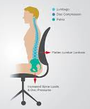 | Summarise your sitting position at your desk comparing it to the image on the left.  Are there any adjustments you can make yourself?

What’s your wrist position at your keyboard?
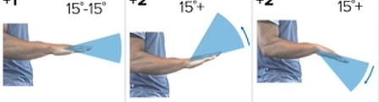
Seating position
See image below for reference of ideal seating position at desk
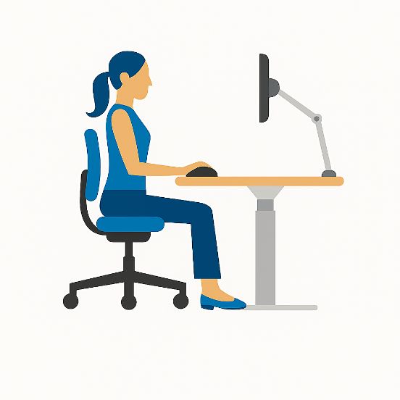 | - Is your eye level towards the top of your monitor?  - Is your monitor roughly arm’s length away?  - Is your back straight?  - Is there minimal bend to your wrists?  - Are your elbows close to your body?  - Is your backrest supporting your lower back?  - Do you have adjustable swivel chair?  - Is the front of the seat pressing on the back of your knees? It shouldn’t be.  - Are your feet flat on the ground or resting on a footrest?

If the response to any of the above questions is ‘no’, then you should make appropriate changes to your position or workstation.

Are there any adjustments that you have had in the past or that you feel would help? Please indicate below with your suggested solution.
Ergonomic need | Suggested solutions
Posture
Desk/work surface
Seating
Equipment
Flooring
Draughts
Lighting
Background noise or other distractions
Rest/refreshment breaks
Working hours
Mobilisation

You should now share this completed form with your employer for them to take any appropriate action.

