**From Zero To 25,000 Ranking Keywords!**

**SEO Case Study**

**Finance Industry**

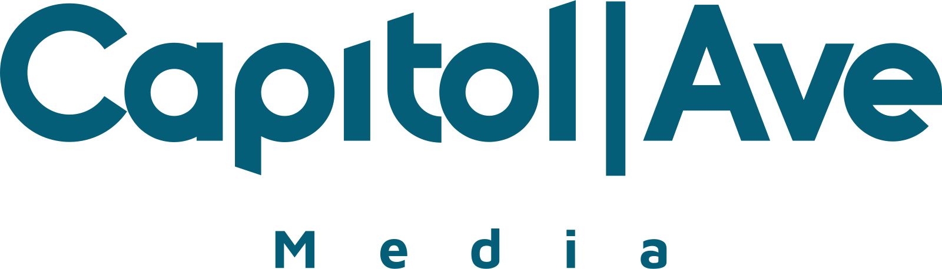

The financial niche is one of the most competitive - and one of the most lucrative spaces online.

This site came to us with a pretty clean slate - starting with not much traffic.

In this case study, you'll see how we drastically increased their total number of keywords ranking, AND brought their estimated traffic value to over $350,000... per month!

**Background**

The owner wanted to compete with the biggest names in the space.

This site started in July 2017 and built up traffic to about 13,000 visitors a month before letting us handle their SEO campaigns in Oct of 2017.

We worked with the client to create an aggressive plan, starting with a $3,000 / month budget progressively working up to $40,000 a month as results came in.

**The SEO Audit**

This site had no previous penalties as it was relatively new.

We did see that it had some aggressive anchor texts making up 7% of the profile, but we knew we had the budget to diversify.

**"Easy Wins" Keyword Analysis**

We identified 230 “Easy Wins” keywords ranking in positions 4-30 with volumes between 20-11,000 MS.

Since these keywords were already ranking near the top, we knew we could focus on them for some quick traffic jumps!

All of the keywords had CPC, meaning that someone was bidding on them in Google Ads and they would be valuable to rank for. In fact, and some of the lower volume keywords were extremely lucrative with CPC up to $20 per click!

We took this all into account when deciding on keyword & page targets, as many of the pages ranked for a multitude of keywords.

Additionally, by sharing this information with the client, they were able to optimize their pages with LSI keywords to help increase the rankings.

**Competitive Gap Analysis**

This analysis is designed to help us locate keywords that your competitors are currently ranking for that you are not. These keywords are great for generating a ton of new content ideas!

We initially identified over 1000+ keywords that competitors were targeting that this site was not.

We identified 3 types of content to target and utilized each at different strategies over the course of this campaign:

**Category Pages**

These are broad, high volume keywords that talk in general about a subject.

**Product Review Pages**

With the content gap analysis, we were able to identify valuable brand and product terms to review. We used this to build a substantial amount of content that would produce revenue.

**Supporting Content**

Later in the campaign, after we completed a multitude of base content, we also began creating supporting content for high competition keywords.

For instance, we would support a large broader category keyword with contextually relevant articles that all linked to the high competition keywords article, building a foundation for the rankings. These were usually niche, avatar-specific, or situational variations of hub pages.

**Kicking Off The SEO Campaign**

With almost all campaigns, we create a diversity of high-quality links and content - The bread and butter of SEO.

Depending on how the campaign progresses, we shift budgets into higher-quality / more powerful links or more content.

You can see in the examples below, we heavily relied on natural white hat blogger outreach as well as a lot of blog content to increase this site's traffic!

Here are a few examples of monthly spends in how the campaign progressed:

This campaign started with a variety of products, including diversity links, Guest Posts, and content.

• 2X Large Diversity Links

• 1X Small Diversity Links

• 2X DA20 Guest Posts

• 3X DA30 Guest Posts

• 2X DA40 Guest Posts

• 7X Blog Content - 1000 Words

As the campaign progressed we added more content and shifted to higher quality links, for example:

• 5X Large Diversity Links

• 10X DA30 Guest Posts

• 15X DA40 Guest Posts

• 5X DA50 Guest Posts

• 16 Blog Content - 1000 Words

Then as we saw the success of content ranking and the large breadth of targeted keywords to rank for, we shifted even more budget into content, while continuing to build high-quality links.

• 4X Large Diversity Links

• 10X DA40 Guest Posts

• 20X DA30 Guest Posts

• 1X DA50 Guest Posts

• 40 Blog Content - 1000 Words

**Results**

The results of this campaign were tremendous thanks to the well-defined strategy, execution, and great communication with the client.

In the span of less than a year, this site became a major contender in the space ranking for some of the most competitive keywords.

The site’s current traffic value is estimated at $351,000 per month:

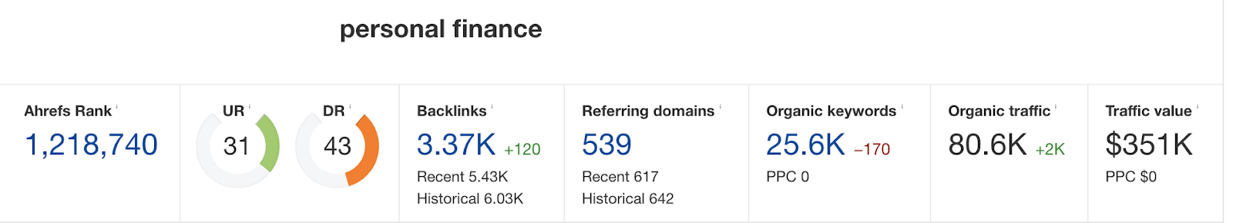

It ranks for over 25,000 keywords, and the traffic graph grew aggressively over the last year:

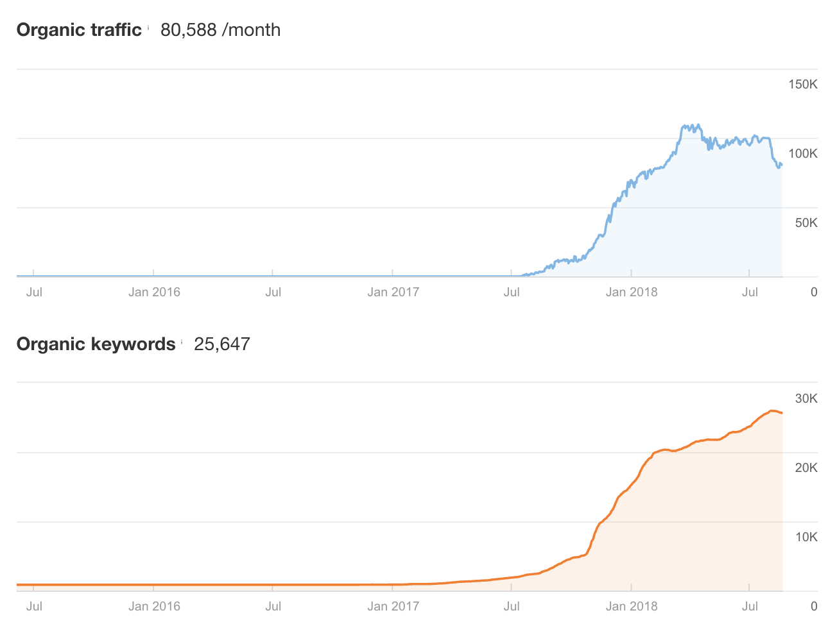

**Conclusion**

This was an amazing campaign for us but not just because of the work that was done, but also how closely we were able to work with the client.

The client put trust in us to follow the process but also worked closely with our team to identify high targets to focus in on as the campaign progressed.

In addition, because of the larger spend level, our team was able to prepare an additional analysis of competitors, which gave the client insights that helped beyond just the search portion of this campaign and influenced business decisions.

Do you want to dominate a competitive online space? Get in touch with us today!