**From 100 to 2500 Monthly Visitors!**

**SEO Case Study**

**E-commerce Industry**



In this case study, you are going to learn how we increased an online store's traffic by 2400%.

Ready to dive in?

## **Background**

This is an online e-commerce store that sells items that cost between ~$50 – ~$300 dollars each. The site originally was getting no organic traffic and was mostly relying on paid traffic.

They started SEO by buying a few ala-carte SEO services but hadn't really committed until they joined our managed SEO program.

There was a lot of opportunity for growth here!

## **SEO Audit**

The first thing we always do is perform an SEO audit. We're looking for anything that could prevent them from ranking.

The good thing is that this site didn't have anything holding them back, they just didn't have much content nor links.

## **Keyword Research - The "Easy Wins" Analysis**

To kick off our keyword research, we always look to find keywords that they are starting to rank for, but aren't ranking at the top of the search engines quite yet.

These are good targets because we can usually boost them up to see quicker traffic wins.

We found 76 potential targets, mostly bottom of page 1 through page 3 all with CPC between .60 and $2.50.

These URLs were a mix of product pages, category pages, and blog content.

We worked with the customer to select a few high priority targets for quick boosts!

## **Keyword Research - Competitive Gap Analysis**

The competitive gap analysis is designed to help you find keywords that your competitors are ranking for that you currently are not.

This is a crucial step as it always helps generate new keywords that you can easily target with content.

E-commerce is a bit different than other sites with the content gap analysis. When you run it, you often get a ton of product names that you may not sell.

We work closely with the client on these and pick targets together to make sure we're targeting keywords related to products that they have in their inventory.

We found some killer keywords where we could write long articles about!

## **The SEO Strategy & Execution**

This was a pretty typical campaign where we built consistent content and links to the site.

For Months 1 – 3, we kept strategy the same:

* 1X Medium Diversity Links: We built in-content links focused on easy wins, using diverse anchor text.
* 4X Blog Content 1000 words: We focused on writing content targeting keywords with good volume related to the niche products.

And for the results, the traffic starts improving when we started:

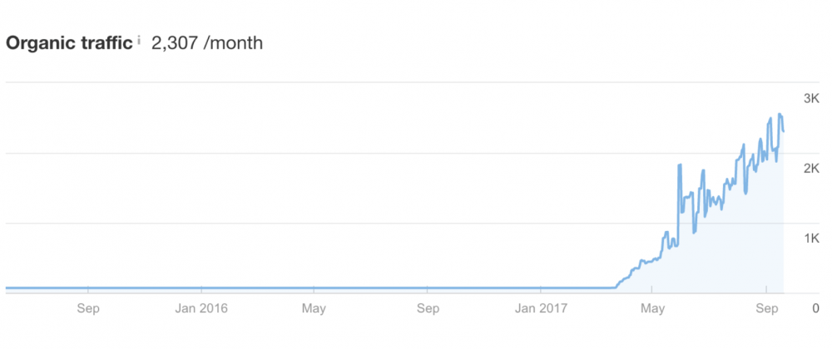

## 

## 

## **Going Forward**

Now we have these awesome, long-form blog content ranking (AND they are valuable pieces of content, as opposed to just product pages), we’ll be able to do some surgical link building and get these pushed up even farther.

What’s great is that we have LOTs of content to work with now… and it’s beginning to show!

By following this strategy, we see Google starting to unlock the floodgates – This is showing the massive potential that we can target coming up:

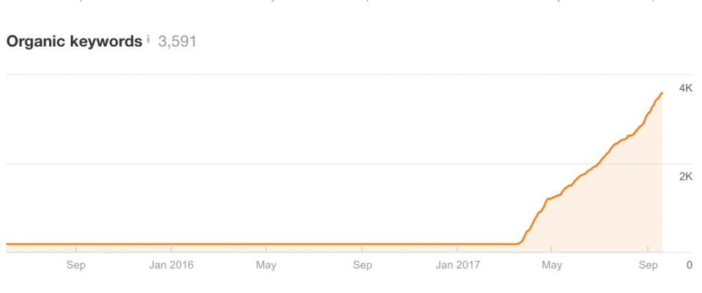

## **Takeaways**

Ecommerce needs content, and by writing long-form blog posts, you can start ranking for your valuable keywords.

These pages are easier to rank, and you can do an internal link to your product pages. After you have the content, it makes getting good links 1000X easier!

Want to get SEO results? Check out our managed SEO program here!