**Fitness E-Commerce Store Earns 5405.85% ROAS**

**PPC Case Study**

**E-commerce Industry**



With overall sales doubling to $2.3 billion in 2020, it’s safe to say that the health and fitness industry has exploded.

Gym and sports equipment companies are poised to make big profits from more people wanting to exercise at home. And with paid ads, these companies can get in front of the right customers looking to expand their home gym.

In this PPC case study, we’re going to show how we helped a fitness online retailer to optimize their Google Shopping Campaign and score a 5405.85% return on ad spend (ROAS) in only two months!

Keep reading below to learn about how we did it.

## Background

We were contacted earlier this year by a fitness e-commerce store that wanted to use paid ads to expand its operation and make more sales.

The client was previously working with another agency but wanted to see more growth. Their specific request was for us to beat the old agency’s Google Ad metrics. We happily agreed to help but discovered there was an obstacle that could make it challenging to optimize their campaign.

They were not transparent with past metrics and couldn’t provide us with access to their old ads. As a brand new account, we didn’t have any past data either.

All we knew was that under the old agency the store had been averaging a 4X return, meaning for every $1,000 spent they were earning $4,000.

Our team knew we could help this client, we’d just have to put in some extra work.

## Building Our Google Merchant Center

The first major step to a successful paid ad campaign is to make sure the products are organized, approved, and stand out from the competition. We’d have to build out their system from the ground up.

Everything was trial and error at first since we had no past data, but we finally obtained access to the client’s analytics about two months into the campaign. (Pro tip: If you ever have a fresh ad account with no data always check the analytics account. This will at least show you campaign types, ROAS, and other key metrics)

Part of the PPC campaign process is to set up the Data Feed inside of Google Merchant Center.

A Data Feed is a list of updated information about all of your products sent to Google. You can send this data from an e-commerce platform, directly add products to the Google Merchant Center, or create a feed using a content API.

Google recommends using the API if your company lists many products or you’re regularly updating inventory.

This client’s titles, descriptions, and imagery passed our pre-optimization checklist so we went ahead and uploaded everything manually to the Google Merchant Center.

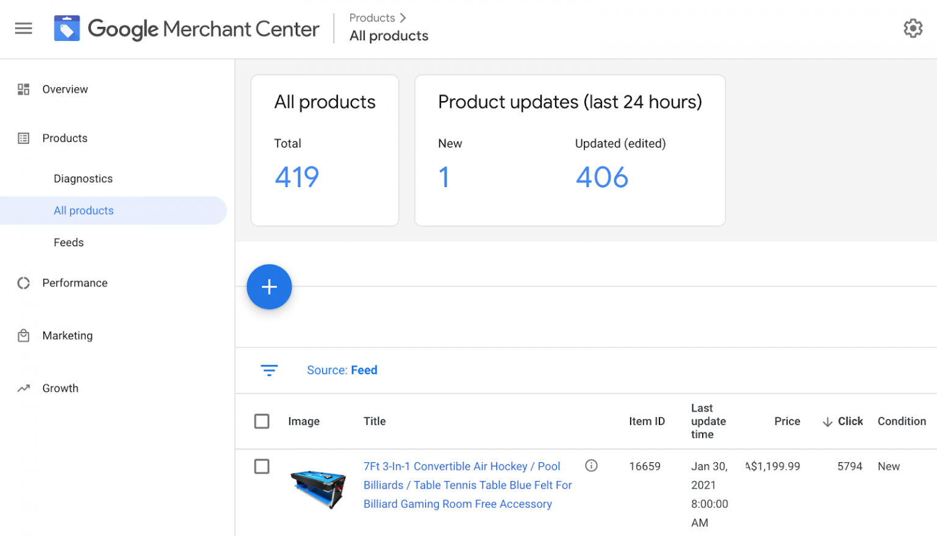

You’re probably wondering why we would choose to do it manually? This allows us to make quick optimization changes down the road. However, API feeds are convenient because they automatically update any changes made in the online store.

Once the products were inputted, our next step was to connect the client’s Google Merchant Center with their ad account. By doing this the client’s nicely organized products would seamlessly route to Google Ads.

It’s also important to note that you won’t be able to run any Google Ads campaigns for your products without first uploading them to the Google Merchant Center.

Believe it or not, manually entering the product feed was the easy part. Now we had to work on optimizing their new campaigns.

## Structuring the Paid Campaigns

After speaking with the client about their goals and expectations, our team settled on three strategies for increasing their revenue:

* Google Shopping Campaign
* Branded Search Campaign
* Dynamic Remarketing Campaign

In case you didn’t know, a Branded Search Campaign is when you actively bid on keywords relevant to your brand. This type of campaign was requested by the reseller.

Google Shopping Campaigns are one of our go-to strategies because they usually offer lower cost-per-clicks (CPC) and deliver us pre-vetted traffic. The Dynamic Remarketing Campaigns would ensure ads are redelivered to visitors who viewed products but didn’t make a purchase. Our primary goal was to get more potential customers on the site.

The Google Shopping Campaign isn’t overly complex. We began by splitting the campaign into two and testing them both to find out which performs best.

In this case, we initiated an automated Smart Shopping Campaign, where Google’s machine learning designs ads for us, and a Standard Shopping Campaign. Over the years we’ve found that Smart Shopping Campaigns perform better.

Our theory behind this is Google’s algorithm, which allows Google to show our products to the right consumers. But, we only use these types of smart campaigns for shopping, not for lead generation or regular search ads.

The role of the Branded Search Campaign was to capture anyone who specifically searched the branded names, whether they spelled it correctly or incorrectly. And our Dynamic Remarketing Campaign was the catch-all for non-converting visitors.

## Optimizing Campaigns

Once the campaigns went live it was time to start optimizing.

One of our daily optimizations is to add negative keywords to our standard campaigns. These are keywords that will prevent your ad from being triggered in the wrong kind of search.

For instance, if your company sells women’s tennis shoes you may want to add “high heels” as a negative keyword so your ad isn’t delivered to customers searching for “women’s dress shoes.”

Although you’re not bidding on specific keywords with shopping campaigns, Standard Shopping Campaigns still have the option of using negative keywords. Check out some of the negative keywords we added for this client:

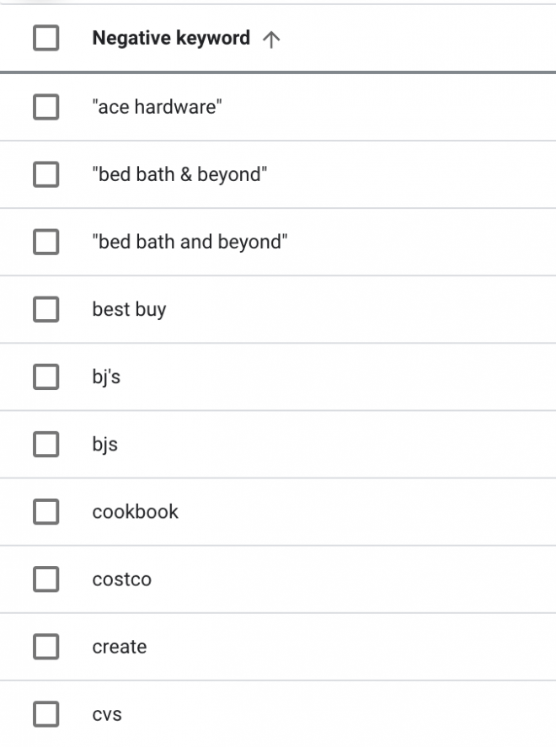

Then, once we have enough data, we can turn off non-performing products. This allows us to target products that are driving new revenue.

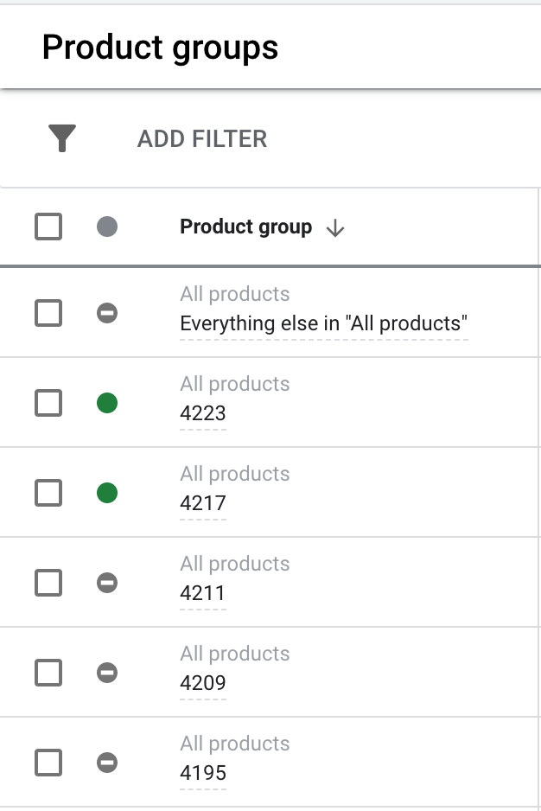

A list of the products we paused in order to promote more revenue-driving products.

It only took us one month to notice that the Smart Shopping Campaign was killing the Standard Shopping Campaign. This is typically how long we like to collect data before making any major campaign decisions.

You can see the results below. The cost per conversion was lower and the conversion value nearly doubled the standard campaign.

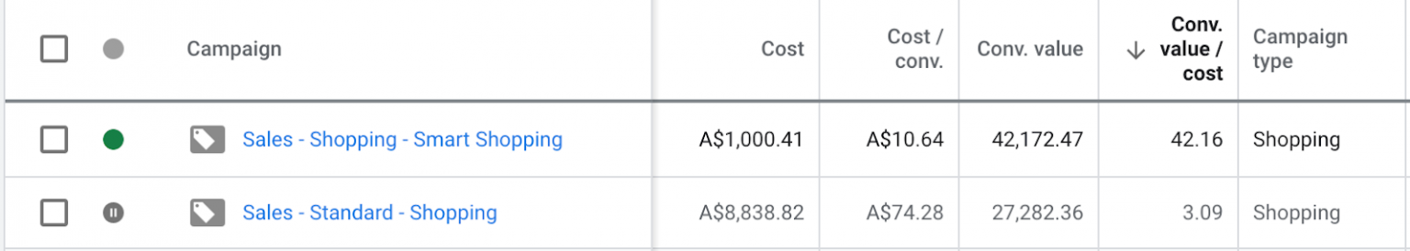

What happened when we paused the client's standard ad campaigns.

We decided to pause the standard campaign altogether and put all of our resources into the smart campaign.

For our branded campaign and dynamic campaigns we did not have many optimization options except for monitoring search terms, daily budgets, and performance.

## The Results

The PPC team knew we were on the right track for this client so we let it ride with these new optimized settings.

While our goal for this campaign was to surpass a 4X return, we eventually surpassed it with a 5405.85% ROAS in the second month!

As you can see below, our client spent $1,505.11 on paid ads with a terrific return of $81,358.36 in new revenue.

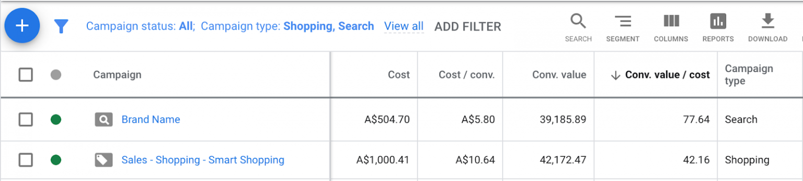

We were also ecstatic about being able to build an effective campaign from the ground up with no past data to use as a benchmark and help bring our client tens of thousands of dollars in sales over two months.

## Conclusion

Our experienced PPC team works with clients from a variety of industries to offer effective paid advertising solutions.

Whether new clients reach out to us about disapproved ads or have no benchmark data to work off of, we help them all get back on track.

We are able to do this because our PPC strategies are individualized for every client. We don’t have a one-size-fits-all approach. Our team follows a process based on the best practices of paid advertising and we formulate a strategy that caters to a client’s unique needs and goals.

Do you need help creating or optimizing paid ads for your e-commerce business? Book a call with one of our PPC experts to discuss what we can do for you.