**147% Traffic Increase!**

**SEO Case Study**

**Car Dealership Industry**

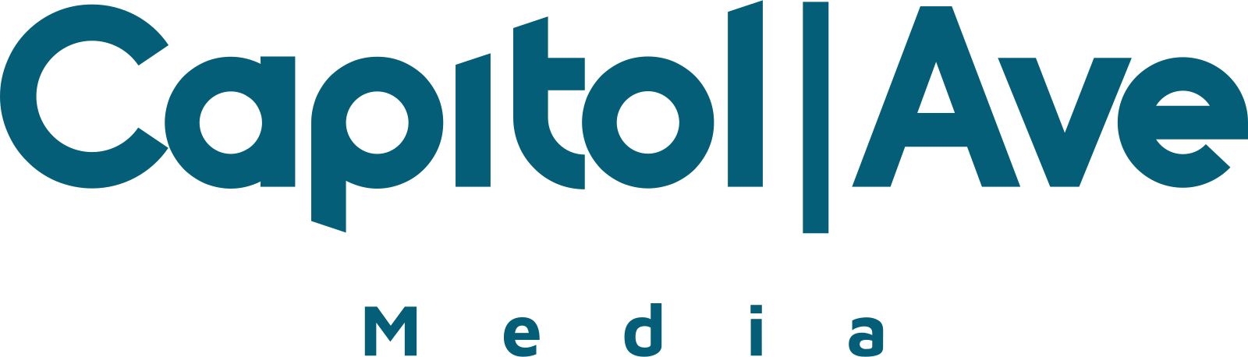

Want to see how we increased a car dealership's website traffic by 147%?

Then this case study is for you!

Like quite a few clients of ours, this dealership didn't come to us with a clean slate. Their rankings were dropping, their keywords were falling off, and their business was hurting.

See how we were able to recover them after a Google penalty and turn their traffic around:

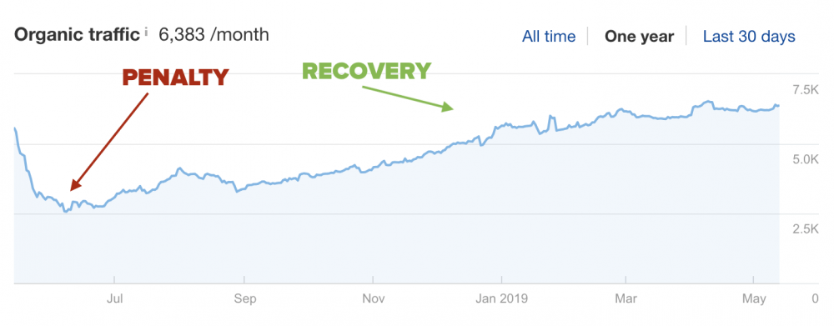

Let’s get into it!

## **Background**

This is a car dealership with several locations based out of the UK. They focus on high-end luxury vehicles.

Most of the terms they want to target have search volume on the lower end, but are extremely lucrative.

Their goal was to first get their traffic back, as well as improve their rankings for a few key pages.

Here’s how we did it:

## **First Things First – The SEO Audit**

The first thing we always do when we get a new site is to audit their SEO history.

This client was experiencing a significant drop in rankings due to the Google Core Algorithm Update in May.

This site’s rankings were affected due to having thin and duplicate pages with little-to-no content as well as a high bounce rate.

This type of problem is very common for auto dealers since most pages are typically just showing inventory pages. That also means there is a huge opportunity to win the traffic back!

They had actually started using our link building services ala-carte and saw a bit of traffic returning, then hopped into our managed SEO program a few months later.

## **Focusing On Improving Existing Pages Rankings & Traffic With Easy Wins**

One of the first things we take a look at is improving traffic to existing pages.

It’s common to find that many sites are close to ranking and getting traffic, but they just aren’t in the top positions yet.

For this we run our easy wins analysis and find keywords that the site is ranking for with the following metrics:

* Positions 4-30 with
* KD equal to or less than 30
* Minimum CPC .01

That way we can find targetable, valuable keywords and pages that are on the verge of ranking and can easily be improved.

On this site, we found 460 potential targets, mostly on the bottom of page 1 through page 3 with CPC between $0.30 and $2.50.

These terms / URLs were primarily product pages leading to specific cars that are available. The keywords have low difficulty, and we can capitalize on these to quickly increase traffic.

## **Competitive Gap Analysis**

The next thing we do is take a look at keywords that you’re competitors are targeting that you are not yet, and then focus on building out content for these opportunities.

The automotive industry is a bit different in terms of the content gap analysis.

When analyzing the competitive gap in this industry, you’ll often find keywords that are irrelevant and not worth targeting (i.e – specific car models, geo-targeted keywords, etc.)

Most of the top competing sites in this niche are thin on content, which allowed us to target the easy wins and create long blog content around them.

Each month we did a combination of high-quality link building and strategic content.

## **SEO Results**

After targeting this site’s easy win key terms, we’ve bumped many of them to page 1. The top 10 keywords are currently all ranking on page 1:

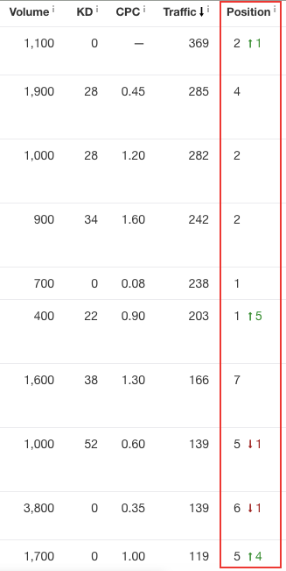

Here’s an example of their #1 exact match key term that experienced serious movement after the 3 month result period of using our managed SEO program.

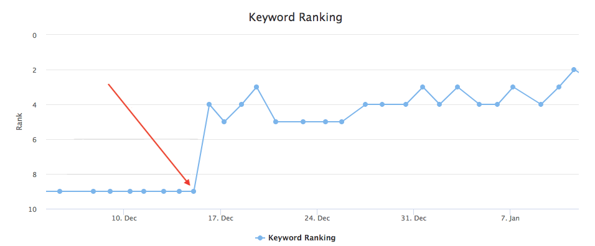

## **Takeaway**

When this client switched over to our managed SEO service, their organic traffic and traffic value started to consistently increase every month.

We focused on building out quality content on the site and a combination of our link building techniques.

As you can see in the image below, the site's backlinks, organic keywords, organic traffic, and traffic value are consistently improving as well.

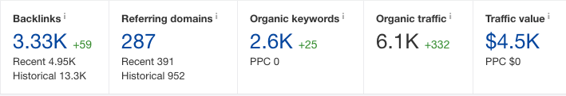

After a few consistent months of hard work, we’ve recovered this site’s organic traffic, bumped many of their keywords up to page 1, and doubled their organic traffic value!

If you’d like some help with your site (even if you’ve had a penalty or dropped in traffic), you might be interested in our managed SEO program.