Contract System

**Acton Academy functions as a miniature Civil Society, and contracts are its “constitution.”** These contracts describe what each party can expect from another.

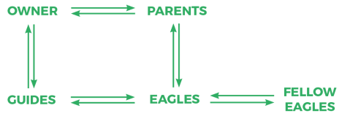Keys to a successful Contract system:

● **Let Eagles create their own contracts.** The more they feel that the contracts are theirs, the more they’ll care to enforce them.

● **Compare world-class examples** like the Declaration of Independence, and those from other Acton Academies.

● **Honor the contracts** with great solemnity, including at the signing ceremony. ● **Constantly revisit the contract** in discussions, peer feedback, and work challenges. ● **Post the contracts in the Studio** in visible places, so you can refer to them frequently. ● **Contracts can be strict, but not coerced.** If both parties agree to strict authority, there is integrity in the relationship, as in the example of a violin master and student.

Final Ownership of Systems:

**Systems where an Owner has final say:**

● Basic safety

● Mission & Promises

● Learning Challenges & Points

● Badges & Graduation

● Studio Schedules

**Systems delegated to Eagles:**

● Studio Contract

● Eagle Bucks

● Rules of Engagement

● Squad Accountability

● Studio Leadership