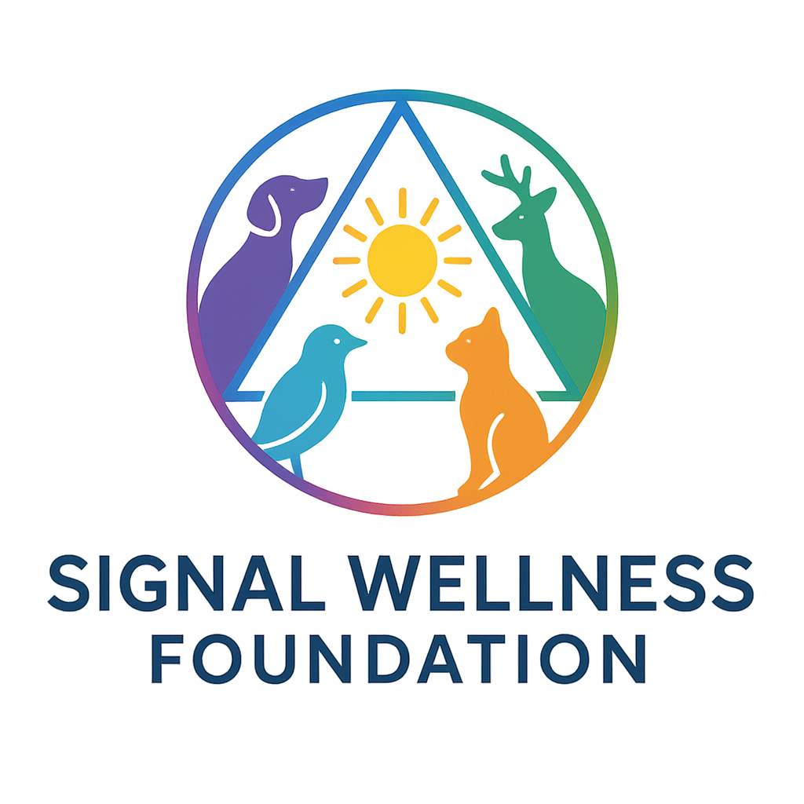

**StreetSafe Strips™
Case Study Protocol for Partner Organizations**
6-Week Wellness Pilot
This case study protocol explains exactly what your organization will do during the 6-week StreetSafe Strips™ Pilot. It is designed to be simple, low-burden, and easy to integrate into your existing workflow.

1. Purpose of the Case Study
The goal of this 6-week case study is to measure:
- Oral comfort (dry mouth relief)
- Hydration comfort
- Day-to-day wellness and energy
- Calmness and steadiness
- Ease of use and participant demand
- Real-world adoption in a shelter or outreach environment
Data will be used to determine citywide or multi-site expansion.

2. Role of the Partner Organization
Your organization will:
- Enroll participants
- Assign anonymous IDs
- Distribute StreetSafe Strips™ once per week
- Ask a short weekly check-in (30–60 seconds)
- Complete simple observation + inventory logs
- Administer the end-of-pilot survey
- Send de-identified logs and survey results back to Signal Wellness
You do not collect names, medical information, or any protected health data.

3. Who Can Participate
Participants must:
- Be 18+ (unless youth protocol is approved separately)
- Receive services from your organization (shelter, outreach, day center)
- Understand what the strips are
- Give verbal consent
- Be willing to answer short weekly questions
Participation is voluntary. They may stop at any time.

4. Enrollment Flow (Week 0 or Week 1)
Each participant receives:
- Anonymous Participant ID (example: SWS-014)
- Baseline Intake Questions
- First Weekly Pack of StreetSafe Strips™ (7 or 14 strips)
Baseline Intake Questions
Staff ask:
- “In the last week, how often was your mouth very dry?”
  - Never / Sometimes / Often / Very often
- “Do you have trouble staying hydrated?”
  - No / Sometimes / Yes
- “How is your overall day-to-day feeling lately?”
  - Low / Fair / Okay / Good
- “Do you often feel rundown or like you’re getting sick?”
  - No / Sometimes / Yes
Record responses under the ID.

5. Weekly Distribution Flow (Weeks 1–6)
Each week the participant:
- Gives their Participant ID
- Receives a new weekly pack
- Answers the Weekly Check-In Questions
Weekly Check-In Questions (30–60 seconds)
- “How many strips did you use this week?”
  - None / A few / Most / All
- “Did they help with dry mouth or oral discomfort?”
  - Not at all / A little / A lot
- “Did you feel more able to drink water or stay hydrated?”
  - No / Somewhat / Yes
- “How was your overall day-to-day feeling this week?”
  - Worse / About the same / Better
- “Did the strips help you feel calmer or more steady?”
  - No / Sometimes / Often
- “Did you scan or look at the QR code on the packet?”
  - No / Once / More than once
Log responses weekly under the ID.
Missed Week
If someone misses a week, mark “Missed.”
If they return, staff ask:
“Did you use any strips since the last time we saw you?”

6. Observation Log
Once or twice per week, staff make short notes:
- Number of people using strips on-site
- Comments they hear
- Requests for more strips
- General patterns (“Most used in mornings,” etc.)
This can be 1–3 sentences each time.

7. Safety + Incident Handling
If a participant experiences any discomfort:
- Log the Participant ID
- Log what they reported
- Let them stop immediately
- Offer medical referral if applicable
- Notify Signal Wellness (de-identified)
Incidents are RARE and normally very minor (taste preference, stomach warmth, etc.)

8. End-of-Pilot Survey (Week 6)
At week 6 (or final visit), ask:
- “Did the strips help with dry mouth?”
  - Not at all / A little / A lot
- “Did they help you stay hydrated or drink water more regularly?”
  - No / Somewhat / Yes
- “Did you feel better day-to-day during the pilot?”
  - Worse / Same / Better
- “Did you feel calmer or more steady after using them?”
  - No / Sometimes / Often
- “Did they make your mornings or evenings easier?”
  - No / Somewhat / Yes
- “Would you want these available year-round?”
  - No / Maybe / Yes
- “Should these be available at other shelters or outreach programs in the city?”
  - No / Maybe / Yes
- “Anything else you want to share?” (Optional comment)
Record answers under the ID.

9. Inventory Log
Each week, staff log:
- Packs distributed
- Packs remaining
- Packs damaged / lost / expired
- Staff initials + date
This ensures clean, transparent reporting.

10. Data Submission
At the end of 6 weeks, send Signal Wellness:
- Intake forms
- Weekly check-in sheets
- End-of-pilot surveys
- Observation logs
- Inventory logs
- Incident logs (if any)
All data must be de-identified.
Signal Wellness will produce the:
- Data analysis
- Graphs + metrics
- Final Pilot Outcome Report
- City-ready expansion summary

11. What Success Looks Like
Success indicators:
- High adoption and usage
- Clear improvements in oral comfort
- Better hydration comfort
- Improved daily steadiness / calmness
- Positive participant comments
- Strong interest in continued access
- Strong partner feedback
- Clean, transparent data
- Low burden on staff
- Clear cost-per-participant for city budgeting

