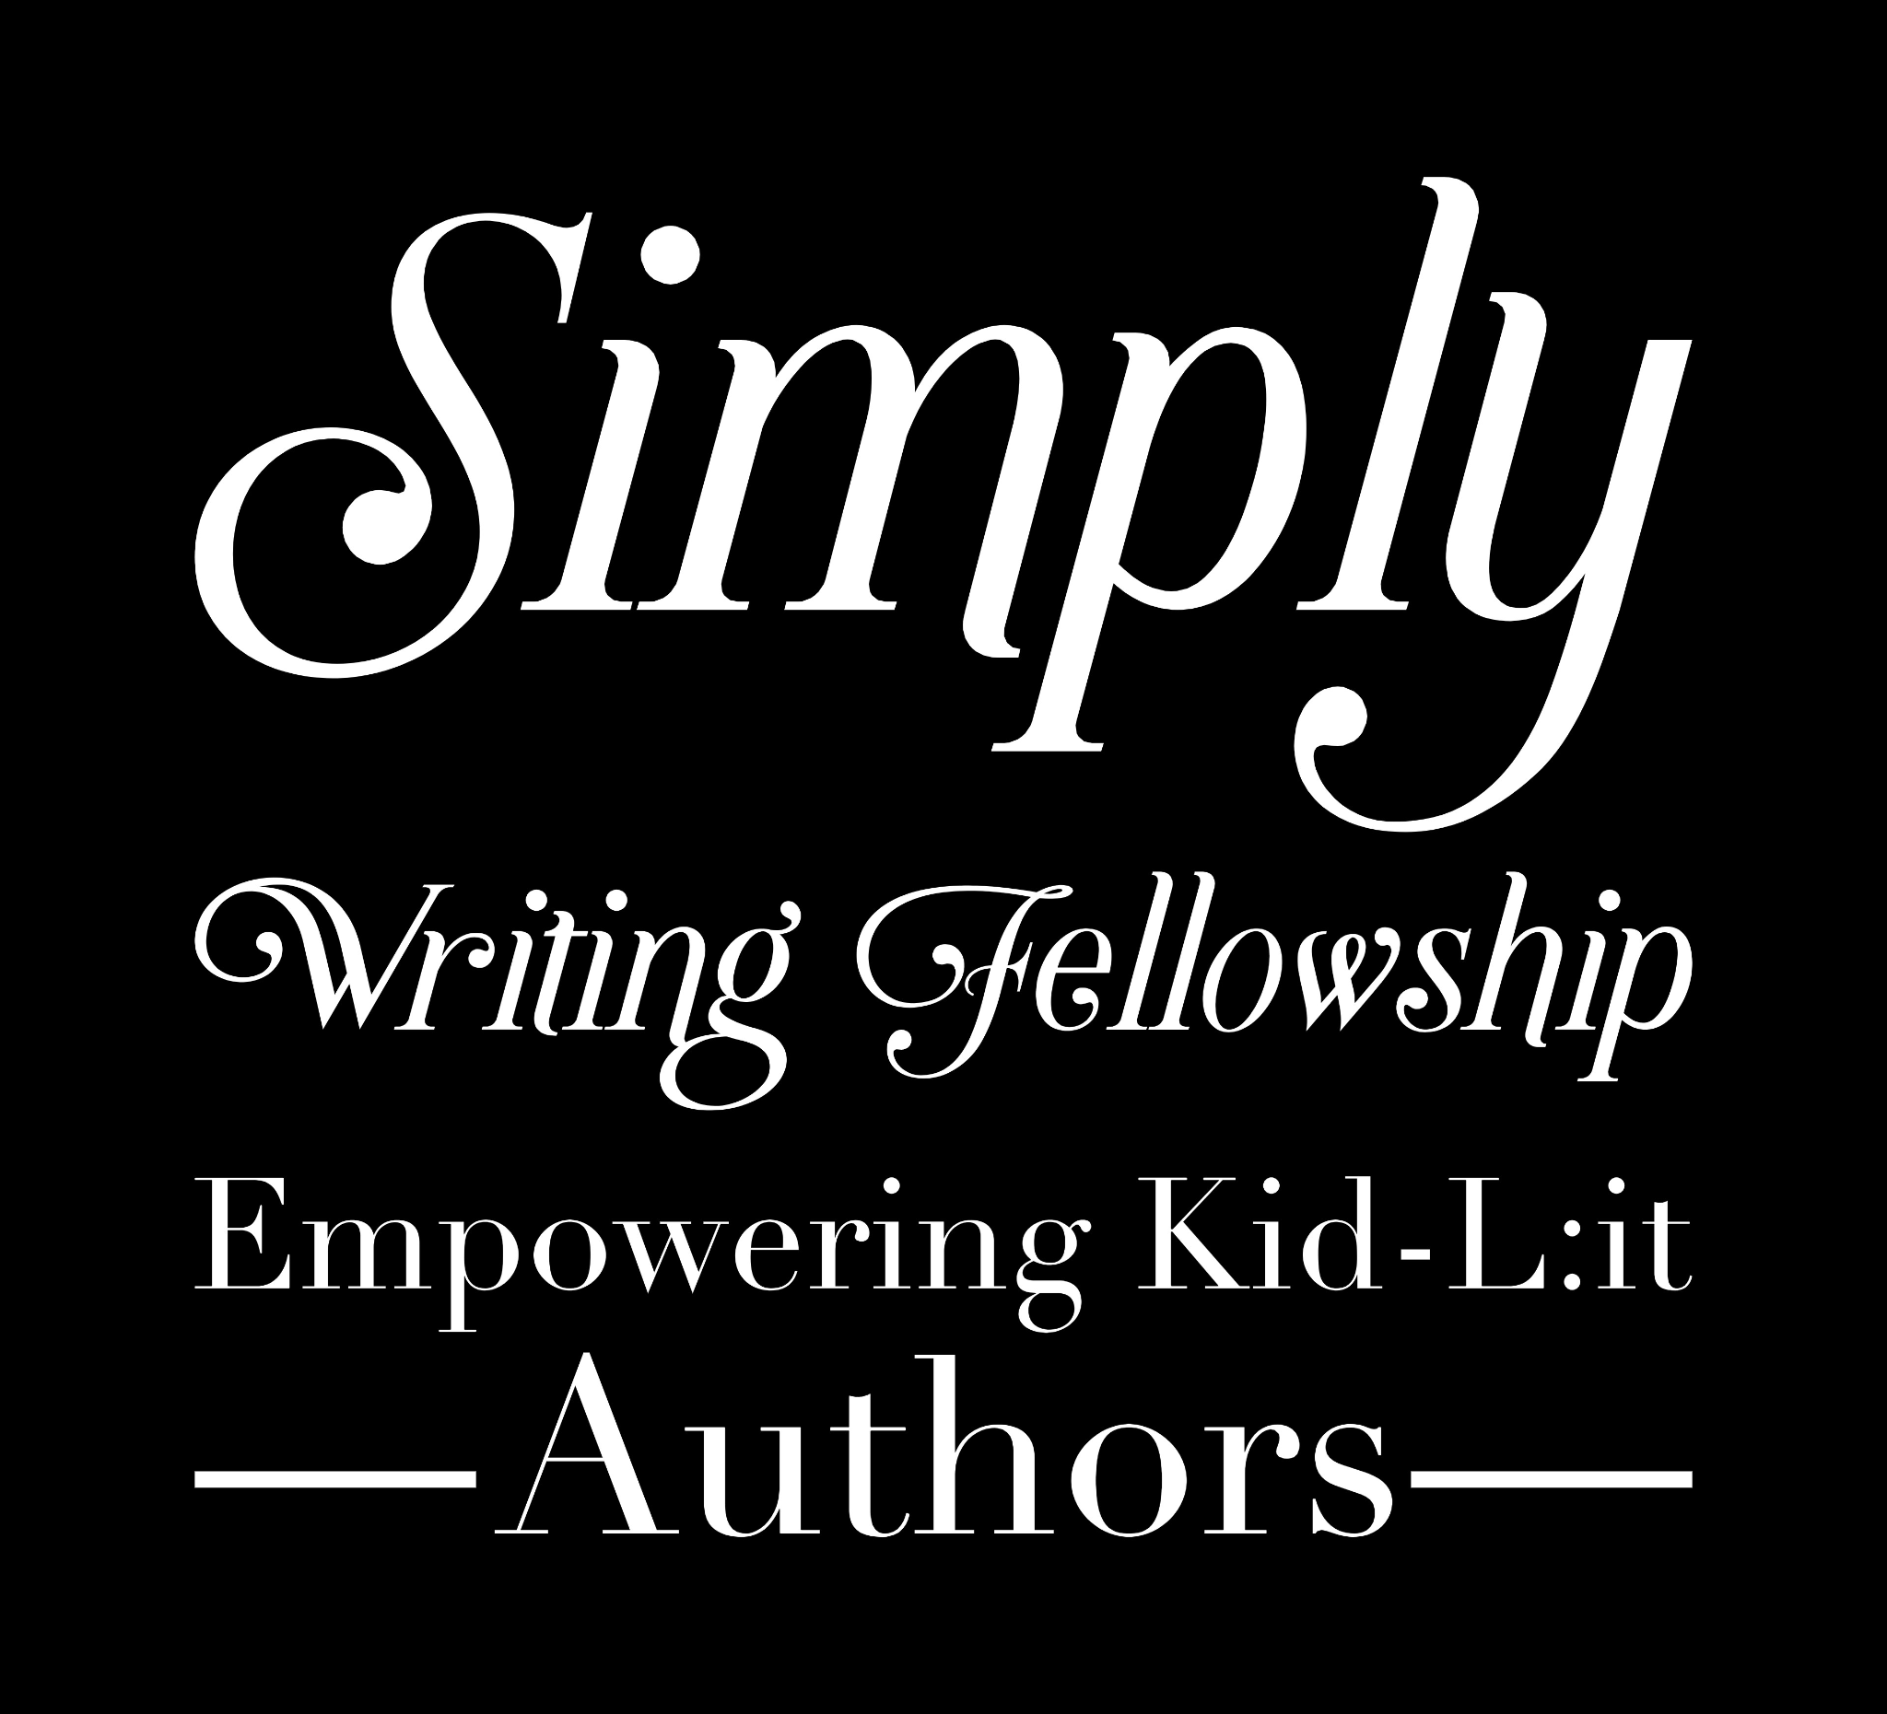

# Character Questionaire

**Being as familiar with your characters as you are with yourself will tell you exactly how they will react in every possible situation you can put them in. In addition, you will understand the interaction between characters as well.**

**Are you writing a memoir or non-fiction and believe you do not need Character sheets? WRONG! It amplifies your writing if you know exactly how a character would sit, stand, react in any given situation!**

**Even if you are writing about someone you know intimately, can you communicate feelings and atmosphere that connect with readers instead of making them feel they are watching from afar?**

**FILL OUT THESE SHEETS!**

**Bonus: For memoir writers, it helps to clarify one's feelings regarding traumatic situations so that healing can begin.**

### Section One:

**Complete this section for all your important characters, starting with the protagonist.** You may want to copy and paste the questions for as many characters as you answer them for or just add the character’s name next to their answers.

1. Name:

|  |
| --- |

2. Age

|  |
| --- |

3. Height:

|  |
| --- |

4. Eye color:

|  |
| --- |

5. Physical appearance:

|  |
| --- |

6. Strange or unique physical attributes:

|  |
| --- |

7. Favorite clothing style/outfit?

|  |
| --- |

8. Where do they live? What is it like there?

|  |
| --- |

9. Defining gestures/movements (i.e., curling their lip when they speak, always keeping their eyes on the ground, etc.):

|  |
| --- |

10. Things about their appearance they would most like to change:

|  |
| --- |

11. Speaking style (fast, talkative, monotone, etc.):

|  |
| --- |

12. Pet peeves:

|  |
| --- |

13. Fondest memory:

|  |
| --- |

14. Hobbies/interests:

|  |
| --- |

15. Special skills/abilities:

|  |
| --- |

16. Insecurities:

|  |
| --- |

17. Quirks/eccentricities:

|  |
| --- |

18. Temperament (easy-going, easily angered, etc.):

|  |
| --- |

19. Negative traits:

|  |
| --- |

20. Things that upset them:

|  |
| --- |

21. Things that embarrass them:

|  |
| --- |

22. This character is highly opinionated about:

|  |
| --- |

23. Any phobias?

|  |
| --- |

24. Things that make them happy:

|  |
| --- |

25. Family (describe):

|  |
| --- |

26. Deepest, darkest secret:

|  |
| --- |

27. Reason they kept this secret for so long:

|  |
| --- |

28. Other people's opinions of this character (What do people like about this character? What do they dislike about this character?):

|  |
| --- |

29. Favorite bands/songs/type of music:

|  |
| --- |

30. Favorite movies:

|  |
| --- |

31. Favorite TV shows:

|  |
| --- |

32. Favorite books:

|  |
| --- |

33. Favorite foods:

|  |
| --- |

34. Favorite sports/sports teams:

|  |
| --- |

35. Political views:

|  |
| --- |

36. Religion/philosophy of life:

|  |
| --- |

37. Physical health:

|  |
| --- |

38. Dream vacation:

|  |
| --- |

39. Description of their home:

|  |
| --- |

40. Description of where they sleep:

|  |
| --- |

41. Any pets?

|  |
| --- |

42. Best thing that has ever happened to this character:

|  |
| --- |

43. Worst thing that has ever happened to this character:

|  |
| --- |

44. Superstitions:

|  |
| --- |

45. Three words to describe this character:

|  |
| --- |

46. If a song played every time this character walked into the room, what song would it be?

|  |
| --- |

### Section Two:

**Complete this just for your supporting characters.**

1. How do they know the protagonist?

|  |
| --- |

2. What do they love about the protagonist?

|  |
| --- |

3. Do they disagree with the protagonist about anything?

|  |
| --- |

4. Similarities to protagonist:

|  |
| --- |

5. Differences from protagonist:

|  |
| --- |

### Section Three:

**Complete this just for your antagonist.** If you don't have a physical antagonist, make up four other questions to answer about the challenge your hero is facing.

1. Why are they getting in the way of your protagonist?

|  |
| --- |

2. How do they feel about the protagonist? Why?

|  |
| --- |

3. Do they have any likeable qualities, or are they just plain evil?

|  |
| --- |

4. Do they have any secret weaknesses?

|  |
| --- |

### Section Four:

**Abstract antagonists.**

1. What is your abstract antagonist? Is it a disease like cancer, a social ill like poverty, or

something larger than life, like grief?

|  |
| --- |

2. How is this antagonist affecting the protagonist?

|  |
| --- |

3. Do other characters notice? How does this antagonist affect the other people in your novel?

|  |
| --- |

## 

## And don’t forget: The Three Big Character Questions

1. What does your main character want more than anything in the world?

|  |
| --- |

## 

2. What do they need to grow as a person (not necessarily the same thing as what they want)?

|  |
| --- |

3. What major flaws (internal problems) and obstacles (external problems) will stand in their way?

|  |
| --- |

Also, just a note: It’s normal not to have a sense of who the heck your characters are until after you finish writing your first draft. So don’t worry if you feel like you don’t have a hold of your characters yet or if they start changing on you as you write. That’s part of the process!

***More Support!*** *If you want more character development help, try watching “* [*Webcast: Games to Develop Your Character*](https://www.youtube.com/watch?v=vs4uhPDEA7s&list=PLYIUGQnYLtxw3-ZZ0umzfjvYE17ZdkzU0&index=3&t=2093s)*.”*