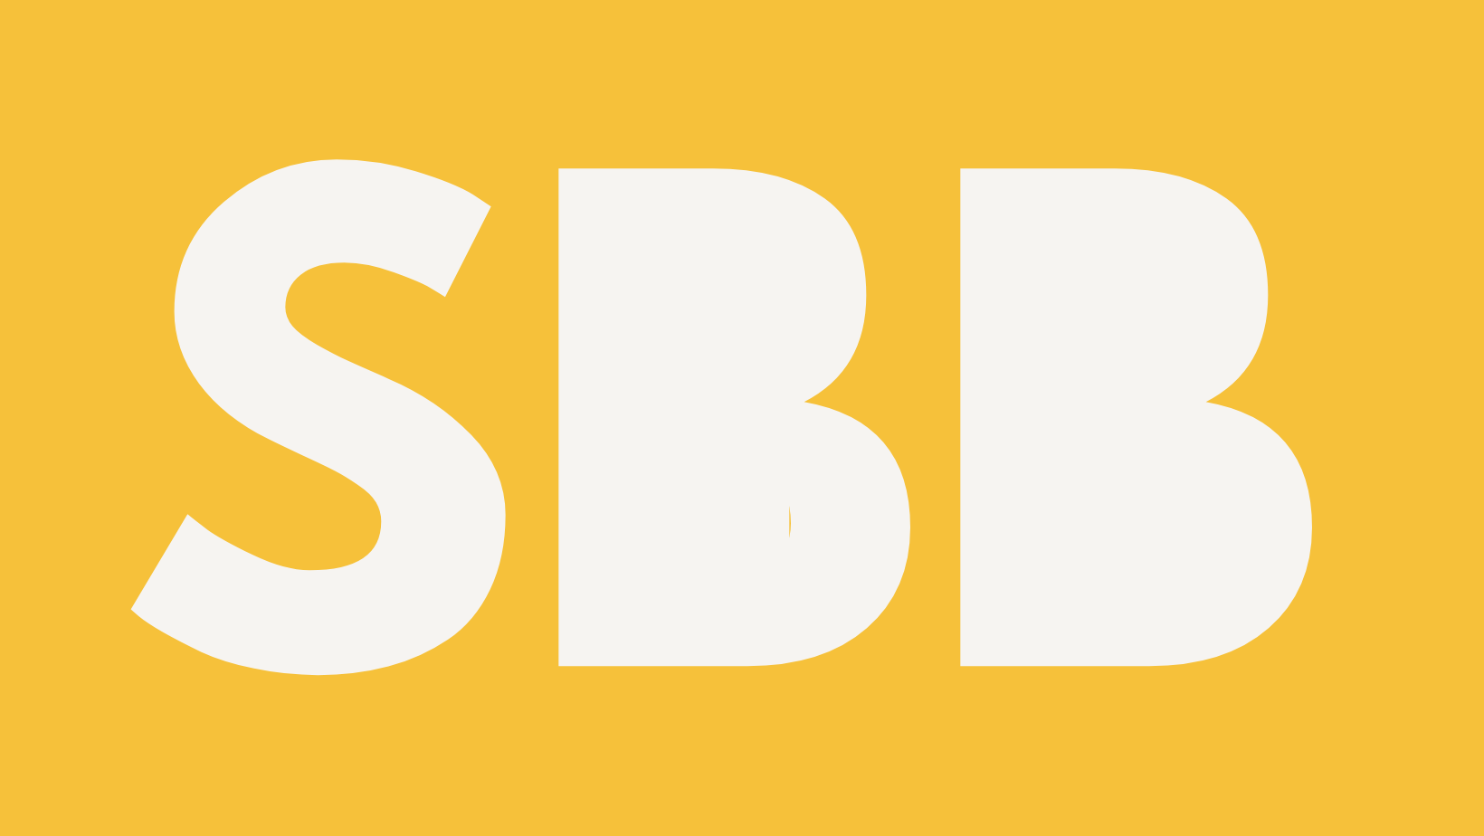
Stories Build Businesses – Website Terms of Use
This Agreement is between Megan Wright trading as Stories Build Businesses (“the Company”) and any person accessing or using the website (“the User”). Together, “the Parties.”

1. Scope
These Terms set out how you may use the website storiesbuildbusinesses.com (“the Site”) and any linked subdomains or pages operated by the Company.
By using or accessing the Site, you agree to comply with these Terms in full.
If you do not agree, you must stop using the Site immediately.

2. Eligibility and Access
The Site is designed for users aged 18 and over and is primarily directed to visitors located in the United Kingdom.
The Company may restrict or suspend access to the Site at any time for maintenance, updates, or any other reason.
The Company is not responsible for the Site being unavailable for any period of time.
You are responsible for configuring your device, software, and internet connection to access the Site safely. The Company cannot guarantee that the Site or its servers are free from viruses or errors. You should always use your own virus protection software.

3. Acceptable Use
When using the Site, you agree:
- Not to copy, reproduce, or distribute any part of the Site without prior written consent;
- Not to use the Site for unlawful purposes or to send or upload harmful, defamatory, or misleading content;
- Not to attempt to gain unauthorised access to any part of the Site, the server on which it is hosted, or any associated databases;
- Not to use the Site in a way that could damage, disable, or impair its functionality for other users.
The Company reserves the right to block or remove access to users who breach these Terms.

4. Intellectual Property
All content, text, graphics, photos, audio, video, frameworks, and downloadable materials on the Site are the intellectual property of the Company unless otherwise stated.
You are granted a limited, revocable licence to view and use the content for personal and non-commercial purposes. You must not:
- Reproduce, sell, or exploit any content for commercial gain;
- Copy or adapt frameworks, methodologies, or branded materials;
- Remove copyright notices or claim any ownership of the content.
Where quoting or linking to Site content, you must credit Stories Build Businesses and include a clear hyperlink to the original source.

5. Third-Party Links and Resources
The Site may include links to third-party websites or resources. These are provided for convenience only.
The Company does not control or endorse third-party content and is not responsible for its accuracy, legality, or availability.
Users access third-party links at their own risk.
If the Company receives commission through affiliate links, this will be clearly disclosed on the relevant page.

6. Disclaimers
The information on this Site and related social channels is provided for general education and information only.
Nothing on this Site constitutes business, financial, legal, or medical advice. You should always seek professional advice specific to your circumstances.
While the Company makes reasonable efforts to keep information accurate and up to date, no guarantees are made as to completeness, accuracy, or fitness for a particular purpose.
The Company is not responsible for:
- Loss, damage, or costs arising from reliance on Site content;
- Technical failures or interruptions;
- Losses caused by events beyond its reasonable control.
Nothing in these Terms limits liability for death, personal injury, or fraud.

7. Data Protection and Privacy
The Company handles personal data in accordance with UK data-protection law and its Privacy Policy.
By using the Site, you acknowledge and consent to this processing of personal data.

8. Cookies
The Site uses cookies to enhance user experience, track performance, and support analytics and marketing.
You can manage or disable cookies in your browser settings.
Some parts of the Site may not function properly without essential cookies.
For more detail, see our Cookies Notice and Privacy Policy.

9. Liability
The Company will not be liable for:
- Business interruption, profit loss, or data loss;
- Damage to equipment, software, or digital content caused by viruses or technical faults beyond its control;
- Reliance on advice, guidance, or opinion presented on the Site.
If defective digital content supplied through the Site damages your device or digital property and this is caused by our failure to use reasonable care and skill, we will repair the damage or pay you compensation, in accordance with UK consumer law.

10. Suspension and Termination
The Company may suspend or permanently block your access to the Site if it reasonably believes you have violated these Terms or engaged in misuse.
Such action may be taken without prior notice.

11. Governing Law and Jurisdiction
These Terms are governed by the laws of England and Wales.
Any disputes arising under or in connection with them will be subject to the exclusive jurisdiction of the courts of England and Wales.

12. Acceptance
By using this Site, you confirm that you have read, understood, and agree to these Terms of Use.

