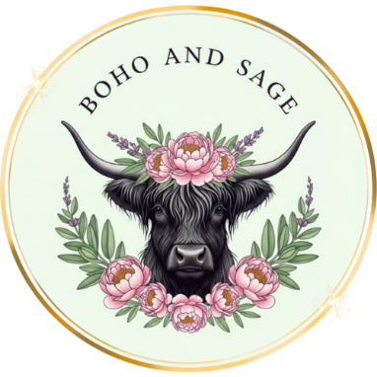

Privacy
Boho & Sage respects your privacy and is committed to protecting your personal information in accordance with the Privacy Act 1988 (Cth). Personal information collected through enquiries, bookings, or our website (including name, contact details, event information, and payment details) is used solely to manage bookings, provide services, process payments, and communicate with clients. We do not sell or share personal information except where required to deliver our services or by law.

Bookings & Payments
- A 20% non-refundable deposit is required to confirm the event date and time.
- The remaining balance is due 3 days prior to the event date.
- Bookings are not confirmed until the deposit has been received.
- Prices are subject to change until a booking is confirmed.

Cancellations & Rescheduling
- Deposits are non-refundable.
- Cancellations made within 3 days of the event may forfeit full payment.
- Rescheduling may be offered at our discretion and is subject to availability.
- Weather-related events are assessed case by case; alternative arrangements or credits may be offered where possible.

Events, Picnics & Locations
- Clients are responsible for ensuring the chosen location is accessible, suitable, and approved where required.
- Boho & Sage is not responsible for venue restrictions, weather conditions, or third-party interruptions beyond our control.
- Event setup and pack-down times are included unless otherwise agreed in writing.

Weddings & Corporate Events
- Final guest numbers, menu selections, and event details must be confirmed prior to the final payment date.
- Any changes after confirmation may incur additional fees.
- Corporate and wedding bookings may require additional setup, staffing, or travel fees, which will be outlined at the time of booking.

Markets & Public Events
- Menu items, availability, and pricing may vary at markets and public events.
- All food is prepared and served in accordance with food safety regulations.

Food & Allergens
Our food may contain or come into contact with common allergens including dairy, gluten, nuts, and meats. While care is taken, we cannot guarantee an allergen-free environment. Clients must notify us of any dietary requirements or allergies prior to the event.

Website Content
All content on this website, including images, text, logos, and designs, is the property of Boho & Sage and may not be reproduced without written permission.

Limitation of Liability
Boho & Sage is not liable for loss, damage, or injury resulting from factors outside our control, including weather, venue conditions, or undisclosed allergies.

Governing Law
These terms are governed by the laws of Queensland, Australia.

