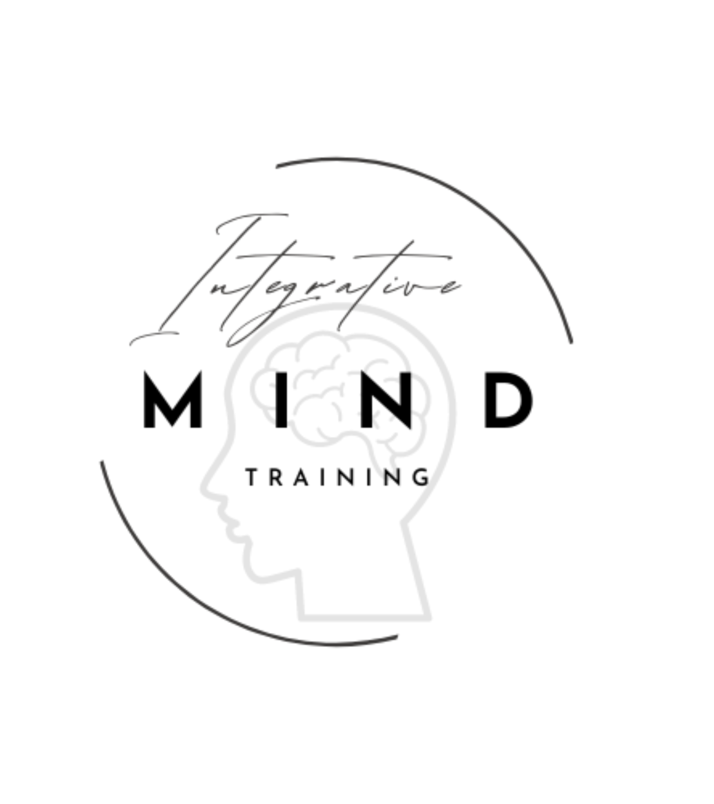

Pathways to Mastery: Choosing Your Training Experience

Integrative Mind Training Certification Program
At Integrative Mind Training, we offer two distinct pathways to your professional certification. Both meet the full IACT 220-hour requirement and provide a Master’s Level education in hypnotherapy. Whether you thrive in a collaborative group setting or require the flexible, high-touch environment of a private mentorship, your journey to becoming a Master of the Mind starts here.

Option 1: The Professional Certification Program
The Collaborative Standard | $5,500
This 6-month immersive experience is designed for those who value learning within a community of peers. You will master the clinical foundations of hypnosis through a blend of academic study and live, interactive breakout sessions.
- Live Group Dynamics: During your weekly live training, you will join dynamic breakout groups to physically practice that month’s techniques. Whether you are perfecting the "Big Five" inductions or practicing advanced deepening techniques, you gain experience both as the hypnotist and the subject.
- Comprehensive Resources: You will receive the official IMT Student Manual and a specialized Study Guide designed to prepare you for both the mini-quizzes and the final 80% passing standard certification exam.
- Module Mastery: Each technical module concludes with a comprehensive review to ensure the concepts are "in your bones" before moving to the next level of training.

Option 2: The Executive 1-on-1 Mentorship
The Elite Fast-Track | $9,700
This is a high-touch, high-accountability program designed for professionals with demanding schedules—such as those in medical, legal, or on-call roles—who require ultimate flexibility without compromising on depth.
- Maximum Flexibility: If your professional schedule prevents you from attending the standard live group times, this mentorship allows you to fulfill your 110 live hours through private sessions scheduled directly with Erika.
- High-Touch Mastery: You receive two 90-minute private sessions per week with Erika S. Grant. This time is dedicated to:
  - Answering complex clinical questions.
  - Direct, 1-on-1 practice of inductions and intervention protocols.
  - Tailoring the training to your specific practice goals (e.g., integrating into a neurology clinic).
- All-Access Integration: The Mentorship includes full access to the 6-month group program. At any time, you are welcome to jump into the live group training to experience different personalities and breakout scenarios.
- Concierge Accountability: This path offers an elite level of oversight. Erika works with you to ensure you are meeting your practice-hour milestones and refining your case studies to the highest professional standard.

Summary of Benefits (Both Pathways)
- Full IACT Membership: Your first year of membership is included upon passing your exam.
- 90-Day Exam Window: You have three months and three attempts to complete your certification after the course ends.
- The "Big Five" Mastery: Both paths guarantee expertise in Progressive Relaxation, Guided Imagery, Focusing, Elman, and the Director Technique.

