FOR IMMEDIATE RELEASE  Contact:  Brandy Vega  Founder – Promise2Live.org  brandy@gooddeedrevolution.org  801-637-5416 | 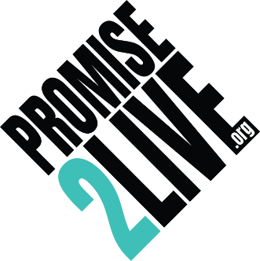

Promise2Live to Host Star-Studded Global Livestream in Hollywood
Hollywood, CA – On September 10, 2025, Promise2Live will take the global stage in Hollywood for an unforgettable livestream and gala dedicated to sharing hope, healing, and life-saving resources with millions worldwide.
The powerful, red-carpet event occurs at historic Avalon Theatre and features an inspiring lineup of advocates and entertainers, including Alison Holker, JoJo Siwa, Rob Riggle, Maroon 5 founding member Ryan Dusick, and suicide prevention advocate Kevin Hines. Many more singers, dancers, and celebrity voices will join them in sharing a single mission: saving lives through connection and community.
Following a year in which Promise2Live’s message reached over 3 million people and distributed 80,000+ “Pocket Hugs”, the 4th Annual P2L Global Livestream & Awards Show aims to surpass that impact through expanded media coverage, celebrity support and global audience participation.
“Our mission is simple but transformative,” said Brandy Vega, founder of Promise2Live. “By helping people commit, connect, and build community, we create real action and accountability before someone reaches a moment of crisis.”
The Promise2Live Mission: The Three Cs
- Commitment – Inspiring individuals to make the Promise2Live, moving from awareness to action.
- Connect – Linking people with trusted resources from vetted partner organizations.
- Community – Creating a global network of support, both online and in person.
How to Join the Movement:
- Attend or Watch Live: Join us in Hollywood or watch the event at promise2live.org
- Partner or Sponsor: Align your brand with a mission to save lives while reaching millions
- Host a Watch Party: Gather friends, family, schools, or workplaces to participate together
- Stream on Your Platform: Share the event on your social media with your followers to expand the reach
- Be an Advocate: Spread the word and invite others to make the Promise2Live
“This is more than an event; it’s a global movement,” added Vega. “Every voice matters, and together we can make the difference that saves a life.”
EVENT DETAILS:
Date: September 10, 2025
Location: The Avalon Theatre, Hollywood, Calif. & Global Livestream
Tickets & Info: https://e.givesmart.com/events/Iso/?isOrderFormActive=true
MEDIA INVITATION
We invite the media to attend and cover this impactful and inspiring event. The Promise2Live Gala offers powerful human-interest stories, emotional performances, and firsthand access to thought leaders and advocates in mental health and suicide prevention. However, space is limited, and media credentials are required—all media must RSVP directly to Brandy Vega at brandy@gooddeedrevolution.org or 801-637-5416 to secure press access and interview opportunities.

About Promise2Live.org
Promise2Live.org is a global mental health movement dedicated to suicide prevention through personal commitment, education, and community connection. By encouraging individuals to make a promise, seek help, stay connected, and support others, the organization aims to save lives and reduce the stigma surrounding mental health struggles.
###

