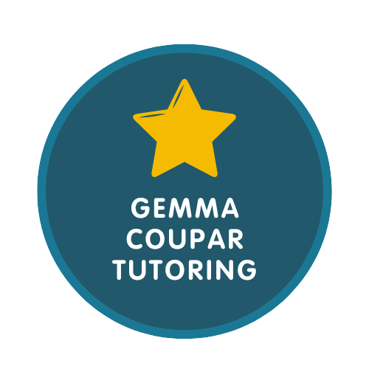
Privacy Policy

Gemma Coupar Tutoring Customer Privacy Notice

This privacy notice tells you what to expect us to do with your personal information.
- Contact details
- What information we collect, use, and why
- Lawful bases and data protection rights
- Where we get personal information from
- How long we keep information
- How to complain

Contact details

Data Protection Contact: Gemma Coupar

Telephone: 07813 192165

Email: gemma@gemmacoupartutoring.co.uk

What information we collect, use, and why
We collect or use the following information for student education and welfare:
- Names and contact details for students/children
- Names and contact details for parents/carers
- Date of birth of student
- School and year group
- Dietary requirements (including vegetarian, vegan, gluten/dairy free and halal requirements)
- Health information
- Payment details and financial information including transactions
- Special Educational Needs and Disabilities (SEND) or additional support information (includes reasonable adjustments and special educational needs and disabilities)
- Photographs
- School Progress reports if shared by parents/carers
We collect or use the following information for information updates or marketing purposes:
- Names and contact details
- Marketing preferences
- Records of consent, where appropriate
- Email addresses
We collect or use the following information to comply with legal requirements:
- Safeguarding information
- Any other personal information required to comply with legal obligations

Lawful bases and data protection rights
Under UK data protection law, we must have a lawful basis for collecting and using your personal information. There is a list of possible lawful bases in the UK GDPR. You can find out more about lawful bases on the ICO website.
Which lawful basis we rely on may affect your data protection rights which are in brief set out below. You can find out more about your data protection rights and the exemptions which may apply on the ICO website:
- Your right of access - You have the right to ask us for copies of your personal information. You can request other information such as details about where we get personal information from and who we share personal information with. There are some exemptions which means you may not receive all the information you ask for. You can read more about this right here.
- Your right to rectification - You have the right to ask us to correct or delete personal information you think is inaccurate or incomplete. You can read more about this right here.
- Your right to erasure - You have the right to ask us to delete your personal information. You can read more about this right here.
- Your right to restriction of processing - You have the right to ask us to limit how we can use your personal information. You can read more about this right here.
- Your right to object to processing - You have the right to object to the processing of your personal data. You can read more about this right here.
- Your right to data portability - You have the right to ask that we transfer the personal information you gave us to another organisation, or to you. You can read more about this right here.
- Your right to withdraw consent - When we use consent as our lawful basis you have the right to withdraw your consent at any time. You can read more about this right here.
If you make a request, we must respond to you without undue delay and in any event within one month.
To make a data protection rights request, please contact us using the contact details at the top of this privacy notice.

Our lawful bases for the collection and use of your data
Our lawful bases for collecting or using personal information for student education and welfare are:
- Consent - we have permission from you after we gave you all the relevant information. All of your data protection rights may apply, except the right to object. To be clear, you do have the right to withdraw your consent at any time.
- Knowing information about the level the students are working at, or any additional support needs they have, helps us to understand the best way to support the students we work with.
Our lawful bases for collecting or using personal information for information updates or marketing purposes are:
- Consent - we have permission from you after we gave you all the relevant information. All of your data protection rights may apply, except the right to object. To be clear, you do have the right to withdraw your consent at any time.
Our lawful bases for collecting or using personal information to comply with legal requirements are:
- Consent - we have permission from you after we gave you all the relevant information. All of your data protection rights may apply, except the right to object. To be clear, you do have the right to withdraw your consent at any time.
- Contract - we have to collect or use the information so we can enter into or carry out a contract with you. All of your data protection rights may apply except the right to object.

Where we get personal information from
- Parents or carers

How long we keep information

Data management and retention

UK GDPR and the DPA 2018 require us to actively manage data and ensure it is retained for the minimum period possible.

Financial Records: We will retain your financial data for up to 18 months to ensure we can complete our legal requirement to file our annual tax return. For all other data, we will archive any accounts we have set up with you and remove any personal data within 1 month of your contract ending.

Client/Customer Data: Retained for the life of the business relationship and subject to the retention periods above

Marketing Data: Relationships with prospective clients may exist for some years via our social media marketing and email marketing systems. The option to unsubscribe from communications is always provided.

Educational Records: Retained for duration of tutoring relationship plus 6 years for safeguarding purposes.

Safeguarding Records: Retained indefinitely where serious concerns identified, otherwise 6 years after child reaches 18.

How to complain
If you have any concerns about our use of your personal data, you can make a complaint to us using the contact details at the top of this privacy notice.
If you remain unhappy with how we have used your data after raising a complaint with us, you can also complain to the ICO.
The ICO address:
Information Commissioners Office
Wycliffe House
Water Lane
Wilmslow
Cheshire
SK9 5AF
Helpline number: 0303 123 1113
Website: https://www.ico.org.uk/make-a-complaint

Last updated
27th November 2025

