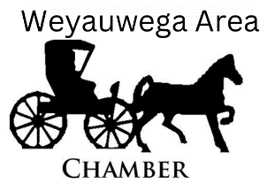
PO Box 531 Weyauwega, WI 54983
920.209.4405 (can text)
weyauwegachamberinfo@gmail.com
Find us on Facebook

Horse and Buggy Days
September 14, 2024
Art, Craft, Vendor
Registration
Booth Size 10X10 - $10

Fill out the registration form and send payment to reserve your space today!

- All registrations must be paid in advance – No Refunds
- Exhibitors are responsible for the set-up, maintenance and safety of their own exhibit. Exhibitors display and exhibit properly at their own risk. W.A.C.C. assumes no responsibility for lost, stolen or damaged articles.
- W.A.C.C. is not liable for any injury occurring during the event.
- All booths must be set up and ready by 8:00 a.m. on the day of the event.
- Solicitations or demonstrations by exhibitors must be confined within the bounds of the exhibitor’s own booth. Aisle space shall not be used for exhibit purposes, sign display, solicitation or distribution of promotional material.

Vendor and space subject to Chamber approval. We will allow only one exhibitor per brand. Confirmation & Booth# will be mailed to you.
Please provide your own tables, tents and seating.
Name: _________________________________________Craft/Product: __________________________________________ Phone: _________________________________Address: ________________________________________________________
# of Booths ____________________ ($10 Each) @ Total due: $________________________
Mail Check or Money Order to:
Weyauwega Area Chamber of Commerce – P.O. Box 531 – Weyauwega, WI 54983
Call: 920-209-4405 or email weyauwegachamberinfo@gmail.com

