
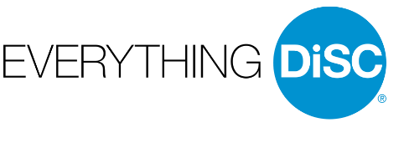
SCAVENGER HUNT
New Everything DiSC
Learning
For You!

New Ways to Love Everything DiSC!

In the past, you completed an Everything DiSC Profile to learn about your strengths, the styles of your coworkers, and ways to adapt to build stronger relationships. We are pleased to announce that you now have access to Catalyst, a robust, online platform that provides a deeper DiSC dive:
- Learn more about your style, motivators, and stressors to be your best every day
- Create comparisons with your coworkers to get personalized recommendations for building connections, handling tense situations, and influencing others
- Get insights about your work groups and ideas for strengthening communication and decision making as a team

You have received an email to upgrade your DiSC Profile and to access the Catalyst system. The upgrade questionnaire takes about 10 minutes. You will have immediate access to Catalyst as soon as you answer the questions.

YOUR CHANCE TO WIN A FABULOUS PRIZE

We are so excited about this new opportunity that we have created this Scavenger Hunt to help you explore the Catalyst system. Send your completed Scavenger Hunt to [NAME] by [DATE] to be eligible to win a [PRIZE]. Please complete your upgrade by [DATE] to take advantage of this valuable tool.

Step One: Discover your Motivators and Stressors
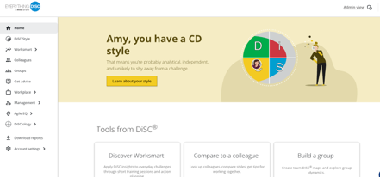
- Log on to Catalyst at https://catalyst.everythingdisc.com/login
Use the Forgot Password option if you do not remember your password
- On the Home Page, choose Learn About Your Style.
Read about your DiSC style.
- Scroll to the bottom of the page, select What Drives You to read about your Priorities, Motivators and Stressors and complete the table below.

What motivates you? | What is stressful for you?
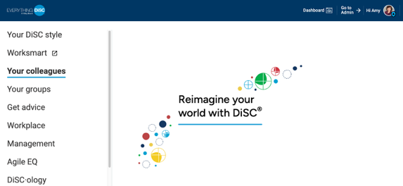
Step Two: Gain Insight About a Colleague

- Use the menu in the upper right corner and select Your Colleagues
- Search for a Colleague to learn about their style, your similarities, and your differences.
- Scroll to the bottom of the comparison screen and get tips for Working Together. Click on the tabs and complete the table below.

How can you and Your Colleague best work together?
In tense situations? | When trying to connect? | To collaborate? | To get their buy-in?

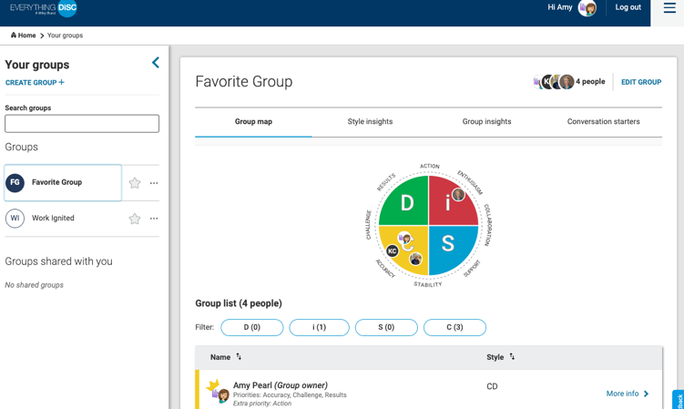
Step Three: Create a Group

- Use the menu in the upper right corner and select Your Groups
- Select CREATE GROUP +
- Complete the screens to name your Group and add team members.
- Use the insight provided to complete the table below.

View your Group Map  What do you notice about  the style of your Group? | Select Style Insights and Group Insights  How might your style best contribute to your Group?  How might your style negatively impact your Group?

Share your findings with your manager to identify ways you can be your best.
Submit your completed Scavenger Hunt by [DATE]
for a chance to win FABULOUS PRIZES!

