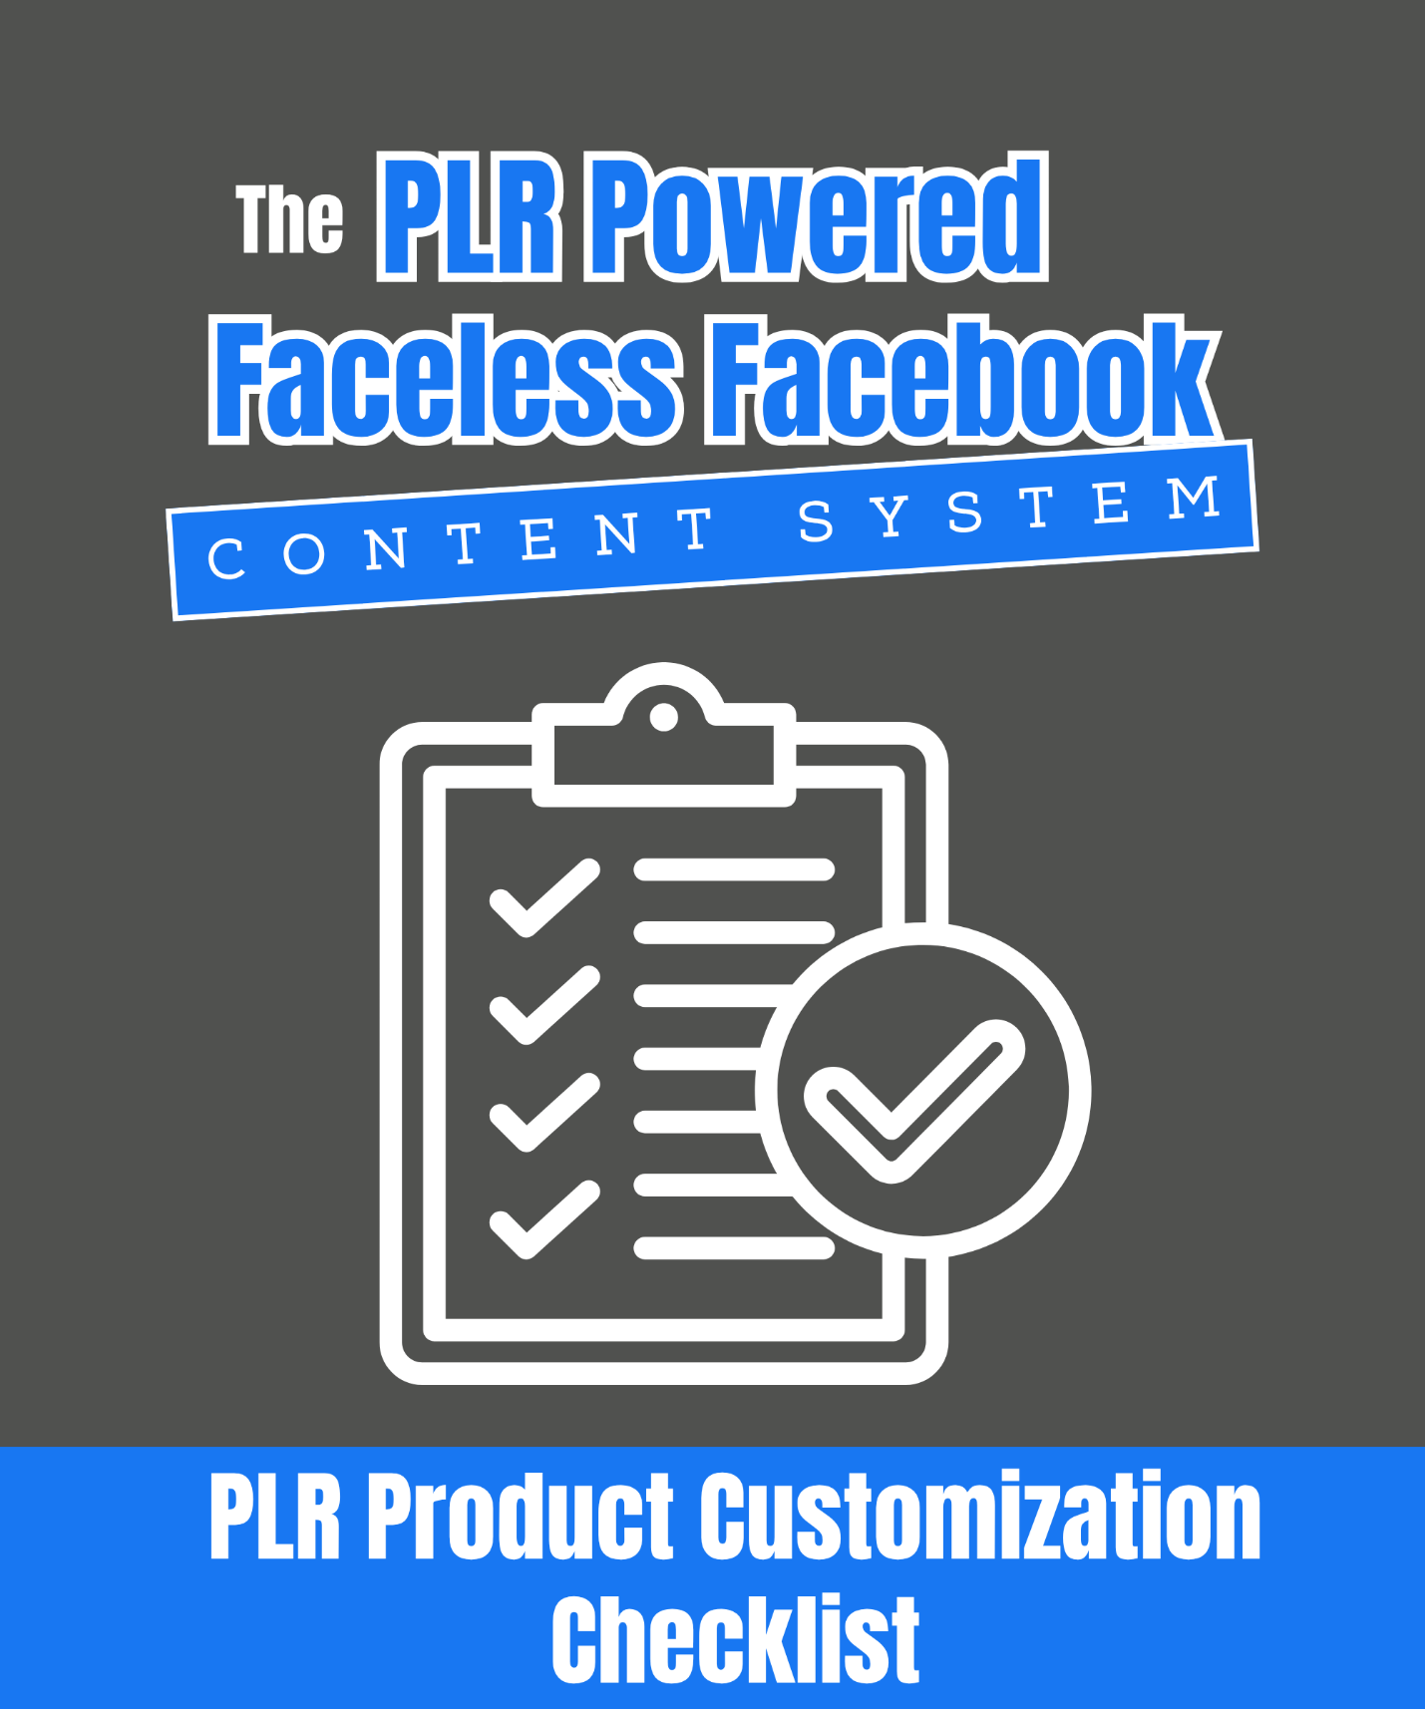
The PLR Powered Faceless Facebook Content System PLR Product Customization Checklist
Customize Your PLR And Get It Ready To Sell... The Right Way!

This checklist walks you through the exact steps to turn a PLR product into something you can confidently put your name (or faceless brand) on and sell.

You’ll learn how to…

- Make the content look and feel original

- Add simple visual branding (even if you’re not showing your face)

- Package your offer so it’s actually worth paying for

Think of this like your “PLR Product Finishing School”. Every item you check off brings you closer to launching a polished, professional offer.

🧩 Use it anytime you’re turning PLR into a paid product

🖼️ Customize what matters (and skip what doesn’t)

💸 Launch with confidence knowing it’s done right

Most people sit on PLR because they feel like it’s not “ready.” This checklist gives you a process to make it ready quickly!

Whether it’s an ebook, a toolkit, or a mini-course, or anything else you create this is the shortcut to going from “raw PLR” to “money-making offer.”

Let’s go…

Step 1: Review And Outline

- Read through the PLR product completely to understand its flow and value.

- Outline the content (chapters, sections, key points). This helps you see where updates or additions are needed.

- Decide on the main outcome your product delivers (e.g., “Teach busy moms how to meal prep in 15 minutes a day”).

Step 2: Rewrite for Your Voice

- Rewrite the title and subtitle to make it benefit-driven and engaging.

- Rewrite the introduction and conclusion in your own words, adding your perspective or story.

- Adjust headings and subheadings to be more eye-catching and aligned with your brand tone.

- Replace any outdated references or stats with current information.

- Add personal insights, examples, or bonus tips to make it feel original.

Step 3: Add Value And Extras

- Include checklists, worksheets, or templates (create your own or pull from other PLR packs).

- Add a quick-start guide or “action plan” section for instant implementation.

- Include a resource list (tools, apps, websites) relevant to the topic.

- Bundle with related PLR content (e.g., a main guide + a checklist + a cheat sheet).

Step 4: Brand Your Product

- Create a new product cover in Canva with your colors, fonts, and logo.

- Add your branding to headers and footers (page numbers, logos, website link).

- Use consistent fonts, colors, and imagery throughout the document.

- Insert a disclaimer and copyright page with your business name.

Step 5: Optimize For Digital Use

- Save as a PDF for easy distribution.

- Add clickable links for any resources or CTAs.

- Ensure the file is mobile-friendly (readable on phones and tablets).

Step 6: Create Sales And Delivery Assets

- Write a benefit-focused product description for your sales page.

- Design 3–5 promotional graphics (mockups, quote images, highlights).

- Set up delivery automation (Gumroad, Payhip, ThriveCart, etc.) to instantly deliver the product upon purchase.

Pro Tip: Even small updates (like rewriting headlines and adding your brand) make a massive difference. Your goal is to make the PLR product feel custom-built for your audience and not something anyone else could sell as-is.

