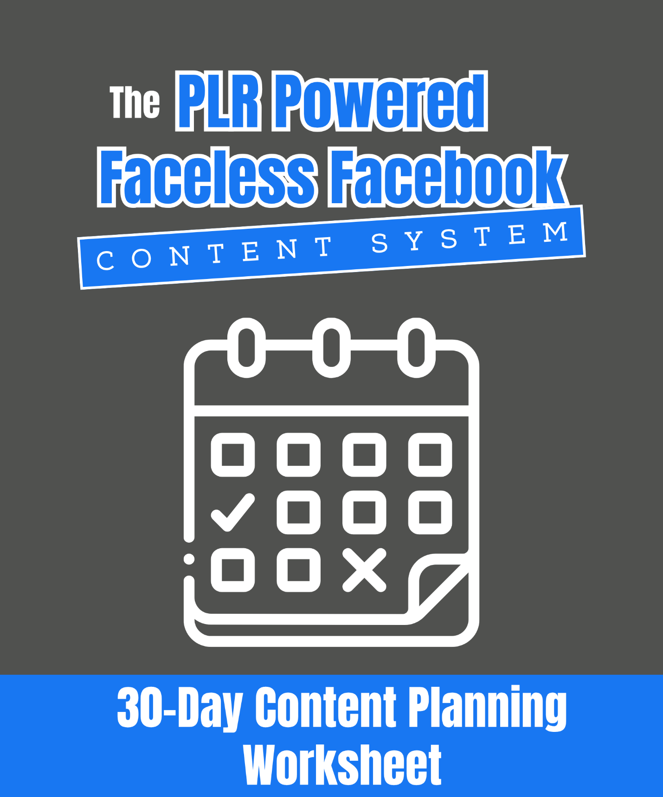

The PLR Powered Faceless Facebook Content System 30-Day Content Planning Worksheet
Plan Your Month Of Content Using Your PLR Library

Use this worksheet to plan 30 days of content that mix value, engagement, and promotions all powered by your PLR library!

Step 1: Define Your Content Goals for the Month

This month, I want my content to:

- Grow my audience

- Build my email list

- Promote my product

- Increase engagement

- Other: ________________________________________________________________________

Step 2: Choose Your Post Types

I will post regularly using these formats:

- Quick tips or hacks

- Carousels (step-by-step)

- Quotes or inspiration

- Checklists or graphics

- Polls or engagement questions

- Promotional posts (freebie or product)

- Other: _______________________________________________________________________

Step 3: Pull Content From Your PLR Library

Go through your PLR packs and list 30 post ideas (mixing value, engagement, and promotional posts):

Day | Post Idea (From PLR) | Post Type | Caption/Hook Idea | CTA

Step 4: Assign Promotion Days

Choose which days will focus on promoting your freebie or product:

Freebie Promo Days:

- Monday

- Tuesday

- Wednesday

- Thursday

- Friday

- Saturday

- Sunday

Product Promo Days:

- Monday

- Tuesday

- Wednesday

- Thursday

- Friday

- Saturday

- Sunday

Step 5: Schedule And Automate

- Schedule posts using Facebook’s built-in scheduler.

- Set aside time for engagement (replying to comments, posting in groups, etc.).

Pro Tip: Aim for an 80/20 balance: 80% value/engagement posts and 20% promotional posts. Use your PLR to fill your calendar fast — no starting from scratch.

