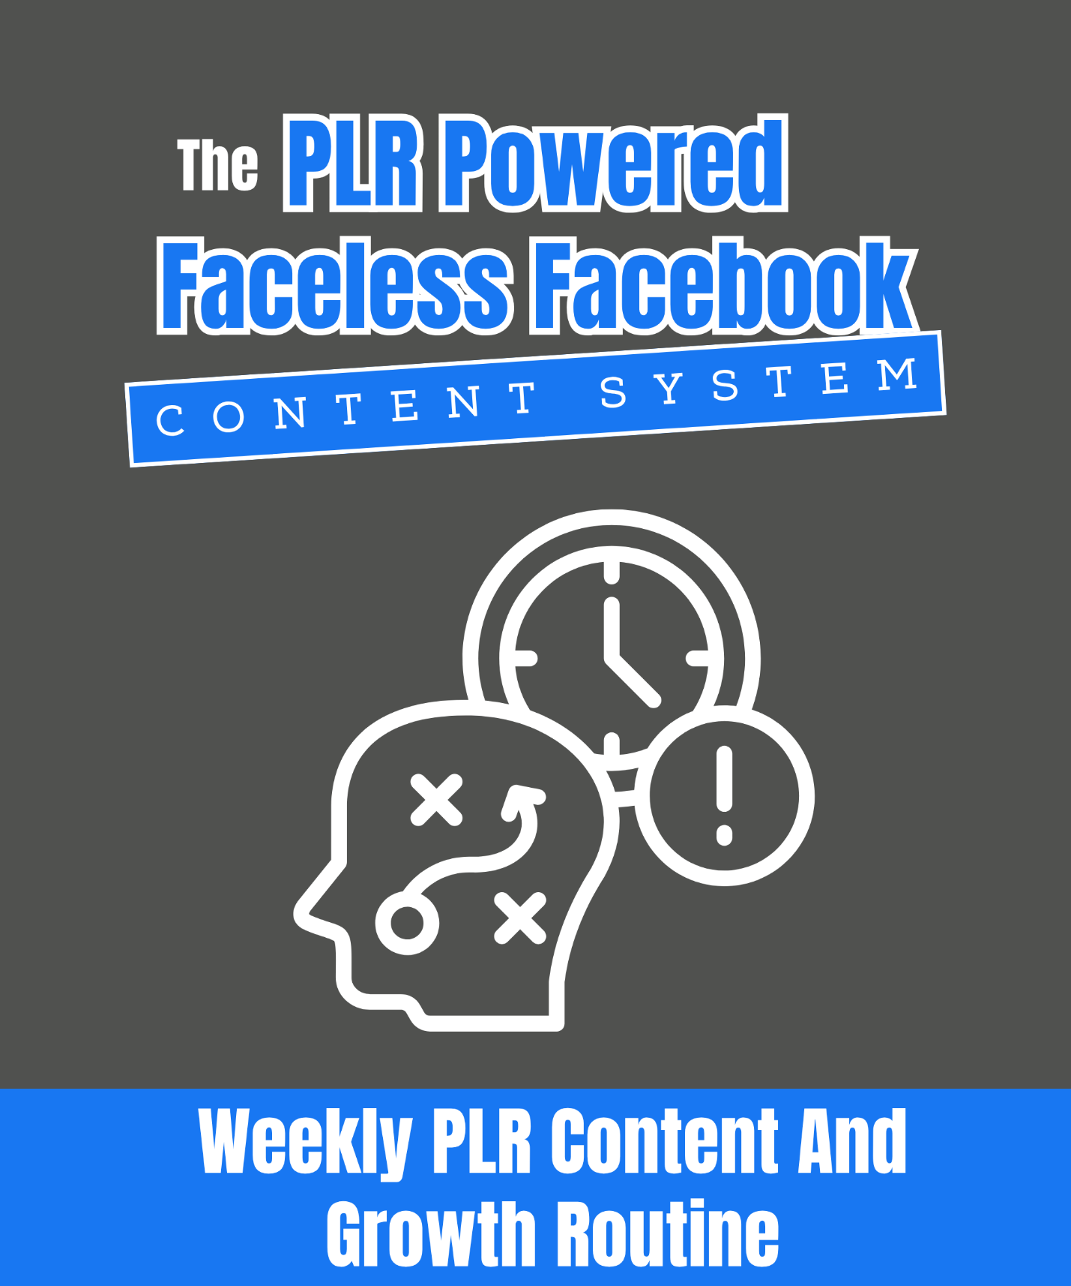
The PLR Powered Faceless Facebook Content System Weekly PLR Content And Growth Routine
Stay Consistent. Stay Visible. Grow Every Week! (Without Burning Out!)

This routine is your go-to weekly checklist for running a faceless Facebook page using PLR.

It keeps your content flowing, your audience engaged, and your monetization goals in motion even if you're doing this in just a few hours per week.

Each task is intentional. Each step helps you build momentum. And since you’re using PLR, you’re never starting from scratch.

Use this checklist at the start of every week

Plan, batch, and schedule smarter and not harder

📈 Watch your audience grow and your income stack

Most pages fizzle out because there’s no system. This is YOUR system! Use it, tweak it, stick with it.

You don’t need to post daily if you plan weekly. This routine helps you show up consistently, without content stress.

1. Batch Your Content (3–4 Hours)

- Pull 5–10 tips, steps, or quotes from your PLR library for this week’s posts.

- Rewrite or enhance each snippet for your page’s tone (use AI if needed).

- Create graphics or carousels in Canva using your branding.

- Write short, engaging captions for each post.

2. Plan Your Promotions (1-2 Hours)

- Select 1–2 posts to promote your freebie (use snippets from the freebie itself).

- Select 1 post to promote your product (pull a key tip or “teaser” from the product).

- Add a clear CTA (download, buy, comment, or share).

3. Schedule Your Content (1 Hour)

- Post 3–5 value-focused posts (tips, tutorials, quotes).

- Post 1 engagement-focused post (poll, question, or myth-busting).

- Post 1 promotional post (freebie, product, or affiliate offer).

- Use Facebook’s built-in scheduler to plan posts for the entire week.

4. Check Your Metrics (30 Minutes)

- Review your page insights:

Which posts had the most engagement?

Which posts drove clicks to your freebie/product?

- Note top-performing post types and topics for future content.

5. Refresh Your Library (Monthly)

- Add new PLR packs to your collection for fresh ideas.

- Repurpose old posts into new formats (e.g., turn a tip post into a carousel or video script).

- Update seasonal/holiday posts with relevant PLR.

Pro Tip: Stick to this routine each week. Over time, you’ll build a library of proven, high-performing content and a page that grows steadily all without creating content from scratch.

