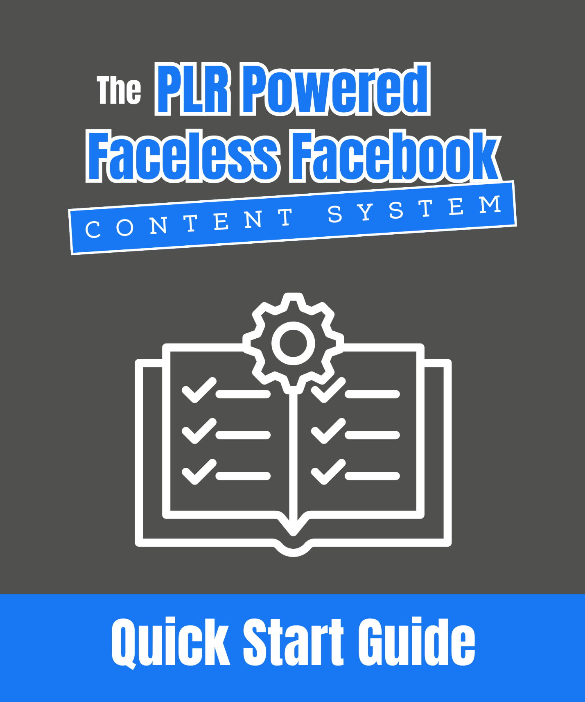

The PLR Powered Faceless Facebook Content System Quick Start Guide!

Introduction: Why PLR + Faceless Pages Is A Game-Changer!

Faceless Facebook pages are one of the easiest ways to build a presence online without putting yourself out there personally. You do not need to show your face, create original content from scratch, or even use your real name. Combine this with the power of PLR (Private Label Rights) content, and you can create a fully functioning content and monetization system in record time for your Faceless Facebook Page!

Side Note: If you've been wanting to make money with a Faceless Facebook Page, but don't know how to do it, I highly recommend getting My Socials Pay and going through it from start to finish.

It's literally THE best course to learn how to make money with a Faceless Facebook Page! Check it out at http://www.LizTomey.com/MySocialsPay

Now, this guide will walk you through how to use PLR to consistently post engaging content, grow an audience with that content, and monetize your Faceless Facebook Page!

Let’s get started…

Step 1: Understanding PLR For Faceless Facebook Pages

For those who don’t know… PLR content is pre-made content that you can edit, rebrand, and use as your own. It comes in many forms like articles, ebooks, videos, reports, checklists, graphics, videos, social media content, and so many more content types.

For Facbless Facebook Pages, PLR is a goldmine because...

1. It saves time because you don't have to start from scratch!

2. It gives you a constant flow of content ideas.

3. It can be repurposed into multiple content formats (posts, carousels, short videos).

Your goal here is to take PLR and make it look fresh, branded, and made for your audience and USE it to make money with your Faceless Facebook Page!

Step 2: Turning PLR Into Content For Your Faceless Facebook Page

To keep your Facebook page active and engaging, post a mix of content types. You can use PLR to create all kinds of posts that get attention and engagement.

Here are several ideas to get you started…

Side Note: I've put these in categories to help you use different PLR for different strategies you'll use in your Facebook Page.

Visual = Eye-catching and shareable

Engagement = Boosts interaction and reach

Value-Packed = Establishes you as helpful

Series = Builds habits and repeat visits

A. Visual Posts (Great For Shares And Saves)

These are highly visual and encourage people to share or save them.

Quote And Motivation Graphics – Pull quotes or powerful statements from PLR and create simple graphics in Canva.

Carousel Or Slideshow Posts – Turn long PLR lists or steps into multi-slide posts.

Infographics And Data Visuals – Use PLR stats or tips to create quick “did you know?” charts or diagrams.

Cheat Sheets And Quick Reference Graphics – Convert checklists or bullet points into one-page, save-worthy graphics.

Before And After Style Posts – Show a “problem vs. solution” transformation based on PLR advice.

B. Engagement Posts (Boost Interaction)

These posts get people to comment, click, or react.

Polls And Opinion Questions – Use PLR points to spark conversations (Example: “Which of these 3 tips do you use the most?”).

Myth-Busting Content – Post “Myth vs. Fact” graphics or captions based on PLR misconceptions.

Interactive Quizzes – Turn PLR guides into short “Which type are you?” style quizzes.

FAQ Posts – Extract common questions and answers from PLR for quick Q&A posts.

C. Value-Packed Posts (Position You As A Resource)

These give your audience something actionable or educational.

Quick Tips And Hacks – Break PLR articles into bite-sized tips (1 post per tip).

Micro-Tutorials – Share step-by-step processes from PLR as short how-to posts or reels.

Curated Lists – Turn list-style PLR content into “Top 5” or “Best Of” posts.

Comparison Posts – Rework PLR to compare tools, methods, or approaches.

Resource Roundups – Share lists of tools or resources pulled from PLR guides.

Templates And Scripts – Extract email templates, scripts, or frameworks from PLR and share them as swipe files.

D. Series And Ongoing Content (Keeps People Coming Back)

This helps you create recurring content people look forward to.

Evergreen Weekly Series – Create recurring themes like “Tip Tuesday,” “FAQ Friday,” or “Myth Monday.”

Mini-Series – Break one PLR article into a multi-part post series (Example: “5 Days to Kickstart [Niche Goal]”).

Quick Wins/Challenges – Turn PLR guides into small daily challenges your followers can try.

Seasonal/Themed Content – Adapt PLR for holidays or events (Example: “5 Ways to Stay on Track This Summer”).

Story-Style Posts – Rework PLR anecdotes or case studies into short, relatable storytelling posts.

Bringing It All Together

The real power of Step 2 isn’t just posting more often. It’s about transforming PLR into content that feels made for your audience and works on YOUR page.

Remember:

- PLR is your raw material. It’s the starting point, not the finished product.

- Customize everything you post. Rewrite headlines, adjust examples, and brand graphics so nothing looks generic.

- Break it down for social. Long guides become short posts. Big lists become carousels. Checklists become saveable graphics.

- Match it to your page’s voice. Even if you’re faceless, your page should have a personality. Add tone, humor, or style so your content feels unique.

This is what separates a page that gets ignored from one that builds a loyal audience. You’re not just sharing any old content, you’re reshaping PLR into bite-sized, branded assets that your followers will want to engage with and share.

If you focus on customizing and repurposing instead of just copying and pasting, you’ll build a page that looks polished, original, and worth following all without having to create anything from scratch!

Now let's talk about how to monetize your Faceless Facebook Page by of course... USING PLR!

Step 3: Monetizing Your Faceless Page With PLR

Creating content grows your audience. We already know that… But growth without a plan for monetization is just vanity metrics. Your Facebook page needs to do more than get likes! It should turn followers into subscribers, customers, and eventually repeat buyers!

Hot Tip: If you're relying on JUST the Facebook Content Monetization Program to make money you may be waiting a VERY long time AND one day you could wake up and be OUT of the program. Make sure you have a couple of monetization methods all setup!

PLR makes monetization simple because you can skip the creation phase and focus on customizing and delivering value.

Here are several ideas you can start using right away…

1. Create A Freebie To Build Your Email List

Why This Works: Social media is risky! Algorithms change, accounts get shut down, and you don’t own your audience. Building an email list gives you control and a direct way to make sales.

How to do it with PLR:

- Pick a short PLR guide, checklist, or cheat sheet that solves one specific pain point in your niche.

- Rewrite the intro and outro, update any outdated info, and add your branding.

- Design a simple cover in Canva.

- Use a tool like MailerLite, ConvertKit, or Aweber to create a sign-up form and thank-you page.

- Promote it on your page with posts like: “Want to finally [solve this problem]? Download our free guide here: [link].”

Example: In a fitness niche: “Download our free 7-Day Meal Prep Cheat Sheet and take the stress out of eating healthy!”

2. Sell Digital Products

Why This Works: People are willing to pay for in-depth solutions. A faceless page can sell guides, templates, and mini-courses without showing your face or being a “known expert.”

How To Do It With PLR:

- Take a PLR ebook or course and make it your own (rewrite the intro, add your branding, and adjust the design).

- Keep it focused and outcome-driven (Example: “Lose 10 Pounds in 30 Days” works better than “Weight Loss 101”).

- Sell it using simple platforms like Gumroad, Payhip, or ThriveCart.

- Drive sales by posting about it regularly!

- You can use Soft sells: Share tips from the product with a CTA to “grab the full guide.” or Direct sells: Create posts that focus on the pain points your product solves.

Example: In a budgeting niche: “Get our $17 Ultimate Monthly Budget Planner and finally take control of your finances!”

3. Build A Low-Cost Membership

Why This Works: Recurring income is powerful. Even a $7/month membership can add up fast when you grow your following.

How To Do It With PLR:

- Use PLR to create monthly resource drops (templates, guides, checklists, exclusive tips).

- Deliver through a private Facebook group, Skool, or a simple membership site (Thrive Apprentice, Kajabi, or Podia are great for this).

- Include community perks like Q&A threads or bonus tips to make it more than just “content drops.”

Example: In a parenting niche: “Join our Parenting Made Simple Membership for $9/month and get monthly checklists, activities, and parenting hacks delivered to you.”

4. Promote Affiliate Products

Why This Works: Affiliate marketing lets you earn commission without creating your own products. Your page builds trust with your audience, making recommendations feel natural.

How To Do It With PLR:

Use PLR reviews, comparisons, or “best tools” lists as the base for your posts.

Add affiliate links (via programs like Amazon Associates, ClickBank, or niche-specific products).

Create content around the products like How-to posts: “How to use [Product] to achieve [result].” or Comparison posts: “[Product A] vs. [Product B] – Which is best for you?”

Example: In a photography niche: “Check out our top 5 must-have editing tools (and why we love them).” Each tool includes an affiliate link.

5. Host Challenges Or Mini-Workshops

Why This Works: Challenges create excitement, urgency, and a sense of accomplishment making them great for warming up your audience for a paid product or membership.

How To Do It With PLR:

- Take a PLR guide and break it into 3–5 small, actionable lessons.

- Host the challenge on your page, in a Facebook group, or via email.

- Offer a paid upsell at the end (like a full course, workshop, or membership).

Example: In a self-care niche: “Join our 5-Day Stress Reset Challenge — learn simple techniques to feel calmer in just 15 minutes a day. Sign up here!”

6. Create Toolkits And Bundles

Why This Works: Bundles make your offer feel high-value and justify higher pricing.

How To Do It With PLR:

- Combine several PLR products (guides, checklists, templates) into one all-in-one toolkit.

- Give it a specific outcome-focused name.

- Use Canva to create a consistent look across all included items.

Example: In a small business niche: “The Entrepreneur’s Starter Kit: Business Plan Templates, Social Media Checklists, and Marketing Quick Wins — all in one!”

Pro Tip: Don’t try to do all of these at once. Start with one (like a freebie or a single product), build your audience, and layer in additional monetization streams over time.

Bringing It All Together

Monetizing a Faceless Facebook page with PLR isn’t about slapping a “buy now” button on random content. It’s about building a path that leads your followers from casual scrollers to committed buyers and PLR makes this so much faster.

Here’s how to think about it…

- Your content attracts them. The tips, graphics, and tutorials you post (from Step 2) draw people in and build trust.

- Your freebie captures them. A rebranded PLR checklist or guide gives them a reason to join your email list, moving them off Facebook and into your ecosystem.

- Your products and offers convert them. A well-packaged ebook, course, or toolkit (that you used PLR to create) becomes your first income stream with affiliate offers and memberships adding extra layers of revenue.

This is your monetization flow...

Engaging content (you can use PLR to create this) → Freebie lead magnet (you can use PLR to create this too) → Low-cost product or affiliate offer (you can use PLR to create this also) → Membership, bundles, or higher-ticket upsells (you can use PLR to create these too!).

The key? Keep it simple at first. Start with one lead magnet and one product. As your audience grows, layer on additional offers like challenges, toolkits, and memberships.

When you treat PLR as a toolbox instead of a finished product, you can create a full monetization system without endless content creation or showing your face!

Step 4: Making Your PLR Content Look Unique

Even though you’re running a Faceless Facebook Page, you don’t want your content to look like it came straight from a PLR pack. If it feels generic, your followers will scroll past. The magic happens when you take PLR and reshape it to feel like it was made for your page.

Here’s how to do that...

1. Rewrite For Personality

PLR is written to appeal to the widest audience possible, which makes it bland. Rewrite intros and headlines in the tone of your page. Add a bit of humor, sass, or urgency depending on your niche’s vibe.

Example:

PLR headline: “10 Tips for Better Sleep”

Your headline: “Can’t Sleep? Try These 10 Weird Tricks That Actually Work.”

2. Add Your Branding

Even though you’re faceless, your page still needs an identity. Add your page name or a simple logo to every image and infographic. Use the same color palette for graphics to build recognition.

3. Mix And Match

Combine sections from multiple PLR pieces to create something new. For example, take tips from one guide, pair them with stats from another, and add a checklist from a third.

4. Use AI To Elevate

AI tools like ChatGPT can help you rewrite, expand, or simplify PLR so it feels conversational and ready for social media.

Example prompt: “Rewrite this article as 5 engaging Facebook carousel posts.”

5. Edit For Clarity And Flow

Many PLR products are info dumps. Cut the fluff, keep the actionable points, and break things into bite-sized chunks for posts.

Bottom line… The goal isn’t to copy and paste. It’s to customize. When done right, no one will know your content started as PLR.

Step 5: Putting It All Together – Your PLR-Powered Faceless Page System

Now that you know how to create content and monetize it, it’s time to tie everything together into a PLR-powered system that works as a machine for growth and revenue.

Here’s how to do that...

1. Gather PLR Strategically

This is about stocking up on the right PLR so you’re never starting from scratch.

Look for PLR packs that solve problems your audience cares about.

Get multiple formats: ebooks, articles, checklists, graphics, and templates so you can repurpose across content types.

Mix and match sources. Using 3–5 PLR packs gives you enough material to create unique content that doesn’t look like cookie-cutter PLR.

Example: In the fitness niche, combine a PLR meal prep guide, a workout checklist pack, and a set of motivational quotes. Now you’ve got a deep well of content for posts, freebies, and products.

2. Pick 3–5 Content Types And Build Them From PLR

Instead of creating content from scratch, use your PLR to quickly fill your posting calendar.

Quick tips and hacks → Pull from list-style PLR articles.

Carousels or slideshows → Break down step-by-step PLR guides.

Quote graphics → Use inspirational lines or stats from PLR ebooks.

Mini-tutorials → Turn “how-to” sections into short posts or quick video scripts.

Pro Tip: Keep a “PLR Master File” where you copy and paste all your favorite snippets and ideas. It makes repurposing fast!

3. Create 1 Freebie And 1 Paid Product Using PLR

This is where PLR becomes your revenue engine.

Freebie: Take a short PLR report, trim it down, rewrite the intro/outro, and brand it as your own. Use it to build your email list.

Paid Product: Turn a PLR ebook or bundle into a branded, outcome-driven product (like “The 7-Day Stress Reset Toolkit”). Add worksheets, checklists, or bonuses from other PLR to increase perceived value.

You now have a lead magnet to attract subscribers and a low-ticket product to make immediate sales all without writing from scratch.

4. Build Your PLR-Powered Funnel

Your goal isn’t just to post content. It’s to move people from followers to buyers.

Here’s the flow (and where PLR fits in):

Engaging PLR-based content → PLR-based freebie → PLR-based product → Upsell (membership, toolkit, affiliate offers).

By using PLR at each step, you’re creating a seamless journey for your audience while saving yourself time and effort.

5. Schedule And Automate Your PLR Content

PLR makes batching and automating simple…

- Batch-create content from PLR once a week (posts, graphics, email copy).

- Use Facebook’s scheduler to keep your page active.

- Automate email delivery for your freebies and product promotions using tools like MailerLite or ConvertKit.

This way, your PLR does the heavy lifting, and your system runs even when you’re offline.

The beauty of this system?

You’re not reinventing the wheel. You’re taking pre-made, high-quality PLR and transforming it into a consistent content engine and monetization funnel that runs with minimal effort!

Step 6: Your Weekly PLR Content And Growth Routine

You’ve built your PLR-powered system (Step 5), but building it once isn’t enough. The pages that actually grow and make money are the ones with a simple, repeatable routine for posting, tracking, and refining their strategy.

This is where PLR shines! It gives you an endless content bank so you can stay consistent without burning out.

Here’s your Weekly PLR Content And Growth Routine…

1. Batch Your Content (3-4 Hours Weekly)

Consistency is easier when you prep in batches!

Once a week, sit down with your PLR library and:

- Pick 5–10 snippets (tips, quotes, steps) from your PLR.

- Create graphics or carousels in Canva using your brand colors/logo.

- Write captions for each post (use AI to rewrite for your page’s tone).

- Pull 1–2 promotional snippets from your PLR products or freebies for soft-sell posts.

Result: You’ll have a week’s worth of content ready in one sitting.

2. Schedule Your Content (1 Hour)

Use Facebook’s built-in scheduler to plan out your week.

Aim for:

- 3–5 value posts (quick tips, tutorials, or carousels).

- 1 engagement post (poll, question, or myth-busting).

- 1 promotional post (freebie, product, or affiliate offer).

Pro Tip: Rotate your content types weekly so your feed stays fresh.

3. Track What’s Working (30 Minutes)

Once a week, check your insights:

- Which posts got the most engagement?

- Which posts drove clicks to your freebie or product?

- What days/times performed best?

Use this info to go back into your PLR library and create more of what’s working. Over time, you’ll build a proven content rotation.

4. Refresh And Reuse Content (Monthly)

PLR doesn’t run out and neither should your content.

Once a month:

- Revisit older PLR and extract fresh angles.

- Repurpose old posts into new formats (turn a tip post into a video script, or combine 5 small posts into a single carousel).

- Update seasonal content (holidays, trends) with relevant PLR.

5. Grow Your Funnel As You Go

Your content drives people into your funnel (freebie → product → upsell). Each month:

- Add one new piece to your funnel (a new freebie, a low-ticket product, or a toolkit).

- Use your PLR library to create it quickly and keep your offers fresh.

The goal: You’re no longer “winging it.” You’re running a content machine where PLR fuels every post, every freebie, every product AND you have a weekly routine to keep it going.

Wrapping It Up

You now have everything you need to turn PLR into a full-blown content and monetization system for your Faceless Facebook Page.

We’ve covered…

- How to repurpose PLR into content that keeps your page active and engaging.

- How to turn that content into a funnel and leading followers from casual scrollers to subscribers to paying customers.

- How to keep the whole system running with a simple, repeatable routine.

But here’s the most important thing... None of this works if you don’t take action!

Don’t let this guide be another thing you “read and forget.”

Create a PLR library. Open up your PLR library. Post something today. Create that freebie. Put up that product.

You don’t need to be perfect... you just need to get started!

And if you’re feeling stuck?

You don’t have to do this alone!

Inside The PLR Profits Society, we’ll work together to turn the strategies in this guide into a living, breathing business.

You’ll get...

- Personal help from me (your PLR coach) to customize these strategies for your niche.

- Workshops, templates, and resources that make using PLR simple!

- A community of PLR users who are building their own products, pages, and funnels... just like you!

If you’re serious about making PLR work for you (whether for a Faceless Facebook Page or any other part of your online business) this is where you need to be.

Join The PLR Profits Society at http://www.PLRProfitsSociety.com

Your Faceless Facebook Page could be just another project that fades away. Or it could become a powerful asset that builds your list, grows your income, and runs like a machine all powered by PLR.

It's up to you so take what you've learned and go put it into action right now!

I wish you much success!

