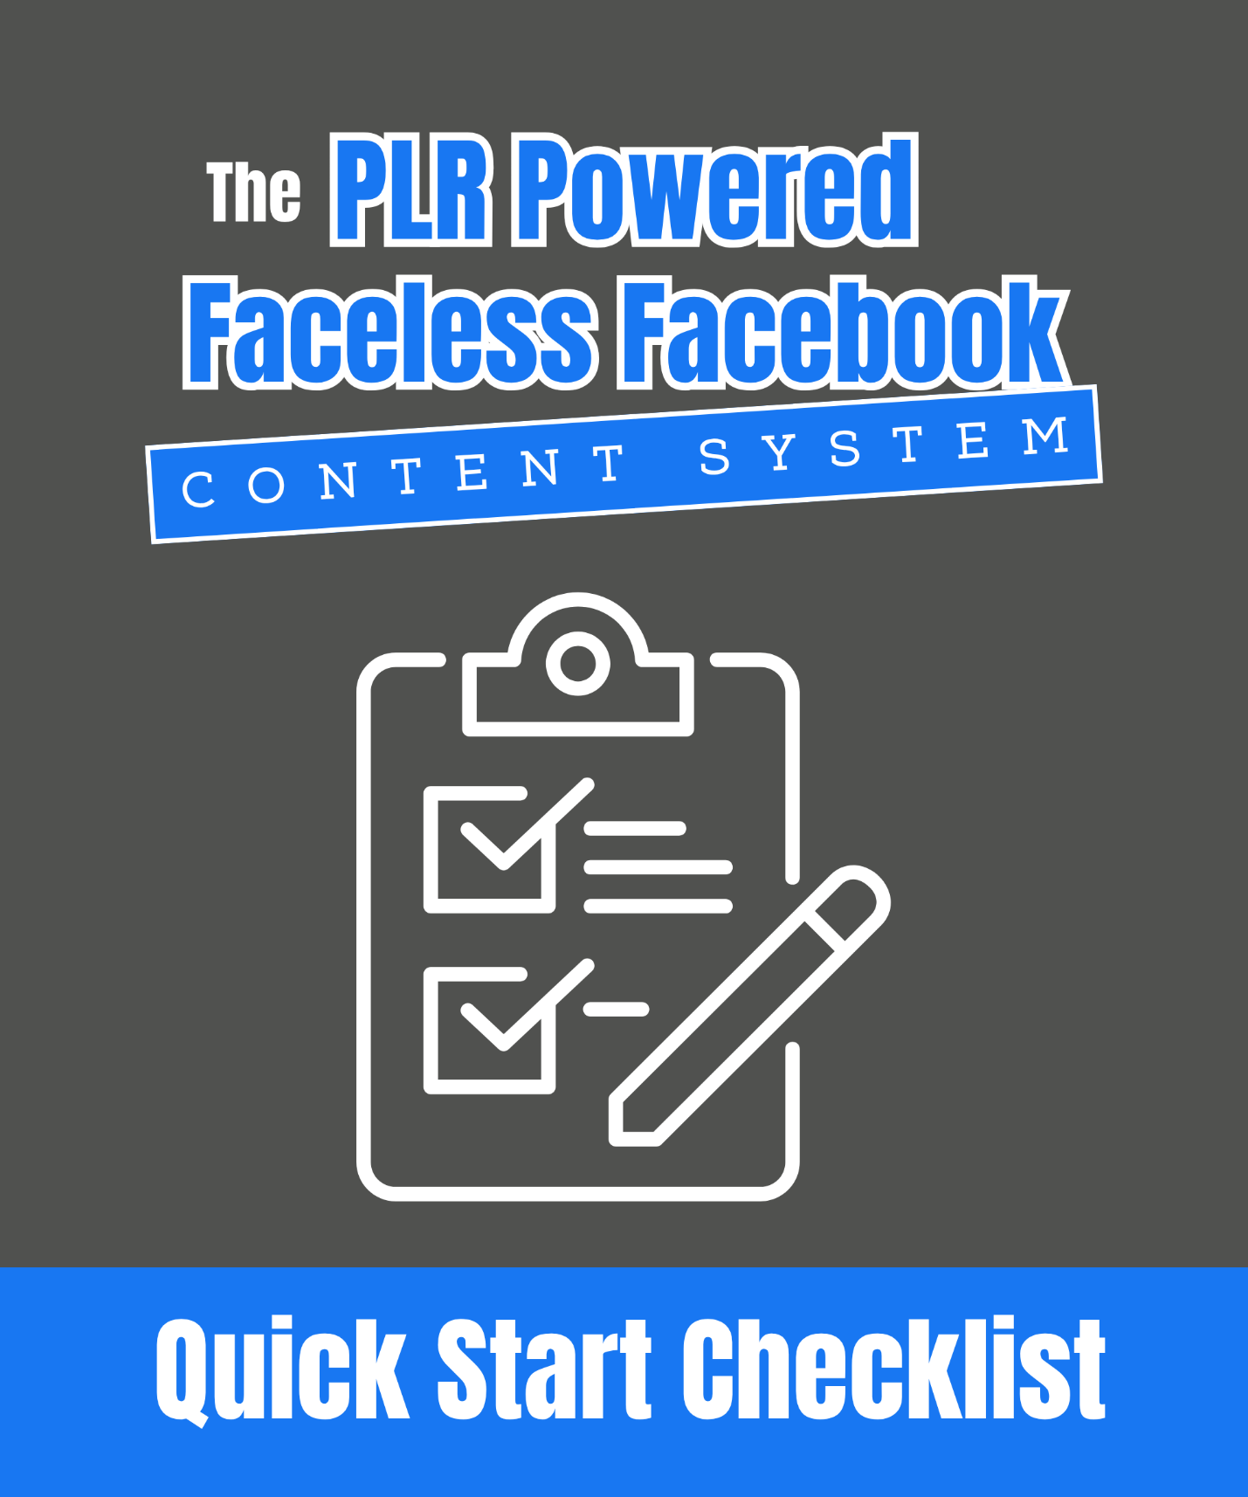

The PLR Powered Faceless Facebook Content System Quick Start Checklist

Your PLR Powered Faceless Facebook Page System

This checklist is your fast-action roadmap. It’s designed to help you move from “I have a bunch of PLR” to “I’m running a content machine that grows and sells without ever showing my face.”

Whether you’re just getting started or need to finally get your system working, THIS checklist will walk you through each key piece and in the exact order you need to do it.

✅ Print it.

✅ Check things off as you go.

✅ Reuse it anytime you want to launch another faceless page.

You don’t need a perfect strategy; you just need to get in motion. Use this to get the system live!

Let’s build your PLR-powered traffic and income engine one step at a time...

Step 1: Choose Your Niche And Gather PLR

- Define your niche! Who is your page for? (You've probably already done this if you have your Faceless Facebook Page up and running.) What problems will you help solve?

- Collect 3–5 high-quality PLR packs with different formats (ebooks, articles, checklists, graphics, videos, etc.).

- Organize your PLR into folders (e.g., “Posts,” “Freebies,” “Products”) for easy access.

Step 2: Plan Your Content

- Select 3–5 content types you can post consistently (e.g., carousels, quick tips, quotes, engagement polls).

- Pull 30 days of content (tips, steps, lists) from your PLR library.

- Rewrite or enhance content to match your page’s tone and style.

- Design simple branded graphics in Canva.

Step 3: Create Your Freebie

- Choose a short, high-value PLR report or checklist.

- Rewrite the intro/outro and add your branding (logo, page name, colors).

- Create a simple cover in Canva.

- Set up a sign-up form using MailerLite, ConvertKit, or Aweber.

Step 4: Create Your First Paid Product

- Pick a PLR ebook, toolkit, or mini-course with a clear outcome.

- Customize the title, intro/outro, and design.

- Bundle extras (checklists, templates) from other PLR for added value.

- Upload to Gumroad, Payhip, or ThriveCart for easy sales.

Step 5: Build Your Monetization Funnel

- Map your funnel: Content → Freebie → Product → Upsell.

- Add email automations: Deliver the freebie, then promote your product.

- Plan your first upsell (e.g., membership, toolkit, or affiliate offer).

Step 6: Schedule And Automate

- Batch-create posts weekly from your PLR library.

- Schedule 3–5 posts per week using Facebook’s built-in scheduler.

- Monitor your analytics weekly and double down on what works.

Pro Tip: Don’t overthink it. Start simple. One freebie, one product, and consistent content are all you need to launch. You can refine and grow as you go.

