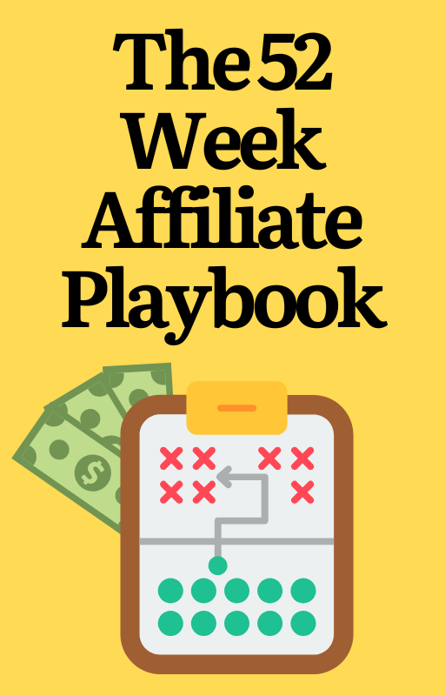
Welcome To The 52-Week Affiliate Playbook!

If you’ve ever felt overwhelmed trying to figure out how to grow your affiliate marketing business, you’re in the right place. My goal with this playbook is to simplify the process and give you a clear, actionable strategy for every single week of the year. Don’t worry about what’s coming next week or the week after.

Affiliate marketing isn’t about doing everything at once. It’s about consistent, focused action that builds over time. That’s exactly what this playbook is here to help you with. One proven tactic each week to keep you moving forward and growing your affiliate income. Worry about THIS week and only THIS week!

Below you will find 52 of my best strategies for affiliate marketing success. These aren’t just ideas. They’re actionable, results-driven tactics that I’ve personally used or taught to my students.

They’re designed to help you:

- Attract more traffic to your offers.

- Build trust and authority in your niche.

- Increase conversions and grow your income.

How To Use This Playbook

Start With Week 1: Each week, focus on implementing the featured tactic. Don’t skip ahead or try to do too much at once. This playbook is all about steady progress.

Adapt as Needed: Some strategies will only take a few hours, while others might require more time and planning. Choose what works best for your schedule each week, and make it happen!

Reflect and Grow: At the end of the week, look at what worked, what didn’t, and how you can improve when you use that tactic again in the future.

Use AI To Help You: If you don’t know how to do a tactic, ask your favorite Chat AI (like ChatGPT) to explain it to you and list out how it works. Then you can also use it to help you create any assets you’ll need to use the tactic.

This is your roadmap to consistent, sustainable growth in your affiliate business. By focusing on just one tactic a week, you’ll avoid burnout, build momentum, and set yourself up for long-term success.

I know affiliate marketing can feel overwhelming sometimes, but with this playbook, you’ll always know exactly what to focus on. Week by week, you’re going to see your business grow and I can’t wait to hear about your success.

So, grab a notebook, block out some time each week, and let’s get started with Week One.

You’ve got this!

The Weekly Tactics

Week 1: Reviews - Write in-depth, honest reviews of products you promote. Focus on benefits and how they solve a problem.

Week 2: Blog Post - Create comparison posts between products in the same niche.

Week 3: Video Marketing - Create tutorial videos demonstrating how to use the product.

Week 4: Social Media Content - Share quick tips, mini-reviews, or success stories related to the product on platforms like Instagram, TikTok, and Facebook.

Week 5: Email Marketing - Build an email list with a valuable lead magnet, such as a free guide or checklist.

Week 6: Case Studies - Document your results using a product or service and turn it into a case study.

Week 7: Testimonials - Share testimonials from satisfied customers (with their permission).

Week 8: Search Engine Optimization (SEO) - Optimize your blog content for long-tail keywords to rank on search engines.

Week 9: Paid Ads - Use Facebook Ads, Google Ads, or native advertising to drive targeted traffic.

Week 10: Pinterest Marketing - Create visually appealing pins that link back to your affiliate content. Use keywords in your pin descriptions for discoverability.

Week 11: Quora - Answer questions related to your niche on platforms like Quora. Include affiliate links in your answers (where allowed) or drive traffic to a helpful blog post.

Week 12: Guest Posting - Write guest posts for other blogs in your niche to tap into their audience.

Week 13: Collaborations - Collaborate with influencers or content creators for joint promotions.

Week 14: Relationship-Building Tactic - Share your personal experiences with the product.

Week 15: Engage in Communities - Be active in Facebook groups, Discord servers, or other communities related to your niche. Offer free advice and solutions, linking to your affiliate offers when appropriate.

Week 16: Webinars - Host webinars that showcase the benefits of the products you promote.

Week 17: Live Streams - Use live streams to engage with your audience in real-time and pitch affiliate offers.

Week 18: Affiliate Bonuses - Offer exclusive bonuses, like guides, templates, or additional training, to anyone who purchases through your affiliate link.

Week 19: Create Funnels - Build a sales funnel that includes a freebie, a nurturing email sequence, and an affiliate product recommendation.

Week 20: Leverage Scarcity and Urgency - Use time-sensitive offers (e.g., “sale ends tonight”) to encourage immediate action. Promote limited-time bonuses to incentivize purchases.

Week 21: Retargeting Pixels - Use retargeting pixels on your blog to show ads to people who’ve already visited your site but didn’t convert.

Week 22: Build a Niche Authority Site - Create a niche-specific website where you consistently post valuable content, building trust and attracting recurring traffic.

Week 23: Repurpose Content - Turn blog posts into videos, videos into social media posts, and so on to reach different audience segments.

Week 24: Email Marketing – Send a sequence of emails that educates and nurtures your audience, leading to product recommendations.

Week 25: Social Media Content - Use polls and Q&A sessions to engage your audience and recommend products as solutions.

Week 26: Video Marketing - Record unboxing videos, testimonials, or walkthroughs showcasing the value.

Week 27: Retargeting Ads - Focus on retargeting campaigns to capture people who previously showed interest.

Week 28: Round-Up Posts - Create lists like "Top 10 Tools for [Your Niche]" and include affiliate links.

Week 29: Success Stories - Share real-world examples of people using the product successfully. Turn these into videos to share to social media or a blog post for your blog.

Week 30: FAQs - Write posts answering common questions about a product or service.

Week 31: Interactive Content - Create quizzes (e.g., "Which [Product] Is Right for You?") that recommend affiliate products.

Week 32: Infographics - Design visually appealing infographics explaining how a product works or showcasing its benefits.

Week 33: Seasonal Content - Promote products tied to specific seasons or events (e.g., "Best Gifts for [Holiday]").

Week 34: Challenges - Host a challenge (e.g., “30-Day Fitness Challenge”) using affiliate products as part of the process.

Week 35: Behind-the-Scenes - Share how you use affiliate products in your own life or business.

Week 36: Influencer Outreach - Partner with influencers to promote affiliate products to their followers.

Week 37: Instagram Stories and Reels - Post short, engaging videos showing product use or benefits.

Week 38: Facebook Groups - Start a niche-focused group and share valuable content, occasionally linking to affiliate products.

Week 39: Evergreen Tutorials - Create how-to videos that remain relevant and continue to generate traffic.

Week 40: Exclusive Deals - Negotiate with brands for exclusive discounts to offer your list.

Week 41: Segmented Campaigns - Target email subscribers based on their preferences and past engagement. You’ll have to already be segmenting and tagging subscribers for this to work.

Week 42: Customer Journey Emails - Design sequences for potential buyers, current customers, and lapsed buyers.

Week 43: Referral Challenges - Incentivize your audience to refer others to products you promote.

Week 44: Guest Appearances - Appear on podcasts or YouTube channels to discuss products and point people to your content with your affiliate links.

Week 45: Native Advertising - Run ads that blend seamlessly with the content on blogs or media platforms.

Week 46: Pinterest Ads - Boost high-performing pins to drive more traffic.

Week 47: Membership Sites - Create a members-only area where you recommend affiliate products.

Week 48: Chatbots and Automation - Use tools like ManyChat to guide users to affiliate products through automated chats.

Week 49: Lead Magnet Funnels - Create lead magnets specifically designed to promote affiliate products.

Week 50: Exit-Intent Popups - Show an offer or discount before users leave your website.

Week 51: Recurring Income Programs - Focus on promoting products with recurring commissions to build a monthly income.

Week 52: Toolkits and Resource Pages - Create a "Tools I Recommend" page featuring affiliate products with explanations of how they help.

Bonus Tactics:

You’ve already got the next 52 weeks planned out, but incase you want to be a total overachiever take one of these and add in an extra tactic during a week you have some extra time.

Bonus Tactic #1: Content Series - Create multi-part blog or video series focused on solving a specific problem using affiliate products.

Bonus Tactic #2: Facebook Messenger Automation - Use chatbots to share product tips and affiliate links.

Bonus Tactic #3: Subreddit Participation - Engage in niche-specific subreddits to recommend affiliate products organically.

Bonus Tactic #4: TikTok Challenges - Create a challenge around using a product and invite others to join.

Bonus Tactic #5: Product Updates Posts - Write posts about new updates or features of products you promote.

Bonus Tactic #6: Blog Post Embeds - Add product banners or widgets to your high-traffic posts.

Bonus Tactic #7: Virtual Summits - Host an event featuring multiple speakers with affiliate product mentions woven into the content.

Bonus Tactic #8: Custom Onboarding Guides - Create tailored guides for users purchasing through your affiliate link.

Bonus Tactic #9: User Journey Mapping - Analyze how visitors interact with your site and improve their path to conversion.

